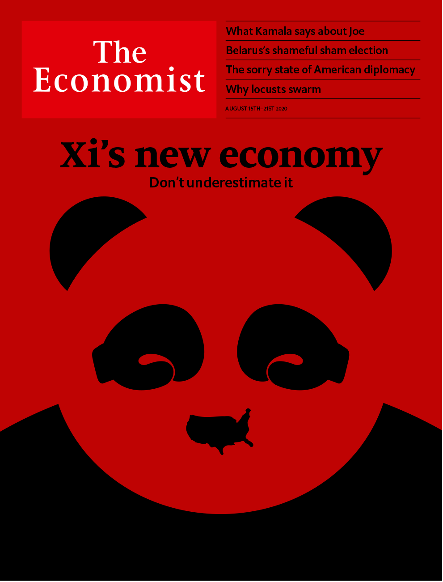

# Table of Contents

The world this week

Politics this week

Business this week

KAL’s cartoon

Leaders

The Chinese model: Xi’s new economy

Belarus: The sham of it

American politics: What Kamala says about Joe

Microfinance: Credit where it’s due

Britain’s economy: Grey v growth

Letters

Letters to the editor: On elderly care, technology, Lyndon Johnson, choral singing, journalism

Briefing

China’s hybrid capitalism: Blooming for the glory of the state

Asia

Development in Cambodia: Service economy

Indonesia’s environment: For peat’s sake

NIMBYism in Japan: Anti-anti-missile systems

Eating ant eggs in Laos: Jungle caviar

Banyan: A one-family state

China

WeChat in America: The big unfriending

Repression in Hong Kong: In the party’s sights

Chaguan: Being blind and young in China

United States

Kamala Harris: Groundbreaking and predictable

Economic stimulus: Prolonging the pain

Looting in Chicago: Smash and grab

Au-pair wars: Essential or exploited?

The decennial census: All flaxen was his poll

Lexington: Flag-rapping

The Americas

Mexico: A new kingpin on the block

Bolivia: Democracy deferred

The Arctic: A shortened shelf life

Middle East & Africa

Tunisia: Ten years after the revolution

Lebanon after the blast: Taking a fall

Ivory Coast: Triumph of the gerontocrats

Nigeria: Hair from everywhere

Tanzania: Courting the big man

Europe

Belarus’s bogus election: The gentle revolution

Russia and the Baltics: Hacker alert

Germany: The ballooning Bundestag

Bike gangs: Sleazy riders

Charlemagne: The other villain

Britain

Economic policy: A grey and stagnant land

GDP: Crash

Exam results: A level playing field?

Migrants in dinghies: A rather small invasion

Fighting covid-19: Local heroes

Farm labour: Ripe for reform

Feminising the Foreign Office: Who runs the world?

Bagehot: A certain idea of Britain

International

America’s State Department: The dereliction of diplomacy

Business

Sino-American commercial relations: Endgame

More Sino-American decoupling: The nuclear option

Bartleby: Labour’s lost love

Saudi Aramco: Trial by fire

Juggling profits and purpose: Profits v purpose

Airbus A380: Superjumbo problems

Schumpeter: The new dividend royalty

Finance & economics

Economic convergence: Club class

Turkey’s currency turmoil: Not at this rate

Tax transparency: Hands off, Uncle Sam

Gold in India: Financial alchemy

Blended finance: Seeking scale

Free exchange: Conscious uncoupling

Schools brief

Raising the floor: What harm do minimum wages do?

Science & technology

Space warfare: A legal void

Quantum mechanics: A flutter in time

Palaeontology: Not guilty?

Zoology: Rules of attraction

Books & arts

Images of covid-19: Decent exposure

People power: Beginner’s luck

Espionage: The Führer’s man in Manhattan

Brazilian literature: Dead man’s blues

Economic & financial indicators

Economic data, commodities and markets

Graphic detail

US presidential election: The old college try

Obituary

Leon Fleisher: Right hand, left hand



### Friday, August 14, 2020

|  |  |
| --- | --- |
| The world this week | 3 |
| Leaders | 5 |
| Letters | 1 |
| Briefing | 1 |
| Asia | 5 |
| China | 3 |
| United States | 6 |
| The Americas | 3 |
| Middle East & Africa | 5 |
| Europe | 5 |
| Britain | 8 |
| International | 1 |
| Business | 7 |
| Finance & economics | 6 |
| Schools brief | 1 |
| Science & technology | 4 |
| Books & arts | 4 |
| Economic & financial indicators | 1 |
| Graphic detail | 1 |
| Obituary | 1 |

|  |  |  |
| --- | --- | --- |
|  | Sections | Leaders |

The world this week

Politics this week

.

Business this week

.

KAL’s cartoon

.

|  |  |  |
| --- | --- | --- |
|  | Sections | Leaders |

|  |  |  |  |
| --- | --- | --- | --- |
|  | Articles | Sections | Next |

# Politics this week

Aug 13th 2020 |

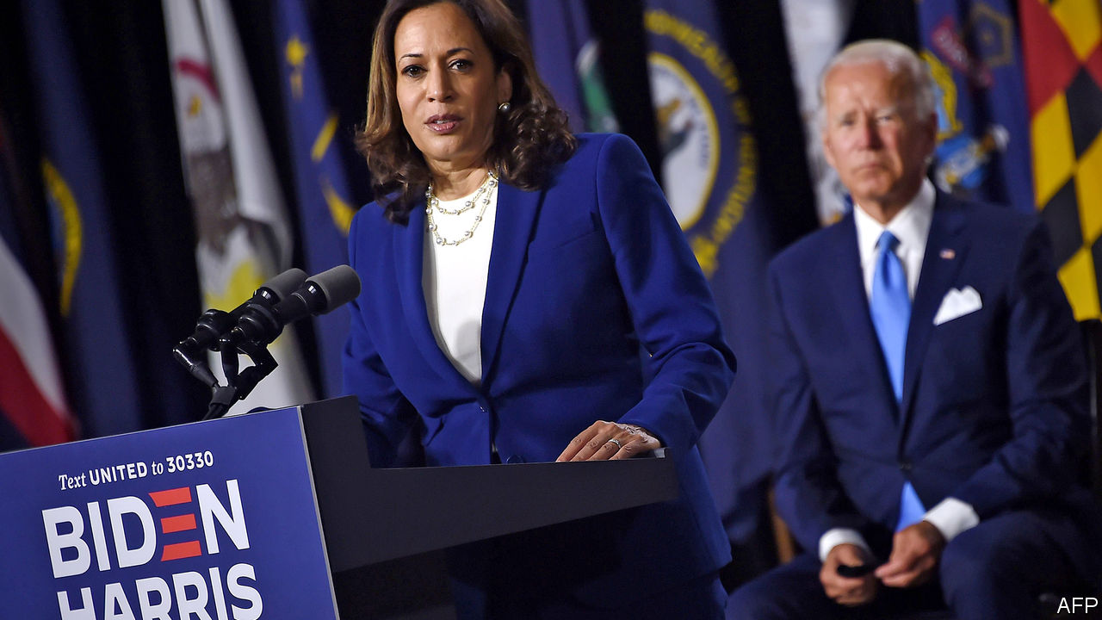

Joe Biden named Kamala Harris, a senator from California, as his running-mate. The daughter of a Jamaican-American economist and an Indian-American cancer researcher, she is the first black woman or Asian-American on a major-party presidential ticket. Democrats largely praised her as a safe, charismatic choice, though some queried her respect for civil liberties, noting her record as a tough-on-crime prosecutor. See article.

The director of America’s counter-intelligence service warned that Russia was using a “range of measures” to undermine Mr Biden’s campaign, primarily because of his support for Ukraine.

Chicago endured a night of looting, after police officers shot and injured a black man who they said was firing a gun at them. Bridges were raised to stop looters roaming. See [article](https://www.economist.com/node/21790917).

Seattle’s council voted to slash the police budget and refocus the city’s force on “public safety”. The police chief, Carmen Best, said she would resign, decrying an “overarching lack of respect” for her officers. She was the first black woman to hold the job.

The Milne ice shelf, the last one that was intact in the Canadian Arctic, split apart during a heatwave. The breakaway piece made up 40% of the ice shelf’s surface area. See article.

Protests by allies of Bolivia’s former president, Evo Morales, over the postponement of an election due to covid-19, have blocked roads and exacerbated shortages of oxygen. The interim government, led by Jeanine Áñez, a conservative, says 30 people have died as a result. A new election, in which Ms Áñez is running and Mr Morales is not, is scheduled for October 18th. See article.

Mexican prosecutors began a corruption investigation into a former president, Enrique Peña Nieto. They are looking into claims that before he became president Mr Peña used bribes from Odebrecht, a Brazilian construction firm, to help finance the election campaign in 2012, and that during his presidency he paid legislators to vote for a big energy reform.

Alexander Lukashenko claimed a sixth election victory in Belarus, with 80% of the vote. Huge crowds protested, saying the count was rigged and the real victor was Svetlana Tikhanovskaya, an ex-teacher. Police arrested and beat thousands. Ms Tikhanovskaya, who had promised to free political prisoners and hold a fair election, fled the country after a long involuntary interview with the security services. Her supporters assume she was threatened. Her husband, who was barred from standing, remains in jail. See article.

Tanzania banned the broadcasting of news produced by foreign media without the government’s permission. Local journalists working for foreign media or with foreign correspondents must now be accompanied by an official minder, as in North Korea.

Rebels in northern Mozambique captured the port city of Mocímboa da Praia, killing dozens of soldiers and sinking a navy patrol boat. The jihadist insurgency threatens the development of offshore gasfields, Africa’s biggest energy project.

The government of Lebanon resigned in the wake of a devastating explosion in Beirut. The outgoing prime minister, Hassan Diab, blamed a “system of corruption” for bankrupting the country and crippling basic services. Tens of thousands of people protested. World leaders and international organisations pledged nearly $300m to help those affected by the blast. See article.

America imposed sanctions on 11 Chinese officials, including Hong Kong’s leader Carrie Lam, for their role in suppressing dissent in the territory. In retaliation, China announced sanctions against 11 Americans, including lawmakers. Hong Kong police arrested Jimmy Lai, a newspaper tycoon, alleging that he “colluded” with a foreign power. Mr Lai, the owner of Apple Daily, has often suggested that America should support democracy in Hong Kong. See article.

China eased sweeping restrictions on entry to the country by foreigners, which it imposed in March in response to covid-19. Citizens of 36 countries, including Britain, France and Germany, who already hold a Chinese residence permit will be allowed to apply for visas. They will still have to be tested and endure 14 days of quarantine.

Alex Azar, America’s secretary of health, became the highest-ranking American official to visit Taiwan since America established formal diplomatic relations with China in 1979, and ended them with Taiwan.

Mahathir Mohamad, a two-time prime minister of Malaysia who was ousted from power earlier this year after a rift within his coalition, founded a new political party that says it will champion ethnic Malays and fight corruption. Dr Mahathir, who is 95, says his previous party, Bersatu, which is now led by the incumbent prime minister, Muhyiddin Yassin, has been hijacked by defenders of kleptocracy.

After a special consultative congress gave the go-ahead, the Afghan government said it would release a further 400 Taliban prisoners, in addition to the 4,600 it has recently freed. The decision paves the way for a peace conference.

## Coronavirus briefs

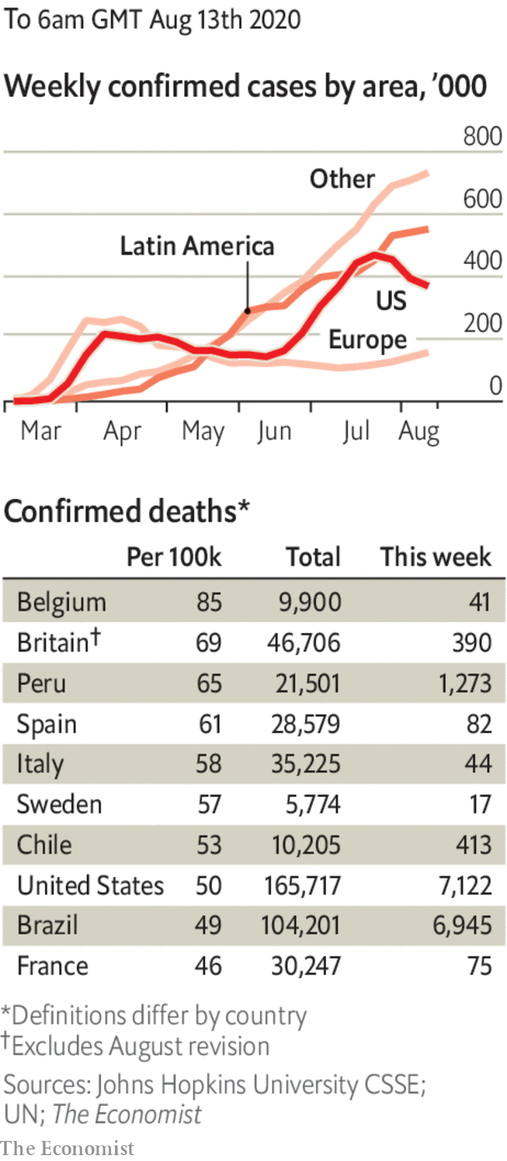

The number of cases in the United States passed 5m. Brazil reached over 100,000 deaths in total.

New Zealand investigated the possibility that its first infections for 102 days had come from freight. The people involved had not travelled. Auckland was locked down.

Masks became compulsory outdoors in Paris and Brussels.

Russia said that it had approved a vaccine against the coronavirus. Scientists elsewhere had doubts. The drug, named Sputnik V, appears simply to have skipped all but the first stages of testing for safety and efficacy.

The estimated death toll in England was reduced by 5,377, or 12%. A review found that anyone who had died following a positive test was being included in the tally, regardless of how, or when, they died.

This article was downloaded by calibre from <https://www.economist.com/the-world-this-week/2020/08/13/politics-this-week>

|  |  |  |  |
| --- | --- | --- | --- |
|  | Articles | Sections | Next |

|  |  |  |  |
| --- | --- | --- | --- |
| Previous | Articles | Sections | Next |

# Business this week

Aug 15th 2020 |

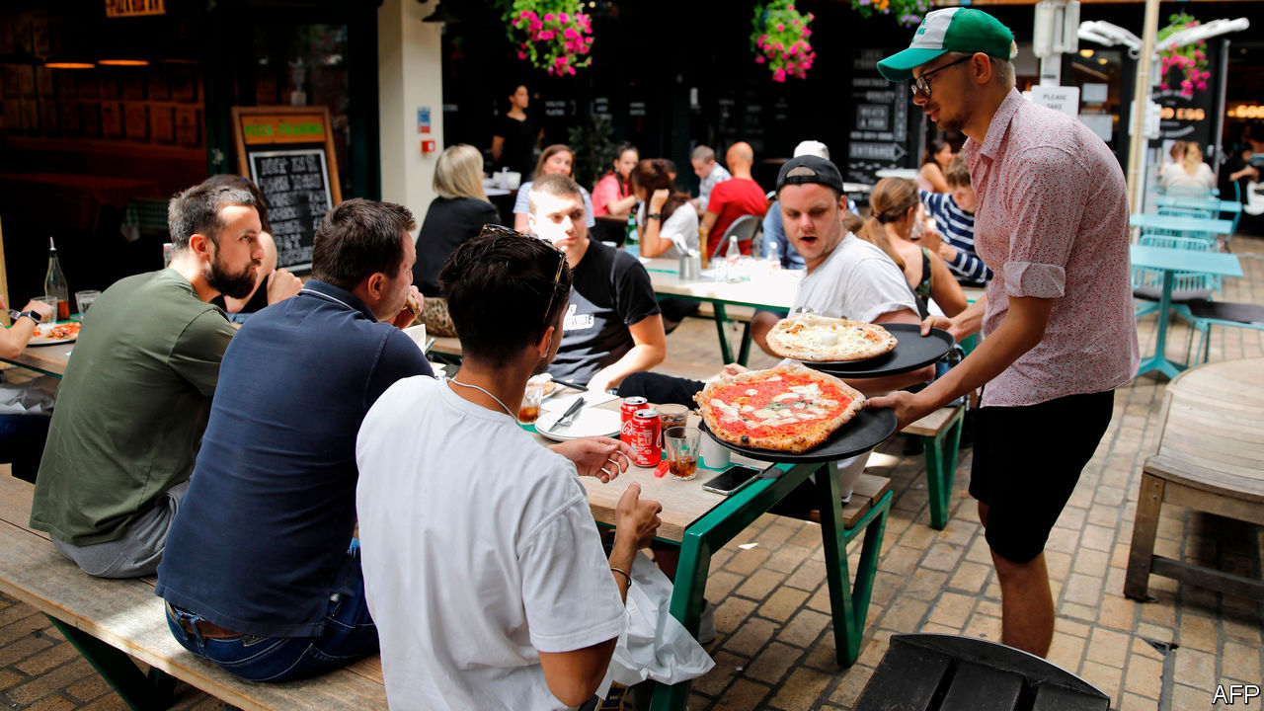

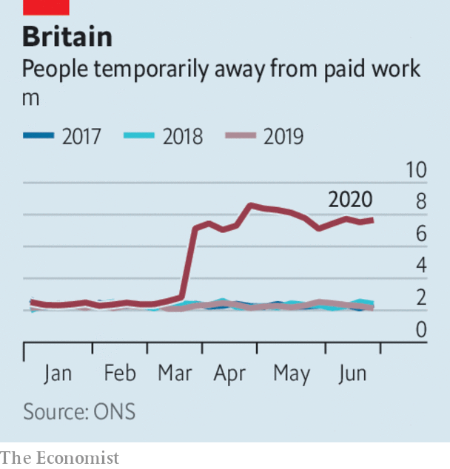

Britain’s economy plunged into recession in the second quarter, as GDP contracted by a record 20.4% compared with the previous three months. In the first half of 2020 the British economy was hit twice as hard as America’s and fared worse than Germany, Italy and France. There was a sliver of positive news—growth picked up again in June. That will be of little comfort to those facing the end of furlough. Figures also showed a huge drop in the number of people in employment, and redundancies are at a seven-year high. The government’s job-retention scheme will soon start to wind down, though millions still depend on it (see chart). See [article](https://www.economist.com/node/21790867).

## Come dine with me

The hospitality industry in Britain has been missing all those absent workers. A government scheme to help the industry by subsidising meals in restaurants, pubs and cafés during August was used by 10.5m diners in its first week. Each customer gets up to £10 ($13) deducted from his meal on Mondays to Wednesdays; the restaurant claims the money back from the Treasury.

America’s unemployment rate fell again in July, to 10.2%. Employers created 1.8m jobs, fewer than the 4.8m that were added to the payrolls in June, when lockdowns eased.

With Democrats and Republicans at loggerheads over a new stimulus package, Donald Trump issued an executive order that, among other things, would reinstate the additional unemployment benefits that ceased in July (though at $400 a week rather than $600) and defer the collection of payroll taxes. The order’s intent may be to concentrate minds; the extra benefits depend on contributions from cash-strapped states. See [article](https://www.economist.com/node/21790921).

Mr Trump also issued orders banning ByteDance, the Chinese owner of TikTok, from America within 45 days and a similar decree curtailing American firms from doing business with WeChat. As with many of Mr Trump’s dictums, the legality of the president’s latest orders is questionable, though they undoubtedly create uncertainty for the companies involved. The share price of WeChat’s parent company, Tencent, was hammered following his pronouncement.

Despite a big drop in quarterly profit, Saudi Aramco said it would still pay a shareholder dividend, most of which goes to the Saudi government. The oil company’s net income in the three months to June 30th was $6.8bn; in the same quarter last year it made $24.7bn. Unlike other oil companies, Aramco has not written down assets because of lower oil prices, but it will slash spending. Occidental cut the value of its assets this week, and reported a quarterly loss of $8.4bn. See [article](https://www.economist.com/node/21790901).

The $765m loan that the American government said it would provide to Kodak to produce generic drugs was put on hold until allegations of wrongdoing are resolved. The company’s share price soared when the loan was made public, but the timing of the announcement has led to claims of insider trading that are being investigated by regulators and Congress. Kodak is co-operating with the inquiries; its stock has plunged by 70% since its post-announcement peak.

## Have a great holistay

Airbnb is reportedly preparing to file documents for an IPO, which could take place later this year. The home-rentals firm has said that demand is picking up, especially for properties that are closer to home for holiday-makers.

Tesla announced a five-for-one split of its stock. From August 28th each shareholder will receive four extra shares for each share they hold, at the reduced price. With the value of its stock tripling since the start of the year, the intention is to make the shares more attractive to small investors. Apple recently split its stock, as its share price has also rocketed in value.

Following its biggest-ever loss earlier this year, SoftBank swung back to a quarterly profit, of ¥1.25trn ($12bn), mostly because the value of its holdings in tech companies rose and it sold a large chunk of its telecoms assets. The Japanese conglomerate is also considering selling some or all of Arm, a British chip designer it bought in 2016 for $32bn.

Steve Easterbrook, who was sacked by McDonald’s as chief executive last November for having a romance with an employee, was sued by the company, which claims he had three additional sexual relationships with staff. McDonald’s said that if it had known about the extent of Mr Easterbrook’s “inappropriate” behaviour it would not have agreed to the compensation package it paid him.

Sumner Redstone died, aged 97. The media mogul’s empire spanned Paramount Pictures, Viacom and CBS. Feuds among family and management over the ownership of his companies entangled Mr Redstone in legal proceedings for years, and his mental competency was challenged as he got older. He once said that success is built on failure, frustration and sometimes catastrophe.

This article was downloaded by calibre from <https://www.economist.com/the-world-this-week/2020/08/15/business-this-week>

|  |  |  |  |
| --- | --- | --- | --- |
| Previous | Articles | Sections | Next |

|  |  |  |  |
| --- | --- | --- | --- |
| Previous | Articles | Sections | Next |

# KAL’s cartoon

Aug 15th 2020 |

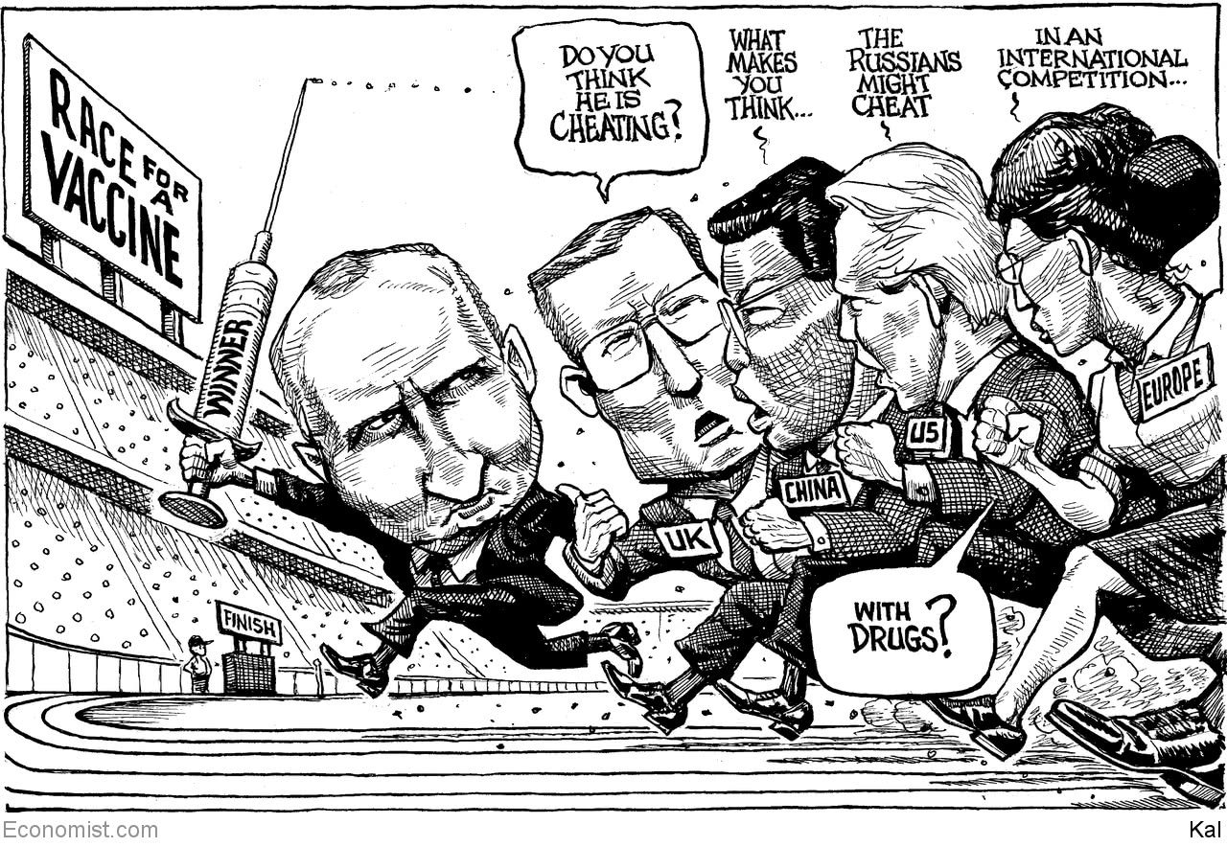

This article was downloaded by calibre from <https://www.economist.com/the-world-this-week/2020/08/15/kals-cartoon>

|  |  |  |  |
| --- | --- | --- | --- |
| Previous | Articles | Sections | Next |

|  |  |  |
| --- | --- | --- |
| The world this week | Sections | Letters |

Leaders

The Chinese model: Xi’s new economy

.

Belarus: The sham of it

.

American politics: What Kamala says about Joe

.

Microfinance: Credit where it’s due

.

Britain’s economy: Grey v growth

.

|  |  |  |
| --- | --- | --- |
| The world this week | Sections | Letters |

|  |  |  |  |
| --- | --- | --- | --- |
|  | Articles | Sections | Next |

#### The Chinese economic model

# Xi Jinping is reinventing state capitalism. Don’t underestimate it

China’s strongman leader has a new economic agenda

Aug 13th 2020 |

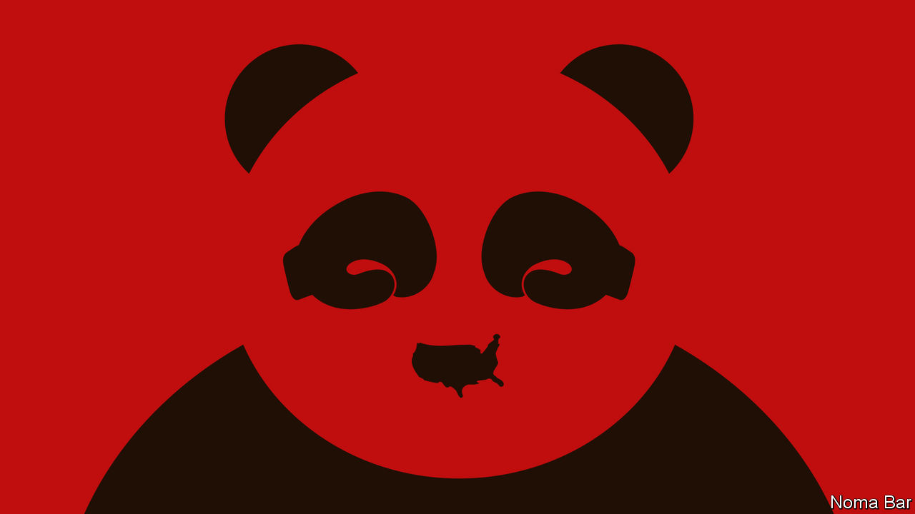

AMERICA’S CONFRONTATION with China is escalating dangerously. In the past week the White House has announced what may amount to an imminent ban on TikTok and WeChat (two Chinese apps), imposed sanctions on Hong Kong’s leaders and sent a cabinet member to Taiwan. This ratcheting up of pressure partly reflects electioneering: being tough on China is a key strut of President Donald Trump’s campaign. It is partly ideological, underscoring the urgency the administration’s hawks attach to pushing back on all fronts against an increasingly assertive China. But it also reflects an assumption that has underpinned the Trump administration’s attitude to China from the beginning of the trade war: that this approach will yield results, because China’s steroidal state capitalism is weaker than it looks.

The logic is alluringly simple. Yes, China has delivered growth, but only by relying on an unsustainable formula of debt, subsidies, cronyism and intellectual-property theft. Press hard enough and its economy could buckle, forcing its leaders to make concessions and, eventually, to liberalise their state-led system. As the secretary of state, Mike Pompeo, puts it, “Freedom-loving nations of the world must induce China to change.”

Simple, but wrong. China’s economy was less harmed by the tariff war than expected. It has been far more resilient to the covid-19 pandemic—the IMF forecasts growth of 1% in 2020 compared with an 8% drop in America. Shenzhen is the world’s best-performing big stockmarket this year, not New York. And, as our briefing explains, China’s leader, Xi Jinping, is reinventing state capitalism for the 2020s. Forget belching steel plants and quotas. Mr Xi’s new economic agenda is to make markets and innovation work better within tightly defined boundaries and subject to all-seeing Communist Party surveillance. It isn’t Milton Friedman, but this ruthless mix of autocracy, technology and dynamism could propel growth for years.

Underestimating China’s economy is hardly a new phenomenon. Since 1995 China’s share of world GDP at market prices has risen from 2% to 16%, despite waves of Western scepticism. Silicon Valley chiefs dismissed Chinese tech firms as copycats; Wall Street short-sellers said ghost towns of empty apartments would bring a banking crash; statisticians worried that the GDP figures were fiddled and speculators warned that capital flight would cause a currency crisis. China has defied the sceptics because its state capitalism has adapted, changing shape. Twenty years ago, for example, the emphasis was on trade, but now exports account for only 17% of GDP. In the 2010s officials gave tech firms such as Alibaba and Tencent just enough space to grow into giants and, in Tencent’s case, to create a messaging app, WeChat, that is also an instrument of party control (see article).

Now the next phase of Chinese state capitalism is under way—call it Xinomics. Since he took power in 2012 Mr Xi’s political goal has been to tighten the party’s grip and crush dissent at home and abroad. His economic agenda is designed to increase order and resilience against threats. For good reason. Public and private debt has soared since 2008 to almost 300% of GDP. Business is bifurcated between stodgy state firms and a Wild West private sector that is innovative but faces predatory officials and murky rules. As protectionism spreads, Chinese firms risk being locked out of markets and denied access to Western technology.

Xinomics has three elements. First, tight control over the economic cycle and the debt machine. The days of supersized fiscal and lending binges are over. Banks have been forced to recognise off-balance-sheet activity and build up buffers. More lending is taking place through a cleaned-up bond market. Unlike its reaction to the financial crisis of 2008-09, the government’s response to covid-19 has been restrained, with a stimulus worth about 5% of GDP, less than half the size of America’s.

The second strand is a more efficient administrative state, whose rules apply uniformly across the economy. Even as Mr Xi has used party-imposed law to sow fear in Hong Kong, he has constructed a commercial legal system in the mainland that is far more responsive to businesses. Bankruptcies and patent lawsuits, once rare, have risen fivefold since he took office in 2012. Red tape has been trimmed: it now takes nine days to set up a company. More predictable rules should allow markets to work more smoothly, boosting the economy’s productivity.

The final element is to blur the boundary between state and private firms. State-run companies are being compelled to boost their financial returns and draw in private investors. Meanwhile the state is exerting strategic control over private firms, through party cells within them. A credit blacklisting system penalises firms that misbehave. Instead of indiscriminate industrial policy, such as the “Made in China 2025” campaign launched in 2015, Mr Xi is shifting to a sharp focus on supply-chain choke-points where China is either vulnerable to foreign coercion or where it can exert influence abroad. That means building up self-sufficiency in key technologies, including semiconductors and batteries.

Xinomics has performed well in the short term. The build-up of debt had slowed before covid-19 struck and the twin shocks of the trade war and the pandemic have not led to a financial crisis. State-run firms’ productivity is creeping up and foreign investors are pouring cash into a new generation of Chinese tech firms. The real test, however, will come over time. China hopes that its new techno-centric form of central planning can sustain innovation, but history suggests that diffuse decision-making, open borders and free speech are the magic ingredients.

One thing is clear: the hope for confrontation followed by capitulation is misguided. America and its allies must prepare for a far longer contest between open societies and China’s state capitalism. Containment won’t work: unlike the Soviet Union, China’s huge economy is sophisticated and integrated with the rest of the world. Instead the West needs to build up its diplomatic capacity (see article) and create new, stable rules that allow co-operation with China in some areas, such as fighting climate change and pandemics, and commerce to continue alongside stronger protections for human rights and national security. The strength of China’s $14trn state-capitalist economy cannot be wished away. Time to shed that illusion. ■

This article was downloaded by calibre from <https://www.economist.com/leaders/2020/08/13/xi-jinping-is-reinventing-state-capitalism-dont-underestimate-it>

|  |  |  |  |
| --- | --- | --- | --- |
|  | Articles | Sections | Next |

|  |  |  |  |
| --- | --- | --- | --- |
| Previous | Articles | Sections | Next |

#### Fraud in Russia’s near-abroad

# Belarus’s election was a sham. The West’s response has been feeble

The biggest protests in the country’s history call for proper democracy

Aug 15th 2020 |

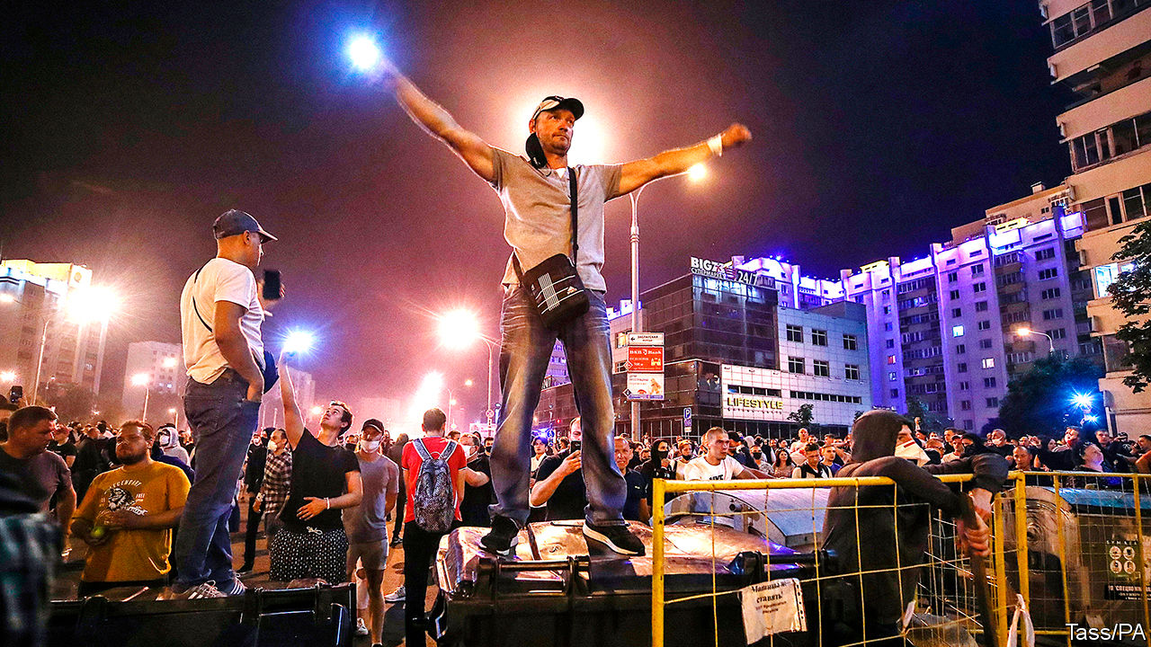

IN A COUNTRY in the heart of Europe grisly acts were being committed this week, with the approval of Russia and China, the mildest of European protests and near-silence from America. An election was rigged; the challenger was forced to leave the country; protesters are being beaten and jailed. The perpetrator is Alexander Lukashenko, a 65-year-old dictator who has ruled the former Soviet republic of Belarus for most of its 30 years of independence. With luck, though, he may have overreached.

After a presidential election on August 9th the authorities proclaimed that Mr Lukashenko had won 80% of the vote. But the process was rigged from the start (see [article](https://www.economist.com/node/21790849)). Opposition candidates had been jailed or had gone into exile; most independent observers were barred and “preliminary” voting was extended to allow more time for ballot-stuffing. Mr Lukashenko has done all this before and got away with it, largely because he retained enough support to claim a degree of legitimacy.

This time, however, he appears to have lost most of the population, thanks partly to his extraordinary incompetence in dealing with covid-19. They queued up to vote for Svetlana Tikhanovskaya, a 37-year-old former teacher who became an accidental candidate after her popular vlogger husband was jailed to prevent him from running. She made only two big promises: to release all political prisoners and to hold a proper election within six months. The authorities said she had won only 9.9% of the vote, an impossibility given the vast crowds she attracted during her rock-star progress around the country during the campaign. The true result is unknowable, but in a few polling stations where rigging was prevented by observers she won about 70%. When Mr Lukashenko was declared the victor, the largest crowds in independent Belarus’s history came out to roar their rage and disbelief.

They were met with rubber bullets and stun grenades. Thousands have been arrested. Journalists have been hunted down. Ms Tikhanovskaya herself was detained inside the central election commission where she went to file a complaint, and was apparently coerced to read out a statement renouncing her claim to power. Her husband is incarcerated and her children are in hiding. Her supporters assume that they were threatened. Ms Tikhanovskaya was forced to go to Lithuania, explaining that: “Children are the most important things in our lives.”

The Western response has been feeble. Ursula von der Leyen, the president of the European Commission, urged Mr Lukashenko to count votes “accurately”. Angela Merkel’s spokesman expressed “great doubts” about the conduct of the election. Donald Trump said nothing. Access to the country has been shut down, so TV pictures are limited. But the main reason for Western acquiescence is that Mr Lukashenko has skilfully portrayed himself as the guarantor of national sovereignty. Without a strongman, some fear, Belarus might be gobbled up by Russia.

This argument is misguided. There is nothing Mr Putin would like more than for Mr Lukashenko to use violence against his own people. Not only would this make him more dependent on the Kremlin, but it would serve as a warning to Russia’s own protesters. By cutting Mr Lukashenko some slack, the West makes that more likely. Instead, it should recognise the election in Belarus for what it was—a sham.

It should demand the release of all political prisoners and the formation of a transitional government. If Mr Lukashenko refuses, the West should impose sanctions not only on him and members of his family but also on everyone involved in rigging the election and abusing protesters. It should warn the heads of the Belarussian law-enforcement agencies and the armed forces of their personal responsibility if they carry out the orders of an illegitimate president. That is the right way to help the people of Belarus, who are demonstrating and striking against repression, and so that a phoney election shall not stand. ■

This article was downloaded by calibre from <https://www.economist.com/leaders/2020/08/15/belaruss-election-was-a-sham-the-wests-response-has-been-feeble>

|  |  |  |  |
| --- | --- | --- | --- |
| Previous | Articles | Sections | Next |

|  |  |  |  |
| --- | --- | --- | --- |
| Previous | Articles | Sections | Next |

#### Kamala Harris

# What Kamala says about Joe

Joe Biden’s choice of running-mate reflects well on him

Aug 13th 2020 |

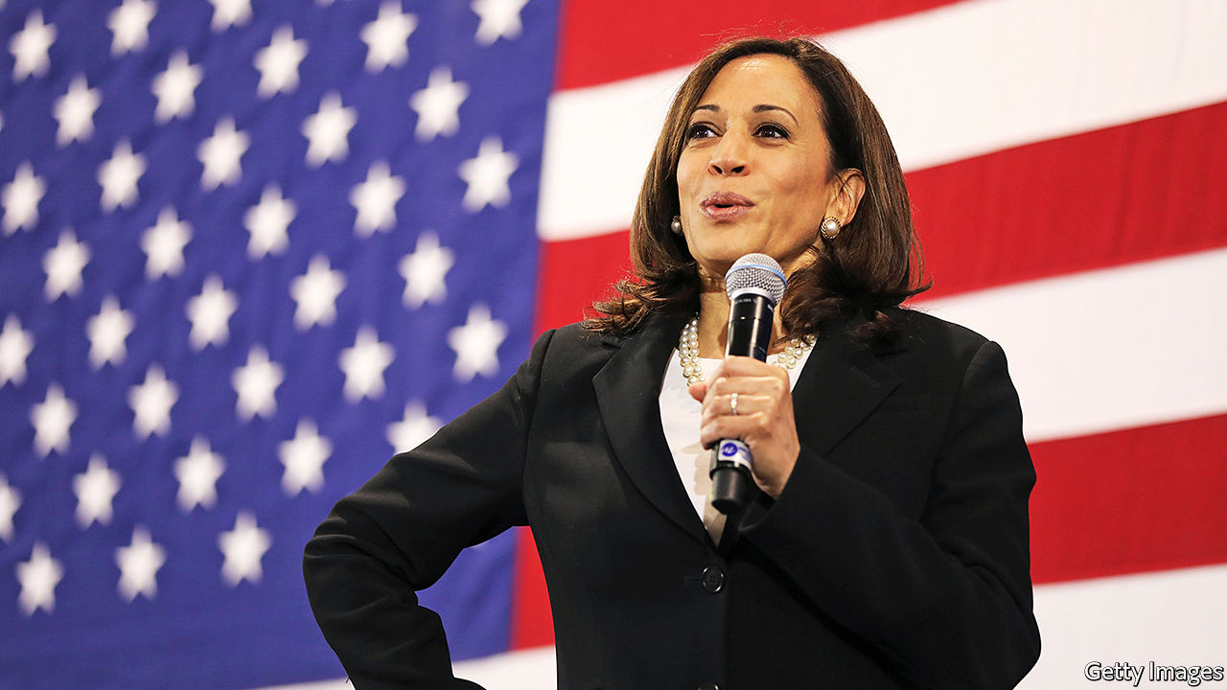

JOE BIDEN’S strategy so far has been to stay out of the way as far as possible. The more the news cycle is filled with President Donald Trump, covid-19 deaths and economic misery, the better for Mr Biden’s campaign. So far it has worked: he is nine points up in our average of polls. Democrats have a shot not just at taking the presidency and retaining the House but also at capturing the Senate, which earlier this year had looked out of reach. With that trifecta comes the power to change America.

But to what end? Mr Biden’s stealth campaign is fine as an approach to winning the election in November, but it has not revealed much about what sort of president he might be. His choice of Senator Kamala Harris as his running-mate is different. Because this is the first big call he has had to make, it says something about how he would make decisions in the White House. It also gives an indication of the ideological leanings of a future Biden administration.

The pick reflects well on the former vice-president, who spent eight years doing the job he has recruited Ms Harris for. Mr Biden has chosen the person who went at him hardest during the primary debates; he has not held a grudge. And he has picked someone who, for all her mould-breaking qualities as the first African-American woman and the first Asian-American on a presidential ticket (her parents are from Jamaica and from India), has come up through the conventional route to high office. Ms Harris has been chief prosecutor in San Francisco, state attorney-general in California and is now a US senator (see article). Mr Biden promises a return to competent governing. His running-mate’s CV reinforces the pitch.

What does the choice say about what a would-be Biden administration might do? Like Mr Biden, she comes from the Democratic Party’s centre. That means pursuing progress on climate change, health care and the relationship between business and the state through incremental change rather than cheerleading for a revolution.

Her main drawback, for both libertarians and progressive Democrats, is her record as a prosecutor. California suffers from overcrowded prisons and a dysfunctional probation system. Ms Harris did not make either better. She opposed the legalisation of cannabis and prosecuted non-violent crime aggressively. But if this becomes a law-and-order election, which is the fight Mr Trump would like, this record would probably be an advantage. She would be hard to paint as soft on crime, which matters in a year that has seen a sharp rise in murders in America’s big cities.

Ms Harris is not particularly ideological, a quality which could also be an asset in November. The Trump campaign was hoping for a crazed leftist; the president’s first attack ad has had to settle for going after “phoney Kamala”. As often with Mr Trump’s insults, there is an element of truth to the charge. During the Democratic primary Ms Harris seemed willing to abolish private health insurance when the wind appeared to be blowing that way. Then, when the scheme began to look like a gift to Mr Trump’s re-election campaign, she ditched it, sort of, in favour of an unworkable, cobbled-together hybrid. This suggests a lack of fixed ideas. It also suggests a kind of flexibility that can be a useful attribute in Washington dealmaking.

In short, she resembles the old white guy at the top of the ticket. Some veep picks try to compensate for the headline candidate’s particular weakness—think of Mike Pence’s evangelical piety and Mr Trump’s Hugh Hefner tendencies. Ms Harris is more of an amplifier. Like Mr Biden she has moved with her party, for example on criminal justice, but without ever straying too far from where a majority of voters are. She has accumulated enough experience in executive positions and as a legislator to provide competent backup. That may not sound inspiring, but it would be a contrast to the administration which the Biden/Harris ticket hopes to replace.

This is all the more important because Ms Harris may one day inherit or win the presidency herself. Average male life expectancy in America is 76. Mr Biden is 77. If he does triumph in November, she may be called on to deputise for him while he is in office. If he loses, she would be first in line next time round. For all the anxiety about racism in America at the moment, Ms Harris feels in many ways like a safe, unremarkable choice for vice-president. That is a sign of progress. ■

Dig deeper:  
Sign up and listen to Checks and Balance, our [weekly newsletter](https://www.economist.com/checksandbalance/) and [podcast](https://www.economist.com/podcasts/2020/08/01/checks-and-balance-our-weekly-podcast-on-american-politics) on American politics, and explore our [presidential election forecast](https://projects.economist.com/us-2020-forecast/president)

This article was downloaded by calibre from <https://www.economist.com/leaders/2020/08/13/what-kamala-says-about-joe>

|  |  |  |  |
| --- | --- | --- | --- |
| Previous | Articles | Sections | Next |

|  |  |  |  |
| --- | --- | --- | --- |
| Previous | Articles | Sections | Next |

#### Credit where it’s due

# Covid-19 is causing a microcredit crunch

Lenders deserve relief, belief and a dose of red tape

Aug 15th 2020 |



ACROSS THE developing world vast numbers of people have lost their jobs or seen their incomes fall. Many are being forced to sell their meagre belongings to pay for food. Ideally state handouts would plug the gap in their finances, but in many countries the public coffers are empty. Often people are too poor a credit risk, or live too remotely, to get help from banks. Microcredit, a form of lending tailored to them, should be part of the answer, but the industry is flunking one of its biggest tests.

In the 1990s and 2000s microcredit was one of the next big things in development finance. In 2006 Bangladesh’s Grameen Bank and its founder, Muhammad Yunus, won the Nobel peace prize. The industry’s champions developed a grand ambition. Letting the poor borrow and invest, they argued, would unleash their inner entrepreneur and allow them to earn their way out of poverty. A new model emerged. Instead of demanding collateral, which few poor people have, loan officers judged creditworthiness by assessing expected income. Lending often went to groups of people, who knew and monitored each other better than banks could. That also saved officers time and hassle, creating efficiencies that enabled clients to borrow small sums at affordable rates.

Today the lending portfolios of microfinance institutions (MFIs) are worth a combined $124bn. But the industry is in trouble. Covid-19 is straining its finances. Repayments, usually done in cash and in person, have plummeted, yet the banks and investors which provide the MFIs with funds still expect money. A crunch looms. More than two-thirds of MFIs have cut lending, often by at least half. Nearly one-third do not have enough cash to meet outflows this quarter. If only this were the industry’s only problem. Compounding it is a set of deeper, longer-standing issues that have begun to undermine its reputation for efficiency and probity (see [article](https://www.economist.com/node/21790899)).

As the industry has grown in size it has also grown in complexity. From insurance to leasing, a lengthening suite of services has turned microcredit into microfinance, adding new players to the fray. A mishmash of regulators have struggled to keep up. Patchy regulation and lots of loopholes have become a serious problem as the industry’s high repayment rates—well above 90% on average—have lured for-profit lenders, some of which demand land titles as collateral, charge extortionate rates and use heavy-handed tactics to collect payments. From Congo to Kosovo, scandals have surfaced.

An expanding body of academic research suggests that microfinance consistently falls short of its boosters’ admittedly high expectations. Among the economists who have plucked at its laurels are last year’s Nobel prizewinners, Abhijit Banerjee and Esther Duflo. They and others have found that its effects on investment, revenue and consumption are small and uncertain. The result is waning interest in the industry from blue-chip investors and donors.

The timing is terrible. People use MFIs for a variety of needs, from buying goods to helping relatives. What matters is less what the funds are spent on than households’ and firms’ ability to smooth their income and outgoings over time, which is particularly important when bad news, or a bad season—or a pandemic—strikes. Without microcredit, covid-19 means more people in desperate situations will turn to loan sharks and pawnbrokers, at the risk of falling into debt spirals.

What to do? In the short term, viable MFIs need support. Donors and investors should consider moratoriums, reschedulings or injecting capital. Nearly half of MFIs say they have not had any discussion with funders yet. Supervisors may need to loosen reserve requirements to provide breathing space. Forbearance with struggling clients should be tolerated, as long as MFIs sketch out a path back to normal for when the pandemic is over.

In the longer term governments need to crack down on predatory lending and make rules more consistent and uniform. That will prevent vulnerable people from being exploited and also help restore confidence in legitimate microlending firms. Calibrating regulation is not easy, but some obvious measures include better information-sharing, so MFIs know what they are doing and people can shop around; an obligation to properly assess borrowers’ ability to repay; transparency on rates and fees; protection against harassment; and credible grievance mechanisms, advertised in information campaigns. For governments battling deep recessions microfinance may seem a sideshow. But all MFIs together have 140m customers, so nursing the industry back to health will give a big bang for the buck.■

This article was downloaded by calibre from <https://www.economist.com/leaders/2020/08/15/covid-19-is-causing-a-microcredit-crunch>

|  |  |  |  |
| --- | --- | --- | --- |
| Previous | Articles | Sections | Next |

|  |  |  |  |
| --- | --- | --- | --- |
| Previous | Articles | Sections | Next |

#### Grey v growth

# Boris Johnson needs to focus on boosting Britain’s economy

The prime minister needs to recover the spirit of Margaret Thatcher

Aug 15th 2020 |



NORTHERN EUROPEAN countries think of themselves as rather superior to southern European ones—economically healthier, less corrupt and generally better run. Britain, of course, places itself firmly in the former group. But since the covid-19 crisis exploded, it has found itself running with a different pack. Its death rate from the disease has been as bad as the worst that southern Europe has seen, and far worse than those in most of northern Europe or America. And now GDP figures from the first half of the year, published on August 12th, show a similar picture on the economic front: Britain’s economy shrank by 22%, twice as much as America, worse than Germany and France, and within Europe better only than Spain.

Getting the country back on its feet economically will require deft management. The chancellor of the exchequer, Rishi Sunak, has shown himself capable of that. His furlough scheme was a well-designed short-term measure, and he seems rightly determined to shut it down in October to allow labour and resources to shift to where they will be most useful. But the government also needs longer-term policies that are focused on boosting growth.

Since Margaret Thatcher turned round a sluggish, unionised economy by sweeping away institutional barriers to growth, Tories have tended to follow her lead, promoting trade, deregulation and flexible labour markets. But in the past decade Britain’s productivity has grown more slowly than that of comparable countries. Part of the problem is a failure to prioritise growth.

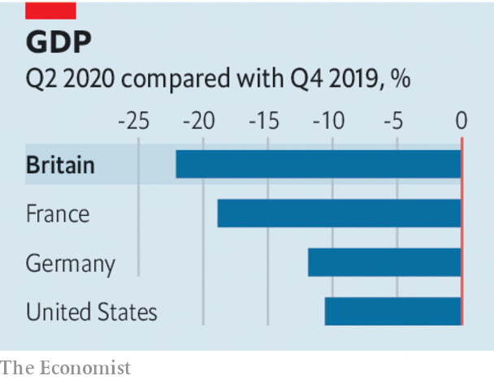

A tension has developed within the Conservative Party, which has run the country for a decade. Although many politicians understand the importance of revving up the economy, Tory voters are ageing, and for many older people the costs of growth loom larger than the benefits (see [article](https://www.economist.com/node/21790852)). Many are insulated against the vagaries of the economy by inflated property prices and generous pensions. They have less of a stake in the future than young people and are more averse to the changes—spoiled views, building work, more immigrants—that go with growth.

Tory voters’ preferences show up in policies that will hamper growth and in spending preferences that will not help it. Brexit, supported by 60% of pensioners but only 27% of under-25s, will damage the economy. Spending on health, which disproportionately benefits old people, has grown from 6% to 7% of GDP since 2010, when the Tories came to power, while spending on education, which matters not just to the young of today but also to the growth rates of tomorrow, has dropped from 6% to 4% over the period. The “triple lock”, guaranteeing that state pensions will rise annually by whichever is the highest of earnings growth, inflation or 2.5%, will be especially generous this year and next: if the government sticks to that promise, pensioners will get a 2.5% increase this year while earnings decline by 1.5%, and a big rise next year too, when they are expected to rebound.

Even when the government does go for growth-oriented policies, they are held back by oldsters’ attitudes. The “big bang” planning reform it announced on August 6th, for example, was something of a damp squib. It contained, among other limitations, a commitment not to loosen restrictions in the “green belt” that is the main constraint on development in the south-east of England.

With the Brexit transition period due to expire at the end of the year, pro-growth policies are urgently needed. It is all very well for the government to aim for “levelling up” the left-behind regions of the country, especially in the north, but it will undermine that effort if it is simultaneously levelling down the country’s overall economic potential. Boris Johnson’s government should go for the softest possible post-transition Brexit to allow trade to continue to flow, a more muscular reform of the planning system, a new focus on education—especially of the vocational sort—and an end to the triple lock on pensions.

Before Thatcher put Britain on a new, higher, growth path, the country appeared to be in long-term decline. Covid, Brexit and a government that fails to prioritise growth could see it resume that dismal trajectory. ■

This article was downloaded by calibre from <https://www.economist.com/leaders/2020/08/15/boris-johnson-needs-to-focus-on-boosting-britains-economy>

|  |  |  |  |
| --- | --- | --- | --- |
| Previous | Articles | Sections | Next |

|  |  |  |
| --- | --- | --- |
| Leaders | Sections | Briefing |

Letters

Letters to the editor: On elderly care, technology, Lyndon Johnson, choral singing, journalism

.

|  |  |  |
| --- | --- | --- |
| Leaders | Sections | Briefing |

|  |  |  |  |
| --- | --- | --- | --- |
|  | Articles | Sections | Next |

#### On elderly care, technology, Lyndon Johnson, choral singing, journalism

# Letters to the editor

A selection of correspondence

Aug 15th 2020 |



## A home from home

Your first-class report on looking after the elderly suggested that caring for old people in their own homes is cheaper and better than caring for them in care homes (“[No place like home](https://www.economist.com/international/2020/07/25/the-pandemic-shows-the-urgency-of-reforming-care-for-the-elderly)”, July 25th). So far as cost is concerned, you pointed to a study that put the saving from staying at home at $4,500 a year. But the average for a group conceals wide variation. A person requiring trained nursing 24 hours a day can be cared for much more cheaply in a nursing home where, for example, the cost of a nurse’s overnight shift can be spread among several residents.

As for “better”, it is true that people say they would prefer to stay in their own homes. However, that preference is expressed without actually experiencing the alternative situations. Being on your own when needing care at home can be a dismal experience. In nursing homes, as I know from my own mother’s experience, staff talk to you and the cheery clatter as they go about their business can make for a better life, as can communal activities and friendships with other residents.

The pandemic has indeed shown that residential care can be perilous. Many of the people affected are of an age and state of health that means they would die quite shortly even without the virus. The inevitable risks can be managed by the proper provision of personal protective equipment and scrupulous hygiene. And the thought of dying at home on your own from coronavirus, which has happened to many old people during this epidemic, doesn’t bear thinking about.

DAVID LIPSEY  
Member of the Royal Commission on the Long-Term Care of the Elderly, 1999  
Brecon, Powys

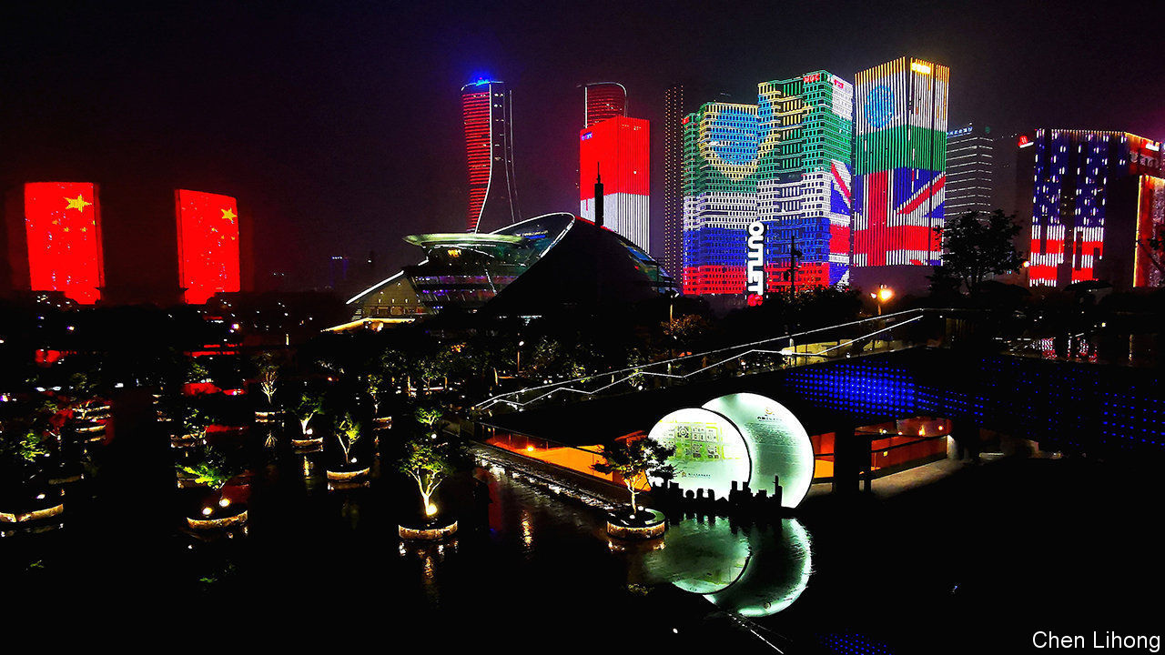

## Tech wars

“[Techtonic plates](https://www.economist.com/leaders/2020/07/09/tiktok-and-the-sino-american-tech-split)” (July 11th) predicted a painful rupture between China and the United States over the technology industry. You are correct but your timing is off. China initiated the split in 1997 when it began building the Great Fire Wall and when it later locked Google, Yahoo and other American tech companies out. China continued emphasising the need for self-sufficiency in technology in its five-year plan of 2005. To ensure there would be no doubt about this it called for “Made In China 2025” in its five-year plan of 2015. Mike Pompeo’s remark about banning TikTok did not signal a new split. It only responded to the great split initiated by China a long time ago.

CLYDE PRESTOWITZ  
President  
Economic Strategy Institute  
Washington, DC

Huawei has not been prosecuted, let alone convicted, of any wrongdoing that deserves banning its business. We cannot attain a rules-based international order if the rules are broken because the defendant is Chinese. In Britain, it is not even clear what the government’s legal basis is to interfere with the normal activities of a private company. I imagine the decision to ban Huawei won’t be challenged in court by the company, but by its network customers.

LEO LIAO  
London

## LBJ and the CRA

Though I wouldn’t want to belittle Hubert Humphrey’s fair share of the credit for America’s groundbreaking Civil Rights Act, Ed Giera’s account amounts to topsy-turvy history ([Letters](https://www.economist.com/letters/2020/07/18/letters-to-the-editor), July 18th). No president but Lyndon Johnson would have been able to manoeuvre a civil-rights bill through a Senate still dominated by southern Democrats. Having once been the “Master of the Senate” (the title of Robert Caro’s seminal biography of LBJ), Johnson not only knew all the parliamentary procedure strategies inside-out, which opponents of the legislation attempted to deploy against its progress, but also blatantly antagonised his former mentor, Senator Richard Russell of Georgia, in navigating the bill through the Senate.

Johnson was able to propel the late John Kennedy’s comparatively meek push for a civil-rights act. It would never have made it onto the statute book otherwise, with or without the assistance of Humphrey, who was too much of a firebrand to build the necessary rapport with southerners.

JAKOB STEFFENWuppertal, Germany



## Sing in, loud and proud

As you noted, “choral singing has been devastated by the pandemic” (“[Voices off](https://www.economist.com/books-and-arts/2020/07/08/choral-singing-has-been-hit-hard-by-the-pandemic)”, July 11th). Singing is so important to our sense of community and to our mental health that we need to find a way that we can safely resume singing without spreading the virus. As the choir conductor you quoted said, “We can innovate”.

How? Well, who says we have to sing while breathing out, which is what risks spreading covid-19? Yes, it will require some readjustments, but I have experimented and I can verify that it is possible to sing while breathing in. Only in my falsetto voice so far. If you’re sceptical about my proposal, just think of the way Parisians say oui! while breathing in. Or the involuntary gasps we make when terrified, while suddenly breathing in.

I suggest we name this new form of music “inspirational singing.”

RICHARD WAUGAMAN  
Clinical professor of psychiatry  
Georgetown University  
Washington, DC

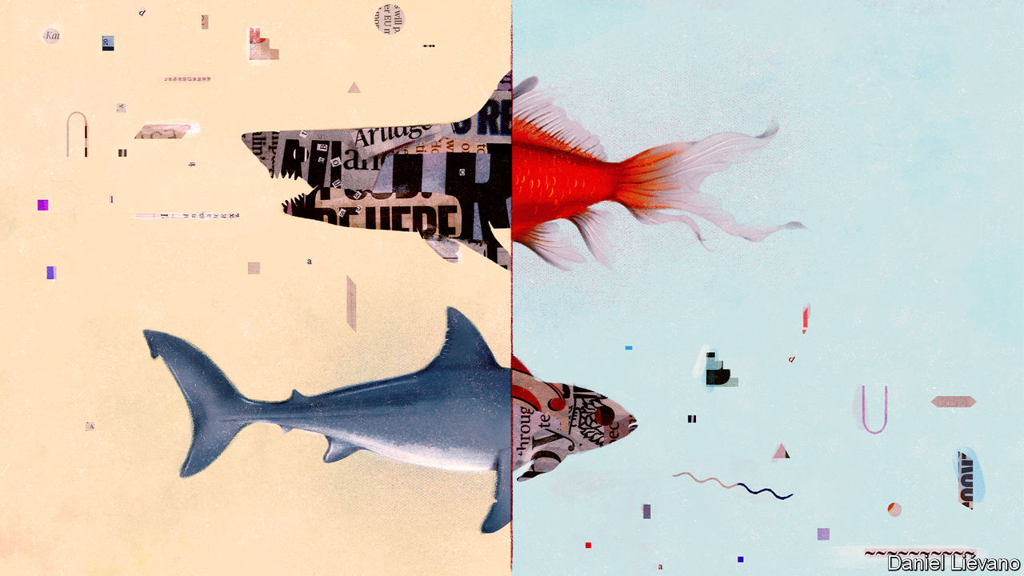

## Journalism’s moral maze

I find it a curious notion that some journalists want to abandon objectivity in favour of “moral clarity” (“[Invisible men](https://www.economist.com/books-and-arts/2020/07/16/how-objectivity-in-journalism-became-a-matter-of-opinion)”, July 18th). This assumes that most people view the world in the same way. As you bite into that beefburger there is no issue of morality in your mind. One billion Hindus may take a decidedly different view. A woman chooses to flush an unwanted fetus from her womb as she exercises her right to agency over her body. There are many who would view this as the moral equivalent of murder. After the Holocaust, the UN established a Jewish state in Palestine irrespective of the views of the indigenous population. And some Christians celebrate gay marriage while others view it as an abomination.

Moral clarity is simply shorthand for, “What I believe is true, proper and correct. What you believe is false, flawed and wrong.” That is no basis for journalism.

GUY WROBLE  
Denver

John Stuart Mill championed the importance of healthy debate, reminding us that “conflicting doctrines, instead of being one true and the other false, share the truth between them”. Rather than convincing people of their arguments, journalists who indulge in self-righteous moralising risk antagonising the other side, thereby entrenching existing ideologies. By seeing just half the story we neuter our ability to come to a thoughtful, balanced consensus on complex, divisive issues.

LAURIE WASTELL  
London

My father, himself a lifetime journalist, offered me this old piece of advice when I entered the trade in the 1950s: The role of the journalist is to comfort the afflicted and afflict the comfortable.

DAVID HARRISONLondon

After reading your thoughtful article a quote came to mind from Vaclav Havel: “Keep the company of those who seek the truth; run from those who have found it.”

RANDY SULLIVAN  
Atlanta

This article was downloaded by calibre from <https://www.economist.com/letters/2020/08/15/letters-to-the-editor>

|  |  |  |  |
| --- | --- | --- | --- |
|  | Articles | Sections | Next |

|  |  |  |
| --- | --- | --- |
| Letters | Sections | Asia |

Briefing

China’s hybrid capitalism: Blooming for the glory of the state

.

|  |  |  |
| --- | --- | --- |
| Letters | Sections | Asia |

|  |  |  |  |
| --- | --- | --- | --- |
|  | Articles | Sections | Next |

#### The new state capitalism

# Xi Jinping is trying to remake the Chinese economy

Party control is mixed ever more intimately with market mechanisms

Aug 15th 2020 | SHANGHAI

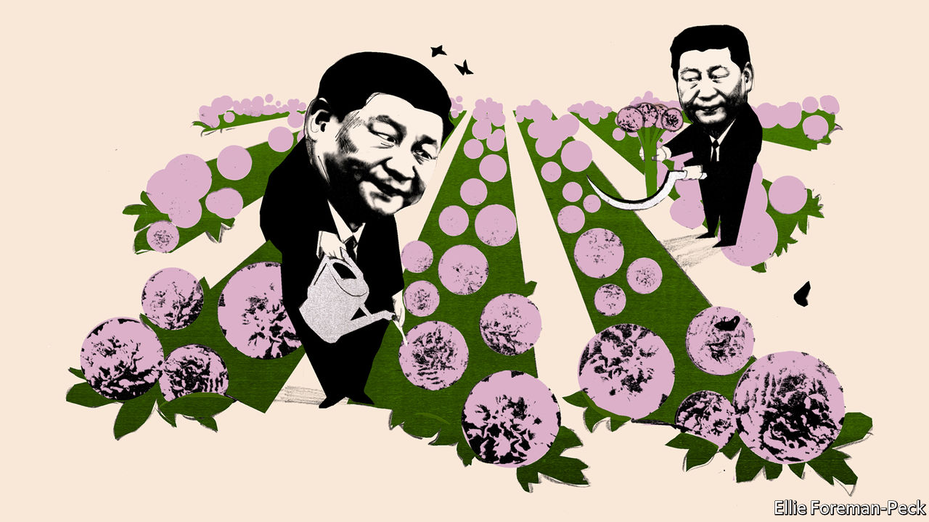

LAST YEAR Zotye, a carmaker, used it to tackle weak sales, and Wuliangye, a distiller, to improve the quality of its baiju; it helped Zheshang Bank to digitise its operations and catalysed the development of energy-saving technologies at China National Nuclear Power. “Xi Jinping Thought on Socialism with Chinese Characteristics for a New Era” is, on the basis of these companies’ annual reports, quite the business-practice panacea.

The time when private Chinese companies downplayed their links to the Communist Party is gone. By The Economist’s count, nearly 400 of the 3,900 companies listed on stock exchanges in mainland China paid homage to the Communist Party and its leader in their annual reports this year. References by both state-owned firms and their private-sector peers to Mr Xi’s guidance have increased more than 20-fold since 2017 (see chart 1).

The trend reflects China’s new reality. The Communist Party has greater control over all aspects of life, and Mr Xi has greater control over the party. This does not just mean it is a good idea for companies to butter him up. It means that he is in a position to reshape the economy within which they prosper or fail. What is he doing with it?

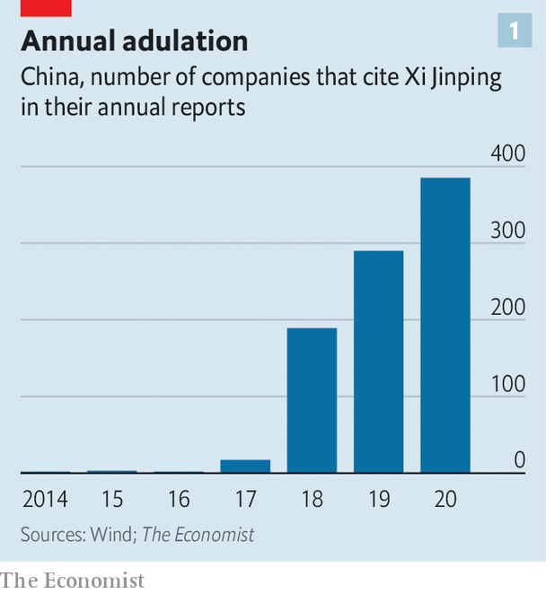

Nothing good, say critics at home and abroad. He has brought reforms that liberalised the economy to a halt and has smothered market forces, returning to a top-heavy state-dominated growth model which looks distinctly creaky. Private companies have rushed to set up party committees with an increasing say over strategy. Their once-swashbuckling bosses have adopted lower profiles. The title of a recent book by Nicholas Lardy of the Peterson Institute, an American think-tank, sums up the worries: “The State Strikes Back”.

Those observations are right. The conclusion is misleadingly wrong, encouraging a complacent and dangerous underestimate of China’s potential trajectory. Mr Xi is not simply inflating the state at the expense of the private sector. Rather, he is presiding over what he hopes will be the creation of a more muscular form of state capitalism. The idea is for state-owned companies to get more market discipline and private enterprises to get more party discipline, the better to achieve China’s great collective mission. It is a project full of internal contradictions. But progress is already evident in some areas.

Mr Xi announced his agenda in 2013, vowing that China would “let the market play the decisive role in allocating resources”, while reinforcing “the leading role of the state-owned sector”. When domestic stocks crashed in 2015 the government’s focus shifted to recapitalising its banks, tightening controls on cross-border cash transfers and taming the wildest corners of its financial system. But the party now thinks it has won this “battle against financial risks” and is getting Mr Xi’s agenda back on track in a new, bolder form.

Ever more tense relations with America have persuaded the party that China must be able to get ahead on its own. At the same time, China’s success in stalling its coronavirus epidemic and restarting its economy has reinforced its belief in what Mr Xi calls China’s “institutional advantages”—the idea that, as a strong one-party state, China can pool its economic and social resources to meet critical objectives.

Mr Xi’s push can be broken down into two big segments. The first is to establish clearer boundaries for the fizz and ferment of the Chinese marketplace: a stronger legal system for businesses; simplified rules for day-to-day activities; a financial system better at allocating funds. The second is to make more adroit use of the government’s grip on the economy’s main levers: to make state firms more efficient; and to team them up with private firms in new industrial-policy initiatives.

Entrepreneurs still have considerable latitude, so long as they stay in their lane and move in government-endorsed directions. And they still have powerful incentives. “To get rich is glorious”, a quip attributed to Deng Xiaoping that became a mantra for China in its go-go years, still applies. But only so long as your pursuit of riches also benefits the state.

Many foreign executives and diplomats have little time for the idea that there is real pro-market reform going on; they talk of promise fatigue. Repeated pledges to level the playing field on which Chinese and foreign firms meet have amounted to naught. State firms benefit from reams of subsidies and preferential rules, often opaque. Foreign companies have scant presence in key sectors such as finance and energy.

## You may now go bankrupt

They are all well-founded complaints. But they ignore the fact that when Mr Xi talks about market reform, it is order, not fairness, that he is after. He wants to define more clearly how businesses and people can work, and within what limits.

Start with the legal system. It is a tool of oppression, as its extension into Hong Kong is making clearer than ever. Mr Xi has been relentless in targeting anyone standing up for human rights. Yet he has also overseen a partial professionalisation of the judicial system and given courts more authority on non-political matters. The economy is simply too complex, and corruption too prevalent, to rely on local officials to adjudicate disputes as they used to.

These changes to the courts have coincided with an explosion in cases. Administrative lawsuits, which typically involve people suing the government, have more than doubled since 2012, the year that Mr Xi became China’s paramount leader (see chart 2). Bankruptcy filings are up ten-fold. Last year Chinese courts accepted more than 480,000 intellectual property cases, nearly five times as many as they did in 2012, with some going to a new national court devoted to the area. Foreign plaintiffs won 89% of all patent infringement cases, according to Rouse, a consultancy.

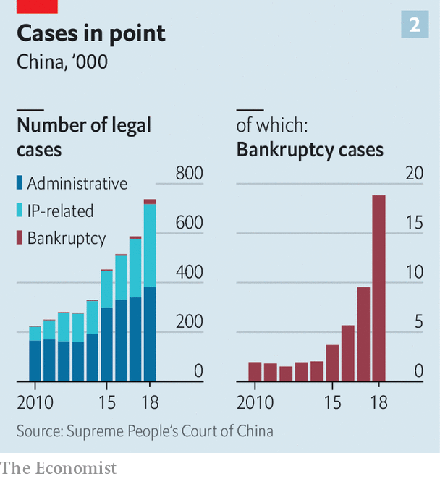

Local officials have until now always had the option of simply ignoring court rulings: the head of a medical-services company complains that he was blamed for a health scandal in a small inland city caused by a firm that had stolen his company’s name and continued to use it three years after a court ruled against it. It is partly to patch up such holes that the government is developing its “social credit” system. The courts can place people on so-called credit blacklists, in effect recruiting automated agents of the state to enforce their judgments. For example, if a court finds that a debtor owes money, its ruling, via the blacklist system, can stop them from buying a plane ticket or getting a loan. As of the end of 2018, some 290,000 business executives were on the blacklist.

It is easy to imagine the system taking a truly dystopian turn if its reach were to become more all-embracing, with access to everything in society made conditional on a history that extends beyond creditworthiness through social-media activity into political reliability. But many in China support it for now. “It’s a price that must be paid to cultivate a healthy business environment,” says Yan Yiming, a lawyer who focuses on corporate malfeasance.

As the law gets more reliable, administration gets simpler. The World Bank has found that the average time taken to start a business, which was 23 days as recently as 2017, is now just nine days—a little faster than Japan, a little slower than America. Construction permits previously took 247 days; now they take 111. Digitisation has made filing taxes much more straightforward. When a business issues an invoice a copy goes directly to the tax authorities. Indeed, some fear that it is all-too-convenient: back doors in the government-mandated software could give hackers access to a company’s computer network.

The last major focus of Mr Xi’s market-orderliness reforms has been the financial system. For those who think that banking regulation is dry paperwork, his reassertion of government control over banks, brokerages and investment firms has been bracingly hands-on, featuring tactics such as the abduction of Xiao Jianhua, a once-mighty financier, from a luxury hotel in Hong Kong in 2017. Several other tycoons have also disappeared, only to re-emerge either chastened or on trial. The message to bankers has been chilling: fall into line with the new order, or else.

The reform is not purely ad hominem. There is real structural change. Between 2008 and 2016, China’s debt-to-GDP ratio rose by roughly ten percentage points a year; from 2017 to 2019, the annual increase averaged just four percentage points. This year debt will soar as a result of Covid-19. But officials insist that this is a one-off. They are already tapering monetary stimulus as growth rebounds.

## A taste for Moonshots

The leverage on which the system is based also looks safer. In the 2010s Chinese banks threw themselves into the lucrative business of repackaging assets into opaque investment products: from 2010 until the end of 2017, banks’ claims on other financial institutions rose 20-fold as they layered credit on top of credit. Over the past two years new rules have forced banks to retrench. The shadow-banking sector, a motley universe of thinly regulated lending and investment companies, has begun to shrink.

The bond market, by contrast, has boomed, going from 50% of GDP in 2012 to more than 100% today, and amended rules have made it somewhat easier for companies to raise capital by issuing shares. In many ways, China’s financial system seems ever more reassuringly normal.

In other ways, though, it is what it was. Banks know that the government almost always bails out state firms, whereas private firms are left to their own devices; they are adept at contriving not to hear official calls for them to help small, struggling firms. Instead they direct most of their lending to state-owned firms—a rational choice in a still distorted market. This points to the other side of Mr Xi’s agenda: remaking China Inc.

Since January 2019 a small Chinese rover has been wandering around on the far side of the Moon, sending back crystal-clear panoramic images of a realm no other nation has reached. But for the economy the image that mattered most was Mr Xi’s meeting with hundreds of the scientists and bureaucrats responsible in the Great Hall of the People—an event at which he hailed their success as emblematic of a “new type of whole-nation system”.

Both China’s boosters and its self-declared victims have long promoted a highly idealised view of its industrial policy. Mandarins decide what the country needs and apply a mixture of cheap capital, well-specified research priorities, intellectual-property theft, protectionism and force majeure to get it done.

In truth, Chinese industrial policy has rarely, if ever, been remotely that coherent. It has promoted industrialisation of more or less any type. Cities compete with each other to attract enterprises. Companies pile into whatever seems ripe for a boom. As a detailed study by Carsten Holz of the Hong Kong University of Science and Technology has shown, these investment patterns have borne little relationship to stated industrial policy, which has often been catching up with the facts on the ground. Sometimes this pans out. There are fast trains and safe-looking nuclear power plants. But decades of official emphasis on semiconductors and internal-combustion-powered cars have failed to lift China to the premier league in either. Huge growth in sectors such as solar power and shipbuilding was bought with wasteful investment which produced overcapacity, huge losses and brutal consolidations.

Cheap land and capital, excellent infrastructure, inexpensive labour and, for years, an undervalued currency allowed stellar progress regardless of rickety strategy. But times have changed. The population is ageing, the debt burden has risen and the environmental effects of all-industrialisation-is-good-industrialisation have been recognised. China needs new tools with which to create new wealth. Mr Xi’s new type of whole-nation system is intended to make real the focused and foundational industrial policy of myth.

In this respect “Made in China 2025”, a new industrial strategy announced in 2015, has proved crucial—though not in the way originally intended. Covering more or less all of manufacturing industry, it is anything but focused. “Basically, every department in the industry ministry came up with pet projects. But there was no real action strategy,” says Yu Yongding, an economist involved in developing some of China’s five-year plans. However its ambition, coupled with China’s industrial-policy mystique and habitual spying, prompted America to react. And that has provided Mr Xi with the criteria by which to select its true priorities.

What China needs are the things which America might hurt it by withholding: the term kabozi jishu, “stranglehold technology”, is much in vogue. Rather than targeting whole sectors, planners talk of prioritising the mastery of jet turbines, precision photolithography for semiconductors, high-speed bearings for machine-tools and a handful of other key technologies.

State-owned enterprises (SOEs) are seen as necessary to this process because, though many have some private shareholders, the government’s controlling stake allows it to dictate the firms’ actions. But that is not much of an advantage if they are not up to the job. At present SOEs consistently lag their private-sector peers in productivity. Their bosses, as political appointees, are wary of risks; and they are often burdened with state duties. During the response to covid-19 officials praised SOEs such as PetroChina, an oil major, for creating extra jobs.

## Mixing it up

Mr Xi has made clear that he does not favour a fundamental overhaul for SOEs. There will be nothing like the wave of closures and privatisations implemented in the 1990s, a cull that carried a steep social price in unemployment but also helped to clear the way for buccaneering entrepreneurs. But it is a mistake to view the situation as static. The state is trying both to get more out of SOEs and to use them to get more out of the private sector.

Last year the government declared that net, not gross, profitability was to be a key measure of an SOE’s success, which could encourage them to be more hard-headed about operating costs. “What makes us somewhat optimistic is that they are talking more about shareholder value,” says a strategist with one of China’s biggest hedge funds. Some are clearly better run than others: shares in China Merchants Bank, for instance, trade at 1.5-times book value, compared with just 0.5-times for Bank of Communications.

Potentially more important—and certainly more misunderstood—is the government’s renewed push for “mixed ownership”. It wants more state firms to attract private-sector investors and private firms to find state-owned partners. Cross-pollination along these lines has happened before (notably, when major SOEs listed on stock exchanges in the early 2000s). But this time it will tie together a wider array of companies, notes Chen Long of Plenum, a research firm. In the past few years, state firms have pulled in more than 1trn yuan ($145bn) of private capital. And in the first half of 2020 nearly 50 private-sector enterprises listed in China attracted chunky investments from state firms.

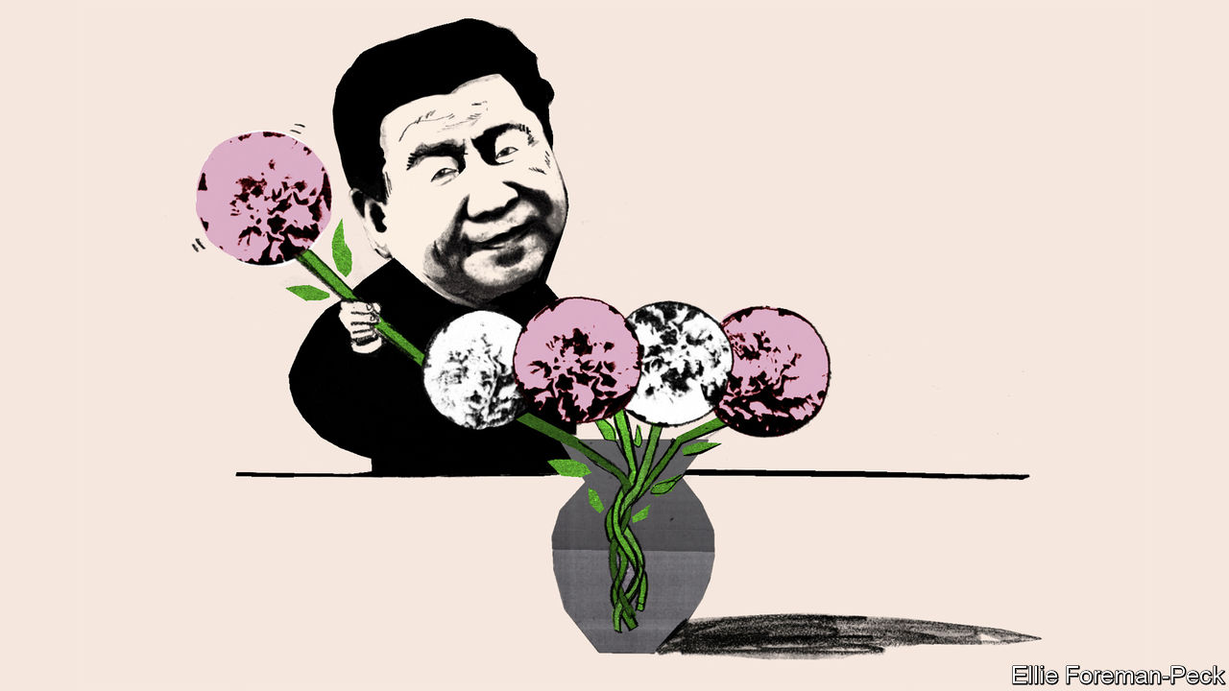

This is not the only way that the boundaries between the private and state sectors are getting fuzzier. Private companies have always been required to have party committees, but for a long time many did not bother. For the biggest that is no longer an option. Wang Xiaochuan, CEO of Sogou, an internet-search firm, expressed the truths of the new alignment bluntly in 2018. “If you think clearly about this, you really can resonate with the state. You can receive massive support,” he said. Woe betide any company that tries to go its own way. “You’ll probably find that things are painful, more painful than in the past,” he said.

There is some evidence that these changes are having the kind of impact the government wants. Zhang Xiaoqian, an economist at Zhejiang University, has found that both SOEs and private firms increase their spending on research and development after being remade as mixed-ownership firms. State firms benefit from an injection of ideas and risk appetite. Private firms benefit from better state connections which make it easier to raise capital.

Take for example integrated circuits, an area perennially targeted by planners without huge success (see chart 3) and which is now of huge significance. The government is funnelling more than $100bn to SOEs, private firms and, most often, projects that bring the two together. There is a lot of waste. But there are signs of progress. In April Yangtze Memory Technologies Co (YMTC), a semiconductor company founded in 2016 with both public and private capital, announced that it could now make memory chips as technologically advanced as the best Samsung has to offer, boasting 128 distinct layers of circuitry.

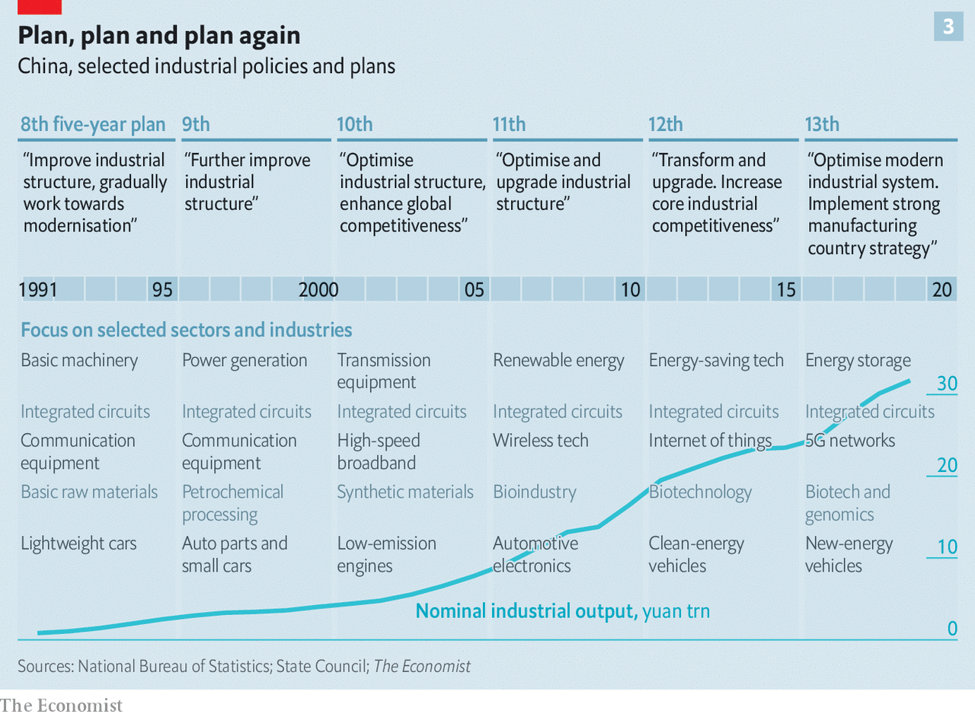

Dan Wang of Gavekal Dragonomics, a research firm, says that YMTC’s chips are probably not actually as good as Samsung’s, but that the achievement nonetheless demonstrates China’s progress in both the design and production of chips. One remarkable element of the YMTC story is that it is based in Wuhan, ground-zero of the coronavirus pandemic. The government kept its factory open and supplied, ensuring that workers could clock in every day, even when the rest of the city was in total shutdown. It was the “new type of whole-nation system” in action.

Yet the basic tension in the SOE sector remains unresolved. Yes, the government has put more emphasis on profitability, but that does not mean decisions get made according to commercial logic. Indeed, under Mr Xi national duty—supporting China’s rise—is more important than ever. And stricter party control is confusing lines of responsibility. An executive with a major state-owned insurance firm says that its party committee now controls all senior personnel appointments and expresses “opinions” on all investments worth more than 20% of net-asset value. Opinion is a euphemism. “It is normally the final decision. No one would go against the party secretary,” he said. “But if something goes bad, the board will be responsible.”

In the private sector, for all the criticism outsiders have of Mr Xi’s increasing reach, it is salutary to note how well some of the biggest players have fared on his watch. China’s ten biggest non-state companies have added roughly $2trn to their market capitalisation since he became party chief. Mr Xi’s strengthening of court decisions and disciplining of the financial system helps incumbents to make acquisitions, to sue firms infringing on their patents and to get financing.

## Contradicting history

This all helps underpin the gradual consolidation taking place across a range of industries—a process which demonstrates that there really are strong market forces at play in the economy, and that they are being channelled more effectively than in the past. In the property sector, for instance, the ten biggest developers now have a 34% market share, up from 20% five years ago, according to UBS, a bank.

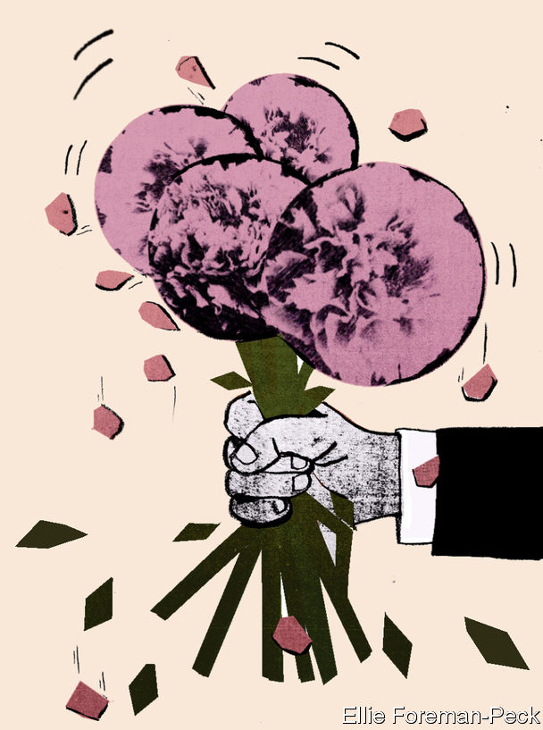

But Mr Xi’s rule has not just been a time of consolidation. Many startups have grown up under him, including the company that created TikTok, the social-media app now at the centre of its own geopolitical storm; Pinduoduo, an e-commerce firm taking on China’s incumbent, Alibaba; and SenseTime, an AI company in the vanguard of facial-recognition technology.

The worry—for the economy as for those whom SenseTime’s wares may victimise—is what comes next. An insistence on forming party committees in private companies, even if they are mainly window-dressing for now, and on mixed-ownership initiatives, can but drag entrepreneurs more firmly into the grasp of the state. Can technological advances delivered by the whole-nation system in any way make up for the constraints, second-guessing and divergent incentives which inevitably come with it?

It has always been possible for major decisions—investments, lay-offs and branding—in big Chinese companies, state-owned or not, to be subject to government scrutiny. But that possibility is now more clearly communicated and more deeply felt. All companies, whoever owns them, exist for the glory of China.

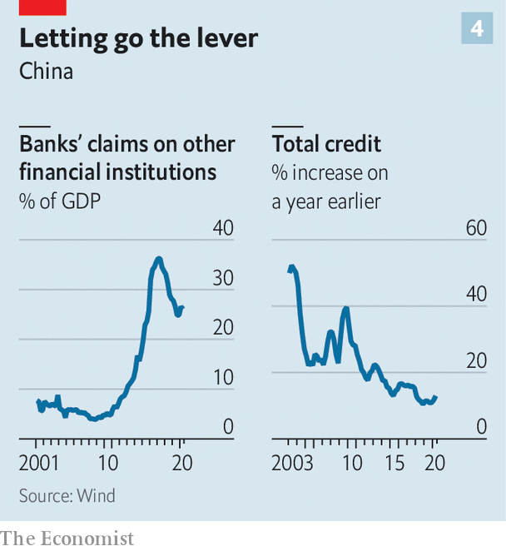

A flag-bearer of the new model is a company like BYD, the world’s biggest maker of electric cars. At one level, it epitomises the can-do entrepreneurial spirit that has fuelled China’s growth. Wang Chuanfu, a chemist, left a poorly paid government job in the mid-1990s to strike out on his own, first developing phone batteries, then cars. Today, his company counts Warren Buffett as its biggest investor.

But BYD’s connection to the party is strong. Mr Wang is a party member. Though BYD has never discussed the workings of its party committee in formal disclosures to shareholders, state media report that it helps to guide the company’s decisions. And its business decisions are sometimes strikingly well aligned with government priorities. When America hit Huawei, China’s embattled telecommunications giant, with sanctions last year, BYD started making smartphones for it.

It is getting harder to distinguish between the state and private sectors. It is getting harder to distinguish between corporate and national interests. And for all its inefficiencies, contradictions and authoritarianism, not to mention its increasingly pious cult of personality, it is getting harder to claim that state capitalism will hobble China’s attempts to produce companies and master technologies that put it on the world economy’s leading edge. ■

This article was downloaded by calibre from <https://www.economist.com/briefing/2020/08/15/xi-jinping-is-trying-to-remake-the-chinese-economy>

|  |  |  |  |
| --- | --- | --- | --- |
|  | Articles | Sections | Next |

|  |  |  |
| --- | --- | --- |
| Briefing | Sections | China |

Asia

Development in Cambodia: Service economy

.

Indonesia’s environment: For peat’s sake

.

NIMBYism in Japan: Anti-anti-missile systems

.

Eating ant eggs in Laos: Jungle caviar

.

Banyan: A one-family state

.

|  |  |  |
| --- | --- | --- |
| Briefing | Sections | China |

|  |  |  |  |
| --- | --- | --- | --- |
|  | Articles | Sections | Next |

#### Service economy

# Cambodians are bingeing on microfinance loans

The downturn brought on by covid-19 will test the industry

Aug 15th 2020 |

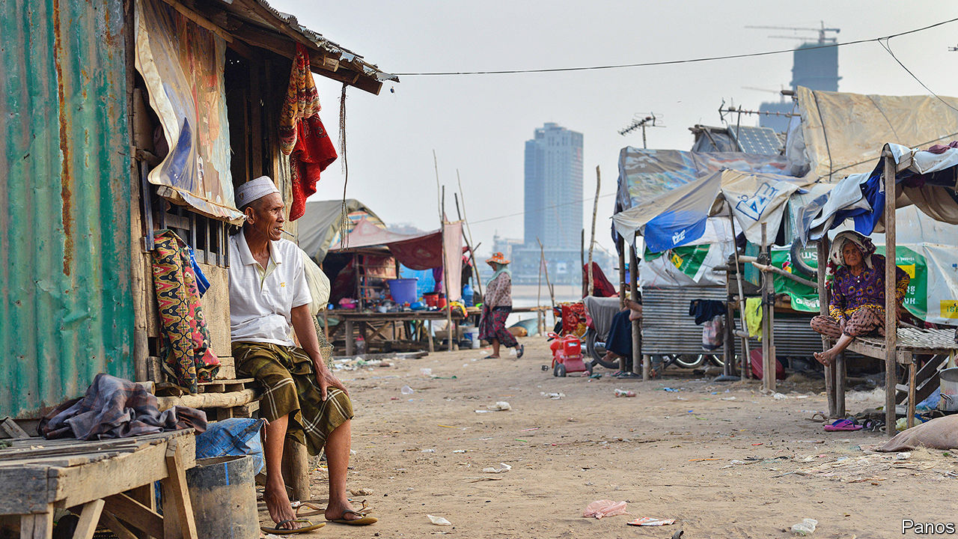

BANGLADESH MAY be the homeland of microcredit, but no country is keener on it than Cambodia. According to its central bank, there were some 160,000 branches of microfinance institutions around the country in 2016—one for almost every square kilometre of Cambodian territory. Almost 2.2m of Cambodia’s 10m-odd adults have a microcredit loan outstanding, according to the Cambodian Microfinance Association (CMA), an industry group. The average debt is $3,320—roughly twice the country’s annual GDP per person. Credit is growing by 40% a year.

The microfinance boom has brought many benefits. An obvious one is a decline in the use of loan sharks. Between 2004 and 2017 the share of households borrowing from formal sources jumped from 8% to 30% while the proportion using informal moneylenders dropped from 32% to less than 6%, according to research published last year by the World Bank. The shift saved people money. The interest rates charged by formal lenders are lower and have been falling for more than a decade, even though some microcredit outfits are purely commercial operations.

All this has made it possible for many Cambodians to fund a new business, obtain an education or pay for urgent medical care. The CMA links growing access to credit to falling levels of poverty. The share of Cambodians living below the national poverty line (earning less than $0.93 a day) dropped from almost 48% in 2007 to less than 14% in 2014—although the main reason for the improvement was Cambodia’s rapid economic growth over that period. Academic research suggests microfinance may have helped improve farming methods and boost living standards for the poorest Cambodians.

But the industry’s breakneck growth may not be sustainable. Household debt has swollen as the size of loans has ballooned. According to the World Bank, the average loan grew “more than tenfold” over the past five years. Larger debts have led to longer repayment periods. “[Cambodia] probably should have had a crisis by now,” admits Daniel Rozas, an adviser to the CMA, “but somehow it hasn’t.”

That may be in part thanks to the efforts of the National Bank of Cambodia, the central bank, to tame the industry. It has raised capital requirements and obliged lenders to maintain hotlines so customers can get in touch directly, if needed, with complaints. It has also introduced rules about how loans should be marketed. The CMA has instituted guidelines for its members, too. And Cambodia has a well-functioning credit bureau.

Some regulations, however, may be exacerbating the industry’s excesses. The central bank’s introduction of an interest-rate cap of 18% a year in 2017 seems to have backfired. Because of the cap, the CMA says, microfinance institutions can turn a profit only by lending more than $2,000. The number of loans of $500 or less declined by 48% after the rule’s introduction, the World Bank estimates. Some fees rose, too.

The CMA says defaults are minimal, with only 1% of loans in serious arrears at the beginning of the year. But there are hints that borrowers are getting into difficulty. The typical loan uses land as collateral, according to a forthcoming paper by W. Nathan Green of the National University of Singapore and Maryann Bylander of Lewis & Clark College in America. Lenders seldom take borrowers to court to repossess land; it is not worth the time and expense for a loan of just a few thousand dollars. But many conscientious borrowers appear to sell their land voluntarily to pay up. Government surveys show that the proportion of people who are landless rose from 32% in 2009 to 51% in 2016. Among the many reasons given for selling land, one of the most common was to repay debts. Given that the government does little to monitor the conduct of lenders, and many land sales are informal, it is hard to tell how voluntary such transactions really are.

Whatever the true state of Cambodians’ finances, they are about to get worse. The garment industry, which until recently employed some 740,000 people, has been particularly badly hit by the covid-19 pandemic, as orders from America and Europe have plunged. Perhaps a third of garment factories have stopped work. Research suggests that each worker in the factories supports three other people, so the effects will ripple across the country. Cambodia’s second-biggest industry, tourism, has been hit even harder.

A farmer in Battambang province gives a sense of the problem. He says that between the downturn brought on by the coronavirus and a recent drought, he is struggling to repay a $600 loan that he took out last year to buy poultry. He relies on a daughter sending part of her wages as a garment-worker to keep making payments—money that is now in doubt.

The government is not blind to the problem. In June Hun Sen, the prime minister, promised to spend about $25m a month to help some 600,000 poor families. The National Bank has encouraged lenders to reschedule or defer payments. The CMA says its members have restructured almost 245,000 loans.

But the few remaining critics of the authorities in Cambodia, which Mr Hun Sen has run for 35 years with ever-increasing repressiveness, clearly consider the growth of debt a weak spot for the government. In April activists called for loan payments and interest accrual to be suspended for three months. In May Sam Rainsy, an opposition politician living abroad, said Cambodians struggling to pay debts should not sell their homes or land. Mr Hun Sen’s advice to lenders was blunt: “Confiscate properties of those who follow the opposition’s appeal not to pay back the loans.” ■

This article was downloaded by calibre from <https://www.economist.com/asia/2020/08/15/cambodians-are-bingeing-on-microfinance-loans>

|  |  |  |  |
| --- | --- | --- | --- |
|  | Articles | Sections | Next |

|  |  |  |  |
| --- | --- | --- | --- |
| Previous | Articles | Sections | Next |

#### For peat’s sake

# Indonesia risks repeating an environmental disaster

A new agricultural scheme may add to the emissions already billowed out by forest fires

Aug 15th 2020 | SINGAPORE

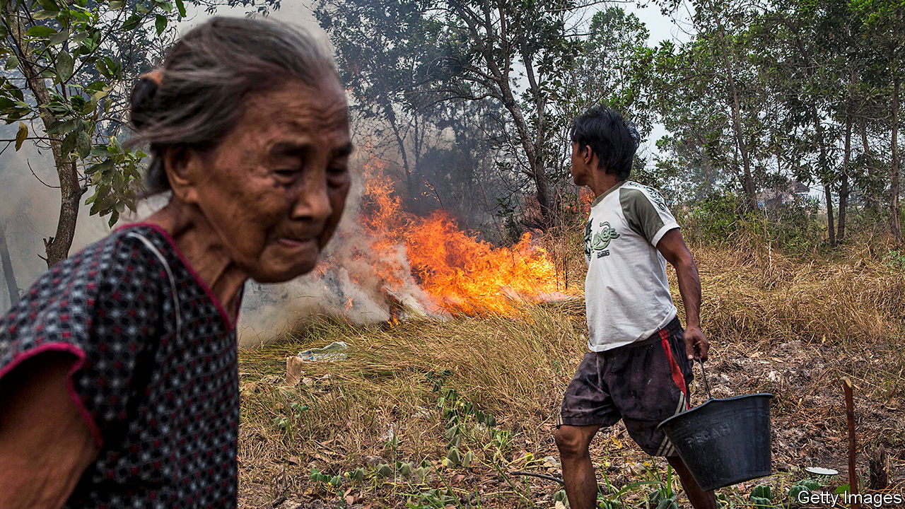

AS THE PRESIDENT’S helicopter flew above the swamp forests of Central Kalimantan, a province in the Indonesian part of Borneo, older residents may have felt a sense of déjà vu. Joko Widodo, popularly known as Jokowi, had arrived on July 9th to inspect the site of a new agricultural zone of 1,650 square kilometres—more than twice the size of New York City. Twenty-three years earlier, President Suharto, the strongman who ruled from 1966 to 1998, travelled by chopper to the same area to admire the 10,000 square kilometres of peat forest being converted into rice paddies. Like Jokowi, he worried about being able to feed his people, so set about turning Central Kalimantan into Indonesia’s “granary”.

The Mega-Rice Project (MRP) was a mega-failure. It produced hardly any rice; the peaty soil, it turns out, lacks the requisite minerals. Instead of spurring farming, the draining of the waterlogged forest with a 6,000km network of canals fuelled fire. A few months after Suharto’s visit, the dried peat burst into flames. It was the biggest environmental disaster in Indonesia’s history. A study published in 2002 found that burning peat in 1997 on Kalimantan and the nearby island of Sumatra generated the equivalent of 13-40% of the average annual global emissions from fossil fuels. The MRP was abandoned in 1999 but its legacy endures in the infernos that have ravaged Kalimantan almost every year since.

As work begins on the new plantation, is history poised to repeat itself? The government says it has learned from the past. Nazir Foead of the Peatland Restoration Agency says that tractors will steer clear of what remains of Central Kalimantan’s pristine peatlands. Just over half of the land earmarked for farming is already used to grow rice; the rest is covered in “shallow peat”, no more than 50cm deep, and so can be cultivated without cataclysm, he says.

Environmentalists are not convinced. The government has yet to confirm the exact location and size of the new plantation or publish any environmental assessments. The planning ministry says the details will not be finalised until September. The deputy defence minister says it could be as big as 8,000 square kilometres. Estimates of its cost range from 5trn rupiah ($340m) to 68trn. Iola Abas of the Peat Monitoring Network, an NGO, worries that peatland may be a casualty of rushed, shambolic planning and a lack of transparency. Even if farmers do steer clear of the peat, she worries that if they drain the land they will lower the water table, leaching moisture from nearby peatland.

“Once peat is drained, it remains a high fire risk,” says Kiki Taufik of Greenpeace, an environmental NGO. Smouldering swamps belch vast amounts of carbon. The government reckons that over a fifth of national emissions are from peat fires. Last year the fires that swept Indonesia emitted 22% more carbon than the conflagration in the Amazon rainforest did. In 2016 Indonesia was the world’s fifth-biggest emitter of greenhouses gases, largely because of deforestation, says the World Resources Institute (WRI), another NGO.

But the government argues it must go ahead with the plantation, and quickly, in case covid-19 brings about food shortages. There is no sign of that happening, says Rainer Heufers of the Centre for Indonesian Policy Studies, a think-tank. Even if it does, the new plantation would not help much. The land is not terribly fecund, as the MRP showed. And topping up the country’s silos is pointless unless the rice is brought to market and sold to the hungriest at affordable prices, says Tezza Napitupulu of the WRI. If the government really cared about hunger, says Mr Heufer, it would concentrate on boosting local yields, which are low by international standards, and make it easier to import food.

The government is unlikely to do so. For decades the political elites “have been chasing this ideal of food self-sufficiency”, says Jenny Goldstein of Cornell University. Prabowo Subianto, the defence minister, is one of its greatest champions. In July Jokowi put him in charge of the plantation as part of his new duty to safeguard “strategic national food reserves”—a task that has little to do with defence. One must hope Mr Prabowo is as keen to defend Kalimantan’s peat as Indonesia’s food security. ■

This article was downloaded by calibre from <https://www.economist.com/asia/2020/08/15/indonesia-risks-repeating-an-environmental-disaster>

|  |  |  |  |
| --- | --- | --- | --- |
| Previous | Articles | Sections | Next |

|  |  |  |  |
| --- | --- | --- | --- |
| Previous | Articles | Sections | Next |

#### Anti-anti-missile systems

# NIMBYs and pacifists thwart Japan’s military plans

No one wants a base next door

Aug 15th 2020 | AKITA

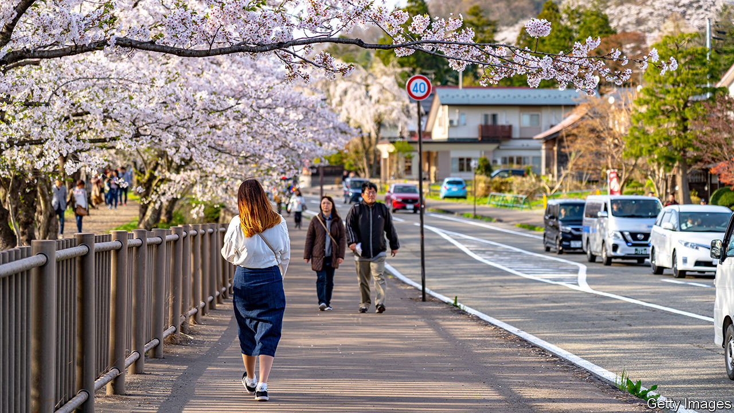

DURING A VISIT to Tokyo in 2017, Donald Trump called on Japan to buy “massive” amounts of American weaponry. At the time, North Korea was testing new rockets regularly. For the Japanese government, buying Aegis Ashore, a pricey American missile shield, allayed both concerns.

Not all Japanese, however, were happy with the purchase, especially in Araya, a quiet residential neighbourhood of low-slung homes next to the sea in Akita city—and the site of a proposed Aegis base. Jittery locals fretted about electromagnetic waves from the system’s radar and debris from its rockets. They worried about becoming a target in a conflict, as the city’s oil refineries were during the second world war.

“Why, why here?” asks Sasaki Masashi, a retired railway worker and head of a neighbourhood council. “It says: ‘Please attack us’,” complains Sakurada Yuko, another anti-Aegis campaigner. They have collected signatures, harangued officials and voted against the ruling Liberal Democratic Party (LDP), which unexpectedly lost a seat in Akita in elections to the upper house of parliament last year.

In June Akita received unexpected but welcome news: the government declared it was scrapping the $4.2bn purchase of Aegis Ashore. Kono Taro, the defence minister, cited the ballooning cost of ensuring that boosters did not fall on civilian property. Some view the cancellation as an underhanded way to initiate debate about pre-emptive strikes on missile bases that threaten Japan—a big step for a country committed by its constitution to pacifism. Others think Mr Kono may be trying to make a splash to enhance his chances of succeeding Abe Shinzo, the current prime minister, who is due to retire next year. Japanese officials may believe Mr Trump is on his way out, and so are less eager to placate him. In addition to all that, however, “There was no consensus locally,” says Terata Shizuka, the independent MP who won the upper-house seat from the LDP.

Akita is a conservative region, but more than 60% of residents opposed Aegis Ashore. The Self-Defence Forces (SDF, Japan’s armed forces in all but name) field seven destroyers equipped with ship-based Aegis systems (an eighth is under construction). A land-based system, the argument went, would provide more consistent coverage. “But wherever there’s flat land there are people, and so it becomes necessary to consider local emotions and feelings and circumstances,” says Suzuki Kenta, an LDP MP from Akita.

It is not just military installations that suffer from NIMBYism. An expansion of Tokyo’s main airport and a new high-speed railway line have been held up by local objections. But the public is especially prickly about military matters, and the government, in turn, treads carefully. After officials in southern Japan objected to the local deployment of Osprey aircraft intended in part to defend the Senkaku Islands, even farther to the south, the government sent the new planes to a far more distant base, notes Michael Bosack of the Yokosuka Council on Asia-Pacific Studies. Although Japanese law allows the government to make forced purchases of land, in practice it almost never does. The defence ministry tends to lease, rather than buy, since the prospect of steady rent payments can win over obstreperous locals.

The LDP had tried to smooth the way for Aegis Ashore. It was to be deployed in the home regions of Mr Abe and Suga Yoshihide, the powerful cabinet secretary. Local politicians had backed the plans. “The mood was that it was inevitable,” says Ogasawara Naoki, who headed the local paper, Akita Sakigake Shimpo, at the time.

But people from across the political spectrum opposed the deployment. There were those who welcomed stronger missile defences, but just not nearby. Others worried that Mr Abe was chipping away at Japan’s pacifism. As the government continues to press to beef up the SDF, whether by spending more on defence or building new bases, it could meet resistance anywhere. “If we don’t want it,” Ms Sakurada says, “our neighbours won’t want it either.” ■

This article was downloaded by calibre from <https://www.economist.com/asia/2020/08/15/nimbys-and-pacifists-thwart-japans-military-plans>

|  |  |  |  |
| --- | --- | --- | --- |
| Previous | Articles | Sections | Next |

|  |  |  |  |
| --- | --- | --- | --- |
| Previous | Articles | Sections | Next |

#### Jungle caviar

# Urban Laotians pay handsomely for ant-egg soup

But will young people retain a taste for this nutritious tradition?

Aug 15th 2020 | VIENTIANE



“YOU WOULDN’T serve this to the king,” says Dalaphone Pholsena, a restaurateur in Vientiane. Before her are two small bowls of ant-egg soup, a favourite dish of the late summer in Laos. In it are chunks of white fish, meaty mushrooms and dozens of splayed and lifeless ants. Bobbing at the surface is the pièce de résistance: clusters of ivory-white eggs that look like tiny white beans. They burst in the mouth like fish roe, but with a more acidic tang.

Ms Dalaphone considers herself a defender of the dishes traditionally eaten by Laos’s subsistence farmers—of which there are still many. Ant-egg soup is a classic: both an important source of protein and an emblem of rural life. The eggs are laid by red weaver ants, which nest in mango trees and coconut palms in April and May. A brave forager—the ants’ bites are like the prick of a needle—uses a stick to tear open the nest, catching the eggs (and lots of livid ants) in a bucket. Wearing as few clothes as possible, the better to brush marauding ants from the skin, and hopping from foot to foot to evade the incensed insects, the harvester then shakes the eggs from the leaves. Rural folk tend to mix this hard-won prize into omelettes, salads or soups, adding a distinctive, sour pop.

Nowadays, however, many pack up the eggs and ship them to markets in the city instead. Laos is urbanising fast. In 2000 about a fifth of its population lived in cities; today over a third does. New urbanites often express nostalgia for the countryside. On weekends many middle-class Laotians drive to the family village to help tend the rice paddies. Failing that, a steaming bowl of ant-egg soup can be almost as transporting. “It’s something that reminds them of life before,” says Gie, a 30-something professional. “You think of 50 or 20 years ago, when you were in the village, with your mum.”

A kilo of eggs can fetch as much as 150,000 kip ($16) in Vientiane, the capital. That is a handsome sum for a poor rural forager. But even as the price of eggs climbs, people like Ms Dalaphone worry about the dish’s future. Urban youth grow up eating pizza and wontons and are often squeamish about gulping down bugs. Asked about ant-egg soup, Gie’s 12-year-old son replies, “It looks awful, not a tasty meal.” He prefers fried rice and noodles, easily ordered by phone or whipped up in an instant from packets imported from China or Thailand.

Chefs say traditional Lao cuisine, including ant-egg soup, needs a charm offensive to survive. A reprieve may come from the covid-19 pandemic, which is likely to hobble the economy and prompt some of those on falling incomes to revert to cheaper folk dishes or even to foraging to save money. But in the long run, in all likelihood, fewer and fewer Laotians will be willing to brave a sting for their supper. ■

This article was downloaded by calibre from <https://www.economist.com/asia/2020/08/15/urban-laotians-pay-handsomely-for-ant-egg-soup>

|  |  |  |  |
| --- | --- | --- | --- |
| Previous | Articles | Sections | Next |

|  |  |  |  |
| --- | --- | --- | --- |
| Previous | Articles | Sections | Next |

#### Banyan

# Sri Lanka is becoming a one-family state

The Rajapaksas’ landslide election win may see them hold power for a long time

Aug 15th 2020 |



USUALLY, WHEN people speak of an electoral landslide, they exaggerate. But the word aptly describes what happened in Sri Lanka on August 5th. The island nation’s voters all but buried the grand old party that had led an outgoing coalition, the United National Party, reducing its 106 members in the 225-seat parliament to a humiliating total of exactly one. They instead awarded a commanding 145 seats to a relative upstart, the Sri Lanka Podujana Peramuna, or People’s Party (SLPP), a vehicle for the powerful Rajapaksa family. With smaller parties now flocking to their support, the Rajapaksas have grasped the two-thirds majority they need to rewrite the constitution to their liking, something they have said they intend to do. One of Asia’s oldest and most durable democracies has in practice entered a period of one-party, one-family rule.

Alas, none of this comes as a surprise. The Rajapaksas are not new to politics. The father and uncle of the current head of the family, Mahinda Rajapaksa, were prominent leaders decades ago. Mahinda, a genial populist who is now prime minister, himself served two terms as a strongman president, from 2005 to 2015, appointing one brother to run the army and helping to install another as speaker of parliament. Gotabaya Rajapaksa, who as defence chief brought the 26-year civil war to a bloody end in 2009, was elected president in November. Another brother, Basil, heads the SLPP and is credited as the brains behind the family’s spectacular comeback. A clutch of younger Rajapaksas, as well as intimates such as the family lawyer, now serve as MPs and ministers.

The surprise, in fact, was the five-year hiatus during which the Rajapaksas were out of power. It was an unlikely combination that kept Mahinda from winning a third term as president in 2015, including defections from his own camp and unprecedented unity among the normally squabbling opposition forces, which were worried that dictatorship loomed. The challengers vowed to punish the Rajapaksas for varied alleged abuses, ranging from human-rights violations to corruption. In office, they did amend the constitution to trim the president’s powers, but soon fell back to squabbling, went limp on prosecutions and were disgraced by a series of terror attacks on Easter Day last year that left 269 people dead. As elections approached, the party leading the coalition broke in two. Its old guard, clinging to the elephant symbol they had proudly waved as the governing party for more than half the years since Sri Lanka won independence in 1948, failed to prevent a stampede to the exits when frustrated younger leaders formed their own breakaway party.

The Rajapaksas, meanwhile, had worked relentlessly to construct a disciplined new political machine. They assiduously cultivated business interests, the press and security forces, many of whose officers were alarmed by UN-backed plans to investigate wartime abuses. The family also surreptitiously played the sectarian card, giving a quiet nod to chauvinist groups that have stoked passions among the Sinhala-speaking Buddhist majority, who are around 70% of the population, against Tamil-speaking Hindus and Muslims. As if on cue, last year’s terror attacks—which largely targeted another minority, Christians—gave substance to the majority’s insecurities and strengthened calls for a firm, “patriotic” government.

Given the success of these tactics and the abject failings of their opponents, the Rajapaksas’ return was perhaps inevitable. Yet the fact that so many Sri Lankans—59% of the electorate as a whole and perhaps 80% of Sinhalese Buddhists—have willingly entrusted the government to a single ambitious family, is nonetheless disturbing. Mahinda’s presidency was marked by harassment of critics and an utter disregard for civilian casualties in the civil war. Gotabaya has presided over creeping militarisation, with the army and police granted sweeping new oversight in civilian matters. Some fear that the Rajapaksas, having returned to power, intend to capture the state for keeps.

If these anxieties prove warranted, the Rajapaksas would be typical of a gathering trend in global politics, whereby strongmen such as Turkey’s Recep Tayyip Erdogan or Russia’s Vladimir Putin subvert democracy to personal ends. Alarmingly, this looks like the direction in which the rest of the Indian subcontinent—despite its much-heralded legacy of lofty constitutions and boisterous Westminster-style parliaments—is also heading.

This article was downloaded by calibre from <https://www.economist.com/asia/2020/08/15/sri-lanka-is-becoming-a-one-family-state>

|  |  |  |  |
| --- | --- | --- | --- |
| Previous | Articles | Sections | Next |

|  |  |  |
| --- | --- | --- |
| Asia | Sections | United States |

China

WeChat in America: The big unfriending

.

Repression in Hong Kong: In the party’s sights

.

Chaguan: Being blind and young in China

.

|  |  |  |
| --- | --- | --- |
| Asia | Sections | United States |

|  |  |  |  |
| --- | --- | --- | --- |
|  | Articles | Sections | Next |

#### The big unfriending

# Donald Trump has caused panic among millions of WeChat users

For all its sinister aspects, its loss to Chinese in America would be sorely felt

Aug 13th 2020 |



WHEN NEWS broke on August 6th of an order from President Donald Trump that could result in the shutdown of WeChat in America, panic broke out among users of the super-app that is the digital bedrock of Chinese society. They shared and reposted step-by-step guides about how to download records of their WeChat conversations and of pictures and videos they had shared through the platform lest they suddenly become inaccessible.

Mr Trump’s vaguely worded ban on “transactions” with WeChat, citing national-security concerns, will affect fewer people in America than his similar move against TikTok, a hugely popular video-sharing app. But for WeChat’s millions of users in America—mainly ethnic Chinese who depend on it to communicate with family and friends in China—the consequences of Mr Trump’s efforts to contain the WeChat “threat” could be devastating. It would also be a blow to many businesspeople who use it for dealings with counterparts in China.

That is because the Chinese government has left them with few other options. Popular communication tools in America such as WhatsApp, Gmail and Facebook Messenger are blocked by the “great firewall”. In China WeChat is by far the most commonly used social-media platform. It is used not only for messaging, but for reading news, shopping, ordering taxis, booking flights, paying bills, making appointments with a doctor and donating to charity. In effect, it is WhatsApp, Facebook, Amazon, Uber, Instagram, PayPal, Expedia and others, all rolled into one.

Among the 1.2bn monthly users of WeChat, only a small fraction are in America—estimates range from fewer than 1.5m to nearly 20m (TikTok, which is also Chinese-owned, boasts 100m there). Its functions are also more limited—American retail, travel and other businesses rarely make provision for WeChat users. Dylan Zhao, a Chinese graduate student in America, says the biggest cost of a WeChat shutdown would be the loss of the vast networks of connections that users commonly maintain through the platform, both with individuals and groups. “It is very difficult to migrate social networks onto other platforms,” says Ms Zhao. She and her mother also use Signal, an American messaging app that works in China. But she worries she will lose touch with her grandparents there, who only know how to use WeChat.

In America most users of WeChat are first-generation Chinese-Americans as well as migrants and students who are still Chinese citizens. Mr Trump is right to be wary of its impact. WeChat in China vigorously censors content that might embarrass the Communist Party and saturates discussion of current affairs with pro-party propaganda. It is also used by police to monitor political dissidents and other people who grumble about the government. A man in China who shared news in a WeChat group about anti-government protests in Hong Kong was sentenced last month to more than a year in prison.

The owner of WeChat, Tencent, is a Hong Kong-listed firm that is not directly controlled by the state. But it has cosy ties to the party. Ma Huateng (also known as Pony Ma), the company’s founder and chief executive, is a delegate to the national legislature. Like all of China’s tech giants, the firm bends to the party’s will.

The app is somewhat different outside China, but not entirely so. Many users in America have WeChat accounts that were originally registered using a mainland Chinese phone number. Even if they later link their account to an American phone number, they are still subject to the same degree of censorship that users are in China. That allows the party to extend its efforts to stifle free speech onto American campuses, where many of the 370,000 Chinese students retain the WeChat habits they grew up with, including self-censorship.

News providers on WeChat are also cautious. Ke Yan is the founder of Houston Online, a popular Chinese-language WeChat account in Texas. With more than 60,000 followers, it focuses on breaking news and lifestyle stories that steer clear of anything that might offend the party. “If you don’t know what the rules are, the only thing you can do is self-censor,” Ms Ke explains.

Even those who download the app outside China and use a non-Chinese phone number to set up their accounts are not immune. Their conversations through WeChat are not so strictly censored, but the news they can read on it is the same. Citizen Lab, a research group at the University of Toronto, says WeChat communications between users who set up their accounts in America are used to refine censorship of users with accounts linked to Chinese phone numbers. To evade such controls, WeChat users in America, like their counterparts in China, use slang, codewords and cryptic images.

Some American businesses in China depend heavily on WeChat. Firms such as McDonald’s, Nike, Starbucks, Walmart and KFC use its e-commerce platforms to connect with customers. They may be hard hit by Mr Trump’s order. So too might Apple, which could have to drop WeChat from its app store in China. If forced to choose between their iPhones and WeChat, more than 90% of 850,000 people surveyed this week on Weibo, a Chinese Twitter-like platform, said they would buy a new, WeChat-enabled, phone.

Foreigners in China have long relied on virtual private networks (VPNs) to jump the great firewall. Now, Oscar Li, a postgraduate in Colorado, plans to do the reverse. After his mother in China heard the news about a possible WeChat ban, she called him, frantic with worry. He reassured her that he would download a VPN to circumvent the new great firewall of America. ■

This article was downloaded by calibre from <https://www.economist.com/china/2020/08/13/donald-trump-has-caused-panic-among-millions-of-wechat-users>

|  |  |  |  |
| --- | --- | --- | --- |
|  | Articles | Sections | Next |

|  |  |  |  |
| --- | --- | --- | --- |
| Previous | Articles | Sections | Next |

#### In the party’s sights

# Jimmy Lai’s arrest is a blow to press freedom in Hong Kong

To the Chinese Communist Party, the newspaper tycoon is the territory’s most reviled democrat

Aug 15th 2020 |

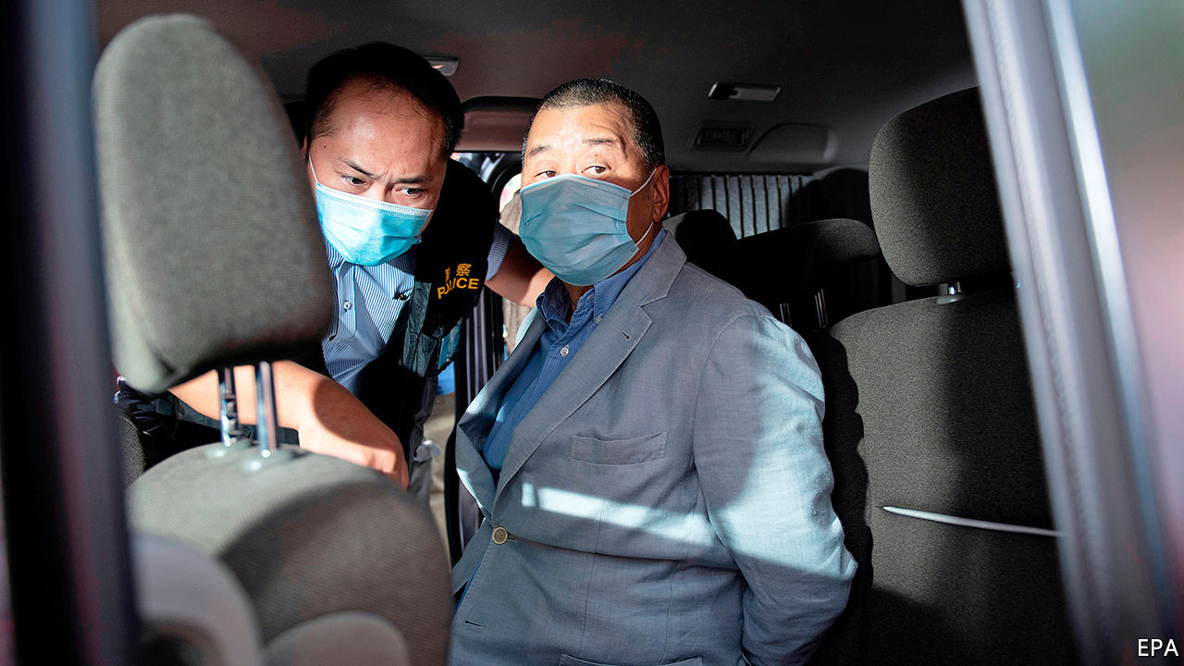

THE SYMBOLISM of the spectacle was lost on few Hong Kongers. On August 10th, amid the city’s third wave of covid-19, which has resulted in restrictions on public gatherings of more than two people, 200 police raided the offices of Apple Daily, a local tabloid, bound the wrists of its owner Jimmy Lai, paraded him around the newsroom and marched him away. Employees live-streamed the show on Facebook.

When Carrie Lam, Hong Kong’s chief executive, endorsed the suffocating national-security law that was imposed on the territory by the central authorities on June 30th, she promised that Hong Kongers would “continue to enjoy the freedom of speech, freedom of press, of publication, protest, assembly and so on.” Implementation of the law, which was not referred to Hong Kong’s legislature, has called those promises into question.

Mr Lai, who arrived in Hong Kong from mainland China as a 12-year-old stowaway and worked his way up from factory hand to media tycoon, is the most high-profile of 25 people arrested so far under the new law. His scalp is one the party had been itching for—its media often call Mr Lai the principal figure among a “gang of four” pro-democracy veterans bent on “causing chaos”. The others are Anson Chan, a former head of the civil service; Martin Lee, a barrister; and Albert Ho, another lawyer.

Details of Mr Lai’s alleged crimes have not been released, save that he “colluded with foreign forces”, a crime that carries a potential life sentence. The charge may relate to his frequent calls for America to “save Hong Kong”. Global Times, a newspaper in Beijing, said Apple Daily had been “instigating hatred, spreading rumours and smearing Hong Kong authorities and the mainland for years”.

The tycoon was among ten people arrested that day on similar charges, including Mr Lai’s two sons; four executives of Next Digital, a company owned by Mr Lai which publishes Apple Daily; and Agnes Chow of Demosisto, a pro-democracy group, which disbanded itself hours after the national-security law was enacted.

The street protests that rocked Hong Kong last year have all but ceased. But public fury over the new law and the way it is being applied is evident. Shares in Next Digital rose more than tenfold in the two days following Mr Lai’s arrest, as activists used online forums to urge people to buy shares in companies such as his that sided with the demonstrators. On the morning after Mr Lai’s arrest, people joined lengthy queues outside shops to buy Apple Daily. The pro-democracy tabloid, which critics dismiss as sensationalist, had increased its print run to more than half a million. Normal daily sales are about 70,000.

The arrests are a sign that China is determined to crush opposition in Hong Kong, ignoring global outrage. Three days earlier, America had imposed sanctions on 11 Hong Kong and Chinese officials, including Mrs Lam, whom President Donald Trump accused of “implementing Beijing’s policies of suppression of freedom”.

China may be trying to keep tensions with America under control. It declared retaliatory sanctions against 11 Americans, but not members of the Trump administration. On August 11th China’s parliament extended the mandate of Hong Kong’s legislature by one year. Mrs Lam had announced that elections due in September would be delayed that long because of covid-19 (and maybe because democrats had been expected to do well in the polls). But to the surprise of some observers, it did not announce that four lawmakers, who had been declared ineligible to run for re-election for political reasons such as opposition to the security law, would be barred from serving during the extended term.

But there is no doubt that the party has the media in its sights. Its targets include foreign journalists—the new law calls for strengthened “management” of them. Some are experiencing unusual delays in their applications for work visas. At least one such request has been denied. Local reports say a national-security unit has been set up in the Immigration Department to handle their cases. A place once renowned for its vibrant press is changing fast. ■

This article was downloaded by calibre from <https://www.economist.com/china/2020/08/15/jimmy-lais-arrest-is-a-blow-to-press-freedom-in-hong-kong>

|  |  |  |  |
| --- | --- | --- | --- |
| Previous | Articles | Sections | Next |

|  |  |  |  |
| --- | --- | --- | --- |
| Previous | Articles | Sections | Next |

#### Chaguan

# Only five blind people sat China’s university entrance exam this year

China is squandering an ocean of talent

Aug 15th 2020 |

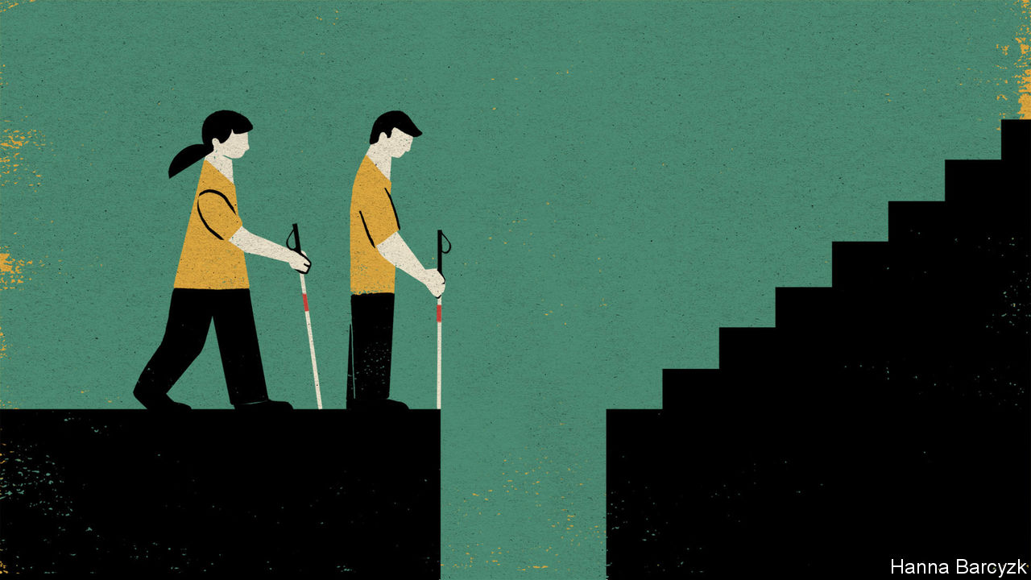

SEVERAL STARTLING things awaited 20 blind Chinese youngsters attending a residential course that began in Shanghai this week, designed to prepare them for university. Adult instructors, many of them also blind, broached topics that protective parents rarely raise, from the rules of raucous student party-games to the perils of falling in love. Learning to navigate a campus alone is not just about finding libraries or canteens, noted Yang Qingfeng of Golden Cane, the charity organising the course. It is pretty vital if teenagers ever hope to go on unchaperoned dates.

In pep talks, students were urged to think beyond the few careers traditionally offered to blind Chinese. Since the 1950s, when China opened vocational schools for disabled war veterans, the visually impaired have typically been pushed to become musicians or, above all, to work as masseurs in state-run clinics or private parlours. People may say there is nothing wrong with being a masseur, a rapt audience heard from Cai Cong, who attended a blind-massage college a decade ago before persuading his parents to let him work as a radio journalist. Well that is fine, said Mr Cai—as long as it is your choice.

Several students, all neatly clad in black trousers and yellow polo shirts, admitted to nerves about the final test of the course. It will involve leaving the hotel alone to find a place to eat in central Shanghai, trailed by sighted volunteers who will intervene only if danger looms. Yet the real novelty of the course is arguably simpler. For this small group of youngsters—at once unusually brave and at the same time awkward and quick to dissolve in nervous giggling—the course promises seven days focused on what they can do, not on things deemed unwise, unsafe or beyond them.

This is almost certainly the best moment to be blind in Chinese history. The past was often exceedingly grim. Chinese literature is filled with stories of blind people who survive by begging or telling fortunes. As modern China grew more prosperous and opened to the world, it built special schools for the handicapped and, by ratifying such agreements as the UN Convention on the Rights of Persons with Disabilities, gave domestic reformers new, albeit limited leverage to press for change. In 2014 China announced that blind students would be allowed to take the national university entrance examination, the fearsome gaokao. This breakthrough followed years of official foot-dragging. In 2015 almost 9.5m candidates took the exam. Just eight students took a special version in Braille or large print. No official count of blind school-pupils exists in China. But if the proportion of American youngsters with legally registered visual handicaps is taken as a guide, as many as 80,000 of those taking the gaokao each year should be blind.

Alas, this also remains a frustrating moment to be blind and Chinese. Of 10.7m students who sat the gaokao this summer, just five took the Braille papers for the blind. Since 2015 candidate numbers have never exceeded ten in a single year, leading some Chinese to grumble about “wasting national resources” on the Braille gaokao, says Mr Cai. That ignores other hurdles still to be dismantled, he argues, noting that only about 30 Chinese universities admit blind students, and that even some of those fail to offer accessible tests and textbooks on a systematic basis. Other universities exclude the blind with medical tests and other gambits. Education officials do see a need to look after the disabled, he says. The problem is low expectations, and an attitude towards the blind and others that “what we give you is what’s best for you”. Doctors play a role in making families timid, too, says Mr Cai, who lost his sight at ten. Once they decide a progressive disability cannot be cured, they too often abandon hope and counsel risk-avoidance.

Nonetheless a handful of blind students manage to stay in the mainstream school system and achieve gaokao scores that entitle them to apply for elite colleges, a feat that reflects luck, talent but also years of grinding toil. One such student, Ang Ziyu, a serious youth from the inland city of Hefei, is attending the Shanghai training course. He must wait until late August to learn if his score of 635 is enough to enter Beijing Normal University, a teacher-training school. He expects no special allowance to be made for years of having schoolwork read to him by his parents, or the trickiness of taking the gaokao in Braille, a tactile form of printing that is ill-suited to transliterating Chinese characters. Mr Ang currently leans towards teaching at a blind school after graduation. But he has heard that attending college often leaves students eager to explore new possibilities. “I feel like that, too,” he says shyly.

## The soft bigotry of low expectations

Each year a few hundred blind students take simplified admissions tests set by special disabled colleges or sections of ordinary universities. That is the path taken by Zhang Shuxin and Huang Kan, two teenage girls from the southern province of Guangdong. Speaking at the Shanghai training camp, they volunteer that the education they received at high schools for the blind was “vastly different” from that of a normal senior school. Ms Zhang plans to be a music teacher. Already her father has offered to buy her a flat so she need not worry about earning a living—an offer not open to her two younger brothers. Indeed, her mother was reluctant even to let her attend the course in Shanghai, thinking it risky.

Ms Huang’s parents would not let her attend an ordinary high school. “They worried I would get in danger or impair my vision further,” she says, conceding: “A lot of us have lived a very closed-off life since we were young.” She credits the internet and screen-reading software with connecting her to the world. She hopes to become a psychotherapist, and to help other Chinese know that the blind are as capable as others. “I have a lot of dreams,” she says. Unexpectedly, the thought brings on tears, but she wants no sympathy, instead apologising for her loss of control. These stubborn, impressive students know what they need: equal chances to show what they can do. Pity is of no use to them.■

This article was downloaded by calibre from <https://www.economist.com/china/2020/08/15/only-five-blind-people-sat-chinas-university-entrance-exam-this-year>

|  |  |  |  |
| --- | --- | --- | --- |
| Previous | Articles | Sections | Next |

|  |  |  |
| --- | --- | --- |
| China | Sections | The Americas |

United States

Kamala Harris: Groundbreaking and predictable

.

Economic stimulus: Prolonging the pain

.

Looting in Chicago: Smash and grab

.

Au-pair wars: Essential or exploited?

.

The decennial census: All flaxen was his poll

.

Lexington: Flag-rapping

.

|  |  |  |
| --- | --- | --- |
| China | Sections | The Americas |

|  |  |  |  |
| --- | --- | --- | --- |
|  | Articles | Sections | Next |

#### Joe Biden’s veep pick

# Why Kamala Harris was a good choice for Joe Biden

Groundbreaking and predictable, just the ticket

Aug 13th 2020 | WASHINGTON, DC

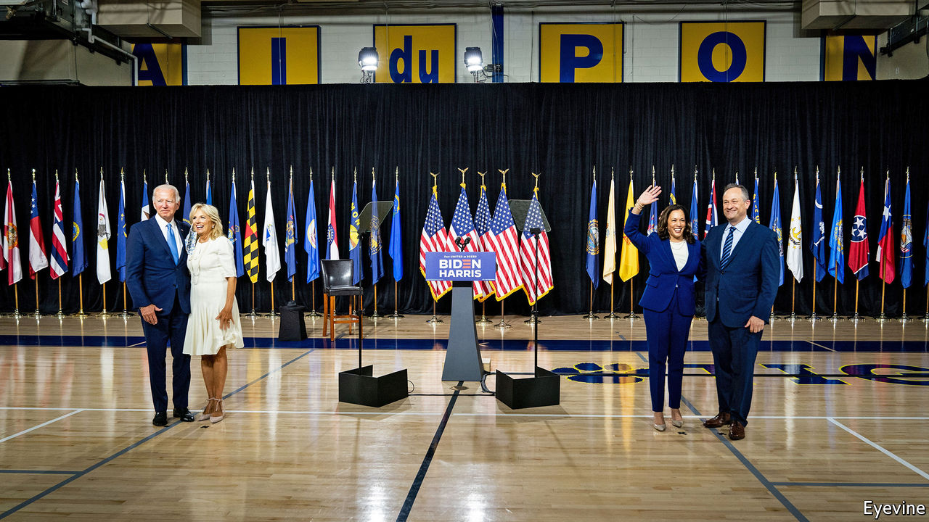

MORE THAN a year ago, before a pandemic put paid to traditional political campaigning, before anyone had heard of Gordon Sondland or Lev Parnas or any of the other minor characters who emerged from Donald Trump’s impeachment saga, the Democratic Party had a problem: how to hold a presidential debate with 20 candidates. They solved it by getting them to draw lots; ten would debate on the first night, ten on the second. The debates’ only memorable moment came on the second night, when Kamala Harris laid into Joe Biden over his opposition to federally mandated busing to integrate schools, and what she deemed to be his too-kind recollection of two segregationist senators.

They were the field’s centrist heavyweights. Mr Biden led in the polls, though many dismissed that as a sign of name-recognition; he was unimpressive on the stump, rambling and half a step too slow. Ms Harris, who served as San Francisco’s chief prosecutor and then California’s attorney-general (where she ran a department of 5,000 people) before becoming a senator in 2016, was seen as the candidate best able to reassemble the Obama coalition of progressives, non-white voters and the young.

What people remember from their exchange was Ms Harris’s line, referring to how she was bused to a majority-white school: “That little girl was me”. Less remembered was that Mr Biden, having absorbed her blows, threw a few back, reminding the audience that unlike Ms Harris, he was a public defender, not a prosecutor (an applause line). He held his own in the ensuing argument, which was no easy feat: Ms Harris is a clinical, relentless debater. In subsequent debates the two circled each other, but never really traded haymakers again, and on August 11th Mr Biden named Ms Harris as his running-mate.

The choice is at once groundbreaking and predictable. It is groundbreaking, of course, because Ms Harris, the daughter of a Jamaican economist and an Indian scientist (her first name means “lotus” in Sanskrit), is the first black woman and the first Asian-American chosen for a major-party national ticket. She is also the first Democratic presidential or vice-presidential nominee from west of Texas. The mountain west is ancestrally Republican, and California’s two presidents, Ronald Reagan and Richard Nixon, were both Republicans. She is only the fourth woman—after Geraldine Ferraro, Sarah Palin and Hillary Clinton—to appear on either party’s ticket.

It is predictable because, ever since Mr Biden announced he would choose a female running-mate, Ms Harris was the front-runner. She seemed to have the fewest flaws. Elizabeth Warren is polarising, almost as old as Mr Biden and might have cost Democrats a Senate seat. (The governor of Massachusetts, who would have nominated her replacement pending a special election, is a Republican.) Stacey Abrams, the progressives’ darling, had never held higher office than in Georgia’s state legislature. Karen Bass, who chairs the Congressional Black Caucus, was a vocal admirer of Fidel Castro—an impediment to any ticket that wants to win Florida. And too many people who know Susan Rice, Barack Obama’s former national security adviser, seem to dislike her.

Of course, Ms Harris also has her share of detractors. Some in Bidenworld deemed her “too ambitious”, a criticism that has more than a whiff of sexism about it, and also makes no sense: an ambitious vice-president will realise her future depends on helping to make Mr Biden’s presidency successful. But her own presidential campaign was dreadful. After a promising start, it fizzled, riven by infighting and disorganisation. By trying to appeal to the party’s centrist and progressive wings, she pleased neither, often looking weak and vacillating in the process, as when she seemed to both support and oppose Medicare for All.

Her record before becoming a senator makes advocates of criminal-justice reform uneasy, with good reason. She fought rulings ordering California to ease prison overcrowding and releasing wrongly convicted prisoners. She opposed marijuana legalisation, threatened truants’ parents with jail, supported a policy to report undocumented children to immigration authorities, defended California’s use of capital punishment in court (despite personal opposition) and aggressively prosecuted non-violent crime.

She has long insisted that she wanted to reform the system from the inside—a position for which her record bears scant evidence. But as a senator she has tried to reinvent herself as a reformer. She helped craft the Justice in Policing Act after George Floyd’s death. That bill would establish a national use-of-force standard for police, ban no-knock warrants in drug cases and expand the investigative powers of attorneys-general. She also introduced a measure to decriminalise and tax marijuana.

One way to read that shift is the Trump administration’s take: Ms Harris is a “phoney” who “will abandon her own morals” in pursuit of power. The other interpretation is that, like Mr Biden, she is an instinctive centrist and insider, open to changing positions, and not motivated by ideology.

Ms Harris also has a star quality that Mr Biden lacks. She wields a deft knife, and will perform the vice-presidential nominee’s traditional attack duties fearsomely well. No doubt Democrats are already salivating at the thought of her facing off against Mike Pence’s tut-tutting. Her background as a prosecutor makes her ideally suited for a law-and-order election, as this one is shaping up to be, and helps counter the Trump campaign’s slur that Mr Biden is simply a front for the radical left. Choosing Ms Warren would have given that argument some validity; choosing Ms Rice would have let Republicans endlessly relitigate Obama-era foreign-policy failures. But finding a potent, specific and coherent attack line against Ms Harris is difficult.

The choice suggests that Mr Biden is not terribly worried about his left flank, or, at least, that he thinks the groundbreaking nature of Ms Harris’s candidacy will do at least as much as choosing Ms Warren or Ms Abrams would have done to boost turnout where he needs help: among young and non-white voters. Mr Biden won the nomination on the strength of his appeal to African-American voters, but he needs non-white voters to turn out in the general election at 2012, not 2016 levels—particularly in swing states such as Pennsylvania, Wisconsin, Michigan and Florida.

The choice also suggests that Mr Biden wants to recapture some of the 2008 magic. Faced with a norm-breaking, attention-grabbing opponent in 2016, Hillary Clinton played it safe and chose Tim Kaine, a worthy but dull running-mate. Mr Biden has opted for excitement. But the fact that the exciting choice—an Indian-Jamaican-Californian woman—is also the safe, predictable one says something about America’s continuing evolution on race.■

Dig deeper:  
Sign up and listen to Checks and Balance, our [weekly newsletter](https://www.economist.com/checksandbalance/) and [podcast](https://www.economist.com/podcasts/2020/08/01/checks-and-balance-our-weekly-podcast-on-american-politics) on American politics, and explore our [presidential election forecast](https://projects.economist.com/us-2020-forecast/president)

This article was downloaded by calibre from <https://www.economist.com/united-states/2020/08/13/why-kamala-harris-was-a-good-choice-for-joe-biden>

|  |  |  |  |
| --- | --- | --- | --- |
|  | Articles | Sections | Next |

|  |  |  |  |
| --- | --- | --- | --- |
| Previous | Articles | Sections | Next |

#### The stymied stimulus

# Donald Trump’s executive orders do little for hard-hit Americans

Congressional gridlock prolongs the pain

Aug 12th 2020 |

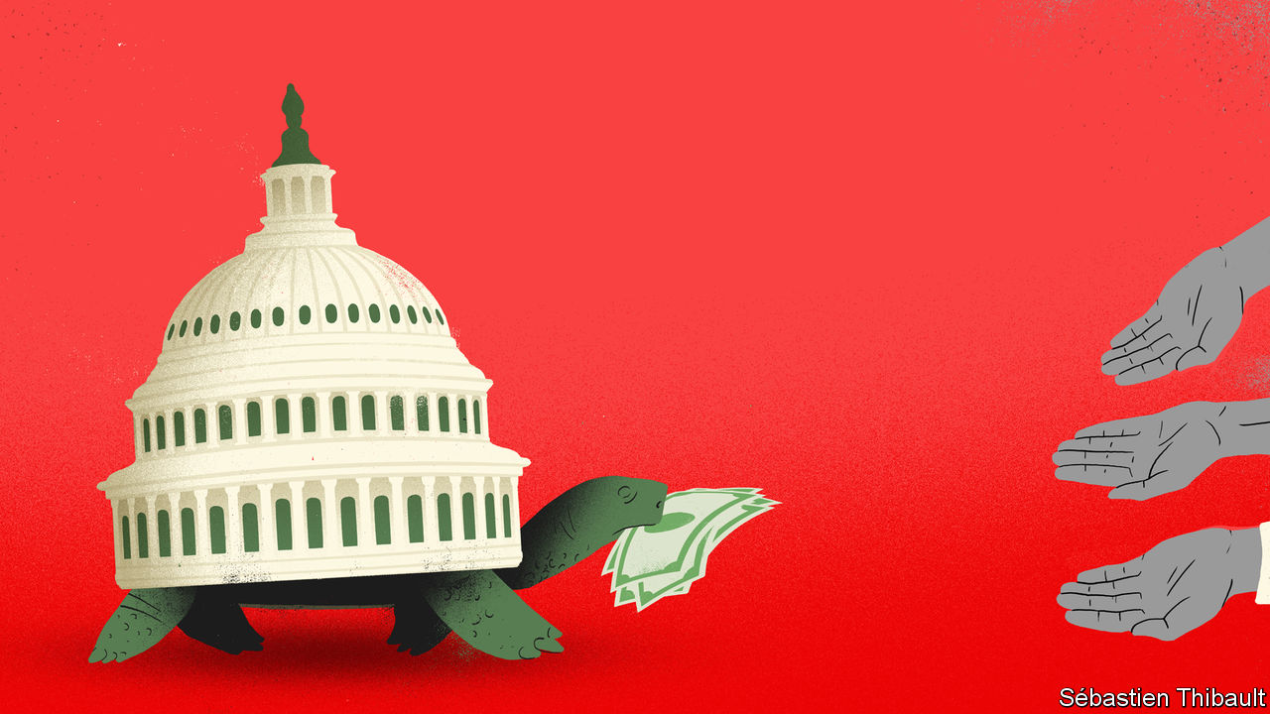

IN LATE MARCH Congress broke its characteristic gridlock and passed the CARES Act, a huge stimulus package. On the day that President Donald Trump signed it into law, around 2,000 Americans had died of the virus. America’s death toll now exceeds 160,000, and its GDP fell by 10% year-on-year in the second quarter of 2020. The case for further stimulus remains strong, but political will has weakened. Congress adjourned without passing another bill, each party blaming the other. That failure imperils America’s shaky economic recovery, and could presage a brutal end to 2020.

In July America added 1.8m jobs. Such is the scale of the damage caused by the coronavirus that the world’s largest economy needs another seven similarly large jobs increases just to reach its pre-pandemic level of employment. And there is growing evidence that the recovery is losing steam. Almost all economists believe the country needs more fiscal stimulus.

Since the pandemic began Congress has passed some $3trn-worth of fiscal stimulus. It has made grants to small businesses, bumped up unemployment-insurance (UI) payments by $600 a week and sent out cheques worth up to $1,200 per person. Both in absolute terms and relative to the size of the economy, America’s fiscal stimulus is the world’s largest. But many of the elements of the various packages have now expired, including a federal moratorium on evictions (which ended on July 24th) and the $600-a-week bump to UI (July 31st).

America probably cannot leave it at that. The numbers of infections and deaths from covid-19 remain extraordinarily high. That threatens the economic recovery which began in April, as state lockdowns have been reimposed and consumer confidence has suffered. A closely watched measure of credit-card spending has not grown since mid-June, while the number of small businesses which are open appears to be in decline. The reduction in fiscal support will be a further drag on growth, not to mention a source of anxiety for many Americans, especially those with less or no work. Worries that investors would balk at another stimulus package have, meanwhile, proved wide of the mark. As talk has swirled of extra borrowing, yields on Treasuries have fallen to new lows.

Moderates on both sides argue in favour of sending extra cheques to households, for more money for bumped-up UI payments, and for extra money for states. But they disagree on how generous these plans should be. The Democrats originally put forward a package worth some $3.5trn (17% of GDP). The Republicans have proposed their own plan, and the Democrats have since made theirs less generous, but there remains a gap of $1trn between them.

## A pen and a phone

With congressional negotiations stalled, on August 8th Mr Trump signed four executive orders that purport to extend UI benefits and the eviction moratorium, and defer student-loan payments and payroll taxes. Democrats howled that these orders were unconstitutional. But except for the UI extension, most appear broadly legal—but ineffective. The eviction order, for instance, simply asks a few cabinet departments to look for ways to help renters; it does not direct anyone to do anything. Payroll taxes will still come due at year’s end, so businesses may well withhold them from employees anyway rather than scramble to find funds in December.

The UI order provides $400 a week, with states (many of which are cash-strapped, and all of which face stricter borrowing limits than the federal government) responsible for $100 of that. It provides just $44bn for these payments, enough for perhaps six weeks. By law only Congress can appropriate funds, though federal law allows presidents to provide financial aid during a “major disaster”. As one conservative legal scholar notes, covid-19 may not qualify: “He can’t call it a disaster just because it’s a disaster for him politically.” But for a court to find it illegal, first someone has to sue, and House Democrats seem an unlikely plaintiff: that would let Mr Trump claim that they are holding up funds to needy people.

Though stubborn partisan disagreement is nothing new, it contrasts sharply with the spirit of co-operation that Republicans and Democrats showed in the early part of the pandemic, when everyone agreed that they needed to get money out as quickly as possible. In some ways the Republicans’ unwillingness to go along with the Democrats’ spending plans this time around is puzzling, not least since a new stimulus would help the economy and thus Mr Trump’s chance of re-election.

A few things are different now. Back in March many people worried that the economy was going to enter a recession of cataclysmic proportions. Research published by the Federal Reserve Bank of St Louis had suggested that the unemployment rate was going to rise above 30%. In fact it peaked at about 15%, and has since fallen to 10%. And whereas six months ago double-digit unemployment would have seemed catastrophic, now it seems almost normal, points out Gbenga Ajilore of the Centre for American Progress, a think-tank. So whereas some fiscal hawks may have been bumped into backing fiscal support in March, they now believe the economy does not need it. (Mr Ajilore adds that the evidence that the pandemic has disproportionately affected non-white folk may also explain why some urgency has been lost.)

Politically, too, the ground seems to have shifted. Mark Meadows became Mr Trump’s chief of staff after the CARES Act passed. In these negotiations, he has taken a prominent role, and he is a longtime fiscal hawk, as are many Senate Republicans. Five months ago fear of crossing Mr Trump before primary season may have pushed many of them into supporting a stimulus bill that they may otherwise have opposed. But the primaries are over, and Mr Trump is trailing in the polls. Ben Sasse, for instance, is a generally principled Republican who went quiet during impeachment and won his primary in May; he called Mr Trump’s executive orders “unconstitutional slop”.

Still, that may be the only relief America sees: a substantive congressional deal looks unlikely before the parties’ conventions later this month. For millions of Americans enhanced UI benefits have already ended, and even if no court stops Mr Trump’s extension, implementing it requires states to reconfigure their rickety payment infrastructure and scrounge between sofa cushions to find the money. Weeks will pass before people see the money. States and cities that need federal aid are similarly left adrift. After the recession of 2008-09, local budgets faced drastic cuts, reducing services and prolonging economic woes. A similarly drawn-out recovery appears far likelier now, unfortunately, than it did just a few weeks ago. ■

Dig deeper:  
Sign up and listen to Checks and Balance, our [weekly newsletter](https://www.economist.com/checksandbalance/) and [podcast](https://www.economist.com/podcasts/2020/08/01/checks-and-balance-our-weekly-podcast-on-american-politics) on American politics, and explore our [presidential election forecast](https://projects.economist.com/us-2020-forecast/president)

This article was downloaded by calibre from <https://www.economist.com/united-states/2020/08/12/donald-trumps-executive-orders-do-little-for-hard-hit-americans>

|  |  |  |  |
| --- | --- | --- | --- |
| Previous | Articles | Sections | Next |

|  |  |  |  |
| --- | --- | --- | --- |
| Previous | Articles | Sections | Next |

#### Smash and grab

# Chicago, civil unrest and inequality

Is it ever legit to loot?

Aug 15th 2020 | CHICAGO

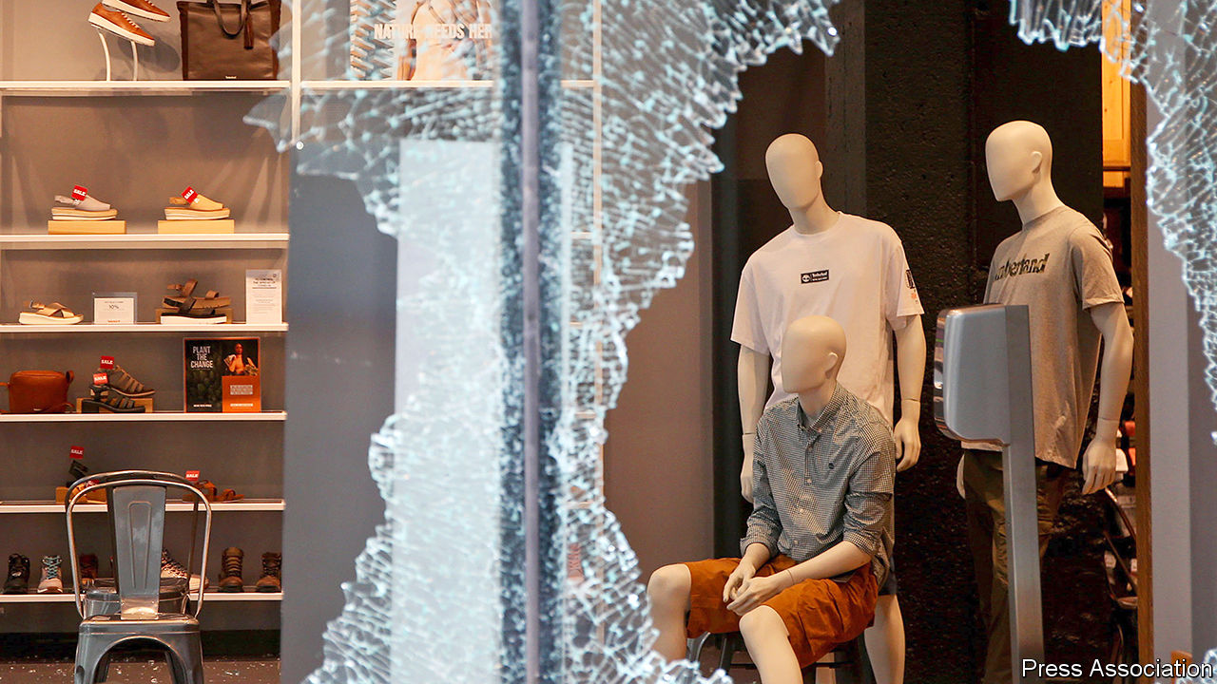

POLICE IN CHICAGO have an unusual tool to deploy for crowd control: 43 liftable road bridges that span urban stretches of river. Officials ordered many to be raised on successive nights this week, to limit access to the city centre after sunset. That followed an outbreak of rioting on August 10th, when looters—some of whom had hired vans for the occasion—flooded to rich central districts and smashed into luxury-goods, electronics and other shops.

Attackers prised open cash dispensers, seized cash registers and hauled off carloads of fancy clothes, jewellery, televisions and alcohol, even as hundreds of police chased them and helicopters watched from above. Eager for notoriety, a few looters laden with armfuls of designer goods live-streamed themselves on social media. Some violence erupted; a security guard was shot. Police arrested over 100 people.

Shopkeepers lamented they had only just replaced stock stolen in an earlier round of looting after police killed George Floyd in Minneapolis, in May. Once more a clash with police sparked the uprising. Officers repeatedly shot a young black man in Englewood, on Chicago’s poor South Side, on August 9th. They claimed he had fired at them first, but failed to produce bodycam video footage to prove it. He survived but, as false rumours of his death spread, angry residents shared plans online for looting that night.

Condemnation flowed from all sides. President Donald Trump had already said he would send federal agents to tackle gun violence in Chicago. A Republican state representative in Illinois said the National Guard should be deployed after the looting. Lori Lightfoot, Chicago’s mayor, rejected that but warned criminals that police would come for them. She blamed the looting on a lax policy of not prosecuting everyone who had robbed shops earlier.

Across a swathe of larger cities, recent months have seen a strange shift in crime rates. As a result of lockdowns, reports of most violent and non-violent crimes have fallen compared with last year. In contrast, rates of murder and violent assault have surged, especially as temperatures have risen. Gun violence is most prevalent. Last month 105 people were murdered in Chicago alone, its bloodiest month in 28 years.

Some civil-rights activists fret that the latest events in Chicago will weaken national support for police reform that has grown in the months since Floyd was killed. The Rev Jesse Jackson called the events in Chicago “humiliating, embarrassing” and “morally wrong” on August 10th. Not everyone agreed. A few radical activists, including some associated with Black Lives Matter in Chicago, argued that looting can be legitimate. One woman, protesting at a police station that held arrested looters, called it a form of “reparations” for white oppression.

This really is a live debate. Vicky Osterweil, author of “In Defence of Looting: A Riotous History of Uncivil Action”, published this month, sets out the same argument at book length. Looting by the poor, black or otherwise repressed is a radical tactic that brings welcome change, in her view. Peaceful civil-rights demonstrations are too easily ignored, whereas “riots and looting are more effective at attracting attention to a cause”. The shared experience of looting can also be “joyous”, produce “community cohesion”, count as a small act of “direct redistribution of wealth” and, she reckons, does little harm to those who have insurance. She thinks it also leads people to question high levels of inequality.

Her claims are unconvincing. Those who snatched swag from Gucci or Louis Vuitton in order to sell them on hardly share her anti-capitalist views. Nor is it clear that looting spreads solidarity in poor neighbourhoods. The grandmother of the man shot by police condemned the looting. Ms Osterweil might be right, however, that residents of poor areas, who rarely even set foot in the wealthy central parts of their city, are fed up. Looting is not a helpful way to respond, but the resentment at this disparity is real enough.■

This article was downloaded by calibre from <https://www.economist.com/united-states/2020/08/15/chicago-civil-unrest-and-inequality>

|  |  |  |  |
| --- | --- | --- | --- |
| Previous | Articles | Sections | Next |

|  |  |  |  |
| --- | --- | --- | --- |
| Previous | Articles | Sections | Next |

#### Au-pair wars

# America’s au-pair programme is under assault from Donald Trump and the left

Changed immigration rules create a bidding war for nannies

Aug 13th 2020 |



WITH SO MANY schools and child-care facilities closed in the pandemic, getting an au pair to help with the children can make a big difference. So it came as a jolt to parents when, on June 22nd, the president suspended the arrival of new au pairs, along with some other sorts of foreigners, until at least the end of the year. His order, meant to protect American jobs, has stranded crowds of would-be au pairs in their home countries. Au pairs already in the United States have fared somewhat better.

Replacing the au pairs who leave the United States when their contracts expire requires about 20,000 new arrivals a year. Now that the number of au pairs in the country is dwindling, the number of desperate families is climbing correspondingly, says Ilir Zherka, director of the Alliance for International Exchange, an industry association in Washington, DC. The result, says Katherine Gallagher Robbins, head of child care at the Centre for Law and Social Policy, an advocacy group in the same city, has been “total chaos”. Wealthier families, she explains, have begun poaching au pairs from households with lower incomes.

Au pairs have typically received a weekly stipend of $195.75, the legal minimum. Now an au pair willing to switch homes can easily secure $500 a week, says Anna Edhegard, a host mother in Alexandria, Virginia. Many parents, she notes, now use social media to attract an au pair by dangling perks like a nice car. Another Alexandria mum, a covid-19 researcher, hopes to secure a “national-interest” exception for her would-be au pair, who is stuck in Colombia. But she frets that if an exception is granted, her au pair may be tempted to “rematch” later with a family offering more money.

The au-pair programme is also under siege from left-leaning outfits that call it exploitation. If you discount room, board and money for education, the minimum stipend works out at $4.35 for each hour of a 45-hour week. This is because au pairs are regulated not by the Department of Labour but by the Department of State, which considers the programme to be a form of cultural exchange and grassroots diplomacy. Colin Seeberger of the Centre for American Progress, a progressive think-tank in Washington, puts it bluntly: “Cheap au-pair labour shouldn’t really exist.”

Au pairs, argues Janie Chuang, a vocal opponent at American University’s law school, undercut the market for ordinary nannies. Beyond that, she claims that lax regulations and hesitation to investigate accusations of mistreatment have made au pairs vulnerable to human trafficking. In response, the industry association’s Mr Zherka points to independently audited surveys that show high levels of satisfaction among au pairs. He describes the harsh rhetoric as “an argument in search of evidence.”

Activists scored a victory in June when the Supreme Court declined to hear a challenge to a ruling that requires au pairs in Massachusetts to be paid the state’s minimum wage of $12.75 an hour. That thrilled pressure groups like the National Domestic Workers Alliance, which are now multiplying suits against the programme. Expect fireworks. The State Department says it is revising its au-pair rules to clarify that they override state and local laws.

This article was downloaded by calibre from <https://www.economist.com/united-states/2020/08/13/americas-au-pair-programme-is-under-assault-from-donald-trump-and-the-left>

|  |  |  |  |
| --- | --- | --- | --- |
| Previous | Articles | Sections | Next |

|  |  |  |  |
| --- | --- | --- | --- |
| Previous | Articles | Sections | Next |

#### All flaxen was his poll

# America’s decennial census and covid-19

Trouble with counting would disproportionately disenfranchise Hispanics

Aug 15th 2020 | WASHINGTON, DC



AMERICA’S GOVERNMENT relies on regularly updated, accurate tallies of how many people live within its borders. To produce the data, the founders charged the government with administering an “enumeration” of “the whole number of free persons” living in each state every ten years. Most notably, the decennial census data are used to assign members of Congress to each state according to population. But the tallies are also used as a guide for allocating billions of dollars in programmes such as Medicaid, child health insurance and food stamps for low-income mothers.

This year the accuracy of the census is at risk. Researchers are afraid that the Census Bureau may not be able to count enough people, or a fully representative set of Americans. Facing extra burdens imposed by the Trump administration as well as staffing shortfalls as a result of the covid-19 pandemic, the agency could end up undercounting minority voters which would bias the government against them for at least the next ten years.

The task of enumerating America is a massive one. Records must be compiled on almost every citizen, which requires hundreds of thousands of hours of research and hiring and co-ordinating more than half a million workers. Aside from data processing and technical work, the actual counting takes place in three stages.

First, the government sends a request to fill out the census questionnaire to every household in the country. The primary census form asks for the name and demographic information of each person living there. In past censuses respondents posted these forms back, but for the first time this year they could fill them out online.

Most Americans end up submitting a completed census form themselves. In 2010, the final self-response rate was 67%, indicating that two-thirds of households were counted by mail. For those who do not respond, the bureau deploys an army of interviewers called “enumerators” to contact them in person. If neither of these approaches gets a response, the bureau hazards a guess as to how many people live in a household by looking at reports for households round about. They use a similar method to fill in demographic information for households who provide no data.

This is all complex enough in a normal year, but the agency faces extra hurdles in 2020. First, Mr Trump and his administration have waged numerous political battles against the census. Put off by the constitution’s stipulation that the census should include all “persons” in the country, which they think unfairly gives a voice to millions of undocumented immigrants, the administration has tried to exclude them from the count. After losing a court battle to add a citizenship question to the questionnaire—which experts believed would have discouraged Latinos and immigrants from responding—Mr Trump on July 21st issued a presidential memorandum declaring that people living in the country illegally should be ignored for congressional apportionment in 2021. The move is probably unconstitutional, but researchers are concerned that the politicisation of the census may hurt its legitimacy and make people even less inclined to fill out the forms.

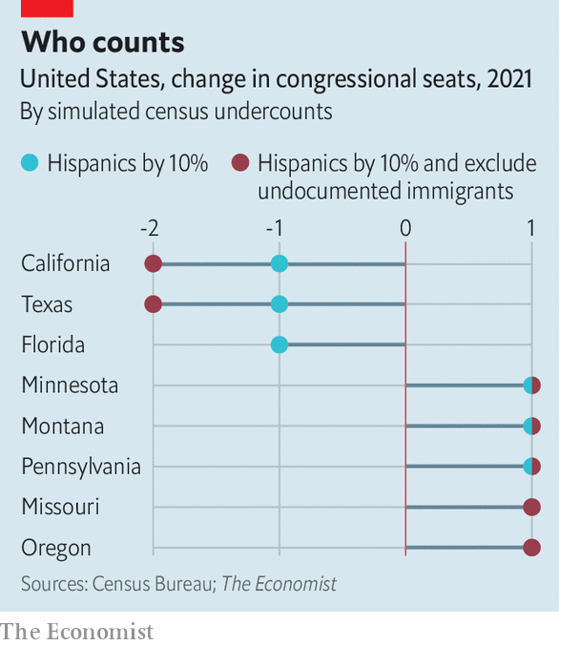

The census also faces a troubling combination of budget problems and large methodological changes. In 2011 Congress instructed the bureau to spend no more on the 2020 canvassing than was spent for the 2010 count. That would be too low even if they kept the same procedures, but experiments with an internet form, and the need to make new adjustments for non-response, has led to other costs.

A final challenge is covid-19, which prompted the bureau to delay field operations and reduce staffing in the spring. Bureau directors have also cut the window for following up on households that fail to respond from three months in the autumn to two months, ending on September 30th instead of October 31st.

Most scholars agree that all this will cause the ultimate census numbers to underestimate the share of minorities in the electorate. That is because harder-to-contact households tend to be composed of minority and immigrant families, with several generations under the same roof (and some spaces shared between families). If census interviewers miss their homes, they will be disproportionately deprived of their fair share of congressional representation and governmental funds. Using data from a census survey conducted last year, The Economist estimates that a 5-10% undercount of Hispanics would cost California, Texas and Florida one member of Congress each. If you exclude undocumented immigrants from the tally, as Mr Trump wants, California and Texas would lose another representative to boot.■

Dig deeper:  
Sign up and listen to Checks and Balance, our [weekly newsletter](https://www.economist.com/checksandbalance/) and [podcast](https://www.economist.com/podcasts/2020/08/01/checks-and-balance-our-weekly-podcast-on-american-politics) on American politics, and explore our [presidential election forecast](https://projects.economist.com/us-2020-forecast/president)

This article was downloaded by calibre from <https://www.economist.com/united-states/2020/08/15/americas-decennial-census-and-covid-19>

|  |  |  |  |
| --- | --- | --- | --- |
| Previous | Articles | Sections | Next |

|  |  |  |  |
| --- | --- | --- | --- |
| Previous | Articles | Sections | Next |

#### Lexington

# The politics of patriotism

Americans are becoming less vulnerable to flag-waving opportunists. This is bad for the president

Aug 15th 2020 |

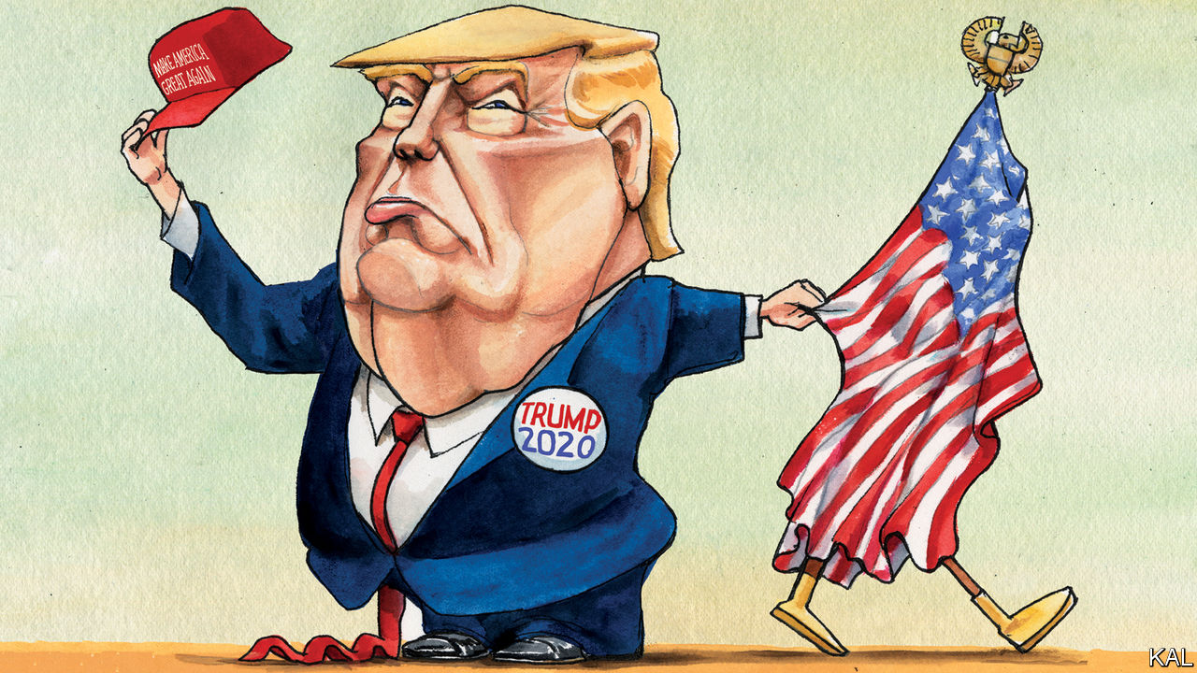

THE LAST time a Democratic presidential candidate was nine points ahead in a two-horse race, less than four months from a general election, Republicans throttled him with the flag. Michael Dukakis’s alleged crime was to have vetoed a bill, as governor of Massachusetts, that would have compelled teachers to lead their pupils in the pledge of allegiance. The Democratic nominee in 1988 said he had had no choice, the bill was unconstitutional. But for his navy-hero Republican opponent, George H.W. Bush, this was a worrying reflection of the swarthy Mr Dukakis’s “values”.

He and other Republican leaders began reciting the sacred pledge at every opportunity. At the Republican convention that year John McCain, a senator and former prisoner-of-war, told a remarkable story about one of his fellow captives sewing Old Glory out of rags with a bamboo needle. Their Vietnamese captors discovered it and pulverised the flag-maker. But no sooner had he been dragged back to their communal cell, half-blind from his beating, according to McCain, than he was back at it with his bamboo splinter, “making that flag because he knew how important it was to us to be able to pledge our allegiance”.

Mr Dukakis’s subsequent hammering underlined how completely the Republicans owned patriotism (and how ruthlessly they were prepared to use it). A Harvard study found that merely exposing Americans to July 4th parades as children made them likelier to vote on the right. Is President Donald Trump ending this decades-old Republican advantage?

His efforts to capitalise on it are not subtle. He has advocated prison for flag-burners and possible deportation for black footballers who kneel during the anthem; he often accuses his critics—including racial-justice protesters in Portland—of “hating our country”. Against the wishes of service chiefs, he presided over a triumphalist military display in Washington. Such gestures would look phoney to everyone outside the president’s base even if he had not also denigrated American generals, sided with Russia against American intelligence agencies, implored Ukraine and China to intervene in American elections and in a hundred other ways run down the “big, fat, sloppy United States”, as he falsely claimed the world sees America.

Polls point to a collapse in national pride, a proxy for patriotism, during his presidency. In recent months, as America has fought a losing battle against the coronavirus, this has extended to the president’s own supporters. Mr Trump’s decision to change his campaign slogan from “Keep America Great” back to “Make America Great Again” was in that sense a response to public demand.

Yet there is more than Mr Trump going on. Even before his election Americans were starting to view patriotism in a more qualified, more Democratic way.

Where conservatives often claim to love their country uncritically—or “unambivalently”, as Ronald Reagan recommended—progressives are likelier to talk of using America’s strengths to correct its weaknesses. For John Lewis, the last titan of the civil-rights movement, non-violent protest was a patriotic act. Until recently, Democrats tended to worry more about threats to free speech than, say, clamping down on flag-burners. Political scientists call this “constructive patriotism”. In the 1930s and 1940s, when Franklin D. Roosevelt united the left and centre-right to defeat poverty and fascism, it was the dominant kind. For Adlai Stevenson, the party’s presidential nominee in the 1950s, patriotism was expressed not in “short, frenzied outbursts of emotion”, but the “tranquil and steady dedication of a lifetime”.

As the cold war loomed, he was traduced by Richard Nixon as an “appeaser”. Yet the more contingent Democratic view is coming back into vogue. Younger Americans are increasingly hostile to ostentatious flag-waving. According to one survey, two in ten millennials even consider the flag a symbol of “intolerance and hatred”. They meanwhile show no waning enthusiasm for American ideals such as equality and opportunity. They are also increasingly politically engaged; turnout among younger voters was sharply up in the 2018 mid-terms and there are indications that it will be again this year. Popular support for footballers taking a knee is consistent with this shift towards restrained national self-criticsm.

Demographic change is playing a big part in it. The armed forces—a generator and focus of patriotic fervour—were 75% white in 1990; now around 45% of their members are from mostly Democratic-voting minorities. And just as Roosevelt was able to push his values by enlarging his coalition, so the extremism of the right is expanding the left. The many veterans, of all ethnicities, who ran for the Democrats in the 2018 mid-terms proved that.

A row between Tucker Carlson, a Fox News talking-head, and Senator Tammy Duckworth encapsulated these developments. Mr Carlson accused her of hating America after she expressed willingness to debate the appropriateness of celebrating George Washington, a slave-owner. Nonsense, said Ms Duckworth, a half-Asian former army pilot: her views reflected her commitment to “every American’s right to speak out”. She had fought for her country—and lost her legs—for that, she said.

## Liberty and justice

This will not be the first election in which the Democrats hope to wrest patriotism from the right. They tried in 2004, through John Kerry’s army record, and in 2016, when the spectre of Mr Trump pushed retired generals and the parents of a soldier killed in battle to Hillary Clinton. Both lost to Republican draft-dodgers. Yet Joe Biden may be a more compelling patriot.

He is not a patrician like Mr Kerry or despised as Mrs Clinton was. He is an amiable former vice-president. And, for all his weaknesses, he is good at admitting America’s failures without underselling its strengths. It will be hard to frame him as anti-American. This suggests patriotism will not be Mr Trump’s last refuge.■

Dig deeper:  
Sign up and listen to Checks and Balance, our [weekly newsletter](https://www.economist.com/checksandbalance/) and [podcast](https://www.economist.com/podcasts/2020/08/01/checks-and-balance-our-weekly-podcast-on-american-politics) on American politics, and explore our [presidential election forecast](https://projects.economist.com/us-2020-forecast/president)

This article was downloaded by calibre from <https://www.economist.com/united-states/2020/08/15/the-politics-of-patriotism>

|  |  |  |  |
| --- | --- | --- | --- |
| Previous | Articles | Sections | Next |

|  |  |  |
| --- | --- | --- |
| United States | Sections | Middle East & Africa |

The Americas

Mexico: A new kingpin on the block

.

Bolivia: Democracy deferred

.

The Arctic: A shortened shelf life

.

|  |  |  |
| --- | --- | --- |
| United States | Sections | Middle East & Africa |

|  |  |  |  |
| --- | --- | --- | --- |
|  | Articles | Sections | Next |

#### Hand-ups, not handcuffs

# How will Mexico’s president handle “El Mencho”, a kingpin on the rise?

Andrés Manuel López Obrador’s policy of “hugs, not bullets” faces a new challenge

Aug 15th 2020 | MEXICO CITY



PLOT TWISTS in Mexico’s underworld happen quickly. In Netflix narco-dramas, Joaquín (El Chapo) Guzmán, the former boss of the Sinaloa drug gang, is the country’s chief mobster. In real life Mr Guzmán is serving a life sentence in a Colorado prison. He has been eclipsed by Nemesio Oseguera Cervantes, the boss of the Jalisco New Generation Cartel (CJNG). Five years ago it appeared for the first time in the list of top drug-trafficking gangs put out by the United States’ Drug Enforcement Administration (DEA). Today Mr Oseguera (aka El Mencho, derived from Nemesio) is the agency’s most-wanted suspect. It calls the CJNG “one of the five most dangerous transnational criminal organisations in the world”. It wants Mexico to nab its boss.

Mexico’s president, Andrés Manuel López Obrador, who is normally keen to co-operate with the United States, may in this case have reservations. A left-wing populist, he has never endorsed his predecessors’ policy of capturing or killing kingpins. With reason. The tactic caused gangs to fracture and proliferate. The former bosses’ lieutenants battled bloodily for control, pushing up the murder rate. Gangs diversified and entered new territories.

The implementation of the kingpin strategy may have been corrupt. The government of Felipe Calderón, Mexico’s president from 2006 to 2012, locked up El Chapo’s rivals but rarely members of the Sinaloa gang. Mr Calderón’s security minister, Genaro García Luna, was arrested on charges of taking $50m in bribes from gangs. He is expected to go on trial in the United States. He denies wrongdoing.

Mr López Obrador has taken a different approach to criminals, based on a philosophy of “hugs, not bullets”. He has had 20 months in office to prove that his pacific policy can work, but so far the results are disappointing. American pressure, and El Mencho’s outrages, could oblige him to adopt tactics he has hitherto resisted.

In June this year Mr Oseguera, now in his mid-50s, allegedly ordered the murder of a federal judge who approved the extradition of his son to the United States. Ten days later, in a posh neighbourhood of Mexico City, gunmen shot at a car carrying Omar García Harfuch, the police chief, killing two bodyguards and a bystander. Mr García, nursing three bullet wounds, accused the CJNG from his hospital bed. Killings of federal judges are rare; the attack on Mr García is unprecedented in its brazenness.

Mr Oseguera owes his rise to the tumult triggered by Mr Calderón’s decapitation strategy, which was continued by his successor, Enrique Peña Nieto. Caught selling heroin in San Francisco in 1992, Mr Oseguera spent three years in a Texan prison and was then deported back to Mexico, where he soon found work as a policeman in the western state of Jalisco. He joined the Milenio drug gang, which split into warring groups after its leaders were locked up. Mr Osegura’s faction became the CJNG.

He is a more shadowy figure than El Chapo. Many of his closest associates have never met him. He deals with them mainly through relatives. Mr Oseguera is thought to be living somewhere in the mountains in one of three neighbouring states: Jalisco, Colima or Michoacán.

The gang he leads now has operations in 27 of Mexico’s 32 states (but has rivals in most). It has succeeded in part because it was among the first to diversify away from cocaine into synthetic drugs like meth and, just as Americans were becoming hooked on opioids, fentanyl. The CJNG’s base is near Manzanillo and Lázaro Cárdenas, seaports where precursor chemicals arrive from China. It oversees manufacture of the drugs (often by independent labs) and ships them to the United States. Unlike the Sinaloa outfit, the CJNG makes much of its money from extortion, robbery, fuel theft and domestic drug-dealing.

Law-abiding Mexicans suffer more from the new business model than the old. The CJNG subjects them to penalties that gangs once reserved for competitors. Last year CJNG gunmen burned down a nightclub in Veracruz, killing 32 people. The owner had refused to pay extortion money. At the same time, the gang poses as the friend of common folk. “You know well that I like to support the people,” a masked figure claiming to be El Mencho told residents of Tepalcatepec, Michoacán, in a video that declared war on a local crime boss. He offered to pay local members of Mexico’s national guard double the money that they get from his rivals. In 2016 a CJNG detainee boasted to his captors that half of Jalisco’s municipal police were on its payroll.

When Mr López Obrador’s government has pursued crime bosses, it has done so reluctantly. Last year, perhaps in response to pressure from the DEA, police and soldiers captured Ovidio Guzmán, El Chapo’s son, in Culiacán, Sinaloa. After the gang threatened retribution, the president quickly ordered his release. A massacre would have left his government “with very little moral authority” and “put at risk” his plans to transform Mexico, he explained in May this year.

This month, after the CJNG’s spree, the government arrested José Antonio Yépez, the head of the Santa Rosa Lima gang in Guanajuato, Mexico’s bloodiest state. Mr López Obrador may have targeted Mr Yépez because his gang specialises in stealing fuel from pipes belonging to Pemex, the state-owned oil firm, which is a pillar of the president’s economic-development strategy. The arrest of Mr Yépez, who had been battling the CJNG for control of Guanajuato, is more likely to empower Mr Oseguera than worry him.

Mr López Obrador’s answer to crime is hand-ups, not handcuffs. He contends that violence is the result of poverty caused by three decades of “neoliberalism”. His administration would end poverty and therefore crime, he claimed. Among its flagship programmes is a nationwide apprenticeship scheme.

There are other elements to his crime-fighting policy, but they are not very effective. He created a national guard, which will have 60,000 troops at full strength, to replace the 37,000-member federal police, but it has made little difference. State and municipal police continue to be underpaid, ill-equipped and badly supervised. This year the federal government told states to divert money from a fund for improving policing to hospitals coping with covid-19.

The government claims some successes. Its Financial Intelligence Unit froze nearly 2,000 bank accounts belonging to the CJNG. The Trump administration accepted Mexico’s demand that it help reduce the flow of weapons to Mexico, but has done little in practice. In March, before the pandemic chased people indoors, 2,628 people were murdered, a monthly record. The lockdown barely reduced the carnage.

If Mr López Obrador’s theory about the connection between poverty and crime is correct, things may get worse. Mexico’s economy is expected to shrink by around 10% this year. GDP will not regain its level of 2018 until 2024, predicts BBVA, a bank.

A dominant CJNG, facing less defiance from other gangs, might lead to a reduction in today’s record murder rates. What now happens in Guanajuato will be “an ideal case study”, says Cassius Wilkinson, a security analyst at EMPRA, a risk-consulting firm in Mexico City.

But there are reasons to doubt that the CJNG will be capable of imposing an unlawful peace, not least competition from such outfits as the Santa Rosa Lima group. The CJNG’S expansion has come about partly through local gangs adopting its name. They may prove fickle. The goons who shot Mr García appear to have been hired guns. El Mencho is thought to have a kidney disease; to treat it he is said to have built a hospital in the mountains of Michoacán. Some analysts wonder if the point of his recent audacity is to scare internal challengers.

His relative weakness does not mean that a government determined to nab him would have an easy time of it. El Mencho seems to have learned from past kingpins like El Chapo, who was captured three times—and escaped twice. He lives less lavishly. Mr Peña’s government tried to catch Mr Oseguera in 2015. He was tipped off by someone in the army. His men shot down a military helicopter and blockaded Guadalajara, Jalisco’s capital, with burning vehicles. Ten soldiers died and Mr Oseguera slipped away. He may never achieve the dominance that El Chapo and his kind once exercised in parts of Mexico. But he remains just as dangerous.

Correction: this article originally misspelled the name of Nemesio Oseguera Cervantes

■

This article was downloaded by calibre from <https://www.economist.com/the-americas/2020/08/15/how-will-mexicos-president-handle-el-mencho-a-kingpin-on-the-rise>

|  |  |  |  |
| --- | --- | --- | --- |
|  | Articles | Sections | Next |

|  |  |  |  |
| --- | --- | --- | --- |
| Previous | Articles | Sections | Next |

#### Democracy deferred

# Protests and the pandemic bring chaos to Bolivia

A crisis of legitimacy that even an election may not solve

Aug 15th 2020 | SÃO PAULO

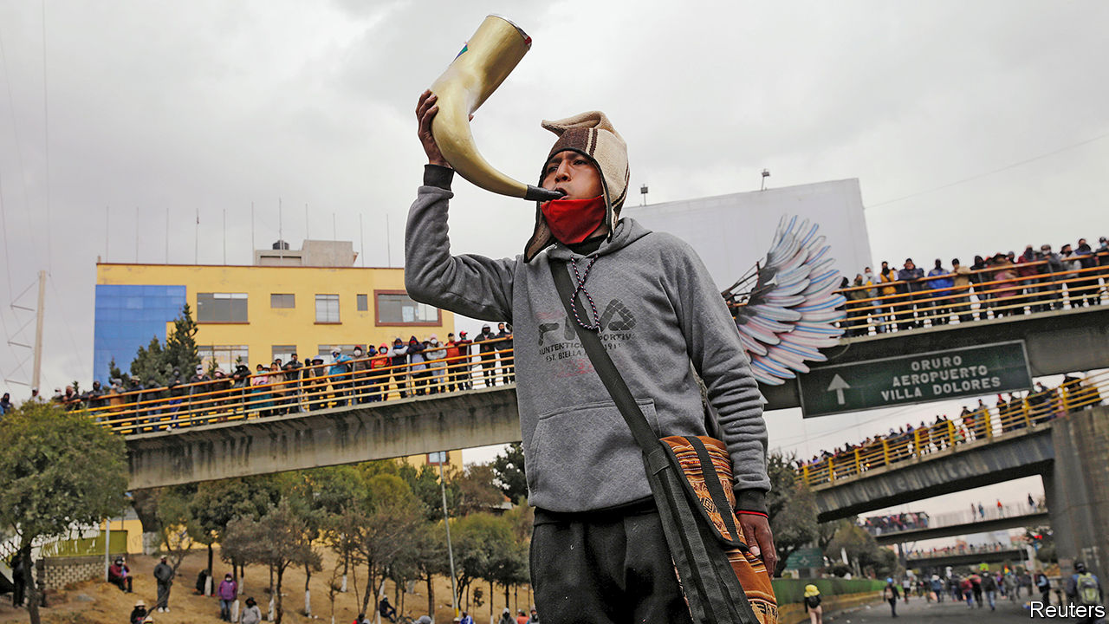

MOST OF THE liquid oxygen in Bolivia comes from Santa Cruz, many miles and many mountains away from other cities. For years doctors urged Evo Morales, the socialist president who was overthrown last November, to boost production in La Paz, the administrative capital, or to equip hospitals with systems to make their own. Supplies were running low even before August 3rd, when supporters of Mr Morales, Bolivia’s first president of indigenous origin, began blockading roads across the country to protest against the second postponement of a general election because of the covid-19 pandemic. Since then, at least 30 people have died because of oxygen shortages, according to the interim government. Protesters say they are letting oxygen trucks and ambulances pass.

“We were already living through a tragedy, but this is a massacre,” says Fernando Romero of the public-health workers’ union. More than 200 doctors and nurses have died from the virus. Personal protective equipment, covid-19 tests and intensive-care beds are in short supply. The precarious health system is a legacy of Mr Morales, who resigned during protests provoked by suspicions that he tried to rig his re-election. But there is plenty of blame to go around. Jeanine Áñez, the right-wing caretaker president, has been an incompetent crisis manager.

The pandemic and the protests are feeding off each other to deepen a crisis that began when Mr Morales ignored the constitution to run for a fourth term. Faith in the legitimacy of Bolivia’s institutions worsens with each month that goes by without an elected president (and with legislators whose mandates have expired). Politically unstable when the pandemic hit, Bolivia is descending into chaos.

The electoral tribunal now says that the vote, a precondition for restoring stability, will take place on October 18th, a year after the original flawed election. But to Ana Suñagua, a student who dragged tyres to help set up a roadblock on a highway outside La Paz, this is another empty promise. Not long after Ms Áñez swore that her only goal was to lead Bolivia through a transition, she announced that she would run for president. Then her government filed charges against members and former officials of the Movement to Socialism (MAS), Mr Morales’s party, for various misdeeds, including sedition. To many, that seemed politically motivated. “Now she’s using the pandemic as an excuse to stay in power,” Ms Suñagua said by phone over the clangs of protesters hitting rocks against highway guardrails and the explosions of tear-gas canisters fired by police.

Bolivia has reported 95,071 covid-19 cases and 3,827 deaths. The real numbers are probably much higher. Last month, police recovered the bodies of 400 people from streets and homes over five days. Four-fifths are thought to have died from covid-19. Patients wait eight to ten days for results from covid-19 tests, which makes them nearly useless. In May the health minister resigned and was arrested on suspicion of corruption involving overpayment for 170 respirators from Spain. He denies wrongdoing.

Even when Ms Áñez does something sensible to contain the pandemic, such as imposing an early lockdown, its effect is blunted by the hostility she provokes. “Everything she says and does is seen as suspicious” because of her candidacy and her attacks on the MAS, says María Teresa Zegada, a sociologist. Bolivians have been stockpiling oxygen canisters at home, exacerbating the oxygen shortage, along with a toxic disinfectant falsely touted as a cure by the MAS-controlled congress. The government has cancelled classes, both in schools and online, for the rest of the year, admitting that it had failed to bring digital teaching to rural pupils.

Like the protests last year, the blockades have begun to take on a life of their own. Demands by indigenous groups and labour unions for prompt elections have evolved into a demand for Ms Áñez’s resignation. Marginalised since Mr Morales left office, they are trying to reclaim their seat at the negotiating table, says Fernando Molina, a journalist. Mr Morales’s enemies are raising the tension. Luis Fernando Camacho, who led last year’s uprising against him and is now a presidential candidate, urged thuggish citizen groups called cívicos to break up the protests. Clashes landed several people in hospital with bullet wounds.

There is a glimmer of hope. After talks mediated by the Catholic church, the European Union and the UN, the government offered to accept a law guaranteeing that elections would not be postponed again. In a tweet from Argentina, where he is in voluntary exile, Mr Morales asked protest leaders to lift the roadblocks, which he had initially encouraged. Anger about oxygen shortages could hurt the MAS at the voting booth, admits Diego Pary, a foreign minister in Mr Morales’s government. Polls suggest that the MAS’s presidential candidate, Luis Arce, a former finance minister, will face Carlos Mesa, a centrist, in a second round. But a fifth of voters are undecided. As The Economist went to press, it was unclear whether protesters would heed Mr Morales’s call to clear the roads. Said one diplomat: “He created a bit of a monster.”■

Editor’s note: Some of our covid-19 coverage is free for readers of The Economist Today, our daily [newsletter](https://my.economist.com/user#newsletter). For more stories and our pandemic tracker, see our [hub](https://www.economist.com/news/2020/03/11/the-economists-coverage-of-the-coronavirus)

This article was downloaded by calibre from <https://www.economist.com/the-americas/2020/08/15/protests-and-the-pandemic-bring-chaos-to-bolivia>

|  |  |  |  |
| --- | --- | --- | --- |
| Previous | Articles | Sections | Next |

|  |  |  |  |
| --- | --- | --- | --- |
| Previous | Articles | Sections | Next |

#### A shortened shelf life

# Canada’s last intact ice shelf breaks up

The fate of a rare “epishelf lake” is unknown

Aug 15th 2020 | OTTAWA

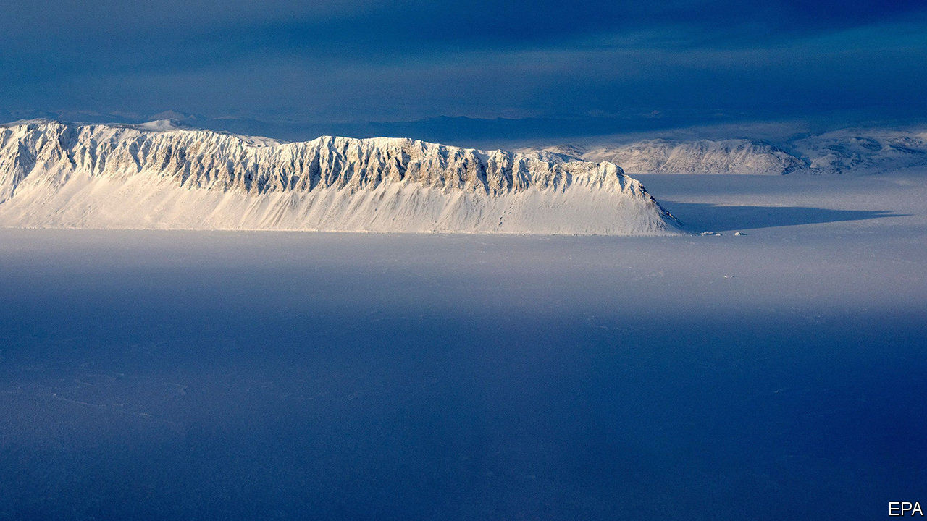

THE LAST whole ice shelf in Canada’s Arctic was no match for this summer’s heatwave. In northern Ellesmere Island temperatures since May have been 5⁰C warmer than the 30-year average of 0-1⁰C. On July 30th-31st, the 80-metre (260-foot) thick Milne ice shelf, which juts out from the island’s north-western coast, split in two. A slab measuring 80 square km (31 square miles), more than 40% of the shelf’s surface area, broke away. By August 3rd the wandering wedge of ice split again. The two strays will now drift on the Beaufort Gyre current as they melt away (see map).

A century ago Ellesmere’s northern coast had one 8,600 square km shelf, a floating island of ice driven onto shore some 4,000 years ago. During the 20th century it broke apart. The Milne shelf is the biggest remaining constituent. Derek Mueller, a geography professor at Carleton University in Ottawa who began documenting the ice shelves’ erosion in 2005, has seen the smaller ones collapse. Until now the Milne shelf had been protected by the high walls of the narrow 30km fjord along which it stretches.

The breakaway block, a frozen chunk of the Arctic Ocean, will not itself raise sea levels. But the shelf’s disappearance would remove a stopper that prevents melting glacial water from seeping into the ocean, notes Luke Copland, a glaciologist at the University of Ottawa.

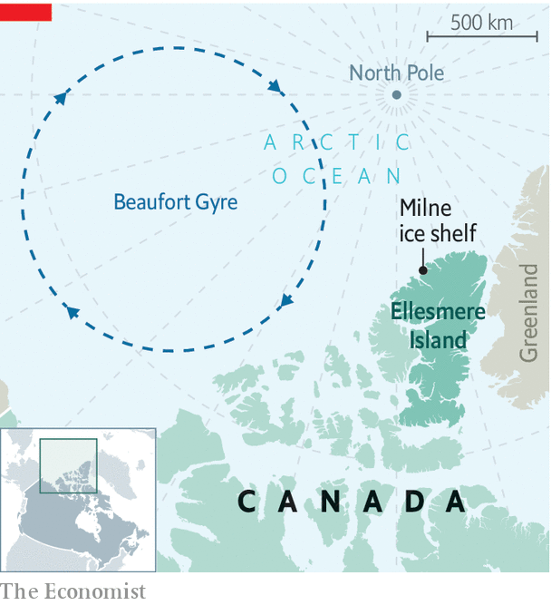

As the ice vanishes, so do ecosystems dependent on it. Mr Mueller must wait until next July to learn the fate of one habitat, a rare epishelf lake. This is a body of ice-covered fresh glacial water trapped between the Milne shelf and the fjord’s wall. Using ice-penetrating radar he and his team discovered a channel consisting of a layer of fresh water atop one of seawater that under some circumstances conducts some of the lake’s water to the ocean. To their surprise, a robot camera lowered into the channel revealed abundant sea life, including anemone, scallops, brittle stars (similar to starfish) and Arctic cod.

Covid-19 obliged Mr Mueller to cancel this summer’s trip to Ellesmere Island. He had hoped to bring back specimens from the channel to figure out, among other things, how long the animals have been there. The shelf’s collapse probably destroyed equipment that checks air and water temperatures. It may also have damaged or drained the epishelf lake and its channel to the sea.

Although the shelves are just fringes along much bigger masses of ice, their disappearance is among the most dramatic signs that the Arctic’s climate is changing profoundly. Since 2007 the mean temperature in summer has flipped from below freezing to above it. The consequences will be felt far beyond the north.

This article was downloaded by calibre from <https://www.economist.com/the-americas/2020/08/15/canadas-last-intact-ice-shelf-breaks-up>

|  |  |  |  |
| --- | --- | --- | --- |
| Previous | Articles | Sections | Next |

|  |  |  |
| --- | --- | --- |
| The Americas | Sections | Europe |

Middle East & Africa

Tunisia: Ten years after the revolution

.

Lebanon after the blast: Taking a fall

.

Ivory Coast: Triumph of the gerontocrats

.

Nigeria: Hair from everywhere

.

Tanzania: Courting the big man

.

|  |  |  |
| --- | --- | --- |
| The Americas | Sections | Europe |

|  |  |  |  |
| --- | --- | --- | --- |
|  | Articles | Sections | Next |

#### Democracy’s growing pains

# In Tunisia, cradle of the Arab spring, protesters want jobs

Nostalgia for the old dictatorship is growing

Aug 13th 2020 | SIDI BOUZID



IN DECEMBER IT will have been ten years since Muhammad Bouazizi, a Tunisian street peddler, set himself on fire. He was protesting against harassment by local police, who often demanded bribes to let him carry on earning his modest living. His death inspired the Arab spring: a series of popular uprisings that toppled autocrats, Tunisia’s included, across the Middle East.

Yet in Bouazizi’s hometown of Sidi Bouzid, deep in the hinterland, few people plan to commemorate him. “He escaped to his maker and left us with this misery,” says Haroun Zawawi, one of several young jobless men sitting near the roundabout where Bouazizi lit the match. On a nearby wall someone has mockingly scrawled “revolution” upside down. “People don’t feel it has improved their lives,” says the city’s MP, Naoufel ElJammali. “There’s nostalgia for dictatorship.”

Tunisia is often praised for being the first Arab country to throw off the yoke of autocracy, and the only one where genuine democracy survives. Elections are still held, the secret police are relatively docile and women participate extensively in public life. But most Tunisians judge the revolution based on the performance of the economy, which has not improved under the new dispensation. Incomes have fallen by a fifth over the past decade; unemployment has been stuck above 15% for years. Powerful unions block reforms. Illegal migration to Europe is up fourfold on last year. Bickering politicians give people little reason to stay.

Tunisia is one of the few countries where more educated people are less likely to find work. So parliament recently passed a law granting jobs to graduates who have been unemployed for a decade. It could not afford to keep that promise, even before covid-19 forced it to lock down the country from March until May. The coronavirus has disrupted important sources of revenue, such as remittances, trade and tourism. The government expects the budget deficit to widen to about 7% of GDP because of the pandemic; the economy is expected to shrink by 6.5% this year.

Tunisia had been in talks with the IMF about a loan, but those were suspended in July, when the prime minister, Elyes Fakhfakh, resigned over allegations of a conflict of interest. His replacement, Hichem Mechichi (Tunisia’s eighth prime minister in ten years), wants to form a technocratic government without political parties. That is, in part, because the parties cannot agree on much. The largest is Ennahda, which is Islamist. Its leader, Rachid Ghannouchi, who is the speaker of parliament, has feuded with Kais Saied, the president, over nominees and power. Mr Ghannouchi himself narrowly survived a confidence vote last month after being accused of exceeding his authority.

Nine years ago Ennahda won Tunisia’s first free election, promising something new. Now its members look tired. Asked what is his biggest achievement, Mr Ghannouchi replies: “Jalusna” (We’re sitting here). Whereas Islamist movements elsewhere have been crushed, Ennahda is still at the forefront of Tunisia’s politics. But critics say it has acquired the traits of the region’s old patriarchies. Mr Ghannouchi, who is 79, has led Ennahda (or its precursor) for 50 years. In 2012 the party decided that he would serve only two more terms as leader, ending this year. Now he wants to change the rules. “He preaches Muslim democracy but rules like a traditional Arab,” says Abdelhamid Jlassi, a former deputy leader of Ennahda who quit in March. The disillusion is spreading. In parliamentary elections last October the party mustered only a third of the votes it won in 2011.

In a presidential election the same month Mr Saied won in a landslide, attracting a huge share of the youth vote. A stiff law lecturer and political outsider, he promised to stamp out corruption. But he also appears hungry for power. The president is in charge of the army, security forces and foreign policy. Mr Saied also wants more say over domestic policy, which parliament claims as its turf. He sparred with Mr Ghannouchi over who should pick the prime minister before choosing Mr Mechichi, a loyal bureaucrat. In the long term Mr Saied would like to move to a system of indirect elections for parliament, with local councils holding more power.

There are some in parliament who seem inclined to do away with democracy altogether. Abir Moussi was a high-ranking official in the party of Zine el-Abidine Ben Ali, the old dictator, and she is nostalgic for the old days. She calls the Arab spring “a spring of ruin”, blaming Ennahda for the upheaval. Like Mr Saied, she is openly homophobic. She now heads the Free Destourian party, which won 16 seats (out of 217) in last year’s elections and led the challenge to Mr Ghannouchi. Members of the middle class who fared better under Ben Ali like her calls to restore the order of pre-revolutionary Tunisia (when Ennahda was outlawed). According to recent polls, she is the country’s most popular politician.

Western diplomats say Tunisia’s democracy has proven surprisingly resilient. Its politics are broadly rooted. Its Islamists have been restrained and conciliatory. There has been very little of the bloodshed that characterised the clash between old and new systems elsewhere in the Arab world. But many Tunisians are less sanguine. Protesters demand jobs—yet make matters worse by blocking oil and phosphate exports. Voter turnout is trending down. Even in the capital of Tunis no big events are planned to mark Bouazizi’s death. Politicians play down the anniversary or, like Ms Moussi, curse it. ■

This article was downloaded by calibre from <https://www.economist.com/middle-east-and-africa/2020/08/13/in-tunisia-cradle-of-the-arab-spring-protesters-want-jobs>

|  |  |  |  |
| --- | --- | --- | --- |
|  | Articles | Sections | Next |

|  |  |  |  |
| --- | --- | --- | --- |
| Previous | Articles | Sections | Next |

#### Taking a fall

# After the blast, Lebanon’s prime minister quits

But real change is yet to come

Aug 15th 2020 | BEIRUT

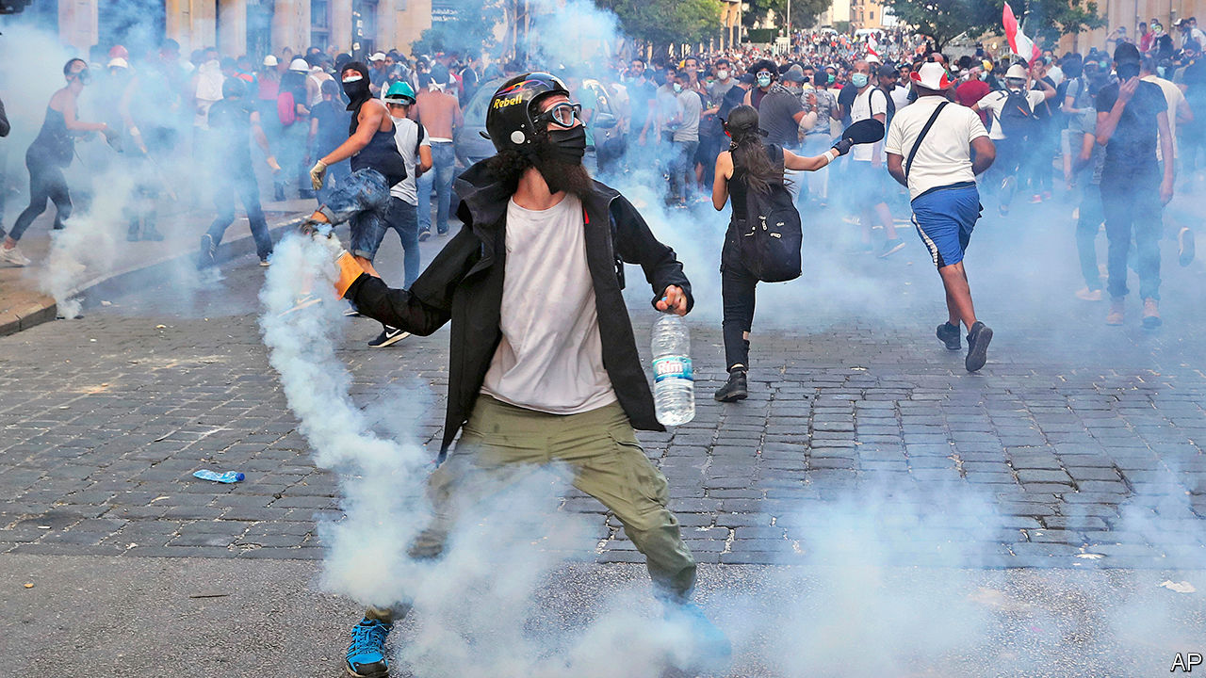

THE DEAD were still being buried, victims treated, rubble cleared. But less than a week after the massive explosion at Beirut’s port on August 4th, which devastated much of the city centre, Lebanon’s leaders had returned to their usual priority: self-preservation. The prime minister, Hassan Diab, announced his resignation six days after the blast. He will linger on as a caretaker until the country’s political leaders choose a replacement. They are determined to escape blame for a disaster of their own making—and, despite the horror, many Lebanese fear they will succeed.

Everyone can agree the blast was caused by stunning negligence. For six years authorities stored at the port 2,750 tonnes of ammonium nitrate, a chemical used in bombs, despite many warnings that this was not a good idea. It may have been heaped in a hangar along with fireworks and other combustible materials. More than 200 people were killed and thousands wounded when the warehouse exploded. An estimated 300,000 people are homeless. Fixing the ruined city could cost $15bn, a quarter of Lebanon’s GDP in 2019.

No one wants to be held responsible for the negligence, however. The judge supervising an investigation is a relative by marriage of Nabih Berri, the parliament’s speaker, whose Amal party wields influence at the port. President Michel Aoun brushes off calls for an international probe. Instead politicians were keen to blame the cabinet, stocked with political outsiders, which took office only in January. Mr Diab beat them to the punch by resigning (under pressure from his own ministers).

His going may not change much. It will not force early elections, which require the approval of Mr Aoun and powerful factions such as Amal and Hizbullah, the Iranian-backed political party and militia. All oppose the idea. Instead it will cause a repeat of what happened in October, when the previous prime minister, Saad Hariri, quit amidst big protests. Lawmakers took two months to agree on a replacement.

Lebanon can ill afford such delay. Apart from the humanitarian crisis, the economy is sinking. The currency has lost 80% of its value since October. Inflation is at 90%. The country defaulted in March. The cabinet put forward a well-received economic plan to reduce debt and clean up the insolvent financial sector, only to back-pedal under pressure from bankers and MPs. Efforts to restructure debt worth perhaps 170% of GDP have stalled: bondholders do not know whom they are negotiating with. Talks with the IMF about a $10bn bail-out have led nowhere.

Yet it may be difficult to find a candidate both acceptable to parliament and willing to take charge of a collapsing country. Some MPs hope to bring back Mr Hariri. The return of a man who led the country for six years, at the helm of governments widely seen as corrupt, is not much of a change. A few other names are being floated, such as Nawaf Salam, a diplomat and judge with a clean reputation. But he would face the same problems as Mr Diab, an academic, who was brought in not to implement reforms but to defuse protests.

While politicians argue, citizens deal with the explosion’s aftermath. Volunteers throng the streets of east Beirut helping to clear debris. Universities have sent teams of engineers to check the structural integrity of damaged buildings. The vast diaspora has contributed money and materials, such as 138 tonnes of glass.

Cleaning up may prove the easy part. To rebuild will require money that Lebanon does not have. A summit on August 9th raised €253m ($297m) for health care, food and other necessities. A bigger aid package will probably require political reforms of the sort Mr Diab failed to implement. The IMF says any bail-out must be linked to changes: a recapitalisation of the banks, with the burden on shareholders and large depositors; a capital-controls law; and an audit of the central bank.

Since August 8th there have been nightly protests near parliament. The mood is furious, but the crowds are smaller than those that gathered last winter. People are preoccupied with survival: rebuilding shattered lives, navigating a brutal economy. The bleak circumstances may help the reviled political class survive as well. ■

This article was downloaded by calibre from <https://www.economist.com/middle-east-and-africa/2020/08/15/after-the-blast-lebanons-prime-minister-quits>

|  |  |  |  |
| --- | --- | --- | --- |
| Previous | Articles | Sections | Next |

|  |  |  |  |
| --- | --- | --- | --- |
| Previous | Articles | Sections | Next |

#### Old actors never die

# Alassane Ouattara gambles on a third term in Ivory Coast

His reputation, and the country’s stability, are at stake

Aug 15th 2020 | NAIROBI

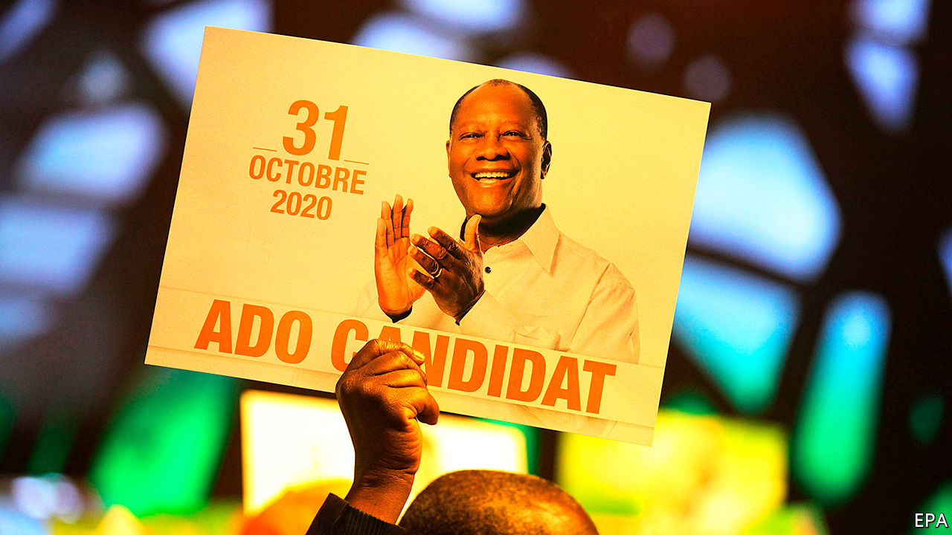

HE IS THE type of leader donors revere. When Alassane Ouattara became president in 2011, Ivory Coast was a ruin, despoiled by two civil wars and a decade of political turmoil. Under his stewardship the country has grown calmer and richer. He has attracted foreign investment, made inroads against corruption and presided over an economy that has grown by an average of 8% a year since he came to power. Ivory Coast was once regarded as the jewel of Francophone Africa. Mr Ouattara (pictured) has restored some of its sparkle.

Such accomplishments aside, the president appeared to have secured his reputation when, after some equivocation, he announced his retirement in March. Though he insisted that a new constitution in 2016 allowed him to seek a third (and fourth) term, the 78-year-old concluded that he would content himself with two—and then hand power to a pliant successor.

In Amadou Gon Coulibaly, Ivory Coast’s prime minister, he seemed to have just the man. Not only had Mr Coulibaly been by his master’s side for 30 years, his loyalty was so fervent that he liked to describe himself as the president’s “disciple”. Mr Coulibaly’s candidacy would prove short-lived, however. On July 8th he died.

So on August 6th, pleading “force majeure”, Mr Ouattara agreed to contest October’s election. Opposition parties have cried foul, saying he has hit his term limit.

Donors will be feeling squeamish, too. It did not help that on the very day Mr Ouattara reversed course, the ruling party in nearby Guinea asked its 82-year-old leader, Alpha Condé, to run for a third term in an election also scheduled for October.

Even so, most outsiders will probably go along with a Ouattara candidacy, if only because the alternatives are unprepossessing. The president’s chief opponent is Henri Konan Bédié, a former president who claims to be the voice of the youth. He is 86. Between 1993 and his overthrow in 1999 his government was venal and inept.

Worse, he stirred up ethnic chauvinism in a quest to prevent Mr Ouattara, a northerner, from running against him and upsetting decades of southern hegemony. The 12 years of upheaval that Ivory Coast suffered between 1999 and 2011 have much to do with Mr Bédié’s pigheadedness.

Even if a third Ouattara term represents the lesser evil (which is unclear), there are still reasons to be anxious. As leaders age they often become more ruthless. Mr Ouattara has already shown an authoritarian streak. Guillaume Soro, a rival presidential candidate and former rebel leader, was sentenced in absentia to 20 years in prison for embezzlement, charges not everyone believes. Nineteen people close to Mr Soro have been in detention since December. Other parties also complain of harassment. More worryingly, Mr Ouattara’s candidacy may increase the chance of violence. Disagreements tend rapidly to take on an ethnic dimension in Ivory Coast, where parties are rooted in ethnicity, not ideology.

Although Mr Ouattara restored stability, he did little to allay the underlying tensions that saw the country split in half when civil war erupted in 2002. Southerners chafe at Mr Ouattara’s perceived favouritism towards the north. “He tried to bring economic responses to political problems,” says Rinaldo Depagne of the International Crisis Group, an NGO based in Brussels. “Reconciliation opportunities have been missed.”

As if there has not been enough drama (“there have been more twists than a Netflix series,” says Mr Depagne), two actors have yet to walk onto the stage. The first is Laurent Gbagbo, another former president. His refusal to concede defeat to Mr Ouattara in 2010 sparked a fresh round of fighting that claimed 3,000 lives. Acquitted of crimes against humanity last year by the International Criminal Court in The Hague, he is plotting his return. Though not a candidate, Mr Gbagbo could sway the outcome should he throw his weight behind Mr Bédié. Mr Ouattara remains the favourite but a combined southern ticket could run him close.

The final actor is the army, which tends to make its entrance late in Ivorian dramas. Some of its officers are former rebels loyal to Mr Soro. Should a contested election trigger violence, some fear that the next act might be a coup d’état. ■

This article was downloaded by calibre from <https://www.economist.com/middle-east-and-africa/2020/08/15/alassane-ouattara-gambles-on-a-third-term-in-ivory-coast>

|  |  |  |  |
| --- | --- | --- | --- |
| Previous | Articles | Sections | Next |

|  |  |  |  |
| --- | --- | --- | --- |
| Previous | Articles | Sections | Next |

#### Thatcherism

# Nigeria’s demand for fancy wigs fuels a global trade

Hair from everywhere adorns Nigerian heads. The posh prefer Peruvian

Aug 15th 2020 | YANGON



“MY OUTFIT FOR the day determines what hair I will be wearing,” says Olayinka Titilope, a Nigerian wigmaker. She has a different peruke for each day of the month. The weather also influences her choice. On cooler days she might opt for long, thick locks. During the summer she tends towards lighter bob-cuts. Ms Titilope hopes her hairdos will inspire the customers who visit her wig gallery in downtown Lagos, Nigeria’s commercial capital. She sells wigs for between $60 and $800. Those at the top end are made of human hair from Cambodia, she says.

Some African feminists argue that to wear a long, straight-haired wig or hair extension is to grovel to Western ideals of beauty. Yet wig-buyers in Nigeria seem to enjoy variety. Sellers advertise hair from everywhere. Brazilian is praised for its sheen and durability; Vietnamese, for its bounce; Mongolian, because it is easy to curl. One seller in Lagos offers “Italian posh hair” which is supposedly odour-free. Whatever the label says, much of the hair really comes from elsewhere, often China, a source some buyers deem downmarket.

It is hard even for the most conscientious hair-traders to trace where their wares came from. Most of the hair that reaches Africa travels via factories in China, where it is sorted and often treated, dyed or curled. Bundles of human hair may be bulked up with horse mane or goat thatch. Chinese locks are sometimes packed into boxes labelled “Peruvian hair”, which is coveted in Nigeria. Responsible shopkeepers must pick a good supplier and hope for the best. Those with fewer scruples rebrand the hair once it arrives.

Demand in Nigeria is huge, but not everyone wants to pay Nigerian tariffs. Benin, a popular route for goods smuggled into its much bigger neighbour, sucked in 11% of the world’s fake-hair imports in 2018—some 50 times what might be expected, given its tiny population. Nigeria itself shipped in more than 3,600 tonnes of hair (including human, animal and synthetic hair, as well as ready-made hair pieces). If even half of that was from human scalps, it would amount to the waist-length locks of more than 10m people. “The demand for hair generally exceeds supply, fuelling an almost constant sense of scarcity,” writes Emma Tarlo in her book “Entanglement: The Secret Lives of Hair”.

In the past decade Myanmar has quadrupled the volume of hair it ships out and is now the world’s fourth-largest exporter. Nay Lin, a hair-trader in the former capital, Yangon, says he knows when the economy is bad because more women turn up at his shop to sell their tresses. “Today I have had ten heads so far,” he says, a lot for one day. A pile of dark bunches glistens on the floor beside him. Clients earn around $18 for their hair, though prices vary according to weight. Most of it gets shipped to China, but he is unsure where it goes after that. Mr Lin exported duck feathers until he discovered that hair was more lucrative.

Some 500km north of Yangon, in the town of Pyawbwe, farmers who once harvested onions and chillies now spend their days unpicking hairballs. These are often gathered by door-to-door collectors, who buy hair from people’s combs and bathroom plugs. Some hairballs arrive in sacks from India and Bangladesh. Workers in Pyawbwe (which has earned the nickname “Hair City”) make about $1.20 a day untangling them and removing lice or white strands. This hair is so common in Chinese factories that it is referred to as “standard hair”. It costs more than the fake stuff, but less than locks cut straight from a head.

“We call that stuff factory trash,” scoffs Ms Titilope, who insists that none of it goes into her products. She does not like using Indian hair, either, because much of it is shorn off pilgrims and some customers think it is cursed. Most Hindus will have their heads shaved at a temple at least once as a symbol of surrendering their egos to Vishnu, a god. The temples sell the tresses. But in Nigeria some believe that snakes have slithered over the hair.

On the streets of Lagos, wigs reflect wealth. Women with silky locks tumbling down their backs stroll past others with coarse, synthetic threads. One of the market’s cheapest wigs resembles a furry black hat. At least those wearing it do not have to fret about where it came from. ■

This article was downloaded by calibre from <https://www.economist.com/middle-east-and-africa/2020/08/15/nigerias-demand-for-fancy-wigs-fuels-a-global-trade>

|  |  |  |  |
| --- | --- | --- | --- |
| Previous | Articles | Sections | Next |

|  |  |  |  |
| --- | --- | --- | --- |
| Previous | Articles | Sections | Next |

#### Courting the big man

# Some Tanzanian judges are bravely ruling against the government

Others seem happy to protect executive power

Aug 15th 2020 |

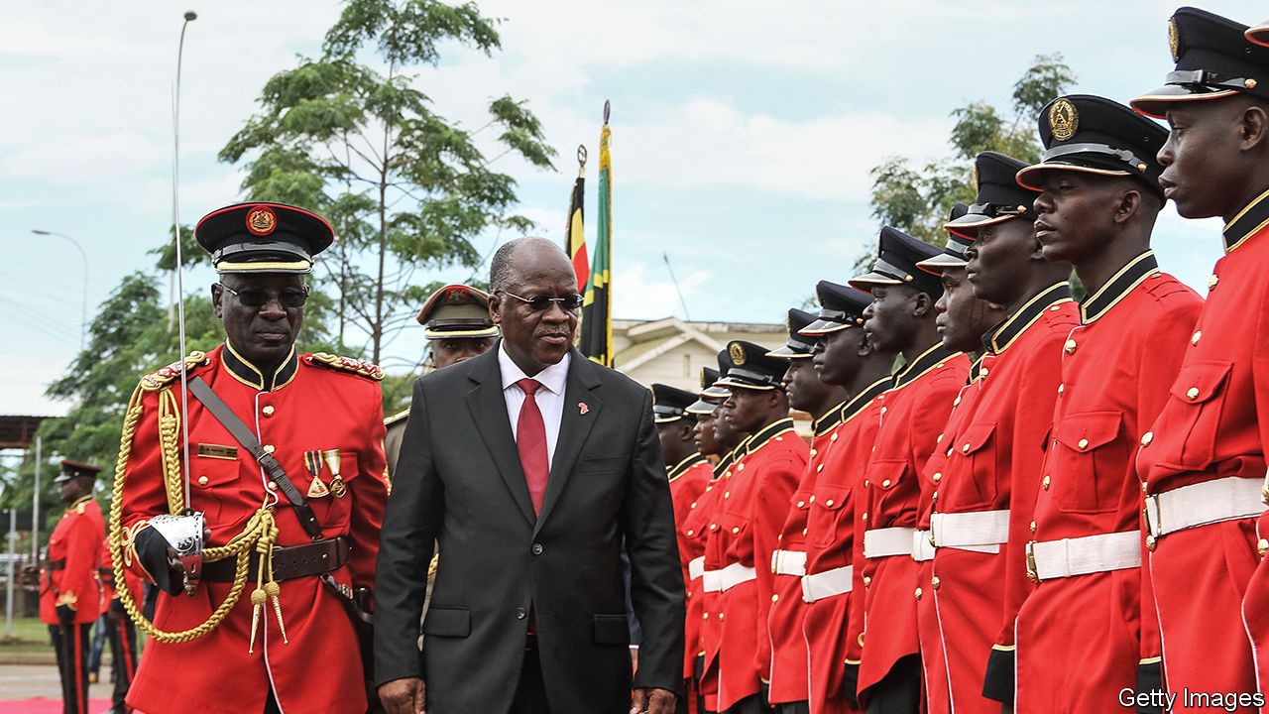

FROM THE parade of politicians and journalists passing through, one might think that the Kisutu Resident Magistrate Court is a high-society haunt. But instead of being offered cocktails and gossip, they are here to be tried (or, at least, denied bail) by a judiciary that looks increasingly like the strong arm of Tanzania’s government.

John Magufuli, Tanzania’s president (pictured), has never been one for democratic niceties such as the separation of powers between the executive, parliament and courts. Since taking office in 2015 he has made it clear that all three should bend to his will. In particular he has attacked the judiciary’s independence, threatening to “take action” against judges who acquitted those accused of crimes (when, at least in his mind, there is clear evidence of guilt).

Parliament, controlled by Mr Magufuli’s CCM party, has limited citizens’ ability to sue over allegedly unconstitutional laws or policies. And last year Tanzania in effect withdrew from the African Court on Human and People’s Rights—an important guardian, with more cases on its docket against Tanzania than any other country.

Given how hard he has tried to control the judiciary, Mr Magufuli must have been gratified when, on August 5th, Tanzania’s highest court gave the constitutional stamp of approval to one of his favourite tactics: charging opponents with offences for which they cannot post bail. Once arrested, defendants pinball endlessly between prison and court, being told at each court appearance that the case against them is not quite ready. Many eventually plead guilty to end the torment. The tactic is used not only against political rivals or critical journalists, but also against executives of companies accused of tax evasion who are ordered to pay arbitrary sums. Fatma Karume, a former head of the Tanganyika Law Society who was suspended from practising law after acting as counsel in a suit against Mr Magufuli, argues that this is legalised extortion. “These people are acting like Henry VII,” she says, referring to a notoriously grabby English king.

Some judges have taken a stand against this repressive tactic. In May the High Court declared that it was unconstitutional to deny people bail automatically, simply because they had been charged with, for instance, money-laundering. The judges said this law impinged on judicial discretion and denied people freedom. But on August 5th the government found a more sympathetic ear at the Court of Appeal, which overturned the ruling.

Demagogues the world over try to control judges. This is made easier in countries such as Tanzania, where the president chooses who sits on the bench. But it is not just the power to appoint judges that matters to Mr Magufuli; he also wants to control the officials who oversee elections.

With Tanzania going to the polls in October, the impartiality of those who will count the votes is particularly important if the result is to be seen as credible. Tanzania’s High Court thought so too last year, when it struck down a law that allowed Mr Magufuli to appoint party hacks as election officials, arguing that it compromised the independence of the electoral commission. Once again Mr Magufuli’s government turned to the Court of Appeal, whose learned judges overturned the ruling, saying that it was “speculative and based on apprehension” to suppose that officers picked by the president might be partisan. Perish the thought. ■

This article was downloaded by calibre from <https://www.economist.com/middle-east-and-africa/2020/08/15/some-tanzanian-judges-are-bravely-ruling-against-the-government>

|  |  |  |  |
| --- | --- | --- | --- |
| Previous | Articles | Sections | Next |

|  |  |  |
| --- | --- | --- |
| Middle East & Africa | Sections | Britain |

Europe

Belarus’s bogus election: The gentle revolution

.

Russia and the Baltics: Hacker alert

.

Germany: The ballooning Bundestag

.

Bike gangs: Sleazy riders

.

Charlemagne: The other villain

.

|  |  |  |
| --- | --- | --- |
| Middle East & Africa | Sections | Britain |

|  |  |  |  |
| --- | --- | --- | --- |
|  | Articles | Sections | Next |

#### A despot wobbles

# After rigging an election, Belarus’s regime beats protesters

The probable true winner has fled. Belarusians are furious

Aug 15th 2020 |

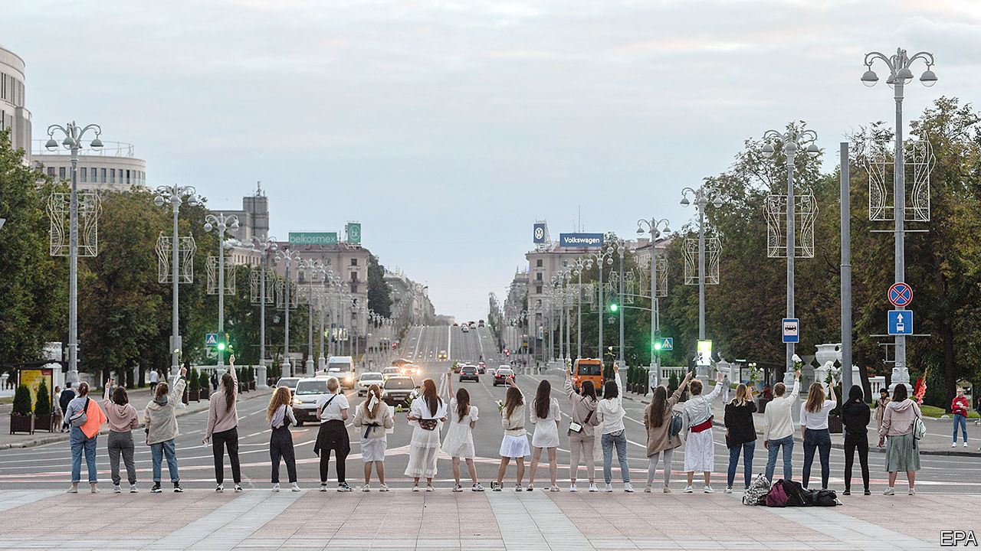

OF ALL THE disturbing sounds and images streaming out of Belarus, it was the broken voice of Svetlana Tikhanovskaya that spoke loudest. If the election on August 9th had been remotely free or fair, Ms Tikhanovskaya, a former English teacher with no political experience, might now be president-elect of her country. During the campaign, she attracted vast, cheering crowds. In the few polling stations where votes were properly observed and counted, she won more than 70% of them.

But Alexander Lukashenko, the dictator who has ruled Belarus since 1994, only three years after it ceased being a Soviet republic, does not give up power easily. The official count proclaimed him the winner, with an implausible 80% of the vote. And it was his 37-year-old rival who ended up making a “concession speech”.

She had gone into the central election commission to lodge a complaint about the obviously bogus result. While inside its walls, she was apparently persuaded to change her mind. She appeared in a short video, recorded inside the commission. Seated on a sofa, her eyes lowered, she read from a piece of paper handed to her by invisible interrogators: “Dear citizens of Belarus, I, Svetlana Tikhanovskaya, thank you for taking part in the presidential elections. The people of Belarus have made their choice…I ask you not to confront the police and not come out onto the streets.”

According to an ally, the video was recorded after she had spent three hours behind closed doors with Mr Lukashenko’s security chiefs. It was released a few hours later, after Ms Tikhanovskaya was driven out of the country by Belarusian security to Lithuania, whose president, Gitanas Nauseda, confirmed that she was now safe. “Not a single person in their right mind would believe that this video was recorded voluntarily,” he noted.

It is not hard to imagine how pressure might have been applied. Her husband, a popular vlogger, was already behind bars. (He was locked up for trying to run against Mr Lukashenko in the election; Ms Tikhanovskaya took his place on the ballot.) Several members of her staff have in effect been taken hostage, too, and her children are in hiding in Lithuania. “God forbid any of you are faced with the choice that I was…No one life is worth what is happening right now. Children are the most important things in our lives,” she said, her eyes welling with tears, in another video she posted on her husband’s website.

If Mr Lukashenko hoped that driving Ms Tikhanovskaya into exile would dampen the protests that greeted his electoral fraud, he was wrong. She was a symbol of resistance, not its leader. Indeed, the only reason she was allowed to register as a candidate instead of her jailed husband was that Mr Lukashenko did not see her as a threat, dismissing her as “poor little thing”.

Repression and hostage-taking have long been among Mr Lukashenko’s favourite methods for keeping a grip on his country. Until recently, there were others. A former collective-farm boss, Mr Lukashenko was swept to power in 1994 promising an end to post-Soviet chaos. Whereas the other former Soviet vassal states rejected the Soviet legacy, he retained Soviet symbols and institutions, including the KGB. He did not privatise large enterprises, and he used Russian subsidies to maintain low, but fairly equal, living standards. That gave him a degree of popularity. In recent years, however, his relationship with Russia has soured, the subsidies have started to dry up, the economy has choked and civil activism has grown, not least because of his bungling response to covid-19. On election day queues to vote against him stretched for several kilometres in places.

So when the electoral commission declared Mr Lukashenko the runaway winner (and gave Ms Tikhanovskaya a ridiculous 9.9% of the vote), gigantic crowds came out to make their true views known. Mr Lukashenko greeted them with stun grenades, tear-gas, rubber bullets and a total internet blackout.

His black-uniformed thugs randomly grabbed protesters and viciously kicked them as they squirmed on the ground. Demonstrators, who communicated by phone, adopted Hong Kong-style tactics of dispersing and regrouping in different parts of the cities, flowing like water. Riot police chased after them, followed them into shops and apartment blocks and pummelled them with batons. They smashed up cars that hooted their horns in solidarity with protesters and dragged their drivers onto the streets. Scores were injured, at least one killed and at least 6,000 were detained. Their relatives gathered outside prisons where they were audibly being beaten up, chanting “Hang in there!” Belarusian women, dressed in white and carrying flowers, marched through Minsk to confront the black-clad goons.

Protesters are calling for a general strike. If they succeed, it will bring the country’s economy to a halt. But this does not mean that Mr Lukashenko’s fall is imminent. In neighbouring Ukraine, scene of revolutions in 2004 and 2014, multiple oligarchic groups jostle for influence. Belarus is far more centralised. Mr Lukashenko so far retains control of the security services and the army, though there have been some reports of police and soldiers refusing to carry out repressive orders. However, terror is of limited use in running the country.

The dictator, who has survived by exploiting rivalry between Russia and the West, is in a weak position now. Liberalising would certainly cost him his job. Cracking down even harder, with Russia’s blessing, would turn him into Moscow’s supplicant. And although Vladimir Putin, Russia’s president, has covered up for him so far, there is no love lost between the two. Mr Lukashenko may hope for a rescue line from China’s Xi Jinping, an old patron who was the first to congratulate him on his victory. But there is one constituency Mr Lukashenko can no longer turn to: the Belarusian people. They have not yet lost him, but he has lost them. ■

This article was downloaded by calibre from <https://www.economist.com/europe/2020/08/15/after-rigging-an-election-belaruss-regime-beats-protesters>

|  |  |  |  |
| --- | --- | --- | --- |
|  | Articles | Sections | Next |

|  |  |  |  |
| --- | --- | --- | --- |
| Previous | Articles | Sections | Next |

#### Hacker alert

# Why the Baltic states are reconfiguring their electric grids

They fear a Russian shutdown

Aug 15th 2020 | VILNIUS

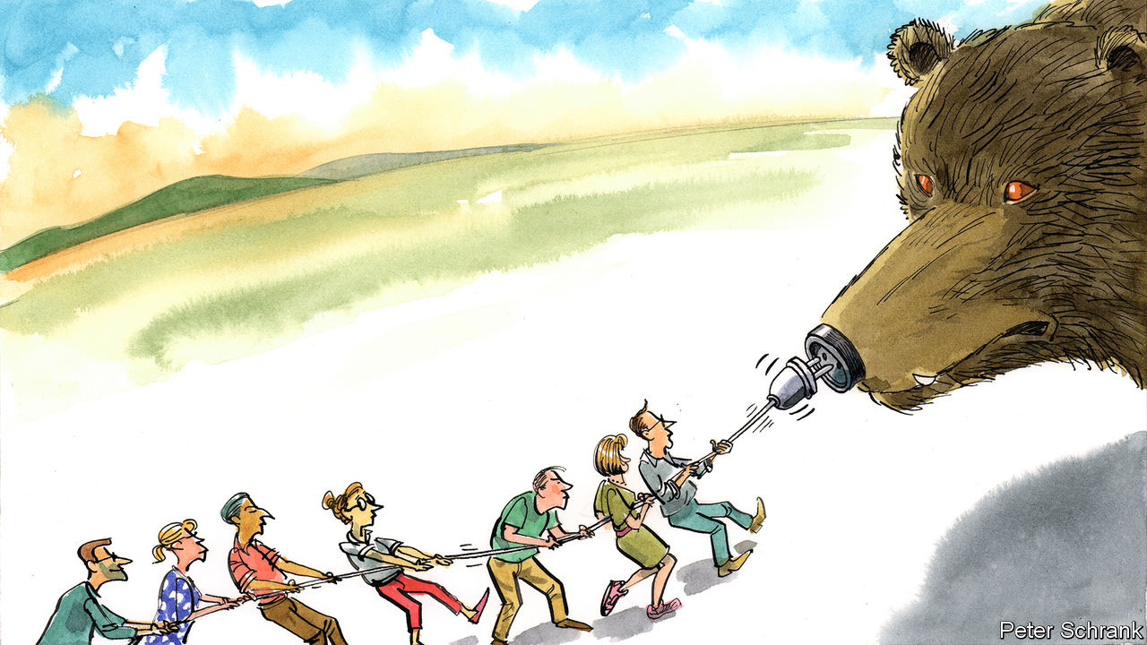

IT DOESN’T SOUND dramatic. Technicians in the Baltic countries of Estonia, Latvia and Lithuania are preparing to change the frequency of their electric grids. This will involve desynchronising from a regional power system called IPS/UPS to allow synchronisation with another one, the Continental Synchronous Area. But look closer, and the switch is part of a contest that pits democratic Europe against autocratic Russia and its tinpot ally Belarus.

As a legacy of the Baltic states’ past as involuntary members of the Soviet Union, the mains frequency of their IPS/UPS power system is controlled from Moscow. This means that Russia’s regime could switch off the Baltics’ power for the better part of a dark and possibly cold week, perhaps longer, while Baltic operators scrambled to restore power with local means. The first three days alone of such a blackout would cost the Baltics €2.3bn ($2.7bn) in lost output, says Taavi Veskimagi, boss of Elering, Estonia’s grid operator. Deaths and instability could add to the toll, especially if meddling took place during a pandemic.

Russia has not explicitly threatened a Baltic blackout. The Kremlin has, however, occasionally cut off hydrocarbon exports, just to remind eastern Europeans what’s what. Russia could add grid power to its “strategic coercion” repertoire, especially if political upheaval led its leaders to seek support by manufacturing a crisis abroad, says Tomas Jermalavicius, formerly a planner at Lithuania’s defence ministry.

A big outage in Latvia on June 9th concentrated minds. Nothing indicates that the central dispatch office in Moscow was behind it. Even so, authorities there, says Mr Jermalavicius, “just sat on their hands and watched” instead of stepping in to prevent more cascading blackouts. (An emergency inflow from Poland saved the day.) At the least, then, Russia appears disinclined to help in a pinch. So the Baltic states must synchronise as quickly as possible with Europe, a “trusted area of high standards and legal norms”, says Mr Jermalavicius, now head of studies at the International Centre for Defence and Security, a think-tank in Tallinn, Estonia’s capital.

Hoping to reduce this threat to its north-eastern flank, the EU is expected to foot three-quarters of the project’s whopping cost of €1.6bn. America is also chipping in. Its departments of energy, state and defence, as well as the CIA, are providing money, kit and expertise. Pro-Kremlin propaganda urging people in the three states to oppose the grid reconfiguration has failed to gain traction. Still, the project will not be complete until 2025.

Baltic strategists have long taken comfort in an aspect of the regional power system’s design. Were the Kremlin to trigger a blackout in the Baltic states, power would also go out in areas of Belarus and western Russia due to the synchronous cross-border connections. But this restraint on the Kremlin’s options is slipping away. Russia is rapidly reconfiguring and upgrading its grid in a way that will insulate itself and Belarus if the Baltic states go dark.

A big recent development concerns Kaliningrad, a heavily militarised Russian exclave detached from the mainland and sandwiched between Lithuania and Poland. Edvinas Kerza, a former vice-minister of defence, says that Lithuanian intelligence has determined that last autumn Kaliningrad’s technicians achieved the ability to operate their grid even if power is down in the Baltic states. Mainland Russia will probably be insulated from any Baltic blackout by some time next year. That is well before the region will be ready to pair with the Continental Synchronous Area.

Until then, a quiet but high-stakes race is on. The Baltic states are upgrading their infrastructure to shorten the time that a locally managed grid reboot would take, says Zygimantas Vaiciunas, Lithuania’s energy minister. Thanks in part to EU monies that have already been allocated, recent progress in Lithuania has probably prevented any shutdown from becoming a national disaster, he says. If a kill switch were to be flipped in Moscow today, Mr Vaiciunas reckons that Lithuania could restore its grid in four days or less. That could still make for a pretty chilly episode. ■

This article was downloaded by calibre from <https://www.economist.com/europe/2020/08/15/why-the-baltic-states-are-reconfiguring-their-electric-grids>

|  |  |  |  |
| --- | --- | --- | --- |
| Previous | Articles | Sections | Next |

|  |  |  |  |
| --- | --- | --- | --- |
| Previous | Articles | Sections | Next |

#### The XXL Bundestag

# Germany’s parliament is bursting at the seams. It may get bigger

Mathematicians have been asked to help devise a better voting system, but MPs can’t agree on change

Aug 15th 2020 | BERLIN

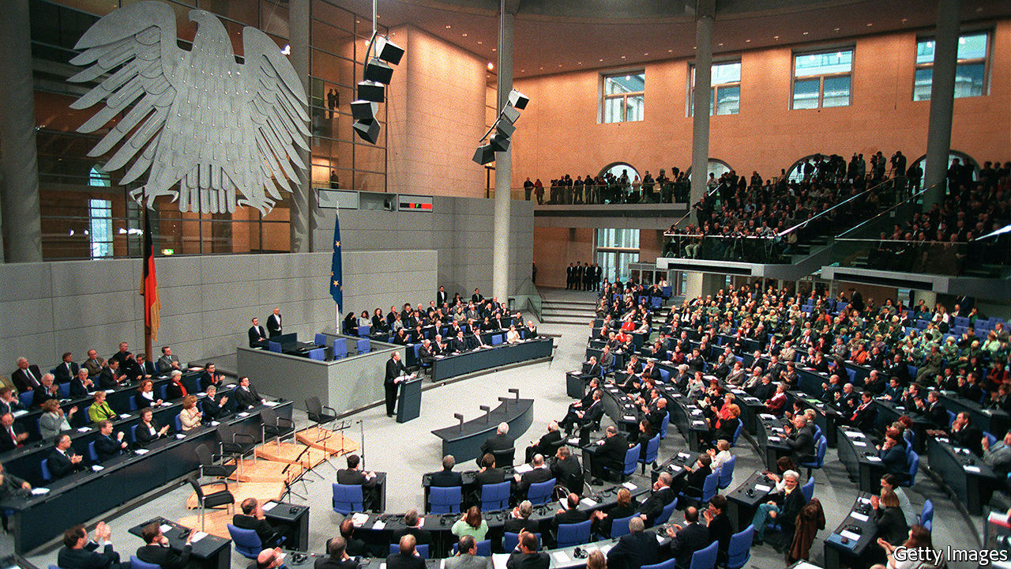

NO VOTING SYSTEM is flawless, as any political-science student can tell you. Britain’s first-past-the-post method can give a thumping majority to a party that wins far less than half the vote. Ultra-proportional systems, as in the Netherlands, lead to fragmented chambers full of fringe parties, with no local links, devoted to animal rights or the elderly. Germany’s “mixed-member proportional” system is supposed to offer the best of both worlds. Unfortunately its size has begun to matter.

Of the 598 seats Germany’s electoral law reserves to the Bundestag (the upper-house Bundesrat comprises state politicians), half are for directly elected constituency MPs, and the rest are for candidates taken from party lists along proportional lines. At general elections Germans therefore cast two votes: one for a local MP, and one for a party. The second vote determines the relative strength of parties in parliament. If some win more constituency seats than their share of that vote would entitle them to, to preserve proportionality others are compensated with party-list seats. This means the size of the Bundestag can go only one way: up.

The problem has grown acute as Germany’s party system has fragmented. For big parties, the gap between their number of constituency seats and their shrinking overall vote share has grown, meaning more compensatory seats are needed. The result is what Germans call an “XXL Bundestag”. The 709 MPs yielded at the last election, in 2017, make the Bundestag the world’s largest elected chamber (outnumbered only by China’s rubber-stamp congress and Britain’s appointed House of Lords). Some fear next year’s vote could produce close to 800. Adjusted for population, the number looks less dramatic. But in a federal country like Germany MPs have less to do; the 16 state parliaments have a further 1,868 members between them.

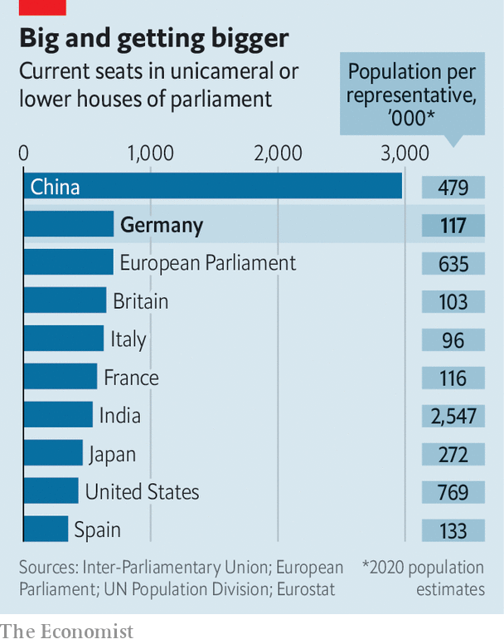

All this squeezes office space, as well as the Bundestag’s budget, which may exceed €1bn ($1.2bn) this year. Parliamentary committees have grown unwieldy. Citizens struggle to understand the link between their vote and their outsize parliament. The problems will grow “severe” if the chamber has to accommodate more than 750 members next year, warns Stephan Thomae, an MP for the liberal Free Democrats who has pushed for a change to Germany’s electoral law in response.

Many have tried. Constitutional lawyers, non-profits and even mathematicians have been drafted to provide solutions. Yet every attempt to shrink the Bundestag has gone nowhere, for every party fears it stands to lose from one or other possible remedy. The most recent plan, pushed by opposition parties, flopped before the summer recess. Attempts to revise the law before next year’s election now look doomed. An XXXL Bundestag looms. ■

This article was downloaded by calibre from <https://www.economist.com/europe/2020/08/15/germanys-parliament-is-bursting-at-the-seams-it-may-get-bigger>

|  |  |  |  |
| --- | --- | --- | --- |
| Previous | Articles | Sections | Next |

|  |  |  |  |
| --- | --- | --- | --- |
| Previous | Articles | Sections | Next |

#### Sleazy riders

# Drugs, torture and turf war: Europe’s biker gangs turn nasty

Some 99% of bikers are law-abiding, say the “one-percenters”

Aug 15th 2020 | AMSTERDAM



IN JUNE DUTCH police cracked open a shipping container on a farm and found it had been converted into a torture chamber, with walls covered in sound insulation and a dentist’s chair equipped with arm and leg restraints, as well as handcuffs, hacksaws and pliers. They were tipped off by an informant inside Caloh Wagoh, a Dutch motorcycle gang whose leader, “Keylow”, had been arrested and charged with running a murder-for-hire scheme. Prosecutors say a Moroccan-Dutch drug kingpin hired Caloh Wagoh to carry out 11 hits, five of which were executed. Keylow denies any involvement. When police asked him why hundreds of texts on his mobile phone referred to hit jobs, he said he was making a film on the subject.

The European drug trade has long-standing connections to outlaw motorcycle gangs. (These often call themselves “one-percenters”, a wry reference to an apocryphal statement that 99% of motorcycle club members are law-abiding citizens.) The Hells Angels and Bandidos gangs, formed in America, began opening chapters in Europe in the 1970s. They soon controlled much of the drug trade in cities like Copenhagen and Malmo.

In the so-called Great Nordic Biker War of the 1990s, these gangs and their allies went after each other with assault rifles, grenades and anti-tank weapons stolen from army bases. From the late 2000s, northern European one-percenters came into conflict with a new rival: street gangs with ethnic-immigrant backgrounds. In Copenhagen, the Hells Angels and Bandidos ceded territory to gangs like Brothas and Loyal to Familia.

In the Netherlands the government has attempted to ban the Hells Angels and Bandidos as criminal organisations. But they already faced competition from new biker gangs with a multicultural flavour, such as Satudarah, which started in the Moluccan community, and No Surrender, a largely Moroccan-Dutch crew. Caloh Wagoh, which has many Surinamese-Dutch members, is a fusion between members of a motorcycle gang called Trailer Trash and a Dutch branch of the Crips, a Los Angeles gang.

One-percenters are involved in the Dutch drug trade, though they do not dominate it. That honour, say police, goes to Ridouan Tagih, the man accused of hiring Keylow. After Panorama, a Dutch men’s magazine, published articles about Caloh Wagoh in 2018, its office was hit by an anti-tank missile.

This article was downloaded by calibre from <https://www.economist.com/europe/2020/08/15/drugs-torture-and-turf-war-europes-biker-gangs-turn-nasty>

|  |  |  |  |
| --- | --- | --- | --- |
| Previous | Articles | Sections | Next |

|  |  |  |  |
| --- | --- | --- | --- |
| Previous | Articles | Sections | Next |

#### Charlemagne

# Fethullah Gulen shares blame for Turkey’s plight

The exiled imam did much to cripple democracy

Aug 15th 2020 |

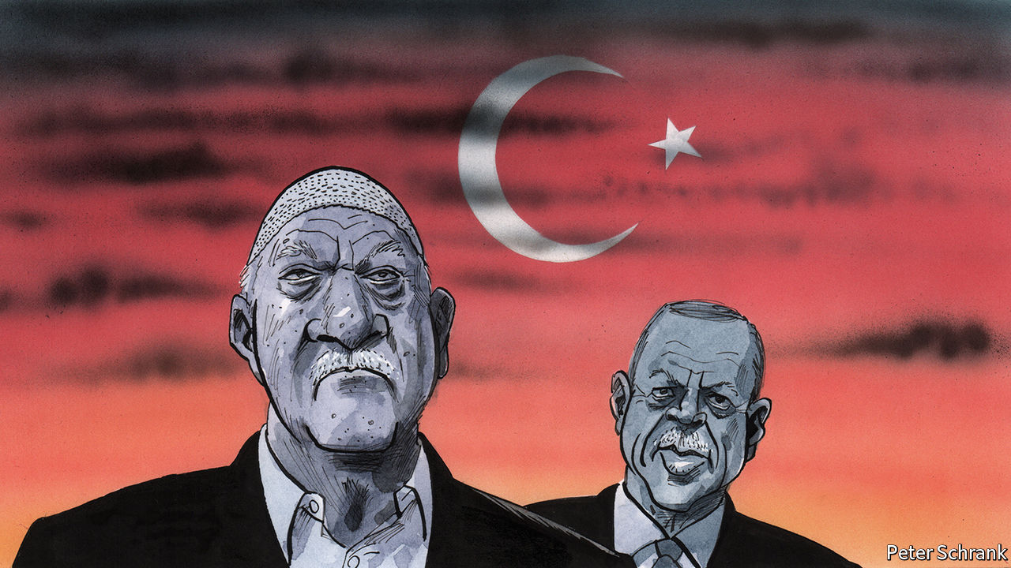

YOU MIGHT think that by now Turkey had run out of handcuffs. But although the wave of arrests related to the bizarre coup attempt that rocked the country in the summer of 2016 has certainly slowed, it has not stopped. Every week seems to bring a new round-up of suspected members of the Gulen community, or cemaat, the Islamist movement that President Recep Tayyip Erdogan blames for the coup. At least 41 people, many of them soldiers, were detained on July 27th. Warrants for over two dozen others were issued last week.

Nearly 600,000 people, most of them suspected Gulenists, have been investigated since the coup; nearly 100,000 have been arrested. Most had only tenuous links to the movement, such as having an account at a Gulenist bank. Some appear to have been tortured in captivity. But while there is sympathy among Turks for individual victims of Mr Erdogan’s purges, there is practically none for the cemaat as a whole, and even less for its leader, Fethullah Gulen, an ageing imam living in exile in Pennsylvania. Ask almost anyone in Turkey, including Mr Erdogan’s most bitter foes, and you will hear that compared with Mr Gulen, Turkey’s leader is the lesser of two evils. Mr Erdogan is an autocrat and a bully. But no one helped him cripple Turkey’s democracy more than Mr Gulen and his sect.

The movement is a tough nut to crack. From the 1970s onwards, it attracted hundreds of thousands of followers, drawn mostly from among the poor and devout students who gravitated to its prep schools and dorms. After the end of the cold war, it began to market itself as the torchbearer of an enlightened Islam, setting up foundations abroad and winning a circle of Western well-wishers. But it was only when Mr Erdogan and his Justice and Development party came to power in 2002 that it started to flourish. Its sympathisers had previously trickled into Turkey’s bureaucracy. With Mr Erdogan’s encouragement, they took over entire institutions. (By one estimate, Gulenists held 30% of top jobs in the judiciary and 50% in the police.) With his approval, they orchestrated the arrests of thousands of Kurdish activists, army officers, secular types and journalists. “The Gulenists played a decisive role in enabling Erdogan to consolidate power,” says Gareth Jenkins, a security analyst.

The Gulenists’ success was their undoing. By the early 2010s, they had amassed enough power to pose a threat to Mr Erdogan. “There was a time when they virtually ruled Turkey,” says Gokhan Bacik, an academic formerly close to the movement, now living in exile. They overreached by trying to torpedo peace talks with Kurdish insurgents, going after Turkey’s intelligence chief in 2012, and implicating Mr Erdogan in a corruption scandal the year after. Turkey’s strongman responded by declaring war on the cemaat and removing its loyalists from the bureaucracy. The purges went into overdrive after the coup attempt.

Much about the night of the putsch remains unclear. Some 250 people died in what resembled an army mutiny accompanied by a series of terror attacks more than a traditional coup. The official version, in which Gulenist sleeper cells in the armed forces awoke to take over the country all on their own, seems as watertight as a teabag. To this day, Turkey’s government has not produced evidence of what the plotters planned to do once they seized power. The coup itself appears to have been the work of a small but diverse coalition. Yet there is no doubt that the Gulenists played a big part. At least some of the officers who directed the violence turned out to be graduates of the Gulen system. Two of the civilians involved appear to have seen Mr Gulen in America only days earlier. Analysts agree there is no chance Gulenist operatives would have acted without their leader’s approval. Mr Gulen denies involvement.

Mr Erdogan and his ministers fume that foreigners do not appreciate the damage the Gulenists inflicted on Turkey. They are partly right. “In many European countries, people think that because Mr Erdogan is a dictator, anyone opposed to him must be a democrat,” says Bayram Balci, head of the French Institute of Anatolian Studies in Istanbul. That kind of logic plays into Mr Gulen’s hands and lets him masquerade as a dissident.

No one, however, is worse placed to preach about the dangers of Gulenism than Mr Erdogan, whose government was once joined at the hip with the movement. By locking up everyone linked to it, including lawyers, teachers and charity workers, Mr Erdogan has ditched the rule of law in favour of a vendetta. He has not helped his case by accusing nearly all of his other opponents of treason or terror. “People [in America] might be more receptive to Erdogan’s side of the story if he had more credibility,” says Gonul Tol of the Middle East Institute, a Washington think-tank. “But he has none.”

## Going but not gone

Today the cemaat seems to be a spent force. Inside Turkey, it has no room to breathe. Because it alienated almost every part of Turkish society, there is no one left to defend it, aside from a handful of human-rights activists. Abroad, the Gulenists are better off, but still on the back foot. Mr Erdogan has successfully pressed a few countries in Africa and Central Asia to sever links with Gulen schools and businesses. Funding has begun to dry up. Long-standing followers are leaving in droves and new ones are almost impossible to recruit. Mr Gulen commands blind obedience. His deputies, says Mr Bacik, are all theologians with no experience outside the group. There are no women in positions of power. For a movement that portrays itself as a modernising force in Islam, this is not a good look. Mr Gulen himself is approaching 80 and in poor health. When he dies, what remains of the cemaat is likely to crumble.

Its legacy in Turkey has been grim. “They have as much responsibility as Erdogan for the state of the country,” says Ms Tol. Much of the outside world seems to think there is only one villain in the story of Turkey’s descent into autocracy. Turks will tell you there is room for more. ■

This article was downloaded by calibre from <https://www.economist.com/europe/2020/08/15/fethullah-gulen-shares-blame-for-turkeys-plight>

|  |  |  |  |
| --- | --- | --- | --- |
| Previous | Articles | Sections | Next |

|  |  |  |
| --- | --- | --- |
| Europe | Sections | International |

Britain

Economic policy: A grey and stagnant land

.

GDP: Crash

.

Exam results: A level playing field?

.

Migrants in dinghies: A rather small invasion

.

Fighting covid-19: Local heroes

.

Farm labour: Ripe for reform

.

Feminising the Foreign Office: Who runs the world?

.

Bagehot: A certain idea of Britain

.

|  |  |  |
| --- | --- | --- |
| Europe | Sections | International |

|  |  |  |  |
| --- | --- | --- | --- |
|  | Articles | Sections | Next |

#### The economy

# Why Boris Johnson’s grey army is bad for growth

The Conservative Party relies on old voters. That’s bad news for the economy.

Aug 15th 2020 |

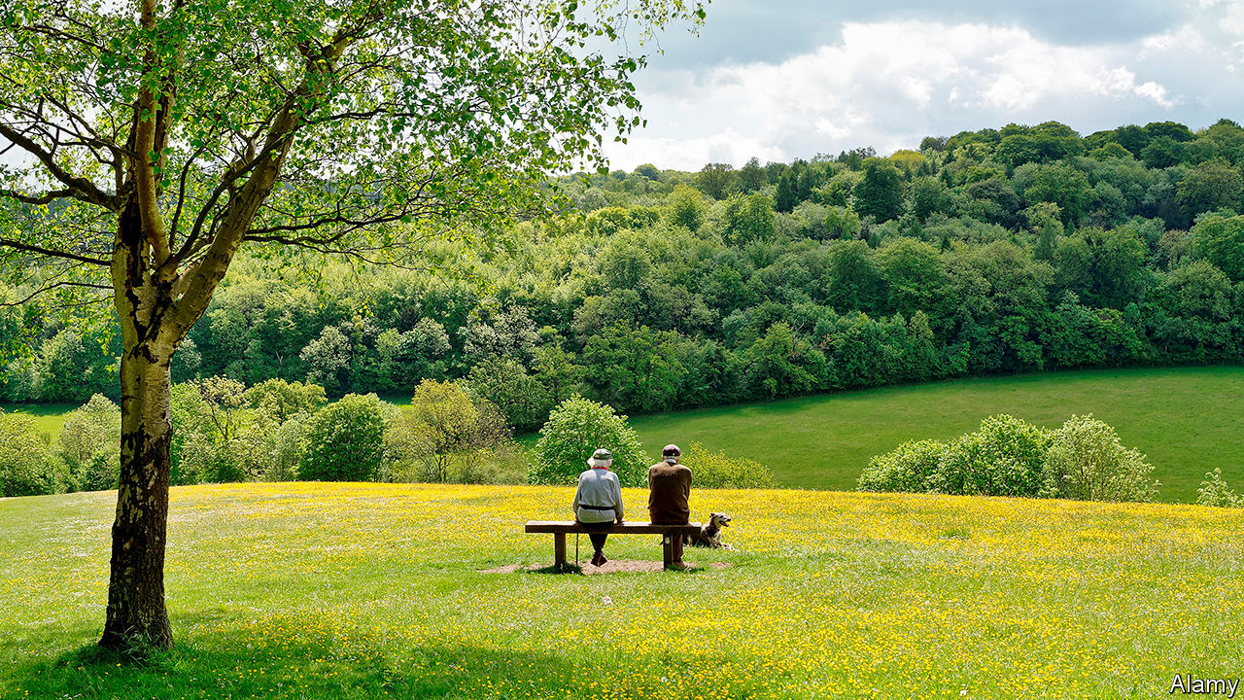

CLIVE THINKS immigration has overwhelmed the health service. Pat says her town is swamped by new housing. Elizabeth voted for Brexit, but doesn’t want a trade deal with America, “especially the pharmaceutical side of it, Trump and his chickens.” So did Kathleen, but she now thinks a no-deal exit will mean shortages of groceries and medicines. “I’m prepared to do without stuff,” she says.

They are part of a focus group organised by NatCen, a social-research institute, studying “affluent eurosceptics”, a Conservative-leaning middle-class tribe. Nearly half the group is over retirement age. They lament their children’s europhilia, their grandchildren’s idleness and the decline of Britain’s industrial prowess. Yet the thread that links their views is a preference for policies that harm growth, and an aversion to those which boost it.

Older voters have long leaned Tory, but in the past decade politics has polarised dramatically along age lines. In 2019, 36% of Tory voters were pensioners, up from 29% in 2010, when the Tories came to power; 56% were over 55.

The Conservative Party used to worry about being hip. In 1977, a 16-year-old William Hague told its conference that it faced extinction without first-time voters. Now, he notes, the party has increased its share of the vote in six successive elections without their help. John Major got a bigger slice of the under-35s when he lost in 1997 than Boris Johnson did when he won in 2019.

The Tories still worship at the Church of Thatcher. Boris Johnson preaches deregulation, globalisation and wealth-creation with the same gusto as his predecessors. But the ageing congregation mumbles through the prayers. Growth means spoilt views and social change. Age is a solid predictor of attitudes to Brexit, a process which has seen constitutional principles repeatedly put before cold economic interest. The old are more likely to oppose immigration and to prioritise spending on health care over education.

Onward, a think-tank close to the government, reported last year that the old are especially hostile to the “drivers of prosperity in the modern liberal market economy”. They are more likely to agree with statements such as “globalisation has not benefited most people”, “jobs and wages have been made worse by technological change” and “more people living in cities has made society worse.”

Older voters’ indifference to growth is understandable, for they have less skin in the growth game. Vincenzo Atella and Lorenzo Carbonari of Tor Vergata University of Rome argue that some European countries underinvest in education and technology because “impatient” old elites don’t expect to reap the long-run benefits. Why pay for a railway that you won’t be alive to ride? Working people feel every bump in the economy, but British pensioners’ well-being is decoupled from the economic cycle in part by a “triple lock”: state pensions rise by the highest of wage growth, inflation or 2.5%. Pensioners’ incomes grew by 20.6% in 2009-20, against 5.4% for working-age people. They worry less about paying rent or a mortgage: 46% of Mr Johnson’s voters own their homes outright.

Freeing pensioners from fear of poverty is a worthy policy. But wealth and security leave older voters insulated from the economic consequences of their cultural preferences, argue Nick Pearce and Joe Chrisp of the University of Bath. “You have a group who are able to vote on things like Brexit without regard to the immediate economic consequences that face somebody in work,” says Mr Pearce. An ex-cabinet minister from the Home Counties agrees. “The economic arguments did not resonate with people whose well-being is not dependent on the performance of the economy,” he says. “In my constituency people would say to me, ‘What do we need growth for?’”

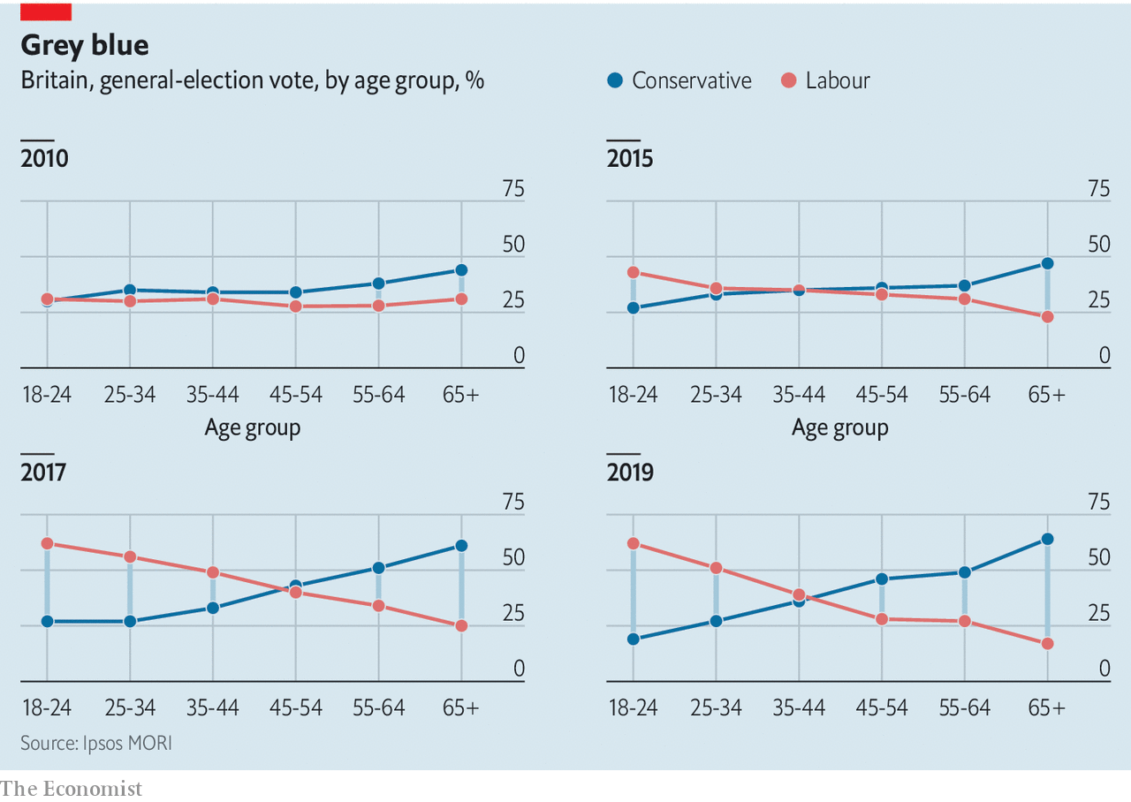

Mr Johnson has shown some willingness to confront his voters. Pensioners oppose his decision to support High Speed 2, a new rail line, by more than three to one, while young people were evenly split on it. One of his main policy planks, “levelling up”, implies more growth in poorer areas, but this barely challenges the beliefs of Tory-voting nimbies in the south-east. As far as they are concerned, growth in other people’s back gardens is fine. Mr Johnson’s reforms to the planning system, announced on August 6th, might have threatened their back gardens, but concessions to nimbies ensure that the green belt, which prevents prosperous towns and cities from expanding, remains protected.

Mr Johnson’s plan to offset the costs of Brexit by making Britain a nimbler, globetrotting place is not popular among the old. A trade deal with America will require loosening food regulations, to which pensioners are particularly hostile. Mr Johnson calls himself a Sinophile, but his MPs have pushed him into banning Huawei, a telecoms company, from Britain’s fifth-generation (5G) mobile network on security grounds. Older voters, unlike the young, overwhelmingly support the move even if it harms trade with Beijing.

Yet Brexit itself, the policy that brought Mr Johnson to power, is overwhelmingly popular with the old and unpopular with the young. Government spending over the past decade has greatly favoured the NHS, which the old use much more than the young do, over education: health spending has risen from 6% of GDP to 7% over a decade, while education spending has fallen from 6% to 4%. Mr Johnson continues to prioritise the NHS, while his plans for child care, a productivity-booster as well as a help for young parents, are stingy.

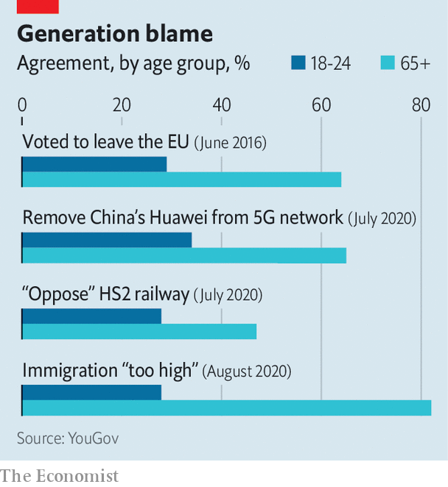

Coronavirus brings new tensions. The health costs have fallen on the old, and the economic toll on the young. Rishi Sunak, the chancellor, will need to suspend at least temporarily the triple lock when wages rebound next year. At some point, taxes must rise or spending fall. Mr Johnson is averse to austerity, and hiking taxes on wages and profits would be unwise in a recession. The Social Market Foundation, a think-tank, argues for higher taxes on property. They would hit minted pensioners the hardest.

Mr Johnson’s choice will reveal whether he wants to appeal to his base or reach out beyond it. Lord Hague thinks the Tories can thrive on an ever-replenishing supply of old people. But David Willetts, a former Tory minister and author of “The Pinch”, a book on intergenerational fairness, argues that “strategically appealing to the older generation of Tory voters at the expense of the young is not a great long-term bet.” The next generation of old people will be less insulated than this one against the impact of a sluggish economy.

Increasingly, Britain is governed in the interests of voters with an insatiable demand for health care and pensions, while a sluggish economy struggles to fund them. But it would take a brave Tory to make the grey voter pay more tax. “Everything I’ve got I’ve earned,” says Kathleen. “The generation under me just seems to expect everything to be given to them.”■

This article was downloaded by calibre from <https://www.economist.com/britain/2020/08/15/why-boris-johnsons-grey-army-is-bad-for-growth>

|  |  |  |  |
| --- | --- | --- | --- |
|  | Articles | Sections | Next |

|  |  |  |  |
| --- | --- | --- | --- |
| Previous | Articles | Sections | Next |

#### The economy

# Britain’s disastrous GDP figures

The economy has been particularly badly hit by the covid-19 recession

Aug 15th 2020 |

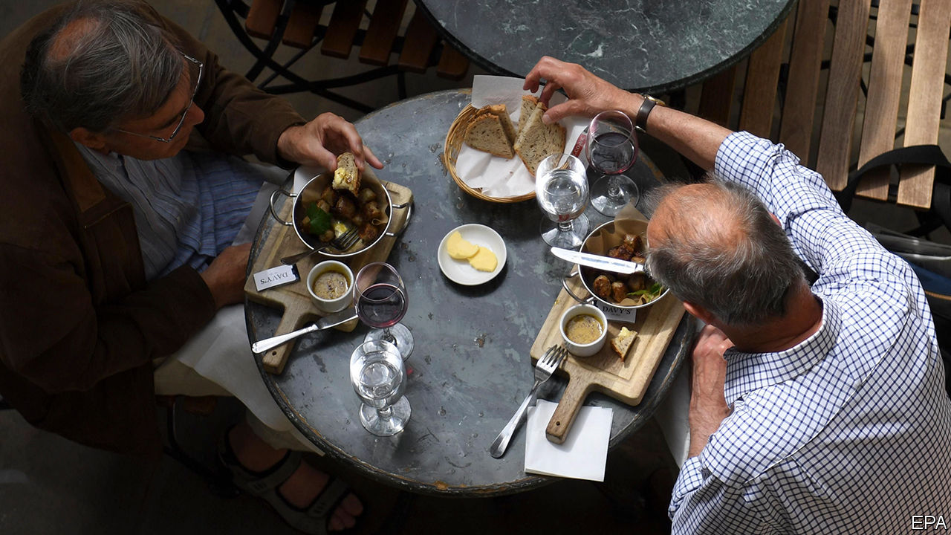

WHEN BORIS JOHNSON opened the year with a video message promising an “exhilarating decade of growth, prosperity and opportunity”, his supporters were quick to predict a new “roaring 20s”. They were not so wide of the mark. This year has opened with Britain’s deepest recession since the post-first-world-war crash of 1919 and 1920.

A later lockdown than in many other rich countries led to better numbers in the first quarter of 2020, but the 20.4% GDP contraction in the second quarter was the deepest on record. Over the first half of the year as a whole GDP shrank by 22.1%. The length of the lockdown—restaurants and pubs reopened in July, later than in most of the rest of Europe—was the primary cause. School closures made life especially difficult for households in which both parents work, and Britain has a lot of those. Lockdown’s impact on data collection probably means these estimates are less reliable than usual, but the broad picture is clear.

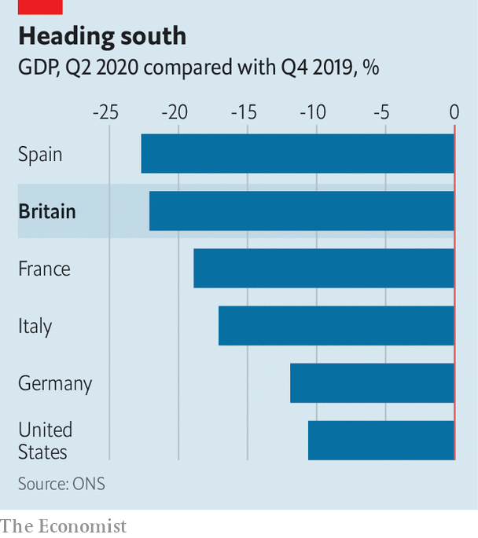

The economy returned to growth in May, and in June GDP grew by 8.7%, the fastest rise on record. But big percentage increases after a huge fall are misleading. Google’s mobility data suggest that Britons have been slower to return to shops, and to start eating and drinking out again, than other Europeans. The climb out of the hole will be a long one.

Editor’s note: Some of our covid-19 coverage is free for readers of The Economist Today, our daily [newsletter](https://my.economist.com/user#newsletter). For more stories and our pandemic tracker, see our [hub](https://www.economist.com/news/2020/03/11/the-economists-coverage-of-the-coronavirus)

This article was downloaded by calibre from <https://www.economist.com/britain/2020/08/15/britains-disastrous-gdp-figures>

|  |  |  |  |
| --- | --- | --- | --- |
| Previous | Articles | Sections | Next |

|  |  |  |  |
| --- | --- | --- | --- |
| Previous | Articles | Sections | Next |

#### Exam results

# Arbitrary A-level results are normal

Complaints have forced a government U-turn, but results are surprisingly random in normal times

Aug 15th 2020 |

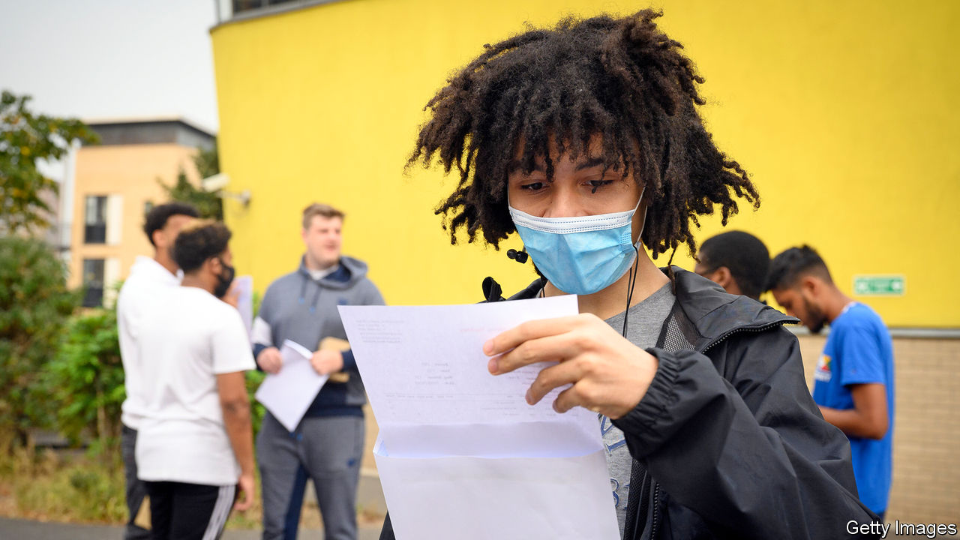

A-LEVEL RESULTS day is traditionally a busy one for pubs and an excuse for newspapers to publish pictures of young women jumping in celebration. This year, it was like no other.

When the schools closed and lockdown began in March, Gavin Williamson, the education secretary, announced that this year’s exams would be cancelled and Ofqual, the examination watchdog, exam boards and teachers would instead work out a grade for each student. The system they devised looked at how teachers ranked their students as well as the marks they had given them, and calibrated those results against the school’s past performance.

On August 12th, two days before the results were released, the government changed course. A-level students unhappy with their grade, it decreed, will now be able to substitute it for what they had achieved in a mock exam, or instead physically sit the exam in September.

Scotland caused the U-turn. The results of Scottish Highers, the equivalent of A-levels, calculated in much the same way as the English results, were released on August 6th. Some 125,000 results had been downgraded from teacher estimates. And though only 6.9% of marks at affluent schools, which tend to perform better, were downgraded, 15.2% of grades at schools in poorer areas were notched down. Pupils complained of being judged on their postcode rather than their ability. The Scottish government abandoned moderation and announced that only teacher assessments would be used to grade students. As a result, the overall pass rate jumped to 89.2%, up from 74.8% in 2019.

Mr Williamson is aiming to avoid the outrage that followed in Scotland without seeing a similar leap in grades. That will be tricky. Teachers argue that mock exams are a poor substitute for the real thing and practices vary widely between schools, with some marking them more harshly to encourage pupils to work harder.

Judging students by their schools rather than their own achievements strikes many as unfair, but the system may end up being no more inaccurate than it usually is. In 2018 Ofqual published the results of a multi-year investigation into marking. An experienced examiner marked papers in 14 A-level subjects and then compared the grades they gave with the ones awarded by the normal process. In around a quarter of cases the senior examiner awarded a different mark. In maths, only 4% of papers received a different grade but in essay-based subjects such as history, it was 44%. Ofqual insists that this does not mean that 44% of history A-levels are awarded the “wrong grade” but merely that many papers could “legitimately” be marked differently. That is scant consolation for a candidate who has got a C when another examiner might have given them a B.

However things work out for this batch of students, they will have a better-than-usual chance of getting into the college of their choice. Universities are desperate for domestic students to replace the foreigners who won’t be turning up next term.■

This article was downloaded by calibre from <https://www.economist.com/britain/2020/08/15/arbitrary-a-level-results-are-normal>

|  |  |  |  |
| --- | --- | --- | --- |
| Previous | Articles | Sections | Next |

|  |  |  |  |
| --- | --- | --- | --- |
| Previous | Articles | Sections | Next |

#### Immigration

# Britain’s migrant invasion that wasn’t

A sense of proportion would help

Aug 15th 2020 |

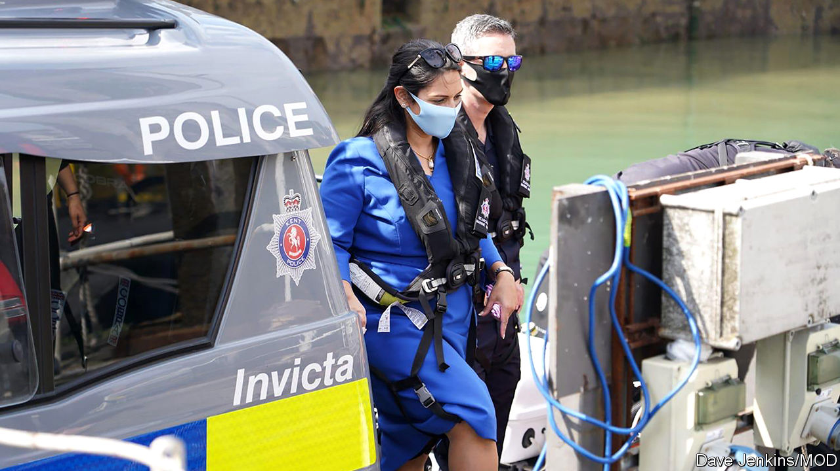

AS BRITAIN SWELTERED in a heatwave—or, as most Europeans would describe it, summer—Priti Patel was far from the only Londoner to go southwards in search of sea air. But the home secretary’s outing, on August 10th, was hardly a jolly. Her day was full of pow-wows with border guards, not of ice cream and sandcastles. In Dover she clambered aboard a police vessel named Invicta and conferred with officials, a latter-day Boudicca inspecting her troops.

A steady trickle of migrants attempting to cross the English Channel in dinghies from camps in Calais has inspired a sea of tabloid headlines. Nigel Farage, a loudmouth Brexiteer, made hay. Tory MPs joined in, too: Natalie Elphicke, who represents Dover, accused incomers of “breaking into our country”; a group of 25 members of the parliamentary party saw not bedraggled groups of people desperate enough to risk drowning but hordes of “invading migrants”. Ms Patel’s trip to the seaside was an attempt to placate such critics. “Ministers want to get it off the front page of the Daily Mail,” says David Wood, a former head of immigration enforcement at the Home Office.

Populists in the media and Parliament make much of a steep rise in such crossings, from about 2,000 last year to 4,000 or so this year, according to an unofficial tally. Less remarked on is that this represents a small fraction of those who claim asylum in Britain: last year they numbered 36,000. And despite the myth that most migrants make a beeline for Britain, far more seek asylum in France (about 124,000 last year) or Germany (142,500). Photographs of the needy huddled in unseaworthy craft recall the migrant crisis of five years ago. But, says Laura Padoan of UNHCR, the United Nations’ refugee agency, “it’s really misleading to talk about a crisis. When I was in Greece in 2015, there were 11,000 people arriving on an island every day.”

Britain’s focus on the issue is regarded with some bemusement across the Channel. On August 11th Chris Philp, the immigration minister, was dispatched to Paris where, according to a press release, he held talks with “the French government”. Such circumlocution did not quite disguise the fact that his hastily-arranged meeting was with officials, not his opposite number: neither of the ministers concerned deigned to interrupt their summer break.

Still, hashing out a plan to stop the crossings—ideally by making it easier for migrants to apply to join relatives in Britain as well as by stepping up French intelligence-gathering and border patrols—is a good idea. That is not because this luckless flotilla poses a threat to Britain; rather that the Channel is the world’s busiest shipping lane. No route is safe—migrants who cross by lorry risk asphyxiation—but this one is particularly dangerous.

A crackdown would also deprive organised criminals of a lucrative revenue stream. Migrants pay smugglers between £1,000 ($1,300) and £5,000 for the 21-mile crossing, depending on the seaworthiness of the vessel, says Mr Wood. And it would deter potential migrants from making the long journey to France in the hope of crossing the Channel. “The black-market migration industry can adjust very quickly to how countries manage their borders,” says Henry Sherrell, an immigration wonk. “If you don’t get on top of it, something small can become something large.”

Any solution requires cross-Channel co-operation. When the Brexit transition period ends in December and, with it, Britain’s right to return incomers to the country where they first claimed asylum, ministers will become even more reliant on France. Hostile press briefings implying that the French government is holding Britain to ransom by “demanding” £30m for enhanced border measures are counter-productive. If this really is a crisis, it is an unusually cheap one to tackle. ■

This article was downloaded by calibre from <https://www.economist.com/britain/2020/08/15/britains-migrant-invasion-that-wasnt>

|  |  |  |  |
| --- | --- | --- | --- |
| Previous | Articles | Sections | Next |

|  |  |  |  |
| --- | --- | --- | --- |
| Previous | Articles | Sections | Next |

#### Fighting covid-19

# England’s contact-tracing system (finally) gets parochial

Local experiments have shown the value of hitting the streets

Aug 15th 2020 |

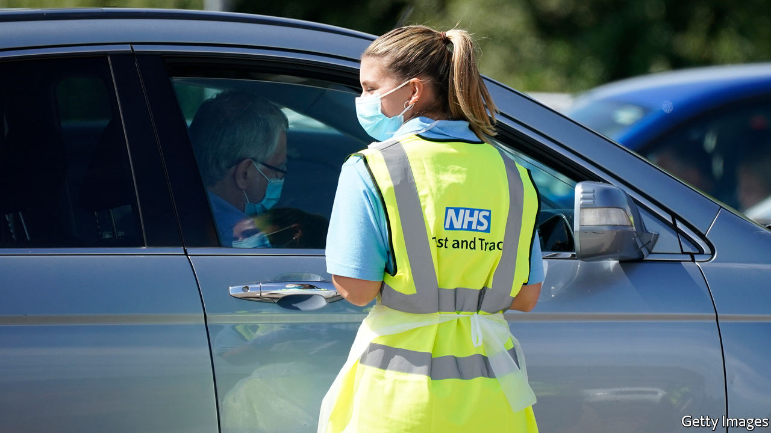

LEICESTER HAS become an unlikely hotbed of covid experimentation. In June the East Midlands city, home to 355,000, was the first to return to lockdown, as the government played “whack-a-mole” with the virus. Since July 17th it has pioneered a more sophisticated approach. The local council has created a team of 21 staff to hunt down cases beyond the reach of the national contact-tracing system. For the most recalcitrant, this involves multiple home visits in full PPE. The effort has been worthwhile: the council says it has found 89% of those whose details they have been passed.

Public-health experts have long argued that contact tracing in England needs to make more use of local knowledge—to find stubborn cases, to work with local leaders, to persuade people to isolate. On August 10th the government tacitly admitted they may have a point. It announced the national test-and-trace system would be rewired, with local public-health teams taking the lead. Some 6,000 of the 18,000 centrally employed contact tracers would be let go. The rest would support local efforts.

Many of the 18,000 have had little to do in recent weeks. Tests are mostly reserved for those with symptoms, meaning asymptomatic cases are rarely caught. Whereas the Office for National Statistics estimates that around 28,000 people had covid-19 in the week to August 2nd, just fewer than 5,000 actually tested positive for it in an overlapping week. According to a senior official, the ability to look for asymptomatic cases is limited both by the availability of antigen tests and concerns about false results when the national case-count is low.

The test-and-trace system has improved since its launch at the end of May. Test results are speedier, for instance, and the government has continued to publish timely data on its effectiveness. Yet there has been little rise in the proportion of those whom contact tracers reach, with the figure remaining just below 80%. That is not disastrous, but the hope is it will now climb.

To be effective, central and local government will need to work hand in glove, something that is rare in England. Indeed, some of the experimentation that proved local teams could hunt down cases—in Blackburn and Sandwell, for example—was driven by unhappiness with the national system, which was failing to do the job in their areas. Local officials have also been unhappy with the quality of the data they have received from the centre, although the situation has now improved.

They are now waiting to see how the changes play out. If those in charge of the national system “really sit down and co-design with us, this could actually be a game changer,” says one director of public health. “If this is just another way of avoiding criticism, without listening to the local level about how the system is working, it won’t deliver.” An effective system would allow the government to push harder on its ambition of getting life back closer to normal, whether that is adults returning to offices or children returning to schools. So ministers have plenty of incentive to get this right.

Editor’s note: Some of our covid-19 coverage is free for readers of The Economist Today, our daily [newsletter](https://my.economist.com/user#newsletter). For more stories and our pandemic tracker, see our [hub](https://www.economist.com/news/2020/03/11/the-economists-coverage-of-the-coronavirus)

This article was downloaded by calibre from <https://www.economist.com/britain/2020/08/15/englands-contact-tracing-system-finally-gets-parochial>

|  |  |  |  |
| --- | --- | --- | --- |
| Previous | Articles | Sections | Next |

|  |  |  |  |
| --- | --- | --- | --- |
| Previous | Articles | Sections | Next |

#### Farm labour

# Inexperienced workers make for a difficult harvest

Britain’s migration system is ripe for reform

Aug 13th 2020 |

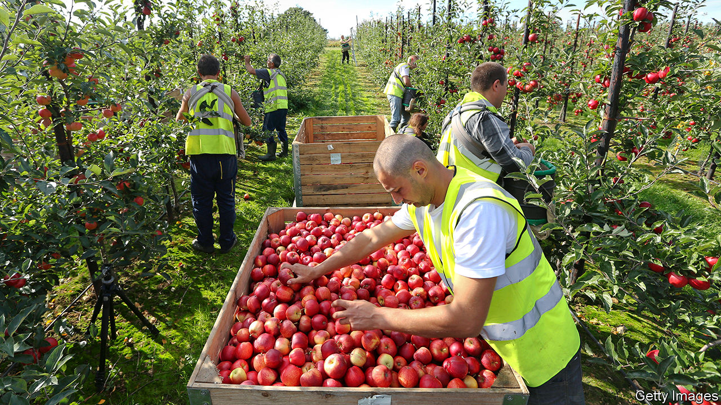

AT STOCKS FARM, on the border between Herefordshire and Worcestershire, where Alison Capper’s family has grown apples and hops for 58 years, the year has a natural rhythm in normal times. Migrants from eastern Europe arrive in February to prepare the orchards—thinning apples, training hops, planting trees. They pick fruit in summer and autumn. By November, they are back home. But this year, they were hard to come by, so Mrs Capper had to supplement her labour force with locals.

Even before covid-19, rising incomes at home and Brexit had put eastern Europeans off. Concerned about labour shortages, the government expanded the seasonal workers’ scheme—a pilot system to allow non-EU farm workers into Britain—from 2,500 to 10,000 in February. Russians, Ukranians and Barbadians filled the gaps in orchards and polytunnels left by Bulgarians, Hungarians and Romanians. Canny farmers continued to bring foreign workers into the country throughout the crisis.

Then came covid-19, and with it travel restrictions. The government created Pick for Britain, a loose network of campaigns, to get British people to fill some 70,000 fruit-picking vacancies. An avalanche of early interest saw Britons make up some 35% of the workforce in May, but they are now down to a tenth. Mrs Capper got a ragged bunch of students, furloughed construction workers and an events worker. Most left before the harvest began.

Despite the difficulties, most farmers still managed to recruit eastern Europeans. Four-fifths of the workers at Angus Growers, a co-operative of 19 soft-fruit farms in Scotland, are from the EU. But many farmers have had to use Britons too, and their productivity has caused problems. At two large soft-fruit farms in south-east England British workers picked at a rate of 15.2kg and 16kg per hour, compared to eastern Europeans’ 28.1kg.

When labour was plentiful, slow workers would have been weeded out and replaced early in the season, but now farmers have to make do with what they can get. Angela Porchez, general manager of Angus Growers, has had to take many British workers off fruit-picking and give them easier husbandry tasks (deflowering, cutting runners, thinning plants and weeding) which are less time-sensitive.

Labour costs—which make up around 70% of total costs—have risen by 9-15%, according to a report by Andersons, a consultancy. Social-distancing measures in packhouses are partly responsible, says John Pelham, author of the report; so is the new workers’ lack of experience. “It takes new workers a period to become commercial. It doesn’t really matter whether they come from Bulgaria or Bolton, they require training in something they haven’t previously done.” This year’s problems come on top of a 34% rise in the minimum wage over the past five years, when prices have stagnated: wholesale strawberry prices are slightly lower now than five years ago.

Rising costs for farmers do not affect supermarket prices, which are agreed with growers long before the season starts. It is profits that have taken the hit, with producers of labour-intensive crops such as strawberries and asparagus most affected. Many crops’ profitability is now “alarmingly marginal”, according to Mr Pelham. In the longer run, labour problems will force prices up, which is likely to reduce demand for British produce.

Farmers fear that, under the current rules, they will have to rely more on Britons in the future. In the short term, they are lobbying for an expansion of the seasonal workers’ scheme to increase the number of temporary non-EU farm workers. In the long term, they want the government to stop prioritising better-paid, better-qualified migrants. “We have an immigration policy that just isn’t fit for the future of farming,” says Tom Bradshaw, vice-chairman of the National Farmers’ Union.

Farmers dream of something like New Zealand’s working-holiday visa, that lets young people travel and work in the country for a year. “There are two choices,” says Mr Bradshaw. “You insist on having a UK workforce and have lower productivity, higher costs of production and higher food costs, or the other way is enabling migrant workers to come over.”■

This article was downloaded by calibre from <https://www.economist.com/britain/2020/08/13/inexperienced-workers-make-for-a-difficult-harvest>

|  |  |  |  |
| --- | --- | --- | --- |
| Previous | Articles | Sections | Next |

|  |  |  |  |
| --- | --- | --- | --- |
| Previous | Articles | Sections | Next |

#### Government jobs

# Why most top Foreign Office posts are held by women

Bureaucrats’ lessons for business

Aug 15th 2020 |

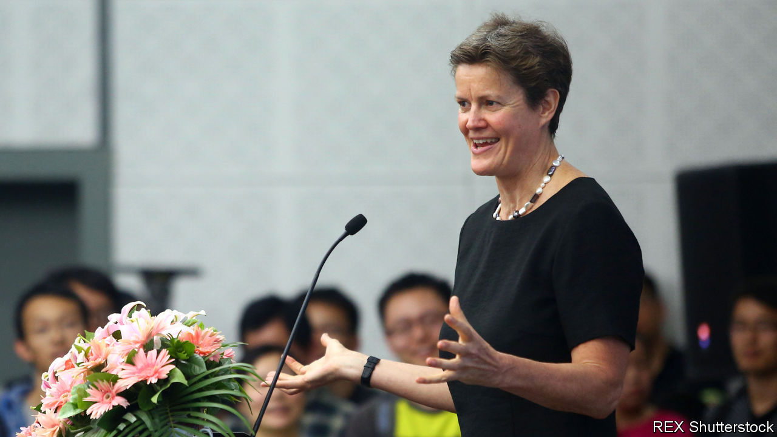

BEFORE 1946, women seeking a role in the Foreign Office could become typists, cleaners or diplomats’ wives, although in 1934 a forward-thinking ambassador suggested they help pick out soft furnishings for the Office of Works. Until 1972 they had to leave the service on getting married; “pestering”, as Dame Nicola Brewer, a former High Commissioner to South Africa, would later recall, was a scourge in the 1980s. “Making a fuss would be career-limiting.” Such treatment left a long shadow. After the current head of the service, Sir Simon McDonald, was knighted in 2014, there were as many men called Sir Simon in the top two grades of officials as women.

But in the past few months, women have seized a clutch of the top jobs. In February Dame Karen Pierce was appointed ambassador to America, becoming the first woman to hold the role since it was created in 1791. Her old job of permanent representative to the United Nations was filled by Dame Barbara Woodward on August 6th. Women fill the ambassadorships to Britain’s other best pals in the Five Eyes intelligence-sharing pact: Australia, Canada and New Zealand. Sarah MacIntosh speaks for Britain at NATO. Women hold the ambassadorships in Beijing, Moscow, Rome, Mexico City, Stockholm and the Vatican, and are soon to take up post in Germany and the Netherlands. They fly the Union Flag in the stickiest spots: Afghanistan, Zimbabwe and Belarus. In total, nearly a third of Britain’s ambassadors, heads of mission or governors are women.

Firms that wish to deal with their own gender imbalances can take some lessons. One is that the leadership needs to be candid about the problem. In 2018, Sir Simon had a wall of mirrors erected in the Foreign Office’s headquarters, each representing a top job that a woman had yet to fill, and encouraging passing women to put their face in the frame. Over time the mirrors have been replaced by portraits of those who got the posts. Some field-seasoned officials find the exercise “a bit cringe”, but it sends an unambiguous message.

Another lesson is the need to build a reliable pipeline. The current crop of female ambassadors began their careers several decades ago. The Foreign Office receives thousands of applications from top graduates each year, which means there’s no excuse for not creating a diverse intake. This year’s fast-stream intake was 60% female, and nearly a quarter non-white. And it’s no good scrabbling round for Mandarin-speaking women the moment a plum China post is advertised. The field of potential applicants for senior jobs is surveyed several years in advance, and potential candidates head-hunted and given advice on how to get themselves qualified.

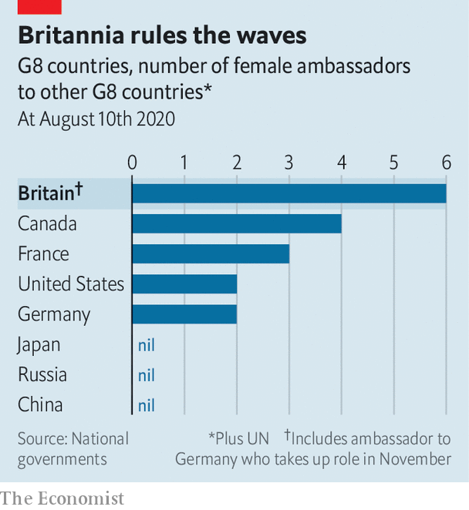

Another practice is to bunch vacancies together. Filling them one-by-one can result in women becoming the serial runners-up, whereas interviewing for half a dozen at a time forces management to look at the bigger picture.

Then there is flexibility. Diplomatic life has traditionally meant moving a whole family from country to country every few years. But the life of a “trailing spouse” is increasingly unattractive for modern couples. The FCO no longer expects husbands or wives to toil on the cocktail circuit; some diplomats in posts close to Britain commute between their home and their posting each week.

The diplomatic corps is still some way short of its aspiration of looking like the Britain it serves. NneNne Iwuji-Eme, Britain’s High Commissioner in Mozambique since 2018, is the first black woman to hold the rank. Officials would like to see more non-white diplomats follow. Sir Simon will be succeeded next month by Sir Philip Barton as the permanent under-secretary, a post a woman is yet to hold, and women are outnumbered on the management board. But next month Britain’s aid department, which is a bit more diverse, will be subsumed into the Foreign Office. As in the private sector, a merger brings the opportunity to shake things up at the top.■

This article was downloaded by calibre from <https://www.economist.com/britain/2020/08/15/why-most-top-foreign-office-posts-are-held-by-women>

|  |  |  |  |
| --- | --- | --- | --- |
| Previous | Articles | Sections | Next |

|  |  |  |  |
| --- | --- | --- | --- |
| Previous | Articles | Sections | Next |

#### Bagehot

# What Boris could learn from de Gaulle

The man who rebuilt post-war France has some important lessons for Britain’s prime minister

Aug 15th 2020 |

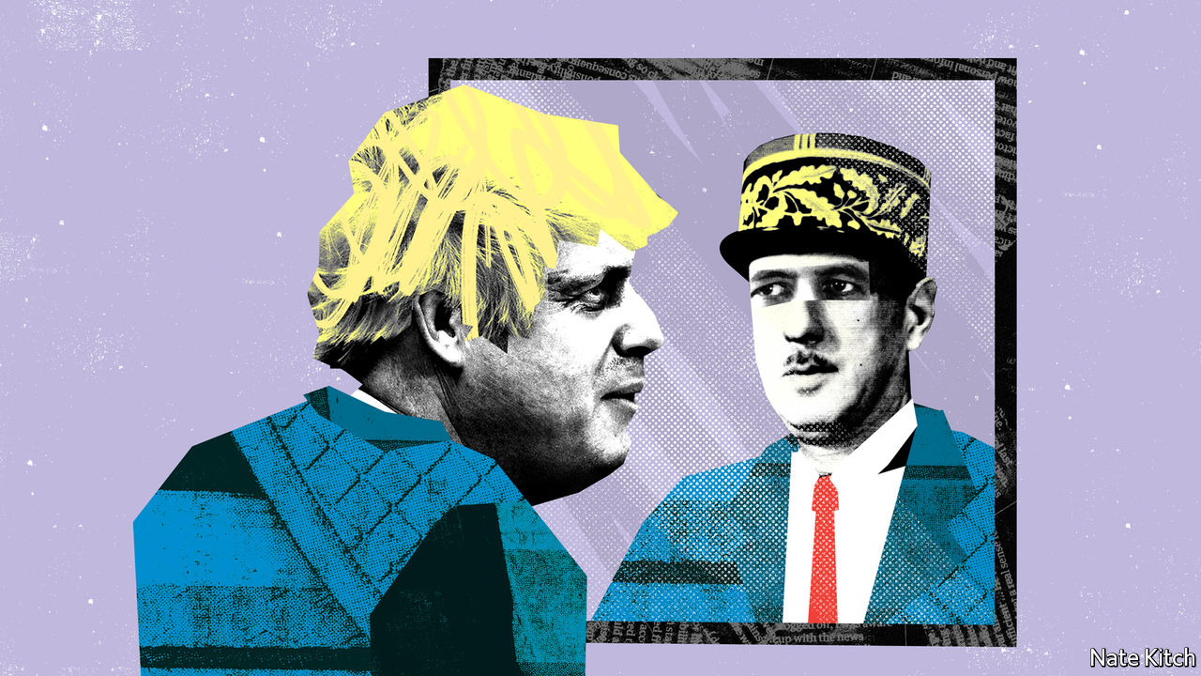

BORIS JOHNSON is taking a fortnight’s holiday in Scotland, armed with a volume of Lucretius, William Boyd’s novel “Any Human Heart” and Brendan Simms’s “Britain’s Europe: A Thousand Years of Conflict and Cooperation”. Few would begrudge him his break: he has lived a lifetime in the past year, having got divorced and remarried, had another child, almost died of covid-19 and struggled with the worst crisis since the second world war. But Bagehot would nevertheless suggest adding a fourth book to his pile—Julian Jackson’s “A Certain Idea of France: The Life of De Gaulle”. Though hefty, the book is enthralling, and offers a wealth of ideas with which to fill the empty box labelled “Johnsonism”.

Mr Johnson is keen on great men. He has written a biography of his hero Churchill and, modesty not coming naturally to a man who as a child announced that he would become “world king”, has recently taken to comparing himself to Franklin D. Roosevelt. But in many ways de Gaulle is a better fit than either. The French president saw eye to eye with Britain’s prime minister on the biggest issues. He regarded the nation-state as the basic building-block of civilisation. He opposed Britain’s membership of the EU on the grounds that Britain by its nature “looks to the sea, towards wider horizons”. He devoted his post-war career to restoring confidence and dynamism to a country that had lost the first in the war and had fallen behind in the second for decades.

Though Britain’s situation is hardly as desperate as France’s in 1945, there are similarities. The 2016 referendum spoke of profound dissatisfaction with the old regime. Confidence in national institutions is at a low ebb. Sections of the left identify “Britishness” with slavery and plunder while sections of the right want to build walls against modernity.

De Gaulle tackled France’s loss of self-confidence by speaking for “la France profonde” and insisting that “France cannot be France without grandeur”. France could easily have wallowed in despair after the war or—what amounted to the same thing—listened more enthusiastically to Marxist intellectuals such as Jean-Paul Sartre. De Gaulle regarded national pride as the only cure for national suicide. Mr Johnson has the same life-preserving instincts. He likes to think that he speaks for Middle England. He identifies Britain with “greatness” as naturally as the general identified France with “grandeur”. He is repulsed by the left’s characterisation of Britain’s past as nothing but a story of oppression and exploitation. It is not only factually wrong, in his view: it is also damaging to teach children to be ashamed of their country’s past.

The general looked forward as well as back: he knew that the best way to restore France’s grandeur was not just to talk about it but to revitalise the country. He ushered in the Fifth Republic, turning the state into an instrument of modernisation, creating a new technocratic elite, rationalising government and investing in infrastructure. France enjoyed “les trente glorieuses”, from 1945 to 1975, when GDP grew at an average of 6% a year.

Mr Johnson shares some of these instincts. He senses that the old political order is crumbling—hence his bold raid on northern voters. He senses that the Tories need to give a more active role to the state—hence his enthusiasm for big infrastructure projects such as HS2, a new railway, and even HS3 (a high-speed link between Leeds, Manchester and Liverpool). His description of himself as a “Brexity Hezza”—referring to Michael Heseltine, a leading Tory critic of Thatcherism, who believed that the state should take the lead in regenerating poor areas—is almost a way of saying “a Gaullist”. His two closest allies, Michael Gove, the cabinet-office minister, and Dominic Cummings, his chief adviser, want to put reforming the state at the heart of politics.

So far Mr Johnson’s moral laziness has prevented him from making the best of these instincts. He has made a mockery of his talk of reforming the state by dumping a collection of cronies on the House of Lords, for example. A reading of Mr Jackson’s book might remind him of the importance of both dignity and high seriousness in political affairs. Not that he should go the whole de Gaulle—that would produce an absurdity—but he would benefit from mixing some gravity into a persona that was crafted decades ago and is in danger of outliving its usefulness. It might also provide him with some ideas. One of the first things the general did in 1945 was to give the green light to the creation of the École Nationale d’Administration, in order to train hauts fonctionnaires in the arts of modern government. A British ENA would send a powerful message that Britain wants its crème de la crème to serve the state rather than McKinsey or Goldman Sachs.

## Master betrayer

De Gaulle also has some darker skills to impart. A pragmatist as well as a romantic, he was a master of the art of betrayal. He repeatedly sold his friends down the river, most obviously the pieds noirs French settlers in Algeria by granting the colony independence. But he turned the boiling hatred this provoked into another source of strength by treating hatred of de Gaulle as hatred of France. Mr Johnson is no slouch when it comes to betraying people: during the Brexit talks he was quick to dump his once staunch allies, the Ulster Unionists, by agreeing to a border in the Irish Sea. But he needs to work on managing the hatred he arouses.

De Gaulle did not much care much for the country that gave him refuge while he was in exile, and even came close to declaring war on Britain in 1945 over France’s imperial interests in Syria. His British fan club is, understandably, small; but it includes some influential names on the right, including Peter (now Lord) Lilley, one of the architects of Thatcherism, and David Frost, the new national security adviser. Without joining the club, Mr Johnson might consider borrowing at least a few of the great man’s ideas, as he tries both to revive Britain’s creaking state apparatus and to embrace the wider horizons which de Gaulle saw as its destiny. ■

This article was downloaded by calibre from <https://www.economist.com/britain/2020/08/15/what-boris-could-learn-from-de-gaulle>

|  |  |  |  |
| --- | --- | --- | --- |
| Previous | Articles | Sections | Next |

|  |  |  |
| --- | --- | --- |
| Britain | Sections | Business |

International

America’s State Department: The dereliction of diplomacy

.

|  |  |  |
| --- | --- | --- |
| Britain | Sections | Business |

|  |  |  |  |
| --- | --- | --- | --- |
|  | Articles | Sections | Next |

#### Facing the world, blindfolded

# The dereliction of American diplomacy

Donald Trump dismisses it as the “Deep State Department”. Yet America needs it more than ever

Aug 13th 2020 |



THE AMERICAN embassy escaped the blast in Beirut’s port unscathed. Many Western countries either have missions in the city centre or diplomats who live in the area. The wife of the Dutch ambassador was killed, as was a German diplomat. But America’s embassy sits in the mountain village of Awkar, five miles (8km) from the port. Security measures are onerous, a hangover from the bombing of the American embassy in Beirut in 1983, which killed 63 people. It took a week before the ambassador, Dorothy Shea, a career diplomat, toured the port. The embassy has been short-staffed for much of the year because of covid-19. Even on social media it has been far quieter than other foreign powers. The ambassador has kept a low profile.

The low visibility is a small sign of a wider malaise in American diplomacy. The country’s foreign service is damaged and demoralised. Last month Bob Menendez, the senior Democrat on the Senate Foreign Relations Committee, released a report warning that the State Department was “at risk of catastrophic failure”. The report is a catalogue of the damage done to America’s oldest federal agency, founded in 1789. It describes a department haemorrhaging talent and influence. The litany of woes is summed up in a leaked recording of a briefing on Washington last November by Colombia’s ambassador there, Francisco Santos, to his incoming foreign minister: “The US State Department, which used to be important, is destroyed, it doesn’t exist.”

Hand-wringing over the state of State is hardly new. More than two dozen government agencies now have people overseas, eroding the State Department’s primacy. Nowadays, the boss of a global American company may have a one-on-one with a head of state without going through the embassy, notes Stuart Holliday of Meridian, a centre for diplomacy in Washington, DC: “There’s been a recognition that the diplomatic channel is not the channel through which all American engagement happens.” In 2015, well before Donald Trump became president, the American Academy of Diplomacy, a club of senior ex-diplomats, warned that the country’s foreign service was in trouble because of its increasing politicisation, poor professional education and outdated career structure.

Mr Trump has tried to cut the department’s budget, most recently by 34%. Congress ignored him. But deep cuts came in the mid-1990s after the end of the cold war, when America thought it could scale back diplomacy—resulting in problems when the government found itself needing to deploy extra diplomats to Afghanistan and Iraq. More belt-tightening followed under the Obama administration. In 2018 Barbara Stephenson, then head of the American Foreign Service Association (AFSA), which represents the country’s diplomats, pointed out that America’s spending on “core diplomatic capability” (excluding outlays on security) declined by nearly a quarter in real terms between 2008 and 2016.

So the State Department was already wounded. “It’s not an exaggeration to say this is the most difficult time in a generation,” says Eric Rubin, AFSA’s current president. Nicholas Burns, an ex-ambassador to NATO now running a project on the future of American diplomacy at Harvard (the project is non-partisan but Mr Burns is an adviser to Joe Biden), believes it is time to “ring the village bell”. William Burns, another former top diplomat, who heads the Carnegie Endowment for International Peace, a think-tank in Washington, DC, decries the “demolition” of the State Department and argues that the damage is “even more severe than we imagine”.

Three things have created a sense of urgency. One is covid-19, the kind of crisis where America is expected to take a lead, but has faltered. In future more global issues—from climate change to cyber-security—will need managing. “Diplomacy is becoming far more important globally now than it has been before,” argues Mr Burns from Harvard. But the diplomatic landscape is more contested. “We’re going to have to fight for influence and for our priorities in a way that maybe we didn’t have to in the past,” says Mr Rubin.

The second worry is the rise of China. Last year China overtook America as the country with the most embassies and consulates around the world, says a Global Diplomacy Index compiled by the Lowy Institute, an Australian think-tank (see chart 1). Mr Trump has sought to slash America’s spending on diplomacy; Xi Jinping doubled China’s between 2011 and 2018.

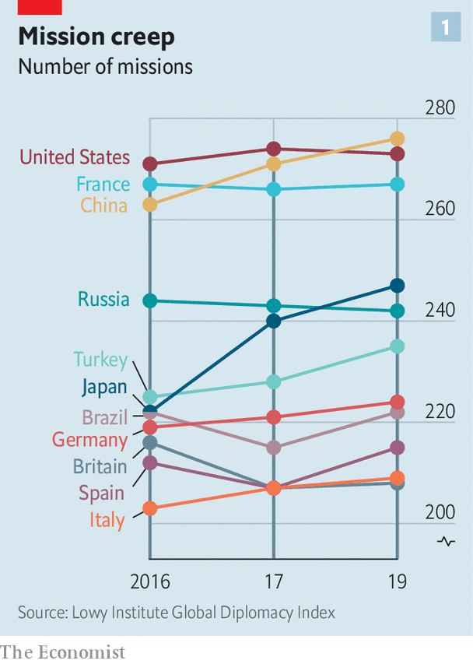

China’s advances are evident at the United Nations, where Chinese nationals now head four of 15 UN specialised agencies, compared with America’s one. America has started to push back. It stopped China claiming the leadership of a fifth agency, the World Intellectual Property Organisation—the job went to a candidate from Singapore, a country, as Mr Pompeo said last month, that “actually gave a darn about intellectual-property rights”. But as America withdraws from bodies such as the World Health Organisation it gives China a chance to exert yet more influence.

## American carnage

Hence the third reason for alarm over the state of American diplomacy: its undermining by its own government. A senior US diplomat says the White House is “blatantly hostile” to the foreign service. Mr Trump publicly refers to “the Deep State Department”, implying its people are out to sabotage him. “Diplomacy is simply not valued,” says Roberta Jacobson, who resigned as American ambassador to Mexico in 2018. “The only form of foreign policy that this administration seems to understand is one of threats.” Mr Trump’s threats have sometimes targeted his own diplomats—including Marie Yovanovitch, who was his ambassador to Ukraine before being abruptly recalled. In the phone call in July 2019 that led to his impeachment by the House of Representatives, Mr Trump told Ukraine’s president, Volodymyr Zelensky, that she was “bad news” and that “she’s going to go through some things.”

In appointing ambassadors Mr Trump has favoured political picks over career diplomats to a degree that is unprecedented in modern times. America has a long tradition of deploying political emissaries. They can have the authority of a direct line to the president. Many also have the financial means to entertain in some style. Don Beyer, a businessman appointed by Barack Obama as ambassador to Switzerland, now a congressman for Virginia, says he spent about $1m of his own money on entertainment over four years. The budget allocated by Congress was a fraction of what he spent (“I was just blessed that Obama didn’t send me to Paris or London, which I could never have afforded,” he quips).

Typically, between a quarter and a third of a president’s ambassadors have been political appointees, often hefty campaign donors. In Mr Trump’s case the figure is 43%. The quality of those picks can be as unsettling for the career diplomats who serve under them as the quantity. Mr Trump’s ambassador to Iceland has been through seven deputy mission chiefs in little over a year. His man in London, Woody Johnson, removed his deputy whose mistake seems to have been to have included a favourable anecdote about Mr Obama in a speech at an English university. At Mr Trump’s behest, Mr Johnson reportedly tried, unsuccessfully, in 2018, to help push the British Open golf tournament towards the Trump Turnberry course in Scotland (Mr Trump has denied making the request).

Although ambassadors are the most visible sign of the politicisation of diplomacy, appointments back home are at least as significant. “The senior jobs in Washington is where policies are made,” says Ronald Neumann, president of the American Academy of Diplomacy. “There you have a wiping out of the career service.” Between 1975 and 2014, the share of career diplomats in the 50 or so jobs at assistant-secretary level and above shrank from about 60% to 30%; now, says Mr Neumann, it is down to 8%. No career foreign-service professional currently occupies a Senate-confirmed assistant-secretary post; according to AFSA, that has never happened before. Talented diplomats leave because of the lack of senior jobs available to them (America’s foreign service, like its army, operates an “up or out” system).

These days it is also hard to spot any senior foreign-service officers working in the White House. Mr Burns of Harvard spent five years seconded to the White House under presidents George Bush senior and Bill Clinton. “Those opportunities are not happening,” he says, “so the State Department has been sidelined.”

Many posts requiring Senate confirmation have stayed unfilled for long periods, creating a sense of drift and neglect. The job of assistant secretary for Europe and Eurasian affairs has been without a nominee since February last year. The Trump administration has so far had no confirmed nomination for assistant secretary for South and Central Asian affairs. Hiring for Africa roles has been painfully slow.

All this has contributed to a hollowing out of expertise that has been particularly severe thanks to a hiring freeze introduced by Rex Tillerson, the former ExxonMobil boss whose brief tenure as Mr Trump’s first secretary of state was a disaster. “Tillerson did more damage to the State Department than I could have imagined was possible in one year, particularly in the loss of experienced senior people,” says Mr Neumann.

Mr Pompeo ended the hiring freeze and has sought to bring back “swagger” to the department. He has taken a lead in belligerent policies towards Iran and, especially, China. He has restored a degree of vigour at the top. But he has not soothed critics.

They worry that he asked Mr Trump to fire his department’s inspector-general, who was investigating complaints against Mr Pompeo himself. They grumble that hardly any career officers are involved in his staff meetings. And they question whether he really has his diplomats’ back. True, he has not actively added to his boss’s attacks on his own envoys—yet, mindful of the art of survival in the Trump administration, neither has he actively defended them. In Senate testimony last month, he refused to say whether Ms Yovanovitch was a talented ambassador. “Hey, look at you, smiling and laughing and calling it silly,” concluded Senator Tim Kaine, a Democrat. “I don’t think it’s silly to Marie Yovanovitch or the people who work for you.”

## Making the foreign service great again

Staff surveys suggest that confidence in the department’s leaders has plunged. Some of its lawyers resorted to a rarely used “dissent channel” to question an agreement to designate Guatemala as a “safe third country” for migrants. The numbers of people taking the foreign-service entrance exam has fallen by more than half over the past ten years (see chart 2). The inflexibility of foreign-service career paths is a problem: how many high-flyers today are happy to envisage a 35-year stay with the same employer and to wait 15 years for a senior job? Linda Thomas-Greenfield, a former head of the foreign service, recalls the case of an African-American woman who asked for three years’ leave to do a Harvard Law degree but had to apply one year at a time; her second year’s request was turned down and she left the department.

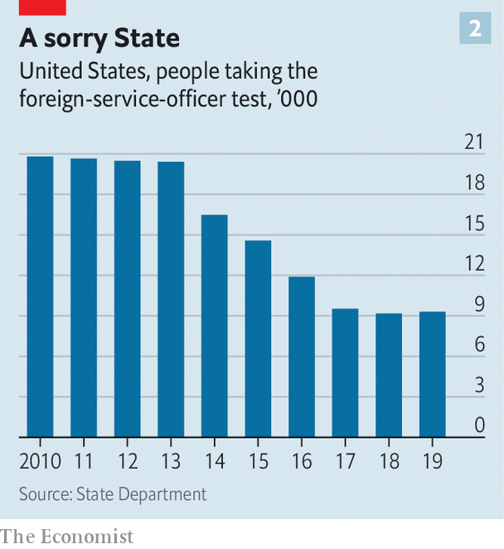

Such experiences have not helped the department’s record on diversity. “As far as African-Americans are concerned, the numbers are appalling,” says Ms Thomas-Greenfield. Just 2.8% of the senior ranks are black; a few years ago the figure was “upwards of 8%”, still short of a representative share. Only three black Americans are currently serving overseas as ambassadors, and four Hispanics. Last month Karen Bass, the chair of the Congressional Black Caucus, introduced a bill, along with the heads of Congress’s Hispanic, Asian and Native American caucuses, that seeks to help the foreign service “reflect the rich composition” of the country’s citizenry.

“It’s really important to understand just how much more quickly the deterioration of the State Department has gone under this administration than under previous ones,” says Ms Jacobson. Seasoned diplomats (including a former secretary of state for a Republican president) think it may take a generation to repair the damage. But several efforts are under way to come up with ideas. In September the Council on Foreign Relations, a non-partisan think-tank, will suggest reforms for the months after the presidential election, whoever wins. At Harvard Mr Burns and three other ex-ambassadors are leading an ambitious project to reimagine the longer-term future of American diplomacy; they will publish their proposals after the election.

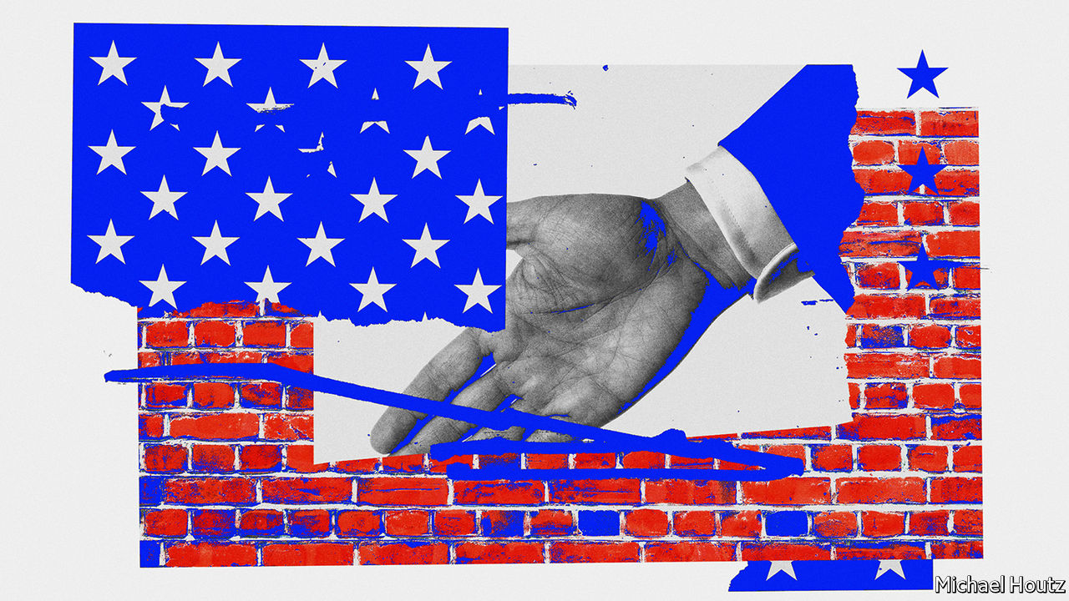

Some changes could come swiftly. A push to fill top positions and promote the brightest career diplomats would help. And a president who believed in diplomacy would be a powerful start in setting a different tone and direction. Clearly, that is not going to happen if Mr Trump is re-elected. A Biden presidency would seem to be a necessary condition for a real revival.

But it is not a sufficient one. The problems of American diplomacy run deeper than the Trump administration’s assault on it. Senator Elizabeth Warren’s campaign envisaged doubling the size of the foreign service—pointing out that “we employ more people to work in military grocery stores than we do foreign-service officers”—and professionalising its envoys instead of “selling swanky diplomatic posts to rich buffoons”. Mr Burns from Harvard also favours a drastic shift in the mix of ambassadors, with perhaps 90% career diplomats and only 10% political appointees.

Ambassadorships are just the tip of the iceberg. “A total review of the personnel system should be a top priority for the next secretary of state,” says Ms Thomas-Greenfield. An inflexible career structure means that the department forces some of its best and brightest out and then doesn’t let them back in. A nimbler entry-exam process, faster promotions and greater opportunities to enter at every level would all help.

So would better training. The State Department is lousy at it. Yet the skills diplomats need are only going to grow. America’s armed forces has about 15% of its officers in training at any given time. Reformers argue that America’s diplomatic service should create a similar “training float”, which would require hiring enough people and spending enough money to have that extra capacity.

Reformers also call for a deeper cultural change. Clunky procedures can require dozens of names to sign off a policy statement. “The State Department as an institution is rarely accused of being too agile or too full of initiative,” says Mr Burns from Carnegie. He thinks it should be stripped of layers of bureaucracy, with authority pushed down to regional heads and out to ambassadors overseas. The place has become risk-averse, and needs to question conventional wisdom, Mr Burns argues.

## Diplomacy first

The scale of the transformation needed in American diplomacy leads some to believe that its mission should be codified in a new act of Congress. Three times in the past century Congress stepped in. At the time of its last reform, in 1980, Leonid Brezhnev was in power in Moscow, China was beginning its one-child policy and home computers were becoming common. There is a case today for Congress to issue new marching orders. But sceptics wonder when—or whether—lawmakers might agree on the terms of a broad new act for the foreign service. Reform cannot wait.

That means changing not only the way the State Department works, but the weight diplomacy carries in foreign policy. America will always rely on a mix of military might and smooth talking. The two complement each other. “If you don’t fund the State Department fully then I need to buy more ammunition,” General Jim Mattis, then head of US Central Command, told Congress in 2013. Since 9/11 the emphasis on military force has made the country’s foreign policy lopsided.

Reformers say America must make diplomacy a first resort. Robert Gates, who was defence secretary in 2006-11, writes in Foreign Affairs about the “overmilitarisation” of American foreign policy and the neglect of its non-military tools. “The State Department should be the central non-military instrument of US national-security policy,” Mr Gates argues. But if it is to be up to the job, it will need more money, more manpower and far better management. ■

Dig deeper:  
Sign up and listen to Checks and Balance, our [weekly newsletter](https://www.economist.com/checksandbalance/) and [podcast](https://www.economist.com/podcasts/2020/08/01/checks-and-balance-our-weekly-podcast-on-american-politics) on American politics, and explore our [presidential election forecast](https://projects.economist.com/us-2020-forecast/president)

This article was downloaded by calibre from <https://www.economist.com/international/2020/08/13/the-dereliction-of-american-diplomacy>

|  |  |  |  |
| --- | --- | --- | --- |
|  | Articles | Sections | Next |

|  |  |  |
| --- | --- | --- |
| International | Sections | Finance & economics |

Business

Sino-American commercial relations: Endgame

.

More Sino-American decoupling: The nuclear option

.

Bartleby: Labour’s lost love

.

Saudi Aramco: Trial by fire

.

Juggling profits and purpose: Profits v purpose

.

Airbus A380: Superjumbo problems

.

Schumpeter: The new dividend royalty

.

|  |  |  |
| --- | --- | --- |
| International | Sections | Finance & economics |

|  |  |  |  |
| --- | --- | --- | --- |
|  | Articles | Sections | Next |

#### The great decoupling

# The Trump administration wants a US-China commercial split

Wrenching Chinese and American corporate worlds apart would hurt everyone

Aug 15th 2020 | NEW YORK AND SHANGHAI

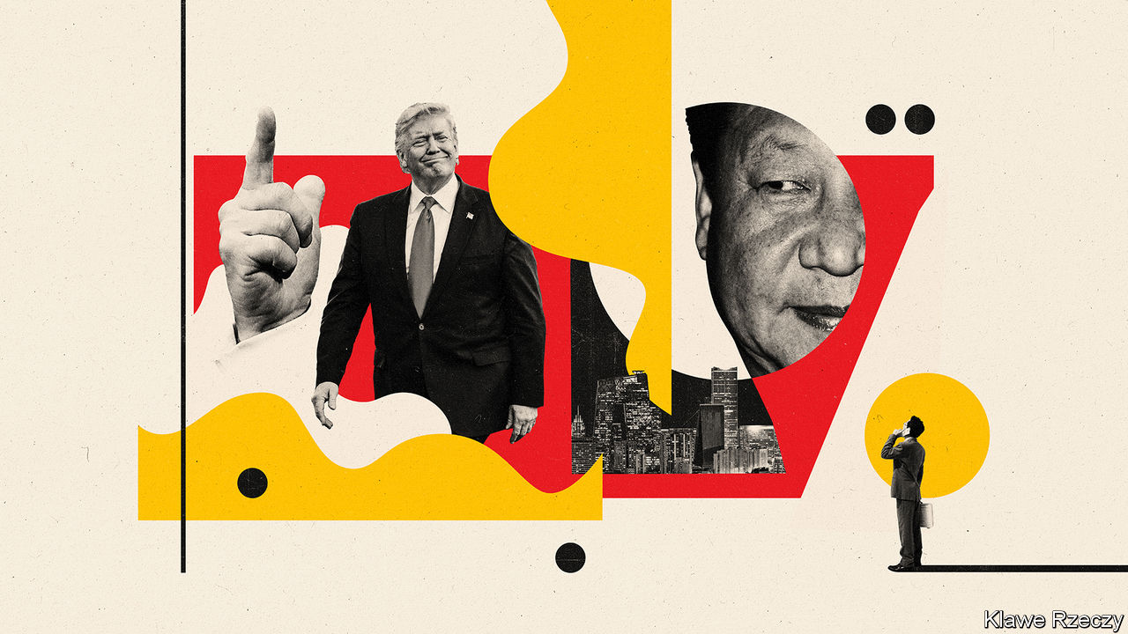

DURING HIS term in office, Donald Trump has often bashed China while occasionally praising its leader, Xi Jinping. Similar two-mindedness characterises his administration. China hawks, led by Robert Lighthizer, his trade representative, and Mike Pompeo, the secretary of state, have tussled for influence with more dovish figures such as Steven Mnuchin, the treasury secretary, who have tried to prevent a rupture between the two giants. Companies and investors from both countries have watched the contest closely.

In the past 18 months the hawks have been ascendant. Now, blaming China for spreading the covid-19 virus that has pushed America and the rest of the world into recession, thus helping to dent the president’s chances of re-election in November, they have prevailed.

On August 6th Mr Trump issued two startling executive orders giving American firms 45 days to unwind all commercial relations with ByteDance, the Chinese owner of TikTok, a video-sharing app popular with youngsters, and with WeChat, a Chinese messaging and payments super-app widely used by Chinese around the world to communicate with those back home (see China section). The previous day Mr Pompeo unveiled a “Clean Network” policy to protect America’s telecoms infrastructure and services against “aggressive intrusions by malign actors, such as the Chinese Communist Party”. This would extend to other Chinese firms, including mobile providers, the sanctions with which America has tried to cripple Huawei, China’s telecoms-equipment giant. In response to a harsh new security law in Hong Kong Mr Trump has stripped the Chinese territory of its special status on immigration and trade. And a presidential working group has declared that in order to trade on an American stock exchange, Chinese companies must give American regulators unfettered access to their books.

All this marks an escalation in the economic war between the two countries. The fallout could be gargantuan. Deutsche Bank reckons that lost revenues in China, the expense of moving factories out of the country and compliance with the Chinese and American technospheres’ diverging standards could cost global technology firms $3.5trn over the next five years. A large chunk of that burden would fall on American firms. The question is, how bad can things get?

It is tempting to dismiss it all as pre-election theatre. Tom Wheeler, a former regulator and venture capitalist now at the Brookings Institution, a think-tank, calls Mr Trump’s moves “showbiz in lieu of substance”. Mr Wheeler has a point. But rhetoric can have real-world consequences. And in some ways Mr Trump is going beyond mere play-acting.

First, explains an American lawyer involved in federal trade and security cases, the International Emergency Economic Powers Act grants the president powers to protect America against an “unusual and extraordinary threat”. These powers are largely undefined but extremely broad. Hardliners sense that a window of opportunity for action will close soon and so have decided, in the lawyer’s words, to “advance their agenda before November”.

Second, many of the Trump administration’s anti-Chinese actions may be hard to unwind, even if president’s challenger, Joe Biden, wins the White House for the Democrats in November. As facts on the ground have changed, Sino-American commercial relations have undergone fundamental change in the past two years, says Edward Tse of Gao Feng, a consultancy.

If the hardline efforts to wrench the two economies further apart succeed, Chinese firms will suffer. A mainland tech entrepreneur stranded in America by covid-19 says his American partners remain keen to do business, but his lawyers warn of two to three years of tension. The TikTok case is so arbitrary, he says, that “no foreign entity in America is fully safe.”

The flows of Chinese foreign direct investment (FDI) and venture capital into America have declined (see chart). The Committee on Foreign Investment in the United States, a federal body, has come under increasing pressure to scupper Chinese takeovers. A tougher audit regime for American-listed firms—which enjoys rare bipartisan support in Congress—would mean that about $1trn in Chinese companies’ market capitalisation “will have to start thinking about a new home”, says Arthur Kroeber of GaveKal, an advisory firm.

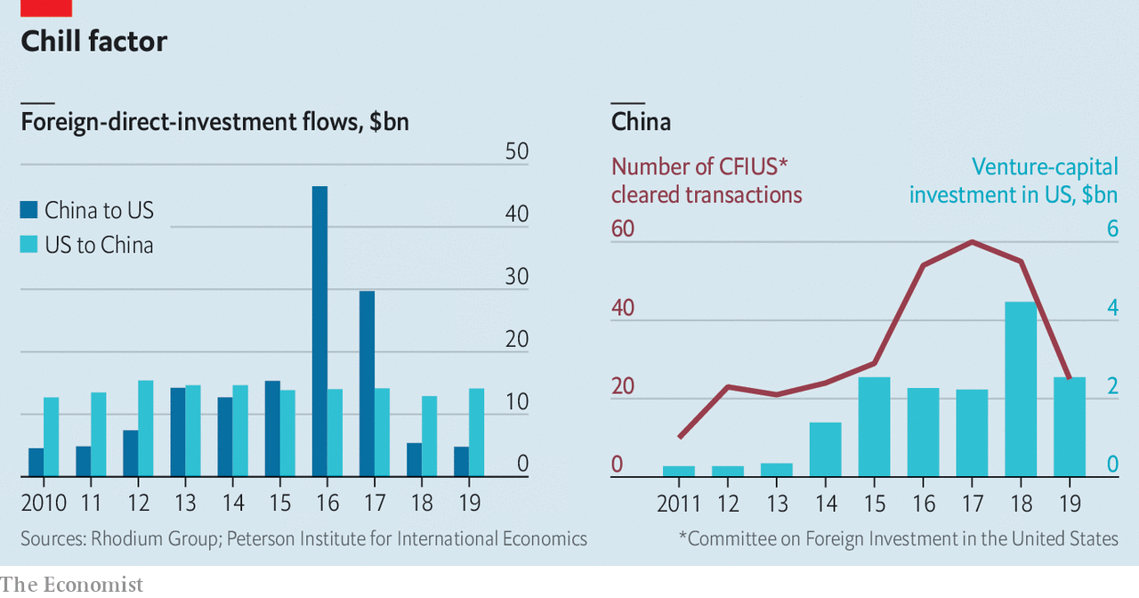

The Chinese would not be the only victims. American firms have robust and growing businesses in China, where they generate about 5% of global sales. Despite trade tensions American FDI in China actually rose in 2019. Before the pandemic Nike’s Chinese sales of sporting goods had grown by double digits for 22 straight quarters. GM sells more cars in China than in America. Tesla may make between 25% and 40% of its electric cars in China next year, reckons Bernstein, a research firm.

Mr Kroeber estimates American firms have over $700bn in assets in China and book about $500bn a year in domestic sales there. A new survey of members by the US-China Business Council, which represents big American firms, reveals that more now consider China a top strategic priority (16%) and top-five priority (83%) than did in 2019. Few plan to decamp from China.

America Inc, in other words, has a lot on the line. James McGregor of APCO, a consulting firm, says that Americans risk forsaking a market to European, South Korean or Japanese rivals. Wall Street could get squeezed by the push to delist Chinese firms. So far this year American banks raked in $414m in fees helping Chinese firms with initial public offerings and follow-on share sales, up by nearly a quarter from a year ago.

The biggest victim of decoupling would be America’s tech giants, many of which rely heavily on Chinese demand, as well as on Chinese suppliers. China represents over a quarter of global sales in sectors ranging from electronic components to internet software to semiconductors (see chart). Qualcomm, a chip giant, earns about two-thirds of its worldwide revenues in China and is lobbying furiously to soften sanctions against Huawei, a big client. Greater China (which includes Taiwan) makes up around 15% of Apple’s global revenues. If Mr Trump’s executive order forces American firms to halt all dealings with WeChat’s parent, Tencent, then Apple will be forced to block Weixin, WeChat’s local version. If that happens, Chinese smartphone users would choose Weixin over iPhones. Ming-Chi Kuo, a seasoned Apple-watcher, warns that a harsh ban could lead to a global decline in iPhone sales of as much as 25-30%.

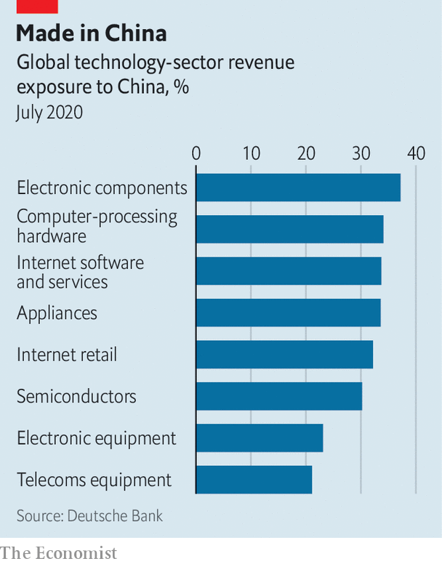

The new troubles reported by one executive at a big American chemicals firm may be a straw in the wind. China has been a great market for his company, he says, and the government at the national and provincial level remains solicitous and supportive. But local rivals have started making appeals to his Chinese clients. “Why would you buy products from an American firm at this time?” they ask. Why indeed.■

This article was downloaded by calibre from <https://www.economist.com/business/2020/08/15/the-trump-administration-wants-a-us-china-commercial-split>

|  |  |  |  |
| --- | --- | --- | --- |
|  | Articles | Sections | Next |

|  |  |  |  |
| --- | --- | --- | --- |
| Previous | Articles | Sections | Next |

#### The nuclear option

# How America might wield its ultimate weapon of mass disruption

Freezing China out of the global payments system could have unthinkable consequences

Aug 15th 2020 |

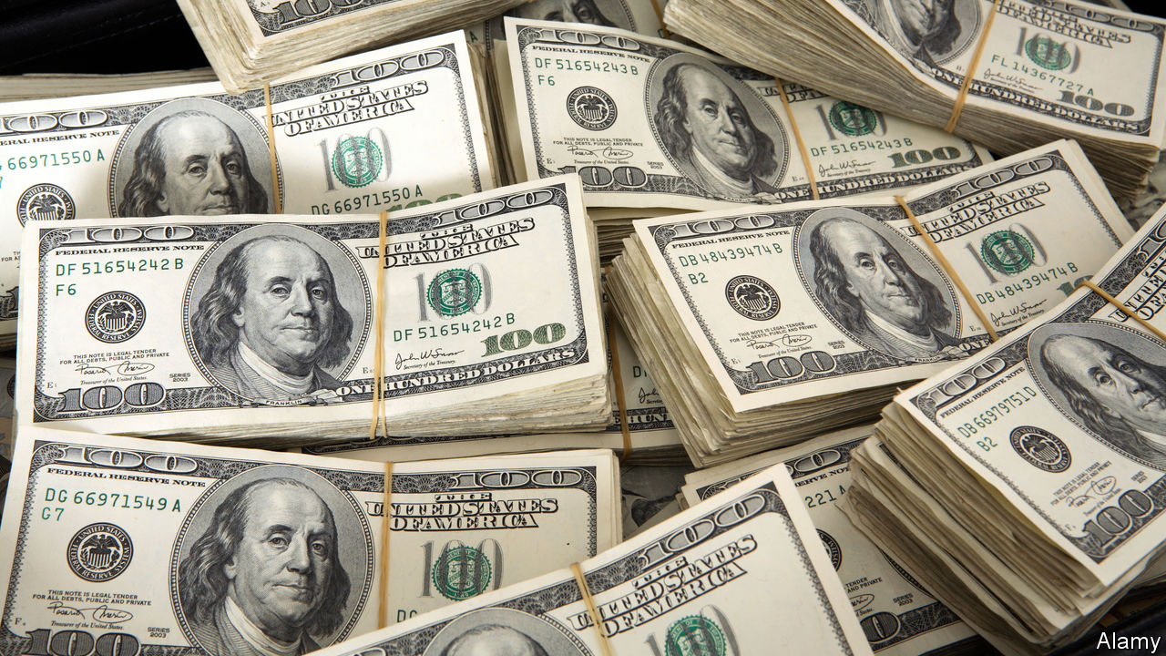

PRESIDENT DONALD TRUMP’S sabre-rattling against corporate China has had a real but, so far, limited impact on relations between the world’s two biggest economies (see [article](https://www.economist.com/node/21790864)). That could change if he decided to go all out and cut China off from the global payments system, which America controls thanks to the dollar’s status as the world’s reserve currency and lubricant of commerce.

Mr Trump has three main ways to constrain another country financially. He can refuse its banks access to CHIPS, a New York-based clearing house through which 95% of all dollar transactions are routed. He can try to force SWIFT, a Belgium-based messaging system which 11,000 banks worldwide use to make cross-border payments, to expel members from the offending state. And he can slap an embargo on its financial system, threatening to punish any foreign or domestic financial institution that uses dollars—as virtually all do—but continues to transact with the embargoed firms.

These tactics have been tested on Iran, North Korea, Venezuela and Myanmar—small economies with which America had few dealings. Mr Trump’s predecessor, Barack Obama, stopped short of deploying them against Russia after its invasion of Crimea in 2014. Doing so against China, with which America trades $560bn-worth of goods annually and whose four mega-banks are the world’s largest by assets, with large dollar loan books and liabilities, looks incomparably more fraught.

What would happen if Mr Trump nevertheless tried it? A huge shock wave would hit financial markets, already knocked about by the pandemic. The Chinese currency, along with those which track it, such as the Taiwanese dollar or the South Korean won, would suffer, says Claire Huang of Amundi, an asset manager. Hong Kong would run down its dollar reserves to try to support its peg with the greenback. Money would pour into gold.

In response, China would increasingly resort to its home-grown alternative to SWIFT, called CIPS. It would also try to persuade America’s allies in Europe and elsewhere that Washington was behaving irresponsibly. Many would not take much convincing. CIPS and the yuan, currently of marginal importance in international finance and commerce, would gain in stature at America’s expense.

China would also retaliate. It could shut its markets to Western banks and firms, block them from its infrastructure projects and limit America’s access to natural resources and basic goods it controls. And it, too, has a last-ditch deterrent: selling its $1.1trn stock of American treasury bills, equivalent to 4% of the total outstanding. America’s highly liquid bond markets may prove capable of absorbing the shock. Then again, they might not. Most observers do not consider dumping its T-bills a serious option for China, which has little interest in destabilising its system of currency reserves. But America is not the only country capable of self-harm apparently in the service of national security. ■

This article was downloaded by calibre from <https://www.economist.com/business/2020/08/15/how-america-might-wield-its-ultimate-weapon-of-mass-disruption>

|  |  |  |  |
| --- | --- | --- | --- |
| Previous | Articles | Sections | Next |

|  |  |  |  |
| --- | --- | --- | --- |
| Previous | Articles | Sections | Next |

#### Bartleby

# The decline of the office romance

Fewer romantic relationships will be forged at the water cooler. That is a shame

Aug 15th 2020 |

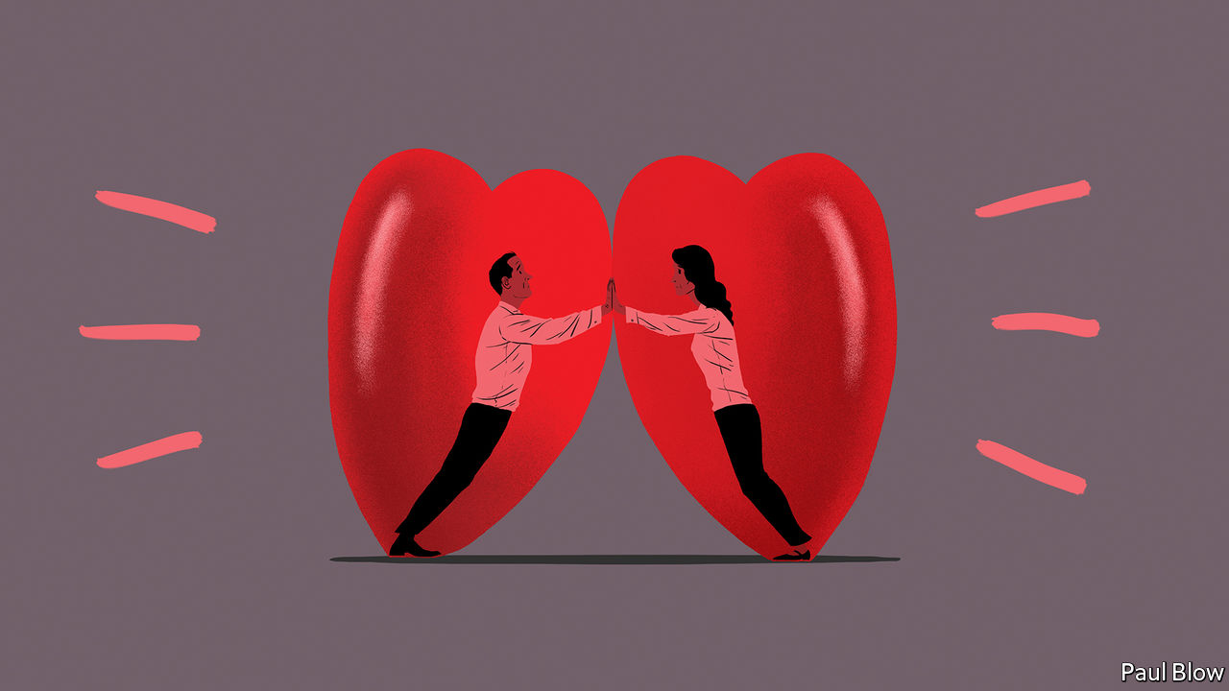

Editor’s note: Some of our covid-19 coverage is free for readers of The Economist Today, our daily [newsletter](https://my.economist.com/user#newsletter). For more stories and our pandemic tracker, see our [hub](https://www.economist.com/news/2020/03/11/the-economists-coverage-of-the-coronavirus)

THEIR EYES met across the office photocopier. At long last, each of them had found someone who could push their buttons. Eventually, they settled down and decided to reproduce. Read more in “Fifty Sheets of Grey Paper”, out soon in paperback.

Romance is a long-established side-effect of office life. After all, people may spend almost half their waking hours at work, and their colleagues will frequently have something in common with them, even if it is only complaining about the manager. Some relationships are inevitably bound to result.

But the lockdown has made the forming of new romances much more difficult. Although online dating has thrived in the pandemic, the number of people who have met their soulmate via a work Zoom meeting must be vanishingly small. It is hard to flirt while your facial expressions are being observed by a dozen colleagues. And how private is company videoconferencing software’s private-chat function, really?

Even before the pandemic, however, office romances were in decline. In 1995, 19% of (heterosexual) people met their partner at work, according to a study by Stanford University. By 2017 this had fallen to 11%. It will be even lower now. As white-collar employees toil more hours at home and fewer at the office—which seems likely even after the virus recedes—opportunities for workplace romantic connections will dwindle.

One reason for the decline is that companies have realised that work relationships give rise to all kinds of ethical questions. The idea of a boss marrying his secretary (or a doctor dating a nurse) is one of the oldest clichés around. Sadly, the trope is so well established that secretaries and nurses have spent decades fending off the unwanted attentions of their superiors. As the #MeToo movement has demonstrated, some men use their positions of power to harass women who work for them.

Consensual relationships can cause problems as well. A relationship with a subordinate makes it hard for a manager to be objective about their performance. Colleagues may understandably suspect the manager of favouritism. Things may be as bad if the romance breaks down. Hurt feelings may make it hard for the ex-partners to work together and will also make it awkward for everyone else in the office.

The result of this is that many companies have policies that discourage or forbid managers from flings with someone who works for them. Office relationships were blamed for the departure of Steve Easterbrook from his role as chief executive of McDonald’s last year; the fast-food company launched a lawsuit against Mr Easterbrook this week.

Some companies ban all office romances outright. Others issue guidelines such as the stipulation that employees should not allow a relationship with a colleague to influence their behaviour at work, and that they should disclose any relationship that might give rise to a conflict of interest. These rules seem perfectly sensible, although they do involve a sacrifice of privacy.

Some of these problems can be avoided if the relationship is at one remove: if people meet their partners through work, rather than at the same office. Clearly there could still be problems if, for example, a purchasing manager was dating the salesperson at a supplier. But in most circumstances these romances avoid the potential problems of favouritism or abuse of power. Bartleby was fortunate enough to meet his spouse through his job 24 years ago (a period that proves Mrs Bartleby’s infinite reserves of patience).

For that reason, this columnist can perhaps be forgiven for hoping that the office romance does not disappear completely. Millions of happy couples have probably met by their desks or the coffee machine. Perhaps couples will get a buzz from defying company rules. But they may have to be subtle about it: “Speak low if you speak love,” as William Shakespeare wrote in “Much Ado About Nothing”. That said, romance novels may need a bit of updating to cope with the post-pandemic era.

Their eyes met across the bottle of hand sanitiser. “Would you like to break the social-distance rules and join my bubble?” he whispered. “Sorry, I can’t hear you through the mask,” she replied. He searched for inspiration. How could he convey his feelings? As creative director of Tomkins & Tomkins, surely there was an answer? A brainwave came: he raised his hands. Her eyes widened in understanding. “First word,” she said. “Sounds like ...”

This article was downloaded by calibre from <https://www.economist.com/business/2020/08/15/the-decline-of-the-office-romance>

|  |  |  |  |
| --- | --- | --- | --- |
| Previous | Articles | Sections | Next |

|  |  |  |  |
| --- | --- | --- | --- |
| Previous | Articles | Sections | Next |

#### Trial by fire

# Profits fall sharply at Saudi Aramco, the world’s biggest oil firm

In its first six months as a public company it has shown unrivalled strength—and unusual weakness

Aug 13th 2020 | NEW YORK

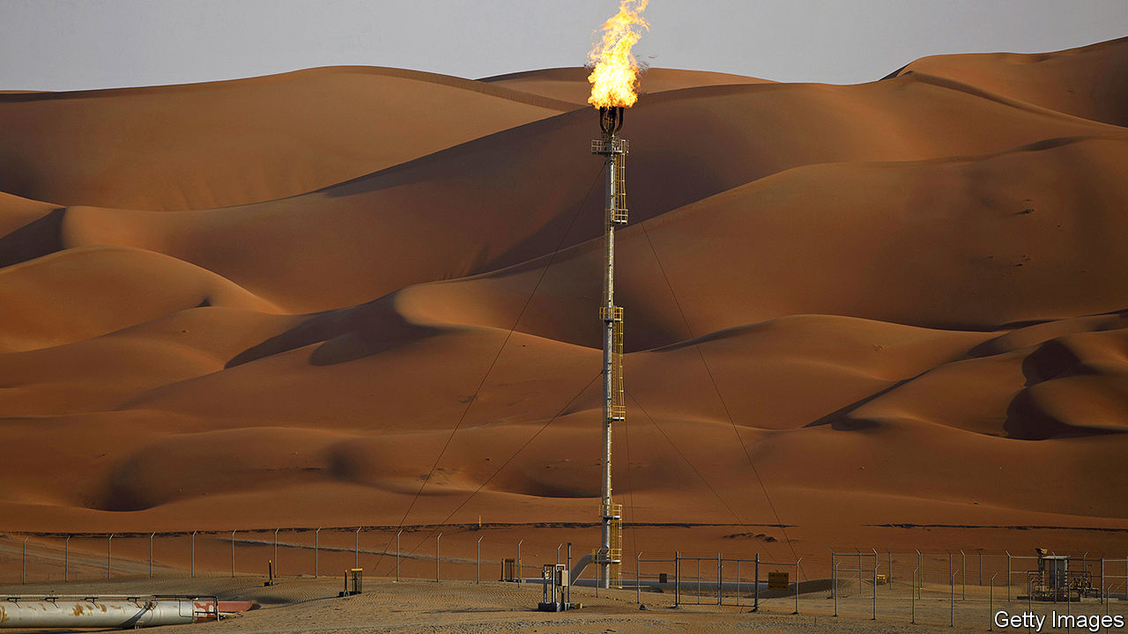

IN DECEMBER, WHEN Saudi Aramco listed 1.5% of its shares on the Riyadh stock exchange, it became the world’s most valuable listed company, with a market capitalisation of $1.9trn or so. The state-backed oil behemoth’s bosses assured investors that low costs and vast reserves would make it resilient in a downturn. Since then Saudi Arabia and Russia waged a short but brutal price war, covid-19 has provoked the most sudden collapse in oil demand on record, and Aramco lost its stockmarket crown to Apple, whose market value has risen by nearly 50% this year to $1.9trn, while Aramco’s has edged down by 6%. Then, on August 9th, the firm reported a 73% year-on-year fall in second-quarter profits.

The events are a Rorschach test both for Aramco’s boosters and its critics. Proponents see a firm that can produce more oil, more profitably than anyone on Earth. Sceptics point to unusual vulnerabilities, notably its majority owner’s dependence on its profits. As with all Rorschach tests, there is no one right assessment.

Start with the optimists. On August 10th Amin Nasser, Aramco’s chief executive, touted its “resilience across oil-price cycles”. Aramco may have endured more of a cyclone than a cycle this year, but Mr Nasser’s claim rings true. His firm has fared well, at least relative to rivals. It still made money, $6.8bn in the three months to June, in contrast to the likes of Royal Dutch Shell and BP, two European giants, which lost $18.1bn and $16.8bn, respectively.

Or take Aramco’s debt. At 20.1% of capital, it is above the range of between 5% and 15% the firm had promised, in part owing to its $69bn purchase of a 70% stake in SABIC, a Saudi state-controlled petrochemicals company. Yet it remains less indebted than other oil majors. Critically, its investors enjoy juicier returns (see chart). In a world where many firms are reluctantly choosing to cut their dividends (see [Schumpeter](https://www.economist.com/node/21790857))—as BP has done by half and Shell by two-thirds—Aramco is keeping its pledge to return $75bn to shareholders this year.

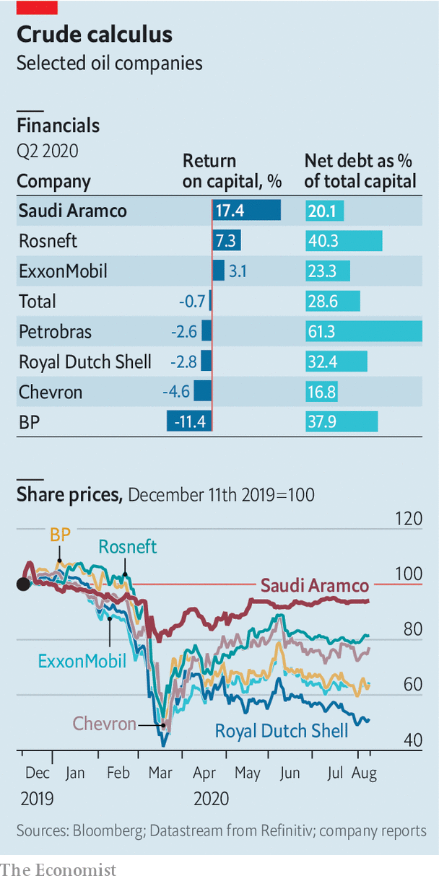

Aramco’s 262bn barrels of crude reserves and low production costs also allow it to limit spending without threatening future output, unlike America’s frackers, forced to pare back activity as investors sour on shale. Big international companies are slashing capital spending, too. BP and Eni, an Italian major, plan to reduce crude production over the next decade, amid investor disenchantment with oil’s returns and rising concern over climate change. If that continues, Aramco may gain market share with no need for another price war.

To the sceptics, saying Aramco is more resilient than rivals is like boasting that milk is sour but not curdled—neither prospect is appetising. The outlook for oil remains uncertain as consumer habits change, electric cars get cheaper and governments mull new climate regulations.

A bigger short-term worry is Saudi Arabia’s sway over Aramco. The firm now has minority shareholders but they remain powerless. And recent months have shown how complicated royal control can be.

Aramco’s production depends not on market forces, but on Saudi priorities. At the height of the price war in April Aramco pumped 12.1m barrels a day—an impressive feat that helped drive down global prices and lower Aramco’s profits. For every dollar the oil price falls, Aramco’s cashflow generally declines by $1.5bn, reckons Neil Beveridge of Bernstein, a research firm.

As Saudi Arabia made peace with Russia and others in an attempt to balance crude markets in May and June, Aramco has returned to its role as oil’s central banker. That is better than waging a price war in a pandemic, but still awkward for Aramco. The kingdom calibrates its output not just to support oil prices but to encourage other petrostates to do the same.

Aramco’s interests and the kingdom’s can diverge in other ways. For example, even as the market value of SABIC, which is also listed in Riyadh, has fallen over the past year Aramco did not renegotiate the $69bn purchase price agreed in 2019. Aramco’s chairman, Yasir Al-Rumayyan, also leads Saudi Arabia’s Public Investment Fund, which sold Aramco its 70% stake in SABIC and which is also tasked with investing to diversify the Saudi economy.

That economy is strained. Last year Saudi Arabia needed an oil price of more than $80 a barrel to balance its budget. Brent crude, the international benchmark, has not fetched more than $50 since February. Despite spending cuts Saudi Arabia still faces a yawning deficit.

All of Aramco’s shareholders covet the same thing: payouts. To lure investors before listing, Aramco said it would give priority to non-state shareholders’ dividends for five years, come hell, high water or cheap oil. No one really thought it would have to make that choice. Now it has borrowed to meet its $75bn dividend pledge. As Mr Beveridge notes, that stategy is unsustainable at current oil prices. Those prioritised payments remain subject to approval by the board. Sooner or later Aramco will have to decide: keep the promise to minority owners or renege? That will be a real test of its bona fides as a public company. ■

This article was downloaded by calibre from <https://www.economist.com/business/2020/08/13/profits-fall-sharply-at-saudi-aramco-the-worlds-biggest-oil-firm>

|  |  |  |  |
| --- | --- | --- | --- |
| Previous | Articles | Sections | Next |

|  |  |  |  |
| --- | --- | --- | --- |
| Previous | Articles | Sections | Next |

#### Profits v purpose

# How American bosses juggle profits and purpose

Of America’s 50 states, 32 have at least one law that lets a firm’s fiduciaries take some non-shareholder interests into account

Aug 15th 2020 |

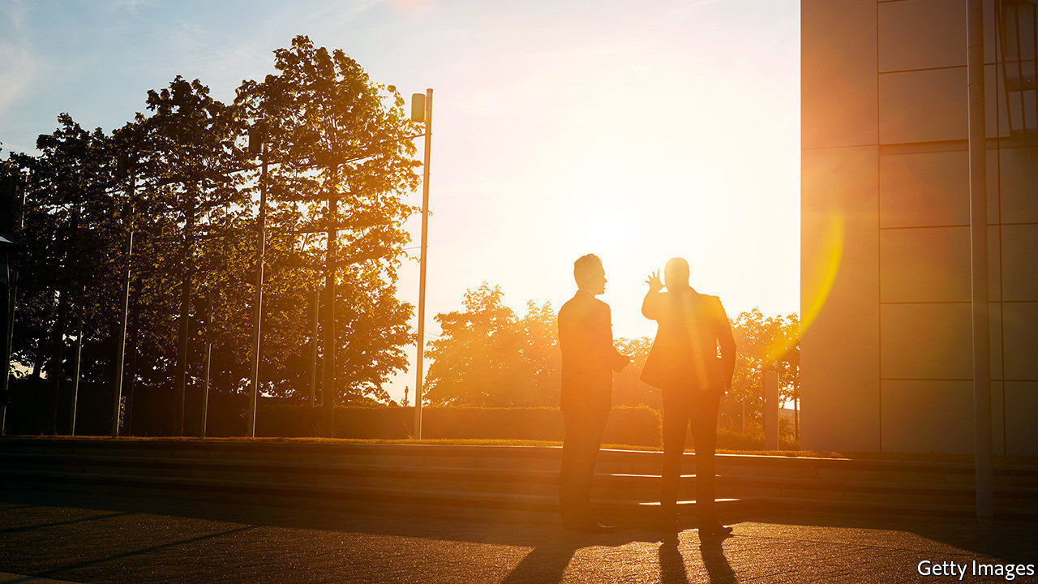

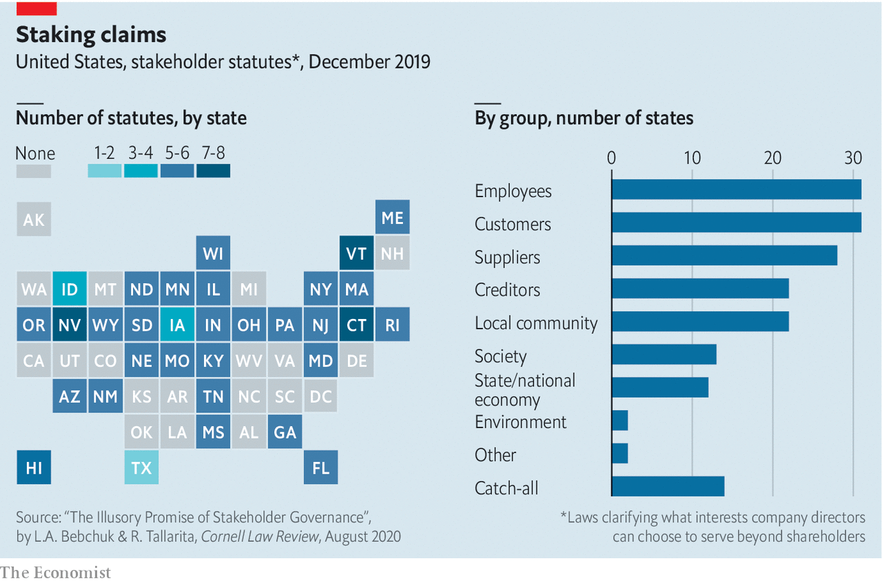

LAST YEAR 184 of America’s mightiest bosses vowed to manage their firms in the interest not just of company owners but also of other stakeholders—from employees to the environment. Of America’s 50 states, 32 have at least one law that lets a firm’s fiduciaries take some non-shareholder interests into account. Still, as new research from Harvard Law School suggests, many firms are only paying lip-service to the fashion for purpose. Tellingly, it finds that ceos did not consult their boards before signing the pledge: of the 48 firms for which data are available, just one boss got the board’s express approval.■

This article was downloaded by calibre from <https://www.economist.com/business/2020/08/15/how-american-bosses-juggle-profits-and-purpose>

|  |  |  |  |
| --- | --- | --- | --- |
| Previous | Articles | Sections | Next |

|  |  |  |  |
| --- | --- | --- | --- |
| Previous | Articles | Sections | Next |

#### Superjumbo problems

# What’s an A380 worth?

The world’s biggest passenger aeroplane is going cheap

Aug 15th 2020 |

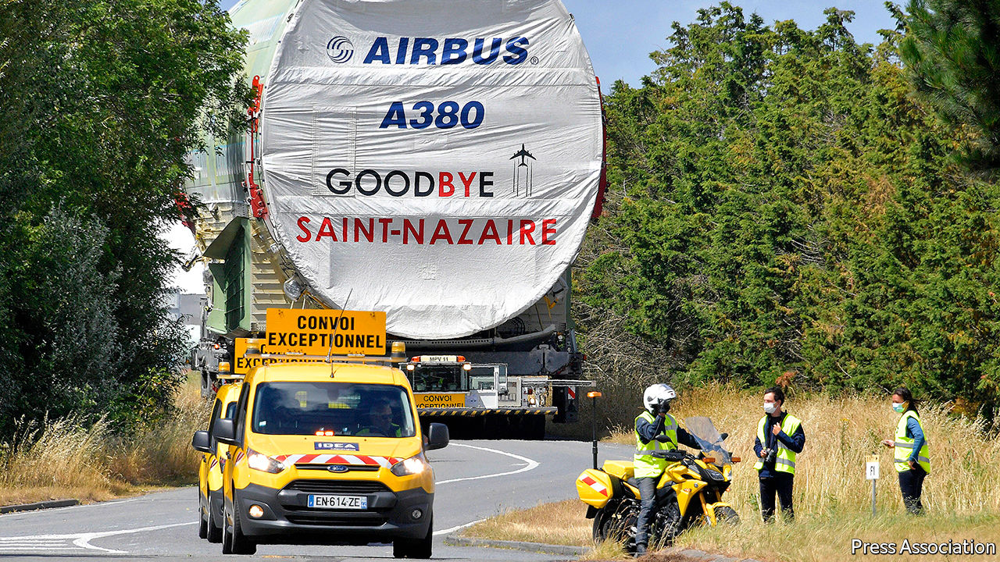

HOW MUCH is an airliner worth if it is languishing on the tarmac, and may never fly passengers again? In the age of covid-19 that is the fate of many double-decker A380 superjumbos built by Airbus, Europe’s aerospace giant. Once seen by airlines as the future of commercial aviation, many are being retired early as covid-19 has cast a pall on the future of globe-trotting. Those still in service could be yours for a few million dollars.

The A380 was in trouble before the pandemic. Delays meant that by the time it at last flew it had to compete with smaller, more efficient jets. Only 14 airlines ever ordered the 500-plus seater, with Emirates, based in Dubai, operating nearly half the 242 planes delivered. After Emirates cancelled orders for 39 in February 2019, Airbus announced it was winding down production of the plane.

All aircraft have lost value as a result of covid-19. But the fall has been unusually steep for A380s. The model’s main attraction for airlines was to relieve congested runways at global hub airports. Now these are empty. Fewer than one in ten working A380s are plying the skies, according to Flightradar24, which tracks air traffic. Smaller craft are faring somewhat better.

The aviation industry may not recover until 2024, according to the International Air Transport Association, a trade group. That is a long time to maintain aeroplanes, so some airlines have thrown in the towel. Air France has announced its nine A380s will never fly again, and booked a €500m ($588m) write-down in the value of its fleet. Germany’s Lufthansa has cut its 14-strong squadron by six. Singapore Airlines, the second-biggest operator with 19 planes, plans an ominous-sounding “review”.

Valuations of A380s have tumbled accordingly. The oldest models have been flying for 12 years or so. At that age, aircraft have typically lost half their value. Given each costs $250m-300m to buy when kitted out, airline accountants might have hoped for $125m. But even before covid-19 appraisers suggested between $75m and $100m. Now some A380s are fetching half what they used to be worth, says Usman Ahmed of Aircore Aviation, a consultancy. The slump is borne out by the accounts of investment funds that own planes and lease them to airlines. A fund called Doric Nimrod Air One recently cut the accounting value of its sole asset, an A380 leased to Emirates, by 51% in dollar terms.

The share prices of listed A380-owning funds suggests the residual values of the planes once the leases expire are between $10m and $15m, says Matthew Hose of Jefferies, an investment bank. Given regular maintenance overhauls of each of the A380’s four engines can cost $6m, existing motors in decent nick are, in principle, worth at least that much. Add the landing gear, also in principle reusable, and that would make the airframe itself worthless. It also signals that even the spares—which in modern planemaking are always aircraft-specific and useless for other models—may not have much value.

Struggling operators sometimes convert unwanted passenger jets into cargo planes. But Airbus never launched a freight version of the A380, so the conversion would be tricky. No scheduled carrier that flies the aircraft already is keen on more, even at knock-down prices. The first A380 to fly, which came into service in 2007, has already been sent to the scrapheap. More are headed that way. ■

This article was downloaded by calibre from <https://www.economist.com/business/2020/08/15/whats-an-a380-worth>

|  |  |  |  |
| --- | --- | --- | --- |
| Previous | Articles | Sections | Next |

|  |  |  |  |
| --- | --- | --- | --- |
| Previous | Articles | Sections | Next |

#### Schumpeter

# Big Tech is the new dividend royalty

Slashed payouts reveal a shifting balance of corporate power

Aug 15th 2020 |



IN THE SHARP-ELBOWED world of business, the dividends that firms pay to their shareholders are often considered a bloodless topic. Compared with share prices, they rarely set pulses racing. Corporate-finance theory says that dividends are largely irrelevant to a company’s underlying value and its shareholders’ wealth—just as withdrawing cash from an ATM machine doesn’t make you richer. Accountants grumble that dividends can increase tax bills. Cynics shrug them off as hush money to shareholders. In America over the past few decades, they have increasingly been overshadowed by the more controversial practice of share buy-backs.

For business historians, though, dividends are full of drama. Their spiritual home is Europe, where they were born as ways of divvying up the spoils of Dutch and British shipping monopolies in the 17th century. On both sides of the Atlantic they accelerated during the railway boom of the 19th century, often through nefarious schemes to keep payments flowing so as to lure gullible new investors. Egregious payouts in the Roaring Twenties helped fuel the Wall Street crash of 1929, yet after the Depression they were seen as the best way to restore investor faith. Psychologically, they are intriguing. The promise of hard cash provides a conduit between managers and investors that some consider more reliable than earnings reports. Those seemingly bland dividend cheques provide a wealth of information that is easy to overlook.

The story they revealed as they dropped through shareholders’ letter boxes—or not—during the covid-19 pandemic only added to the cooped-up recipients’ woes. In Europe especially, a rash of dividend cuts showed how sick many of the region’s most blue-blooded firms were. Royal Dutch Shell and BP, two European oil majors, bowed to the inevitable toll of collapsing oil prices and took an axe to their dividends. Across Europe banks and life insurers, mainstays for many income-hungry pension funds, have suspended payouts under pressure from financial regulators. The unmistakable picture is of corporate Europe’s fragility and decline.

In America it is a different story. Firms there tend to prefer share buy-backs. Last year, for instance, the biggest American companies paid out an average of 41% of profits as dividends; comparable European firms paid out 66%. The respective shares for buy-backs were 59% and 23%. One reason for the preference is that American rules make repurchases a more tax-efficient way to return cash to shareholders than dividends. Many critics complain that American firms irrationally gorge on buy-backs as a result. But 2020 has highlighted the great benefit of this type of payout: its flexibility. As the economy tanked many big firms instantly dialled down their repurchases in order to conserve cash.

What about dividends in America? As in Europe, some so-called dividend aristocrats—ie, those who have increased the base dividend consecutively for years—were living beyond their means even before the pandemic struck, shovelling more money to shareholders than they made in profits. They include ExxonMobil as well as AT&T. The risk is that their bosses view dividend cuts as career suicide, and damage their firms’ balance-sheets in an attempt to maintain them, much as GE, a conglomerate, did in the latter years of Jeff Immelt, its ex-boss.

But overall the signal that dividends send about America Inc is of relative resilience. North American dividends (including Canadian ones) inched up in the second quarter, compared with the same period in 2019, according to Janus Henderson, an investment firm. Most big financial firms have managed to sustain their payouts even as regulators insist they build up buffers against a wave of bad debts (Wells Fargo is an exception). That fits into a longer-term pattern of American muscle: the dollar value of dividends from big firms has risen from $342bn in 2013 to $535bn in 2019, growing three times faster than dividends in Europe did.

That rise reflects the increasing generosity of a group of American companies which not long ago scoffed at dividends as condescendingly as they did suits and ties: technology firms. Strange as it sounds in the land of the buy-back, Big Tech is ascending to the ranks of the world’s dividend royalty, thanks to its prodigious and fast-growing cashflows. Since 2016, even with low payouts relative to earnings, Apple and Microsoft have been among the world’s five biggest payers of dividends in absolute terms, alongside Shell, its American rival ExxonMobil and AT&T. And because of the pandemic what would have seemed unthinkable not long ago may happen: Microsoft will probably take Shell’s crown as the world’s biggest payer among listed firms (with the exception of Saudi Aramco, the Gulf kingdom’s state-controlled oil colossus).

Once the pandemic passes it is likely that buy-backs in America will resume. Even so, the trend of growing dividends could continue, too. Many big payers have room to fork out more: Microsoft’s $15bn dividend in the financial year ending in June was barely a third of its $44bn in net profit. It had money left over even after adding a $23bn buy-back. Apple is in a similarly enviable position.

## From miser to monarch

Other well-endowed firms in America could join the ranks of the payout elite—if they choose to. They include remaining Big Tech giants—Alphabet, Amazon and Facebook—and Berkshire Hathaway, Warren Buffett’s investment behemoth. None of these pays dividends. In the brave new world of near-zero interest rates, the promise of a regular dividend yield, even a relatively low one, may become increasingly enticing to investors, who may lobby stingy managers for bigger payouts.

The tech firms might fear this would make them look middle-aged. Microsoft and Apple show that dividends need not thwart corporate ambition—at least if you make enough money, which Alphabet, Amazon and Facebook do. As investors’ desperation for yield increases, these firms may sooner or later face irresistible demands to join the dividend royalty. Long may they reign. ■

This article was downloaded by calibre from <https://www.economist.com/business/2020/08/15/big-tech-is-the-new-dividend-royalty>

|  |  |  |  |
| --- | --- | --- | --- |
| Previous | Articles | Sections | Next |

|  |  |  |
| --- | --- | --- |
| Business | Sections | Schools brief |

Finance & economics

Economic convergence: Club class

.

Turkey’s currency turmoil: Not at this rate

.

Tax transparency: Hands off, Uncle Sam

.

Gold in India: Financial alchemy

.

Blended finance: Seeking scale

.

Free exchange: Conscious uncoupling

.

|  |  |  |
| --- | --- | --- |
| Business | Sections | Schools brief |

|  |  |  |  |
| --- | --- | --- | --- |
|  | Articles | Sections | Next |

#### Club class

# A new study shows emerging economies are catching up

It also sheds light on some of the mysteries of economic growth

Aug 15th 2020 | HONG KONG

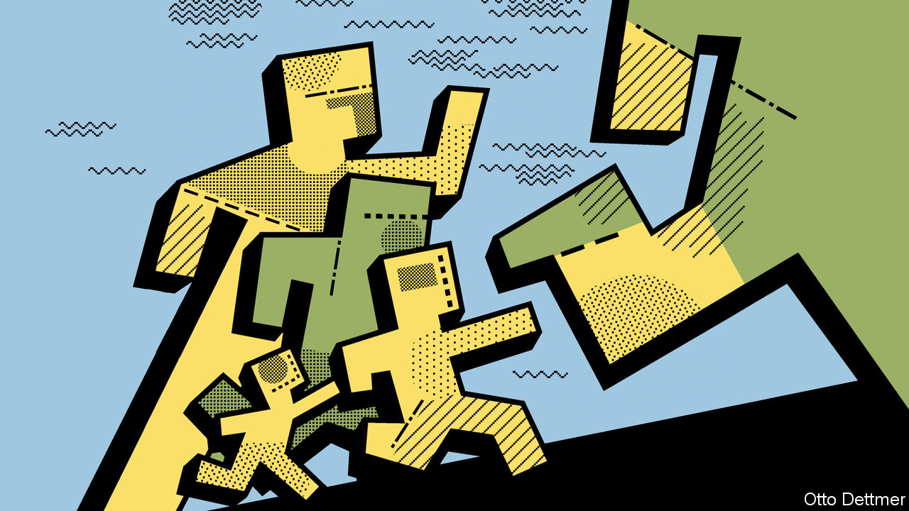

THIS AWFUL year could, paradoxically, be a good one for what economists call convergence. This normally takes place when poor economies grow faster than rich ones, narrowing the income gap between them. This year will be a bit different. Few emerging markets will grow at all—perhaps China, Egypt and Vietnam. But because advanced economies will probably retreat even faster, the gap between them will narrow. In the pandemic, like a 400m race, the laurels go to whoever slows down least.

The last time there was such a decisive growth gap between advanced and emerging economies was in 2013 (see chart 1). That was year of the “taper tantrum”, an emerging-market sell-off prompted by fears that America would slow its pace of monetary easing. It marked the end of a decade of heady emerging-market optimism best symbolised by the enthusiasm for the “BRICs”, an acronym coined by Goldman Sachs, which helped sell many investors on four of the most populous emerging markets: Brazil, Russia, India and China.

The idea that “backward” economies could grow faster than mature ones was first spelled out by economic historians like Alexander Gerschenkron in the 1950s and Moses Abramovitz in the 1970s. It rests on the assumption that imitation is easier than innovation and returns to investment are high where capital is scarce. The evidence for faster growth was weak between the 1970s and the early 1990s, but has become stronger since, as Dev Patel of Harvard University, Justin Sandefur of the Centre for Global Development and Arvind Subramanian of Ashoka University have pointed out most forcefully.

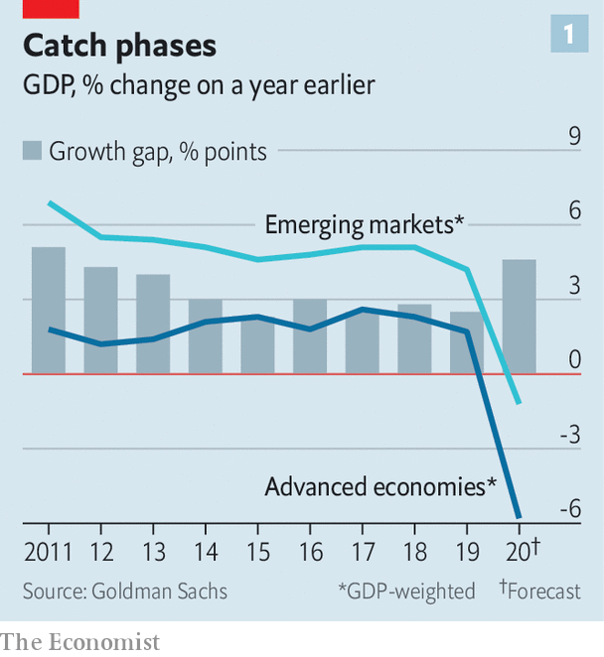

In making their projections for the BRICs, Goldman drew on a cautious version of the thesis, called “conditional” convergence. Simply put, this says that poor countries will grow faster than rich ones, other things equal. Those other things, for Goldman, included a country’s level of education, its openness to trade, its internet penetration and ten other characteristics. Academics have ranged even more widely. According to Steven Durlauf of the University of Chicago, Paul Johnson of Vassar College and Jonathan Temple, a freelance economist, researchers have identified 145 plausible factors that must be accounted for. The list includes everything from inflation and foreign direct investment to religion, frosty weather and newspaper readership.

Goldman assumed that emerging economies would catch up with a productivity frontier exemplified by America. But many economies seem to converge not towards a global leader but with their neighbours or peers. Indeed, some of the best examples of convergence come from within countries or economic blocs. Poor Japanese prefectures have tended to catch up with richer ones, as have Canadian provinces, Indian states and the regions of Europe.

If the forces of convergence operate within these blocs, it is reasonable to wonder if other such groupings exist. Are there any other convergence “clubs”, rich or poor, the members of which are bunching up?

In a new book, “Global Productivity: Trends, Drivers, and Policies”, the World Bank uses an algorithm to sort through many combinations of countries, looking for groups that seem to be converging with each other. Based on the productivity performance of 97 economies since 2000, the bank identifies five clubs. The three gloomiest groups comprise fairly poor countries. A fourth contains some big ones of unfulfilled potential, such as Argentina, Brazil, Indonesia, Mexico and South Africa.

The most successful club spans all today’s advanced economies as well as 16 emerging markets, such as China, India, Malaysia, Thailand and Vietnam (see chart 2). Poorer members tend to grow faster than the rich ones, at a pace that would halve the productivity gap between them every 48 years.

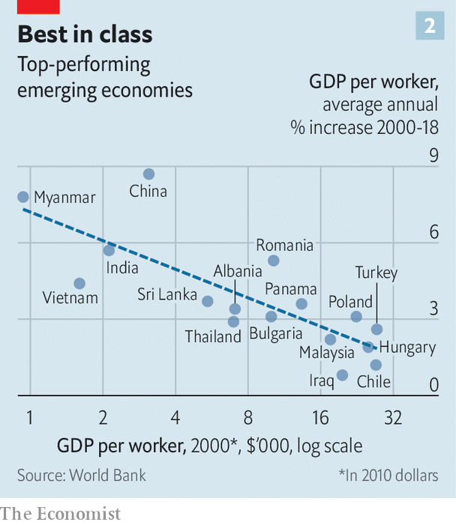

What explains the centripetal forces at work? It is not proximity: the countries range from Myanmar and Canada to Finland and Chile. Many members have impressive levels of investment and trade, but so do others in the clubs below them. Higher levels of education and government effectiveness make a bigger difference, at least at the start of their catch-up phases.

Most members of the top club also do well on a measure of economic “complexity” developed by Ricardo Hausmann of Harvard and César Hidalgo of the Massachusetts Institute of Technology. Countries score highly if their exports are both eclectic and exclusive, spanning a diverse range of products that few other countries also export. But there are exceptions. Chile is in the top club, but appears economically uncomplicated. That may be because its exports (copper, salmon, fruit) look simple but are produced, differentiated and packaged in sophisticated ways. Its round, red cherries, for example, are carefully selected for export to China as symbols of luxury.

The authors of the World Bank’s book worry that the covid-19 pandemic will inhibit investment, shorten supply chains and breed insularity, all of which could hamper convergence. But they also note some potential silver linings. Crises, for instance, can encourage structural reforms; the lack of upkeep of outdated capital during dark times can hasten its replacement with newer technologies in the recovery.

Pioneers of convergence theory understood that a country cannot fully exploit industrial advances if it clings to customary patterns of production and consumption: what Thorstein Veblen, a sociologist, called “the received scheme of use and wont”. For this reason Abramovitz believed that war and political convulsion can serve as a “ground-clearing experience opening the way for new men, new organisations and new modes of operation”. Optimists, who pray that convergence will outlast this convulsive year, must hope that the received scheme of use and wont is one of the pandemic’s many casualties. ■

This article was downloaded by calibre from <https://www.economist.com/finance-and-economics/2020/08/15/a-new-study-shows-emerging-economies-are-catching-up>

|  |  |  |  |
| --- | --- | --- | --- |
|  | Articles | Sections | Next |

|  |  |  |  |
| --- | --- | --- | --- |
| Previous | Articles | Sections | Next |

#### Not at this rate

# As the lira slides, what will Turkey’s central bank do?

The authorities are desperately trying to avoid rate rises

Aug 15th 2020 | ISTANBUL

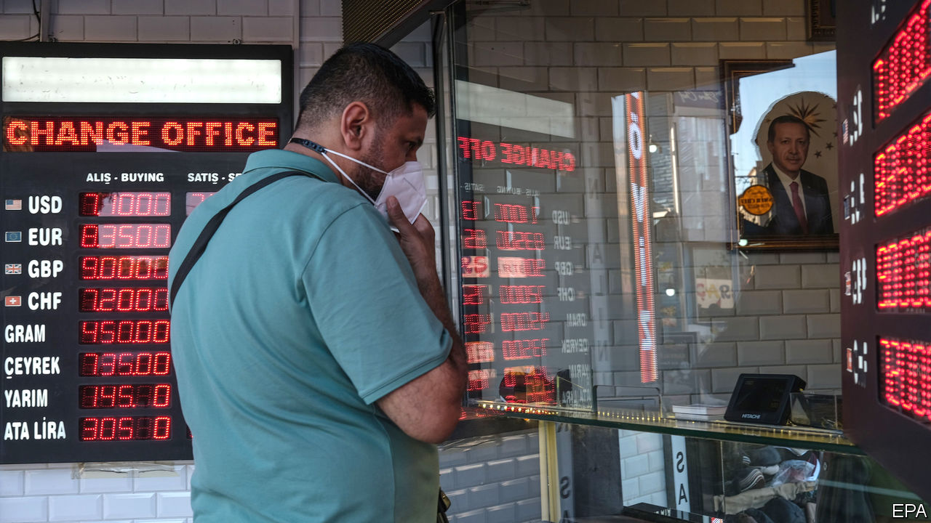

THERE SEEMED to be no end to the unusual measures Turkey would take to shore up the lira. The government had made it prohibitively hard for foreigners to bet against the battered currency. By the end of June the central bank had burned through $65bn in foreign reserves to protect it, in effect pegging it to the dollar for the past couple of months. On August 6th, however, the bank gave up and allowed the lira to float. It promptly sank (see chart 1). The currency fell by more than 3% during the day, reaching a record low.

Turkey may now be facing a repeat of the crisis of 2018, when a standoff with America, a credit boom and a bulging current-account deficit forced the central bank to impose towering interest rates in order to prevent a currency meltdown. Its monetary-policy board meets on August 20th. But the bank is even less independent than it was in 2018. Turkey’s president, Recep Tayyip Erdogan, sacked its previous governor for refusing to slash rates. His successor is highly unlikely to raise them without Mr Erdogan’s permission.

Another complication is that the bank’s foreign-currency assets are depleted. Gross assets dipped to $90bn in July (see chart 2). Net assets, which deduct foreign liabilities and borrowing through currency swaps with local banks, stand at -$41bn. “They have run out of ammunition,” says Ozlem Derici Sengul of Spinn Consulting, an advisory group. “If they continue like this, they may have no hard currency left.”

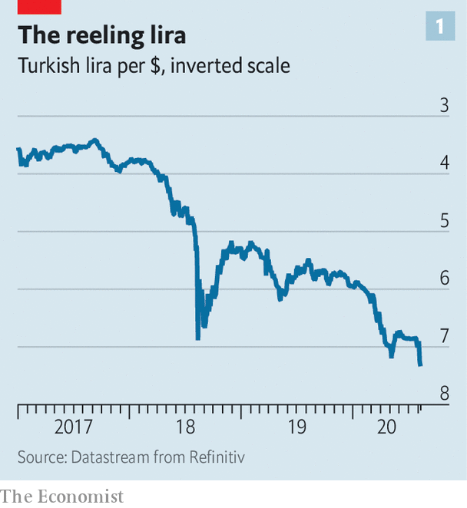

Turkey can still try to restore investors’ confidence in its management of the lira and the economy. But no one is certain it is willing to do so. For now, the government has begun cutting the money supply through the back door. Earlier this year, in an attempt to soften the blow from the covid-19 pandemic, state-run banks had flooded the market with cheap loans. The ensuing credit boom, the biggest in a decade, put renewed pressure on the lira and pushed inflation up. Days after the latest run on the currency, however, the banking regulator relaxed its rules on asset ratios, which had required lenders to pump out loans or face heavy fines. The central bank, meanwhile, has reverted to using a baffling system of policy rates, through which it can raise borrowing costs indirectly.

The combination of smoke and mirrors will not do. With the central bank’s benchmark policy rate at 8.25% and inflation at nearly 12%, Turkey has one of the lowest real rates among big emerging economies. Since the start of the year, the lira has shed nearly a fifth of its value against the dollar. Foreign investors have pulled $11bn from Turkish shares and bonds. Local depositors are running to the greenback for safety.

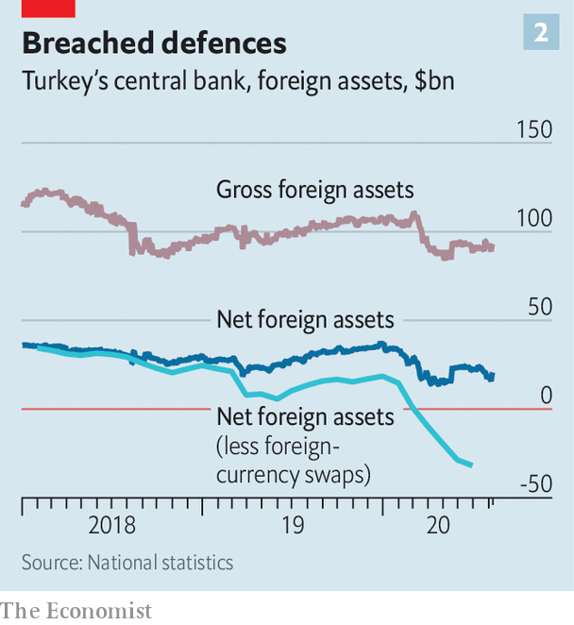

Analysts warn that the central bank’s failure to win back some of its credibility with a moderate interest-rate increase now may force a massive one later. Even this may not be enough. The right response, says Hakan Kara, a former chief economist at the central bank, would be to give the bank the freedom to raise the main policy rate. State banks must also take their foot off the gas, urges Mr Kara, and the authorities should let the financial system price risks freely.

Consistency would also help Turkey win back foreign investors. One day, regulators are punishing the banks for not handing out cheap loans, complains Gizem Oztok Altinsac, an economist; the next, they ask them to turn off the taps.

The problem is that Mr Erdogan is deaf to all this advice. On August 10th he called for rate cuts. “God willing”, he said, “they will go down further.” God help the lira. ■

This article was downloaded by calibre from <https://www.economist.com/finance-and-economics/2020/08/15/as-the-lira-slides-what-will-turkeys-central-bank-do>

|  |  |  |  |
| --- | --- | --- | --- |
| Previous | Articles | Sections | Next |

|  |  |  |  |
| --- | --- | --- | --- |
| Previous | Articles | Sections | Next |

#### Hands off, Uncle Sam

# Should personal financial data be sent to foreign tax authorities?

Activists argue current rules favour transparency over privacy

Aug 15th 2020 |

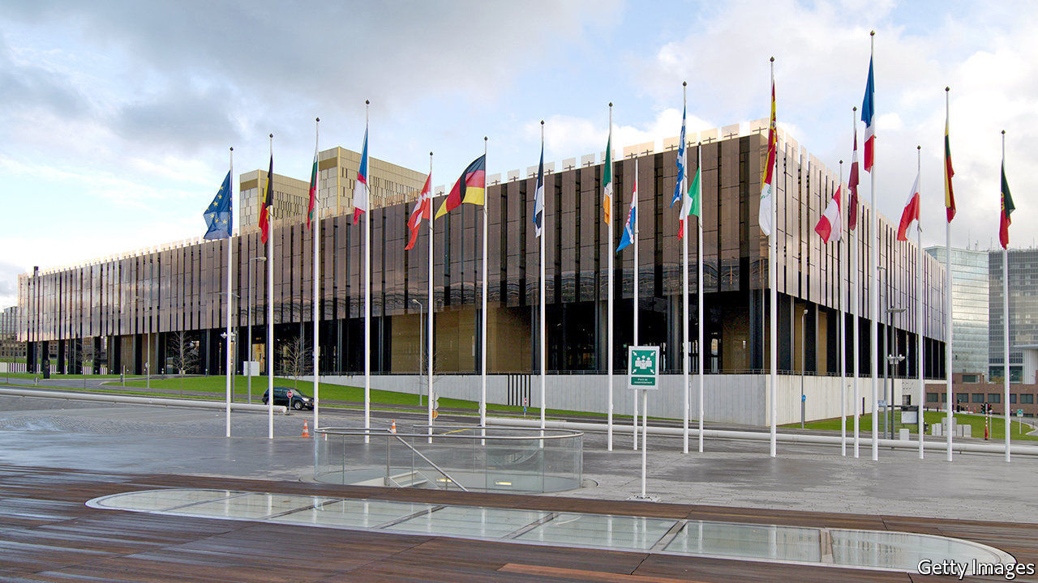

AMERICA’S ONGOING assault on firms from China, spurred by worries about its citizens’ personal data being passed to the Chinese government, will have put wry smiles on some faces—not least those of activists who for years have used similar arguments to try to stop their governments passing individuals’ financial data to America and other countries. Their legal challenges against transfers of tax-related data have had little success so far. But a recent ruling by the European Court of Justice (ECJ), the EU’s top court, could change that.

War on tax evasion was officially declared in 2010, when America passed the Foreign Account Tax Compliance Act (FATCA) in response to scandals involving rich Americans stashing undeclared money offshore. The law requires foreign banks and other financial firms to send data on American account-holders to the Internal Revenue Service. FATCA spawned a global version. Under the Common Reporting Standard (CRS), overseen by the OECD, more than 100 territories swap data on their financial firms’ foreign clients.

Who, apart from tax-dodgers, could complain about this? Quite a few people, it turns out. Critics say the sweeping arrangements favour transparency over privacy and data-protection rights. The transfers, they note, do not depend on there being any indication of tax evasion; all account-holders are treated with equal suspicion.

Europe takes privacy seriously; the EU’s General Data Protection Regulation (GDPR) is one of the bloc’s most treasured legal texts. But national governments have put up little resistance to FATCA, despite qualms. Some of them worried about the poor optics of appearing to defend the tax-shy. Others simply had no stomach for a fight with the financial superpower.

Legal challenges to the data-swapping provisions of FATCA and the CRS have been launched in Britain, Canada, France and elsewhere. Most have failed. One that lives on was brought by “Jenny”, a pseudonymous American living in Britain who crowdfunded the case. She complained to Britain’s data-protection authority, challenging the taxman’s right to send her information to America (where she owes no tax). Doing so, she argued, breached her rights under GDPR.

The data tsar rejected her claim, even though it accepted that the tax authority did violate some GDPR guidelines. It is not the only European data-protection body to duck the matter. “It’s perceived as a political issue. They don’t want to rock the boat,” says Filippo Noseda of Mishcon de Reya, the law firm that represents Jenny. The European Commission has also pulled punches. After first raising concerns about the data implications of FATCA, it then distanced itself from the issue, even claiming it had not been party to the original negotiations with the Americans, despite a document unearthed by an MEP, and seen by The Economist, suggesting that it was.

Jenny has until August 29th to seek judicial review of her case. She is likely to press on despite being short of funds. The case could end up at the ECJ—if it makes it there by December 31st, when the transition period for Britain’s exit from the EU ends.

The ECJ has already sided with data privacy activists in two cases involving an Austrian who complained about Facebook sending his data to America. In the second ruling, in July, the court went beyond social media, punching a hole in the “Privacy Shield” deal which governs transatlantic data transfers. That arrangement, it ruled, was invalid because it did not sufficiently guard against data falling into the hands of, say, America’s National Security Agency. The judgment could be a “game changer” for FATCA too, reckons Mr Noseda.

In the meantime, privacy is not the only worry. Security is one too. Tax authorities in Canada, Germany and elsewhere have had data stolen in cyber-attacks. In 2019 countries swapped data on 84m accounts, covering €10trn ($11.7trn)—nearly three times Germany’s GDP. A bane for tax-dodgers, then, but a boon for hackers. ■

This article was downloaded by calibre from <https://www.economist.com/finance-and-economics/2020/08/15/should-personal-financial-data-be-sent-to-foreign-tax-authorities>

|  |  |  |  |
| --- | --- | --- | --- |
| Previous | Articles | Sections | Next |

|  |  |  |  |
| --- | --- | --- | --- |
| Previous | Articles | Sections | Next |

#### Financial alchemy

# In India, gold-based finance is booming

Jewellery turns to collateral in troubled times

Aug 15th 2020 |

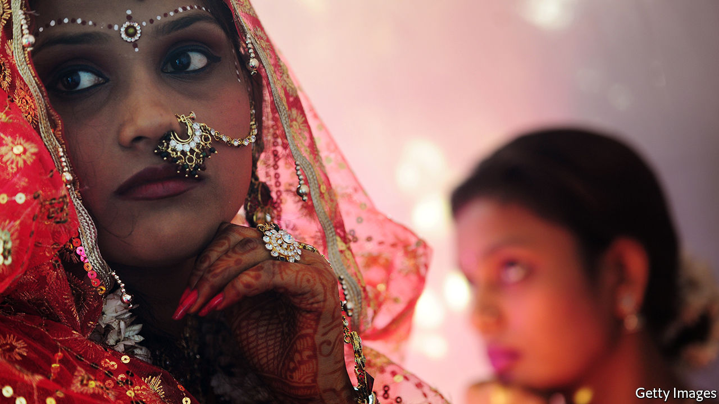

CLOSING TIME for the Kondapur branch of Muthoot Finance, in Hyderabad, is usually 5.30pm on a Monday. But on August 10th it was only two hours later that the manager, Haripuri Padmavati, and her five colleagues, could shut the doors. More than 150 customers had visited the gold-backed lender, six times as many as on a Monday before covid-19. Among the borrowers were those caring for infected family members; those who had lost their jobs but had big bills, such as school fees, to settle; and business owners needing to pay creditors and employees. The average loan size was 50,000 rupees ($700).

The pandemic has meant huge uncertainty about banks’ loan losses. Business at Muthoot, though, is booming. Loans are extended for a year in exchange for collateral in the form of gold—usually a bangle or necklace of the sort that lights up Indian weddings. The entire lending process usually takes 15 minutes. Jewellery is weighed, then scratched on a small square stone. Acid and salt are applied to the scratch, to test purity; 5-10% of items fail. With experience, says George Alexander Muthoot, the company’s managing director, you can tell by touch. In a video call with your correspondent, he demonstrates by putting a chain in his palm, flopping his hand to the left and right, and then opening up his fingers with a nod and a smile: appraisal done.

Muthoot has grown steadily since the early 1950s. It has more than 5,000 branches serving 250,000 customers a day, ranging from construction workers to IT professionals. Total loans exceeded $6bn in the year to March. Muthoot is the largest of the formal gold-backed lenders: collectively, their assets come to $40bn. Smaller lenders, which make loans worth twice that, charge annual interest rates as high as 50%. Muthoot charges 12-24%, as do its direct rivals. Banks, which are tiptoeing into the business, charge a bit less.

When the price of gold rises, as has happened for much of the past few months, so does a client’s ability to borrow. But lenders’ greatest risk is that the gold price falls, undermining collateral values. To provide a buffer, regulators had required that loans be less than 75% of the value of collateral. On August 6th the limit for banks was raised to 90%. But the gold price fell by 5% on August 11th—a reminder of why the buffer exists. Muthoot follows the old rule.

The greatest virtue of gold-backed finance, though, is how neatly it fits with India’s long-standing love for the yellow metal. In the past decade, despite high tariffs, India has imported 8,400 tonnes of it, more than the holdings of America’s Federal Reserve, the world’s largest repository. Windfalls are often channelled into gold. Jewellery bought in times of plenty becomes collateral when things go wrong—“the poor person’s insurance”, says Mr Muthoot. What makes his business especially lucrative is that borrowers work so hard to redeem their collateral, not just to help guard against future troubles, but to adorn the good times to come. ■

This article was downloaded by calibre from <https://www.economist.com/finance-and-economics/2020/08/15/in-india-gold-based-finance-is-booming>

|  |  |  |  |
| --- | --- | --- | --- |
| Previous | Articles | Sections | Next |

|  |  |  |  |
| --- | --- | --- | --- |
| Previous | Articles | Sections | Next |

#### Seeking scale

# Blended finance is struggling to take off

Hopes that it will fill a trillion-dollar financing gap seem far-fetched

Aug 15th 2020 |

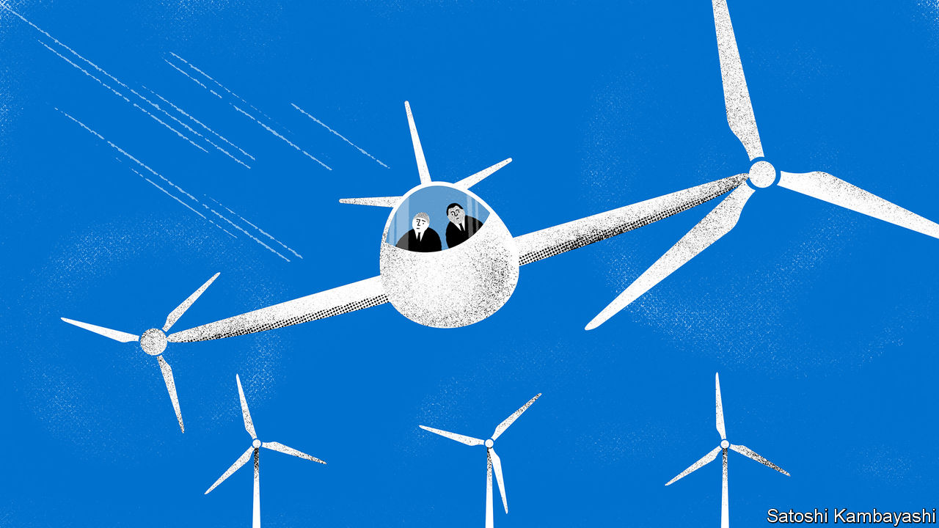

ANDREW JOHNSTONE runs a fund that goes “where people have not gone before”. Launched in 2015, Climate Investor One finances renewable-energy projects that the market deems too risky, such as wind farms in Vietnam and hydropower facilities in Uganda. It uses grants from development agencies to attract capital from pension funds. That allows it to raise more cash. For every $1 in grants, it has secured $12 from the private sector.

The fund is an example of blended finance, where public or philanthropic money reduces the risk from investments for the private sector, using financial vehicles such as default insurance or loan guarantees. The mixed-up money either directly finances projects, often infrastructure in poor countries, or pays into a fund supporting many ventures. The idea took root in development circles in the late 2000s. Many still see it as a way for markets to plug the gap in financing the achievement of the UN’s sustainable-development goals, estimated to be a whopping $2.5trn a year.

Institutional investors, the thinking goes, gain exposure to emerging markets at a lower risk. Development institutions, such as the World Bank’s financing arm, marshal more capital. Ideally, blended finance would open up new markets. Once the viability of water-treatment plants in Kenya is shown, say, the private sector should fund similar projects by itself.

Yet blended finance has struggled to grow. Since 2014 the flow of public and private capital into blended projects and funds has stayed flat at about $20bn a year, according to data from Convergence, a non-profit organisation. That is far off the goal of $100bn set by the UN in 2015, which targeted climate-change spending and was meant to be met this year. Even some advocates admit that the approach is stalling.

What is going wrong? For one thing, institutional investors are reluctant to get involved. The asset class is unfamiliar. Projects are often bespoke, and too small to make the effort worthwhile; the median value was $50m in 2018. That raises another problem, says Jay Collins of Citigroup, a bank. Creating a blended structure requires financial wizardry. But the wizards tend to work for big financial firms with little interest in titchy deals. Getting blending right also requires trust on both the public and private sides, says Mr Johnstone. A culture clash may prohibit that. One portfolio manager describes working with the lumbering bureaucracies as “tortuous”.

Another stumbling block lies with the public institutions. On average multilateral development banks mobilise less than $1 of private capital for every public dollar, says Katherine Stodulka, of the Blended Finance Taskforce, a global body. That is partly because their internal workings incentivise grant-making above blending.

Viable projects are also hard to find. In poor countries governments struggle to make projects investor-ready, lacking for instance the expertise to do feasibility studies. Private investors want to make the most returns, for a given risk; grant-makers want the most impact. A blendedfinance project must balance the two, and there are few of those, says Christoph Kuhn of the European Investment Bank (EIB).

To help blended finance bloom, some development banks are working with poor governments to show that projects are viable. That costs 2-5% of the project spending (in consultancy fees and so on), but reassures investors. Mr Kuhn advises using blending techniques that are familiar to investors. The EIB is focusing on layering equity, where the public tranche takes the first loss if a project goes wrong, and guarantees against losses for banks.

Greater transparency could lure investors too. Data on deals are often confidential, so it is hard to tell what returns are normal and how many projects go bust. Development banks promise more disclosure (but investors doubt it will happen).

Such small fixes will encourage growth. But merging public and private money will always be hard, and early hopes may simply have been too starry-eyed. A trillion-dollar market seems well out of reach. Even making it to the hundreds of billions a year may be a stretch. ■

This article was downloaded by calibre from <https://www.economist.com/finance-and-economics/2020/08/15/blended-finance-is-struggling-to-take-off>

|  |  |  |  |
| --- | --- | --- | --- |
| Previous | Articles | Sections | Next |

|  |  |  |  |
| --- | --- | --- | --- |
| Previous | Articles | Sections | Next |

#### Free exchange

# Has the ECB found a way around the lower bound on interest rates?

Its cheap loans to banks could help kickstart inflation

Aug 15th 2020 |

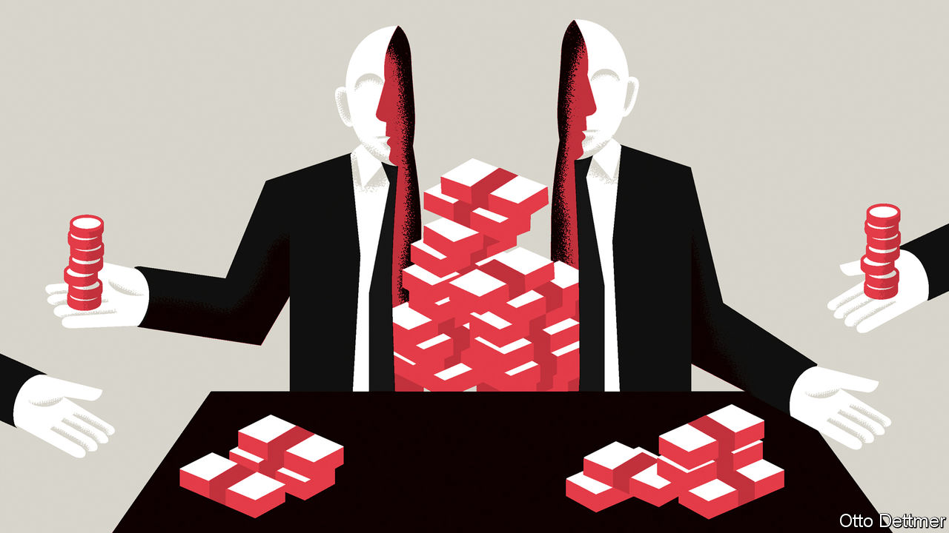

IMAGINE BEING locked in a dark room. Fearful of slamming into a wall or tripping, you inch forwards, arms outstretched. That is roughly how the European Central Bank (ECB) has approached interest-rate cuts since it first ventured into sub-zero territory in 2014. It knows there is a limit to how low rates can go, and that the limit is near, but, like the economics profession more broadly, it has no idea when it will hit the wall. With growth and inflation subdued, it cut rates gingerly, by 0.1 percentage points at a time. Even before covid-19 struck, its deposit rate was down to -0.5%. Rather than cut rates further, it has since relied on unconventional measures, such as bond-buying. Much of its stimulus has come from expanding its loans to banks, and decoupling the scheme’s interest rate from the main policy rates. With the introduction of dual interest rates, the ECB could well escape its locked room.

Cuts to interest rates are aimed at encouraging firms and households to spend by making borrowing more attractive, and saving less so. But when rates are negative their transmission to the real economy breaks down. Depositors can always choose to hold their funds in cash, which has an effective interest rate of zero. Banks worry that if they pass on negative rates, customers will yank their money out and stash it under mattresses instead. The result is squeezed net interest incomes for banks, a hit to their profitability, and, potentially, a reduced willingness to lend. Economists reckon that at a certain point—the so-called reversal rate—the stimulative effect of an interest-rate cut will be offset by the strain placed on banks. Fear of reaching this point helps explain why no central bank has gone deep into negative terrain.

In order to get around the problem, the ECB has souped up its long-term repo operations (LTROs), which lend to banks. When introduced during the euro area’s sovereign-debt crisis in 2011, they were meant to quell fears about banks’ funding shortfalls. Since then they have come in several flavours, from VLTROs—“very long-term”—to three rounds of TLTROs, or “targeted” operations, to PELTROs, for the “pandemic emergency”, announced in April. And the intention behind them has changed. TLTROs are a way to encourage banks to lend to the private sector. The more a bank lends to households and businesses, the lower the rate at which it can access TLTRO funds, according to a sliding scale set by the ECB. And in the topsy-turvy world of negative rates, the ECB is paying banks to extend credit to the economy.

This sort of scheme is hardly unique. The Bank of England has something similar. But one feature makes the ECB’s set-up novel. Until March the TLTRO rate was tied to the ECB’s benchmark interest rates. But the link has since been severed, and banks that meet the lending criterion can access funds at a much lower interest rate of -1%. The result is that banks can now get super-cheap funding, making a profitable spread when they use the proceeds to make new loans. Meanwhile deposit rates remain closer to zero, preventing savers from running to the door.

So far it seems that TLTROs have been popular and effective. Whereas the Fed this year has mostly focused on supporting capital markets, lending to banks has made up the bulk of the ECB’s stimulus—hardly surprising given the much bigger role banks play in intermediating credit in the euro area. By August 7th the ECB had lent €1.6trn ($1.9trn or 13% of euro-area GDP) through its lending schemes. In June alone banks borrowed €1.3trn. Once you add these in, finds Frederik Ducrozet of Pictet Wealth Management, the ECB’s balance-sheet has expanded more quickly this year than the Fed’s (see chart). In a speech in June Philip Lane, the ECB’s chief economist, reckoned that the measures alone, by averting a liquidity crisis, may prevent output in the euro zone from falling by three percentage points over 2020-22.

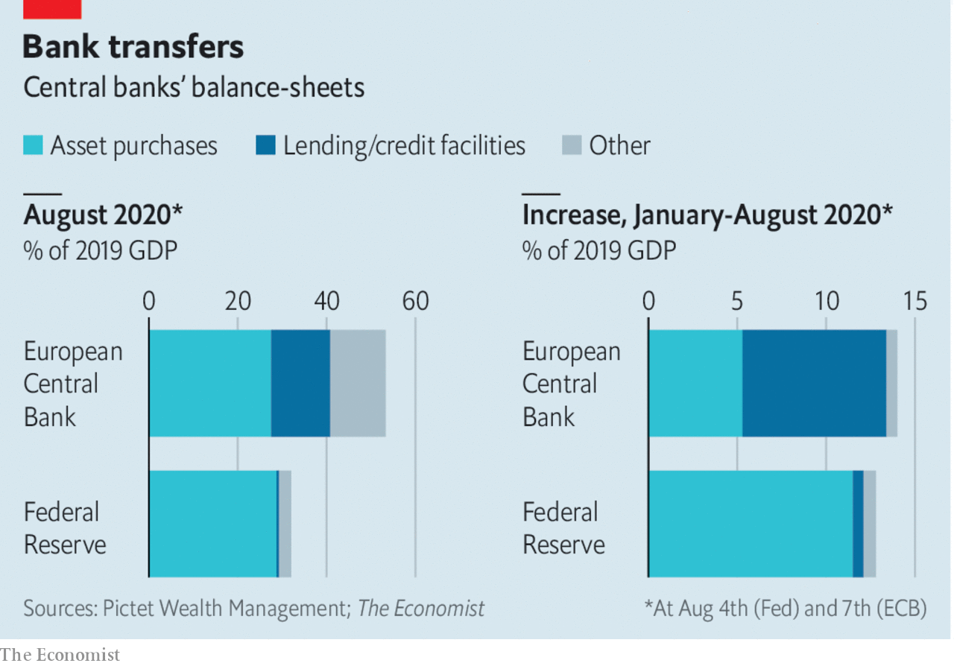

Proponents say dual rates could be more powerful still. There is no technical floor on the TLTRO rate: it can fall to -5%, -10%, or further. Lower rates could give inflation, long subdued, the kick it needs. Meanwhile the central bank could start to raise its deposit rate, satisfying critics in Germany and elsewhere, who worry about the impact of negative rates on savers. The sliding scale for assessing who gets access to cheaper ECB funding could be altered to, say, improve the transmission of negative rates. Banks could be asked to reprice their existing loan books, suggests Eric Lonergan of M&G Investments, a fund manager; in its most daring form, perpetual TLTROs could require banks to lend at negative rates—a way of transferring cash to citizens.

## The art of the possible

Could dual rates in some form become an established part of the toolkit, at the ECB and at other central banks? The impediments may well be political not technical. If a central bank lends to banks at a cheaper rate than the rate at which it remunerates reserves, then it makes a loss. (At the ECB, these losses are probably more than offset by profits on asset purchases.) Most economists would point out that losses do not matter; central banks can just print more money to pay their bills. But in practice central bankers have been wary of making losses, fearing that recapitalisation by governments might open them up to political pressure and scrutiny. They may also not want to be seen to be subsidising greedy bankers with deeply negative loan rates: some commentators in France, says Mr Ducrozet, are already muttering that the ECB is doing so. Perhaps it was for a combination of such reasons that Andrew Bailey, the governor of the Bank of England, told Bloomberg on August 6th that he did not expect to follow the ECB’s lead.

Dual rates may also not seem worth bothering with when fiscal policy is the more potent tonic for an economy in a recession. Even the European Union has managed to loosen the fiscal purse strings this time. But a quick, sufficiently large and well-targeted response from governments in the next downturn is not guaranteed. One lesson from the past decade of attempts to revive growth and inflation is that every stimulus measure has a political downside of one kind or another. If dual interest rates hasten the day that the economy recovers enough for monetary policy to be tightened, then surely they are worth having. ■

This article was downloaded by calibre from <https://www.economist.com/finance-and-economics/2020/08/15/has-the-ecb-found-a-way-around-the-lower-bound-on-interest-rates>

|  |  |  |  |
| --- | --- | --- | --- |
| Previous | Articles | Sections | Next |

|  |  |  |
| --- | --- | --- |
| Finance & economics | Sections | Science & ... |

Schools brief

Raising the floor: What harm do minimum wages do?

.

|  |  |  |
| --- | --- | --- |
| Finance & economics | Sections | Science & ... |

|  |  |  |  |
| --- | --- | --- | --- |
|  | Articles | Sections | Next |

#### Raising the floor

# What harm do minimum wages do?

Three decades of research have led to a rethink

Aug 15th 2020 |

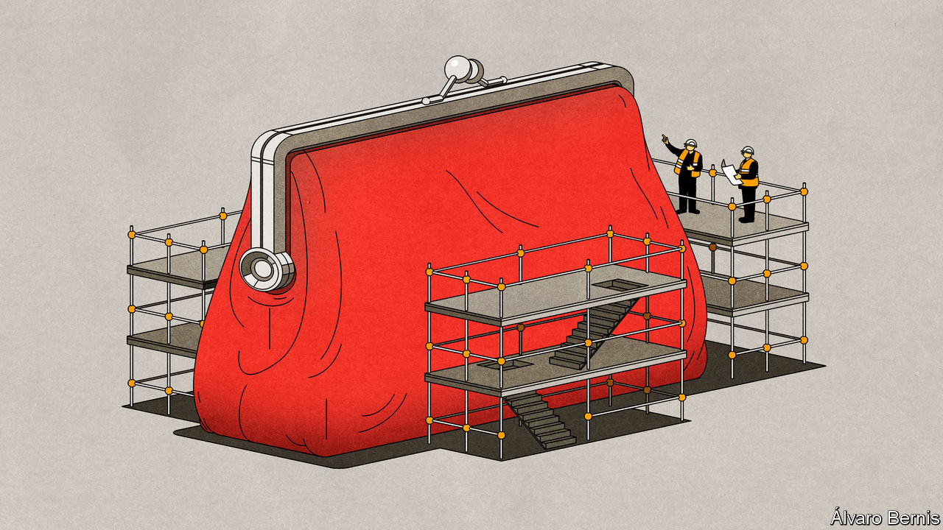

FOR A LONG TIME economists—whose median income, according to a survey of the American Economic Association (AEA), is $104,000 a year—considered minimum wages to be harmful. A survey of AEA members in 1992 found that 79% of respondents agreed that a minimum wage increases unemployment among young and low-skilled workers. In an often fractious field, that is about as close to a consensus view as can be found. Although many economists recognised that low pay can indeed be a real problem, they argued that no pay was worse.

They were not the only people who thought so. The same argument was used by Republican politicians. In 1968, America’s federal minimum wage stood at its highest level since first being applied in 1938. During the following two decades it fell, in real terms, by 44%. Though Jimmy Carter raised the wage in each of the four years he was president, keeping pace with inflation, Richard Nixon raised it only twice in six years and Ronald Reagan not once in eight. Some state and local politicians, mostly Democrats, tried to offset the fall by raising their minimum wages, creating a patchwork of different levels. The disparities this created allowed detailed empirical research on the policies’ effects, and provided the means by which the economists’ consensus would be undermined.

Not only did this see the conventional wisdom on minimum wages challenged in America; it also saw such policies spread elsewhere. Britain introduced a national minimum wage in 1998, and has increased it in recent years. Germany’s came into effect in 2015. Around 90% of countries have some sort of legal wage floor, although enforcement practices vary widely. Economists now have lots of data with which to understand how minimum wages affect the economy in practice and, in the context of a promise by Democratic presidential candidate, Joe Biden, to raise America’s federal minimum wage to $15, to argue about how high they can go.

The concern that minimum wages destroy jobs comes from the most basic of economic models: supply and demand. If labour is made more expensive, employers will probably want less of it. Textbooks state that, in the absence of a minimum wage, a worker is paid his “marginal product of labour”, which means the value of what he produces. There is no room to deviate from this wage in either direction. If an employer tries to pay a worker less, a rival firm will poach him. If the government imposes a minimum wage that is higher than a worker’s marginal product, the firm loses money by employing him. He is left jobless instead.

Reality is more complex. Firms do not know how much each worker contributes to their revenues. Few workers can find a new job at the drop of a hat. Yet the basic model reveals one important truth: the workers who are most vulnerable to losing their job as a result of the minimum wage are those whose productivity is low—the very people the policy is designed to help.

More sophisticated theorising about labour markets recognises that they are not perfectly competitive. There is no single wage at which a worker has his pick of employers. As a result, firms probably pay workers less than their marginal revenue product. How much less depends on negotiations and who does best there depends on bargaining power. In this framework, the goal of the minimum wage is not to defy market logic but to stop firms in a strong negotiating position from squeezing their workers.

The upper bound on the minimum wage still applies: firms will not willingly employ workers at a loss. But below that ceiling, the effect of the minimum wage is ambiguous. It depends on a series of questions. Can a company replace its workers with machines? Can it raise prices and make its customers pay for the minimum wage? Does it face competition from foreign firms who face laxer rules overseas?

Consider a comparison between factories and restaurants. Logically, there would be little scope to increase manufacturing pay using minimum wages, because firms face stiff international competition, and jobs are constantly automated away. By contrast, jobs in restaurants are hard to automate and face no foreign competition. Any increase in costs affecting the whole sector should be passed on to consumers. Job losses should be lower—especially if it turns out that consumers are willing to pay higher prices. So can one minimum wage do justice by both sectors?

The empirical study which revitalised the debate on minimum wages in the 1990s was by David Card and Alan Krueger, both then at Princeton University. In 1992 New Jersey increased its hourly wage floor from $4.25 to $5.05. Neighbouring Pennsylvania kept its own at $4.25. Thrilled at the prospect of a naturally occurring case study, the two economists gathered information of employment at fast-food restaurants in both states before the April increase and again several months later. Fast food seemed to offer the ideal conditions for a study, as a homogenous sector employing unskilled workers.

The increase in the wage floor did not lead to jobs being lost in New Jersey; employment in the restaurants they looked at went up. Nor did the authors find any indication that the opening of future restaurants would be affected. Looking at the growth in the number of McDonald’s restaurants across America, they saw no tendency for fewer to open where minimum wages were higher.

Their book, “Myth and Measurement” (1995), changed a lot of minds. By 2000 only 46% of AEA members were certain that a minimum wage increased unemployment among the young and low-skilled: to the rest the textbook view—that, faced with a rise in the cost of employing workers, firms would use fewer of them—was wrong. But why? Over the past 20 years a growing body of research has shown that a key consideration is the power enjoyed by employers.

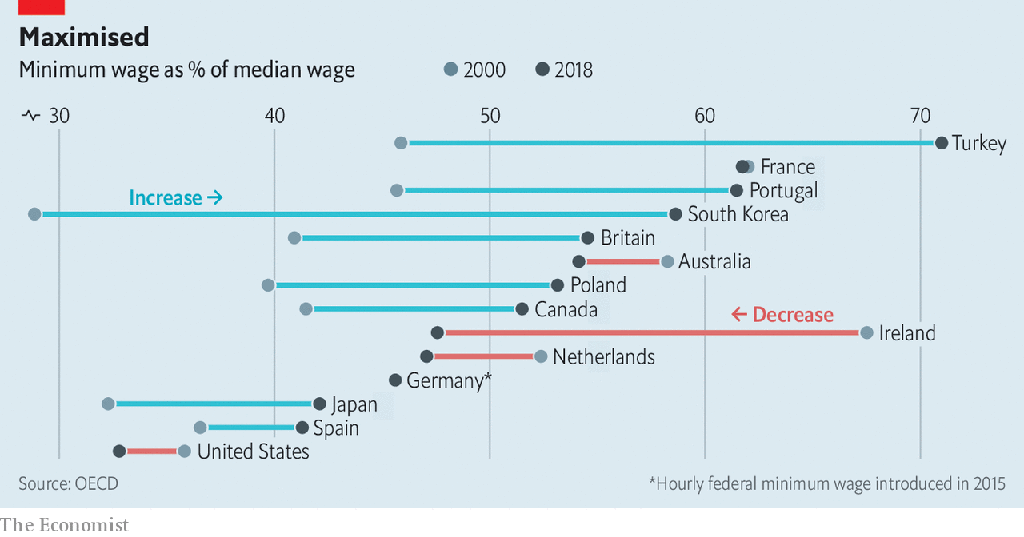

This school of thought argues that some labour markets are characterised by a market structure known as monopsony. Under a monopolistic regime one dominant supplier sells to many buyers, whereas under a monopsonic regime, one dominant buyer purchases from many sellers. Just as a monopolist can set prices higher than would be the case in a competitive market, a monopsonist can set prices artificially lower.

Thus, though it may sound counterintuitive for a higher wage to lead to more employment, it makes sense if what the legislation is doing is pushing a wage kept artificially low by monopsony back to where it would be in a market where supply and demand were matching each other freely. People who may not have bothered to look for a job at $10 an hour may be drawn into a job market offering $15 an hour. Push the minimum wage significantly beyond that point, though, and jobs will indeed be lost as companies find labour too expensive to afford.

Once the role of competition in the labour market is accepted, the debate on minimum wages becomes more nuanced and more empirical. Gathering data is not easy. Researchers must consider whether to track jobs or workers, and whether to study certain groups, such as teenagers or the unskilled, or broader sectors. And the job market is affected by more than just minimum-wage rules. Constructing reasonable counterfactuals is hard.

## Specific north-west

Consider an example from Seattle. The city has been at the forefront of the “fight for $15” campaign that led to Mr Biden’s pledge, and its rapid wage rises have made it an attractive laboratory for economic studies, despite the fact, some grumble, that it is unrepresentative. A paper by Ekaterina Jardim and others at the University of Washington, published in 2017, found that minimum-wage increases in the city in 2015 and 2016 led to employers reducing hours in low-paid sectors. The average low-paid worker earned more per hour but, because they worked fewer hours, their monthly earnings dropped by $74—the equivalent of five hours’ pay.

That paper used aggregate data on hours and earnings by sectors. In a paper published in 2018, the same authors used administrative data to track individual workers rather than looking at averages. This time they found that low-paid workers saw their weekly earnings increase by $8-12 a week. The majority of that gain, though, was taken by low earners with above-median experience levels and some of it from workers making up lost hours worked in Seattle with additional hours elsewhere in Washington state.

In 2019 a review commissioned by the British government of more than 50 recent empirical studies into wage floors found the effect on employment to be generally muted, even with relatively ambitious increases. Yet some studies did find higher impacts. Arindrajit Dube, the author of the review, warned that the evidence base is still developing. It is, for instance, too soon to opine on South Korea’s 25% increase in its minimum wage between 2016 and 2018.

The effects of a wage floor can also be felt outside low-pay sectors. A preliminary study in 2019 of the impact of Germany’s minimum wage found it led to more reallocation of workers from smaller, lower-paying firms to larger, higher-paying ones. The same year an article in the Quarterly Journal of Economics found that the impact of minimum-wage laws on average earnings was amplified by small but important spillover effects higher up the earnings ladder. Employers tend to want to maintain some sort of wage differential for staff with more responsibility. So if the minimum wage boosts the pay of fast-food workers, then restaurants may also need to raise the pay of fast-food supervisors.

Who pays for the minimum wage? In theory a higher cost base could be passed on to consumers through higher prices, or absorbed by employers through lower profit margins. In reality the answer varies by market. In competitive sectors, such as fast food, research has found that a 10% increase in the wage floor pushes up burger prices by just 0.9%. In 2019 a study of supermarkets in Seattle found no impact on grocery prices from big increases.

Economists no longer think higher minimum wages are always bad. But that is not the same as saying they are always good. In 2018 a paper by Isaac Sorkin and others cautioned policymakers to take a longer-term view, rather than worry about short-term unemployment. Its authors found that if firms perceived a higher wage floor to be permanent and unlikely to be eroded by inflation, it could encourage them to automate more and decrease employment growth in the future. The idea that a minimum wage can sometimes lead to higher rather than lower employment does not mean it always will. When pushing up the floor, policymakers need to ensure they do not hit the ceiling. ■

This article was downloaded by calibre from <https://www.economist.com/schools-brief/2020/08/15/what-harm-do-minimum-wages-do>

|  |  |  |  |
| --- | --- | --- | --- |
|  | Articles | Sections | Next |

|  |  |  |
| --- | --- | --- |
| Schools brief | Sections | Books & arts |

Science & technology

Space warfare: A legal void

.

Quantum mechanics: A flutter in time

.

Palaeontology: Not guilty?

.

Zoology: Rules of attraction

.

|  |  |  |
| --- | --- | --- |
| Schools brief | Sections | Books & arts |

|  |  |  |  |
| --- | --- | --- | --- |
|  | Articles | Sections | Next |

#### Satellite warfare

# An arms race is brewing in orbit

Experts want to clarify how the laws of war on Earth apply beyond it

Aug 15th 2020 |



KOSMOS 2542, a Russian satellite that was launched in November, was “like Russian nesting dolls”, said General John Raymond, head of America’s newly formed Space Force, in February. Eleven days after its launch it disgorged another satellite, labelled Kosmos 2543. Then, on July 15th, Kosmos 2543 itself spat out another object, which sped off into the void.

Merely a “small space vehicle” to inspect other satellites, said the Russians. Nonsense, said the Americans; it was a projectile. The intent, said Christoper Ford, the State Department’s top arms-control official, was to signal Russia’s ability to destroy other nations’ satellites.

Anti-satellite weapons are not new. During the cold war, America and the Soviet Union developed several ways to blow up, ram, dazzle and even nuke each other’s satellites. The countries conducted two-dozen anti-satellite tests between them. Ten were “kinetic”, involving a projectile physically striking a target.

But new competitors, and new technologies, mean anti-satellite warfare is a hot topic once again. China has conducted ten tests over the past 15 years, including a kinetic one in 2007 that created a great deal of space debris. India conducted its first kinetic test in 2019. America, Russia and China have all manoeuvred their satellites close to others, sometimes provocatively so. New methods of attack are being tested, including lasers and cyber-attacks.

There is little in the way of law or custom to restrain this new arms race. Alarmed by the risks, several groups of diplomats and lawyers are trying to change that, and work out how to extend the laws that cover Earth-bound war into orbit.

They must grapple with several thorny issues that make space war different from the terrestrial sort. Some satellites, such as America’s GPS constellation, blur the distinction between military and civilian assets. Over the past decade, America’s armed forces have put payloads on three commercial satellites, and plan to pay Japan to host others on its own navigation satellites.

Then there is the question of what counts as an attack. Michael Schmitt, a law scholar, and Kieran Tinkler, a professor at the US Naval War College, say it is unclear whether jamming a civilian satellite would violate the general prohibition on attacking civilian objects. Blowing up a military one, meanwhile, might or might not constitute an indiscriminate (and hence illegal) attack, depending on whether it could have been disabled by other means and how much debris was produced.

Perhaps the biggest difference between space war and terrestrial war is how long the consequences can last. Much of the debris from China’s 2007 test, for instance, will still be in space at the turn of the next century. The more debris, the greater the likelihood of accidental collisions with other satellites, which generates more debris in turn. Enough debris could lead to a chain reaction known as Kessler syndrome, which could render entire swathes of near-Earth space unusable for decades.

For now, there are no widely accepted answers to any of these questions. The Outer Space Treaty of 1967 requires states to consult each other on actions that “would cause potentially harmful interference”, though the rule has rarely been heeded. Most countries accept that, in wartime, a body of existing laws known as international humanitarian law would apply, as on Earth—something America confirmed in its “Spacepower” doctrine, published on August 10th. International humanitarian law is based on principles such as distinction (between combatants and civilians) and proportionality (between civilian harm and military advantage). But how to apply such ideas in a place with few humans is not always obvious.

In other domains of war, like naval conflict, legal manuals spell out what is and is not permissible. Legal experts are now attempting to do this for space. The Manual on International Law Applicable to Military Uses of Outer Space (MILAMOS) is being spearheaded by McGill University, in Montreal, and a separate Woomera Manual by the University of Adelaide. Both hope to publish their documents next year.

Hitoshi Nasu, a director of the Woomera project, says that—perhaps surprisingly—big countries are genuinely interested in complying with international law in war, if only to deprive their rivals of an excuse to break the rules. The trickier and more pressing issue, he says, is clarifying the day-to-day rules in peacetime, which might help avert a conflict in the first place.

Russia and China would like a formal treaty banning all weapons in space. Both are keen to prevent America from deploying space-based anti-missile systems which might threaten their own nuclear forces. America and its allies resist this. They argue that it is impossible to define a space weapon—anything that manoeuvres in orbit could serve as one—and that it would be easy to cheat.

The European Union has instead proposed a voluntary code of conduct. Many non-Western countries would prefer a binding treaty, says Daniel Porras of SWF. Though most are not space powers, many are likely to become so in the future, so their buy-in is important. Later this month Britain will publish a draft UN resolution seeking views on behaviour in space, with the results to be submitted to the secretary-general next year.

A group of experts has met regularly at the UN to try to hash out a solution, without much progress. On July 27th America and Russia held a 13-hour “space security exchange” in Vienna, the first such talks in seven years. It produced warm words, but is unlikely to lead to new laws—especially with existing arms-control collapsing.

Back in orbit, the problem is pressing. In January America complained that Kosmos 2542 and 2543 had tailed a spy satellite in an “unusual and disturbing” way (American satellites have also sidled up to others in the past). As space gets more “congested and contested”, the diplomats and lawyers have their work cut out. ■

This article was downloaded by calibre from <https://www.economist.com/science-and-technology/2020/08/15/an-arms-race-is-brewing-in-orbit>

|  |  |  |  |
| --- | --- | --- | --- |
|  | Articles | Sections | Next |

|  |  |  |  |
| --- | --- | --- | --- |
| Previous | Articles | Sections | Next |

#### Self-healing physics

# Quantum mechanics is immune to the butterfly effect

That could help with the design of quantum computers

Aug 15th 2020 |



IN RAY BRADBURY’s science-fiction story “A Sound of Thunder”, a character time-travels far into the past and inadvertently crushes a butterfly underfoot. The consequences of that minuscule change ripple through reality such that, upon the time-traveller’s return, the present has been dramatically changed.

The “butterfly effect” describes the high sensitivity of many systems to tiny changes in their starting conditions. But while it is a feature of classical physics, it has been unclear whether it also applies to quantum mechanics, which governs the interactions of tiny objects like atoms and fundamental particles. Bin Yan and Nikolai Sinitsyn, a pair of physicists at Los Alamos National Laboratory, decided to find out. As they report in Physical Review Letters, quantum-mechanical systems seem to be more resilient than classical ones. Strangely, they seem to have the capacity to repair damage done in the past as time unfolds.

To perform their experiment, Drs Yan and Sinitsyn ran simulations on a small quantum computer made by IBM. They constructed a simple quantum system consisting of “qubits”—the quantum analogue of the familiar one-or-zero bits used by classical computers. Like an ordinary bit, a qubit can be either one or zero. But it can also exist in “superposition”, a chimerical mix of both states at once.

Having established the system, the authors prepared a particular qubit by setting its state to zero. That qubit was then allowed to interact with the others in a process called “quantum scrambling” which, in this case, mimics the effect of evolving a quantum system backwards in time. Once this virtual foray into the past was completed, the authors disturbed the chosen qubit, destroying its local information and its correlations with the other qubits. Finally, the authors performed a reversed scrambling process on the now-damaged system. This was analogous to running the quantum system all the way forwards in time to where it all began.

They then checked to see how similar the final state of the chosen qubit was to the zero-state it had been assigned at the beginning of the experiment. The classical butterfly effect suggests that the researchers’ meddling should have changed it quite drastically. In the event, the qubit’s original state had been almost entirely recovered. Its state was not quite zero, but it was, in quantum-mechanical terms, 98.3% of the way there, a difference that was deemed insignificant. “The final output state after the ‘forward evolution’ is essentially the same as the input state before ‘backward evolution’,” says Dr Sinitsyn. “It can be viewed as the same input state plus some small background noise.” Oddest of all was the fact that the further back in simulated time the damage was done, the greater the rate of recovery—as if the quantum system was repairing itself with time.

The mechanism behind all this is known as “entanglement”. As quantum objects interact, their states become highly correlated—“entangled”—in a way that serves to diffuse localised information about the state of one quantum object across the system as a whole. Damage to one part of the system does not destroy information in the same way as it would with a classical system. Instead of losing your work when your laptop crashes, having a highly entangled system is a bit like having back-ups stashed in every room of the house. Even though the information held in the disturbed qubit is lost, its links with the other qubits in the system can act to restore it.

The upshot is that the butterfly effect seems not to apply to quantum systems. Besides making life safe for tiny time-travellers, that may have implications for quantum computing, too, a field into which companies and countries are investing billions of dollars. “We think of quantum systems, especially in quantum computing, as very fragile,” says Natalia Ares, a physicist at the University of Oxford. “That this result demonstrates that quantum systems can in fact be unexpectedly robust is an encouraging finding, and bodes well for potential future advances in the field.” ■

This article was downloaded by calibre from <https://www.economist.com/science-and-technology/2020/08/15/quantum-mechanics-is-immune-to-the-butterfly-effect>

|  |  |  |  |
| --- | --- | --- | --- |
| Previous | Articles | Sections | Next |

|  |  |  |  |
| --- | --- | --- | --- |
| Previous | Articles | Sections | Next |

#### An ancient murder-mystery

# What killed the woolly rhino?

Not humans, for a change

Aug 15th 2020 |

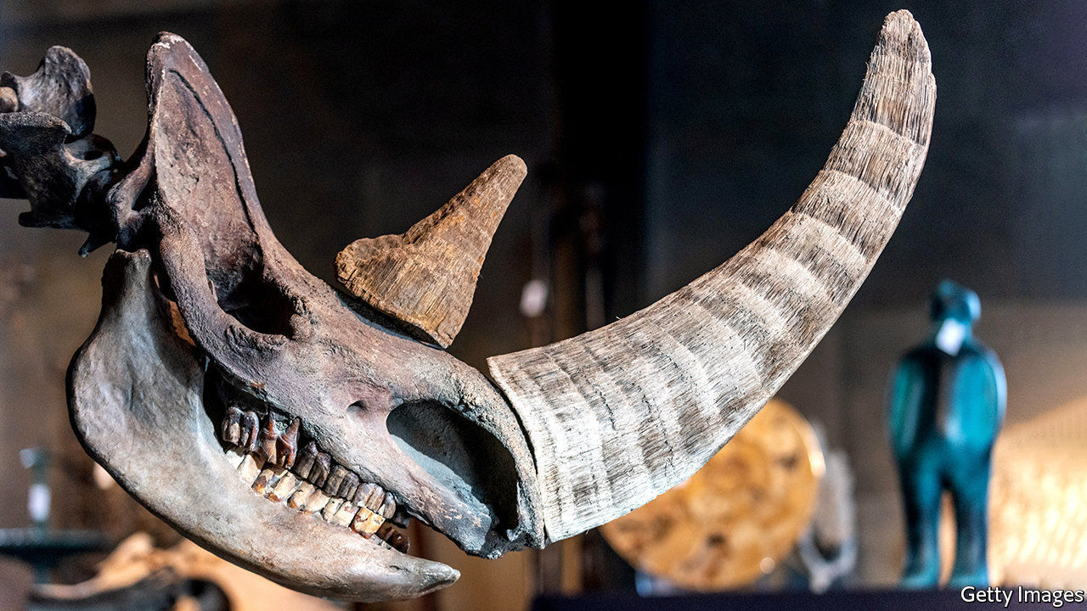

FROM THE moa in New Zealand to the dodo in Mauritius, the arrival of humans has often spelled extinction for tasty but previously isolated animals. Many scientists had assumed that the woolly rhinoceros, a shaggy beast that sported an enormous horn, suffered the same fate. The animal was common in northern Europe and northern Asia 30,000 years ago, when the first humans arrived. Shortly after, it disappeared.

But Love Dalén, a professor at the Centre for Palaeogenetics in Stockholm, and Edana Lord, one of Dr Dalén’s PhD students, are not so sure. In a paper published in Current Biology, they use data from ancient DNA to argue that, this time at least, humans might be innocent.

Until recently, information on the fate of the great ice-age mammals had been limited to what could be gleaned from fossilised bones. While useful, bones can only tell you so much. They can reveal the number of animals of different ages present at a specific location at a specific time. With some species sex can be determined. Occasionally the cause of death can be detected.

In the past couple of decades, though, scientists have learned to tap another, richer source of information: ancient genomes. By itself, DNA degrades quickly, attacked by water and sunlight. But DNA encased within bones and teeth can survive for longer, especially if those bones and teeth are themselves encased in permafrost. It was this sort of DNA that enabled Dr Dalén and Ms Lord to investigate the woolly rhino’s disappearance.

Working with a team of colleagues, the researchers obtained DNA from 12 woolly-rhinoceros bones collected from permafrost in Siberia, dating from the beginning of the Late Pleistocene, about 130,000 years ago, until the animals were on the verge of extinction. Extra DNA was recovered from one sample of rhino hair and one piece of tissue found in the stomach of a frozen wolf that had been preserved by the cold.

Analysing the genetic diversity of the samples allowed the researchers to make a rough calculation of the size of the woolly-rhino population over time. Rather than declining as humans arrived, the population remained stable from 29,000 years ago until 18,500 years ago, just a few thousand years before the species went extinct.

That suggests that, far from being hunted to extinction, the rhinos co-existed stably with humans for around 10,000 years. Perhaps the people who encountered the beasts found them unpalatable. Or perhaps the rhinos were simply too dangerous to hunt with their simple weapons. (They were the size of the modern white rhino, which is not an animal that takes kindly to being stabbed with spears.)

The researchers’ case is not quite conclusive. It is possible that some sort of technological advance eventually gave ancient humans the ability to hunt rhinos safely, and that extinction followed after that breakthrough. On the other hand, the animals’ decline lines up suggestively with a rapid bout of global warming that began around 14,700 years ago. The researchers argue that this was the more likely cause of the animal’s disappearance. This time, it seems, it was Mother Nature whodunnit. ■

This article was downloaded by calibre from <https://www.economist.com/science-and-technology/2020/08/15/what-killed-the-woolly-rhino>

|  |  |  |  |
| --- | --- | --- | --- |
| Previous | Articles | Sections | Next |

|  |  |  |  |
| --- | --- | --- | --- |
| Previous | Articles | Sections | Next |

#### A plague of insects

# Why locusts swarm

A new discovery could offer novel ways of controlling the insects

Aug 15th 2020 |



IN SOME PARTS of the world, covid-19 is not the only plague that 2020 has brought. In parts of Asia and east Africa, swarms of locusts have stripped fields. The UN reckons the swarms in India and Pakistan are the largest for a quarter of a century, and that the numbers in Kenya are the highest for 70 years. One swarm in northern Kenya was estimated to be 25 miles (40km) long and 37 miles wide.

Locusts are usually inoffensive, solitary creatures that do not stray far from the place that they were born. But under the right circumstances—namely heavy rain, and a subsequent boom in plant growth—they can become “gregarious”. When that happens the insects change colour and gather in ravenous swarms which can fly more than 100km in a day.

In a paper published in Nature, Xiaojiao Guo, of the Institute of Zoology in Beijing, and a group of other researchers, shed light on part of the biochemical machinery that drives that transformation. They think they have identified the specific pheromone that attracts the insects to each other, and thus causes them to swarm.

Dr Guo and her colleagues collected 35 chemicals collected from the bodies and faeces of the migratory locust, the most widespread species. Six of those showed significantly higher production among gregarious locusts than among solitary ones. When tested, gregarious locusts were strongly attracted to just one, a chemical called 4-vinylanisole (4VA). That attraction was strong for immature and mature locusts alike, and for both males and females. And locusts in the solitary phase of their existence found it just as attractive as gregarious ones did.

Scientists already know that swarming is a response to overcrowding, and Dr Guo and her colleagues found that 4VA production rose with population density. Intriguingly, concentrations began to increase when just four or five individuals were present. Further investigation pinpointed the odour receptor on the insect’s antennae that is sensitive to the compound. Disabling the gene responsible for that receptor yielded locusts for whom 4VA held no particular interest. And all this lab work was double-checked with a field trial, in which sticky traps spiked with 4VA attracted significantly more locusts than traps without it.

Dr Guo’s results could be of more than academic interest. Humans have tried everything from insecticides to flame-throwers to deal with locust swarms, with mixed results. Pheromones offer new angles of attack. Synthetic versions of 4VA might be used to bait traps. If a chemical could be developed that blocks the receptor, the insects might be made deaf to its call.

The first task will be to determine how widely applicable the results are. The insects plaguing India and Africa are desert locusts, a different species from those studied by Dr Guo. But the sensory apparatus of the two insects is similar. If 4VA turns out to be a language that all locusts understand, then it may help humans persuade them to abandon their gregarious ways, and return to a life of peaceable solitude.

This article was downloaded by calibre from <https://www.economist.com/science-and-technology/2020/08/15/why-locusts-swarm>

|  |  |  |  |
| --- | --- | --- | --- |
| Previous | Articles | Sections | Next |

|  |  |  |
| --- | --- | --- |
| Science & ... | Sections | Economic & ... |

Books & arts

Images of covid-19: Decent exposure

.

People power: Beginner’s luck

.

Espionage: The Führer’s man in Manhattan

.

Brazilian literature: Dead man’s blues

.

|  |  |  |
| --- | --- | --- |
| Science & ... | Sections | Economic & ... |

|  |  |  |  |
| --- | --- | --- | --- |
|  | Articles | Sections | Next |

#### Decent exposure

# Capturing the pandemic for posterity

Photographers shooting patients and carers have wrestled anew with thorny ethical questions

Aug 15th 2020 |

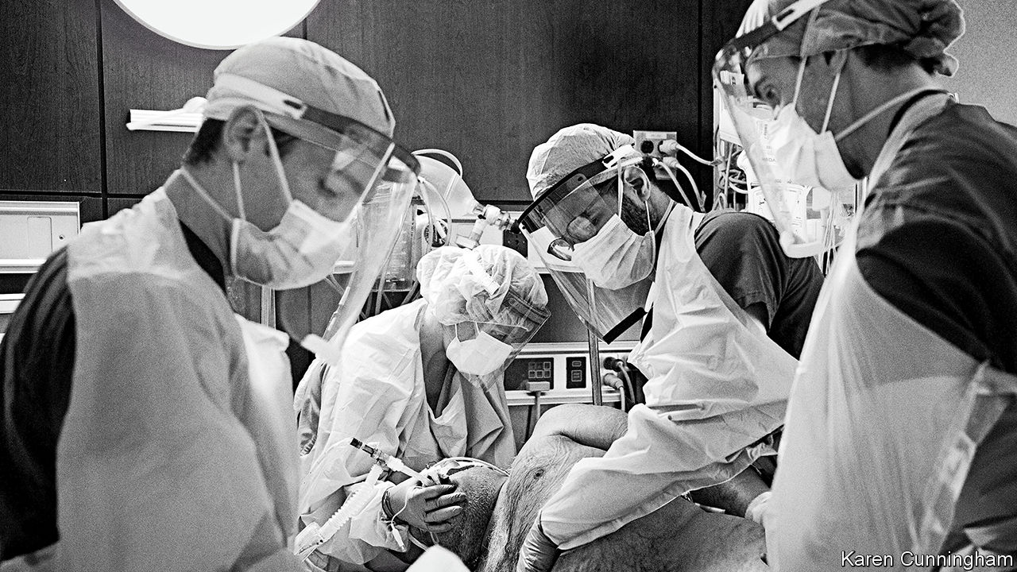

Editor’s note: Some of our covid-19 coverage is free for readers of The Economist Today, our daily [newsletter](https://my.economist.com/user#newsletter). For more stories and our pandemic tracker, see our [hub](https://www.economist.com/news/2020/03/11/the-economists-coverage-of-the-coronavirus)

IN MID-APRIL of intensive-care beds at Lenox Hill Hospital in New York were occupied by patients with covid-19. Karen Cunningham was caring for them: intubating the worst-affected and responding to countless emergency messages on the hospital’s tannoy. She was also taking photographs, capturing images of medical staff who were, to her surprise, eager to be included. Ms Cunningham says she felt a moral obligation to relay her colleagues’ experiences to the public.

A professional photographer, ten years ago she also became a registered nurse. When a friend at the New Yorker had first suggested she take her camera to work, Ms Cunningham was sceptical. But at the time reporting from inside hospitals was rare, and amid the pandemic photography could be a powerful public-health tool. So she agreed to shoot on the wards, often laying down her camera to help turn patients onto their fronts to ease breathing difficulties.

The results are an intimate depiction of the zone between life and death. In one image of an intubated patient (above), you can see the hair on the man’s chest and beard, his age signalled by the grey swirls among the black. His vulnerable skin contrasts with the armour-like layers of protective equipment worn by the four doctors surrounding him. Around the same time, Philip Montgomery, who previously chronicled America’s opioid epidemic, was touring New York’s public hospitals for the New York Times Magazine (NYTM). He also works in black and white, softening the garish hospital light to convey the motion and intensity of the carers. In Mr Montgomery’s pictures, their limbs blur as they rush through the wards.

Photography, the critic Susan Sontag wrote, “has kept company with death ever since cameras were invented.” This year it has helped tell the story of covid-19. Photographers around the world have documented suffering and treatments that might otherwise have remained unseen. In their tragic subject-matter and informative role, images of the pandemic have resembled war photography—except that, instead of capturing far-away conflicts, photographers have turned their lenses on their own communities. As in a war, sharp ethical questions have arisen: about the camera’s intrusion on pain, and how the story of the disease is told.

The use of black and white is a key choice. Historically, says Jennifer Good, an expert on photojournalism at the London College of Communication, the palette “serves a particular function in the photography of war, because it negates the shocking redness of blood”. Some of the most famous images of the Vietnam war, for instance, were shot this way. But there are illustrious peacetime precedents, too. Ms Cunningham cites “Country Doctor”, W. Eugene Smith’s series for Life magazine in 1948—for which he followed a doctor in rural Colorado—as an inspiration. The subject, Ernest Ceriani, is depicted as a charismatic, slick-haired saviour (see picture below). Black and white, Ms Good says, can be “a distancing measure. It cuts out some of the more striking or shocking aesthetic elements of the picture, creating an elegance and a timelessness.”

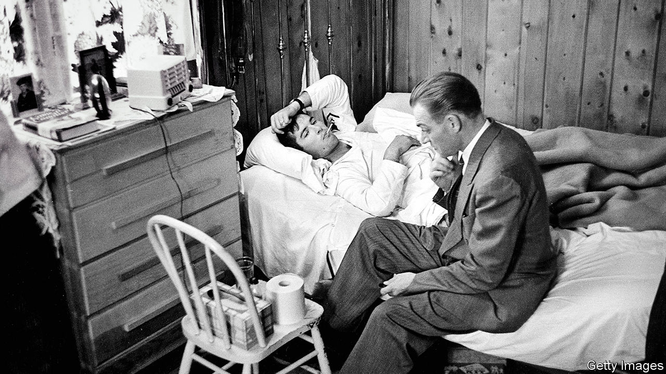

Along with these associations, black and white can focus attention. Mr Montgomery used strobe lighting to direct the viewer’s gaze, calling attention to individual actions within the often frantic ward. In one image, the arm of a paramedic performing CPR is tensed, the force of motion clear, but the outcome unknown. When health-care staff look straight into the camera, viewers feel transported to the hospital—admiring the doctors and nurses, yet unsettled by their own voyeurism.

## The home front

For both viewer and photographer, there is a fine line between compassionate observation and indecent intrusion. Hospital wards are full of sensitive information which must be repositioned or omitted while shooting. Patients and doctors must give their consent before their pictures are taken. Being a nurse, Ms Cunningham says, “gave me a certain moral and ethical freedom. I knew there was a line I would never cross.”

Her perspective inside the hospital was unique. But a series Mr Montgomery did at the Farenga Brothers Funeral Home in the Bronx involved even thornier ethical challenges. His images of the dead and their grieving relatives are meant to humanise the fact of mortality (see picture below). They also restore the individuality of some of the pandemic’s many victims.

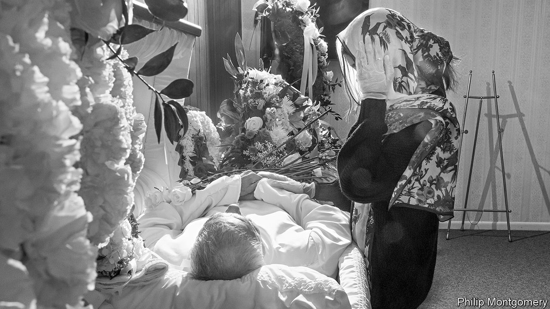

“The moral issues were huge,” acknowledges Kathy Ryan of the NYTM. “It’s not very often you see pictures dealing with the dead in our culture in this way.” In one image, editors blurred out a name-tag attached to a body bag. The series includes open coffins and refrigerated corpse trucks, but the most graphic scenes were omitted. The Purewals, the family at the centre of the shoot, were willing to be photographed as a way of honouring their late father. For some who were unable to give their loved ones proper funerals, Mr Montgomery’s pictures became a memorial.

What, for the West, has been an unusually intimate encounter with death has affected views on how suffering elsewhere in the world is portrayed. In March, after seeing the devastation that covid-19 was causing in Lombardy, Nana Kofi Acquah, a Ghanaian photographer, posted an address to white journalists on Instagram. “Can you photograph Africa with the same level of respect and empathy?” he asked. Azu Nwagbogu, director of the African Artists’ Foundation, hopes the global nature of the pandemic will lead to a levelling in the way anguish in different places is covered. “I think there’s now a clear understanding of the dignity and respect for human life that needs to be given to all patients.”

Pictures are, after all, one of the ways posterity will remember the pandemic and the lives it disrupted. Arts institutions are already beginning to shape the way it will be seen—and they are not relying only on professionals. The National Portrait Gallery in London, for example, has received over 30,000 submissions for “Hold Still”, a community photography project launched in response to the virus. “I see people voicing gratitude and manifesting dreams about better times, lives and loves after lockdown,” Magda Keaney, a curator, says of the entries. Professionals still shape perceptions of crises, wrestling with their motives and responsibilities as they shoot. But they are no longer alone. ■

This article was downloaded by calibre from <https://www.economist.com/books-and-arts/2020/08/15/capturing-the-pandemic-for-posterity>

|  |  |  |  |
| --- | --- | --- | --- |
|  | Articles | Sections | Next |

|  |  |  |  |
| --- | --- | --- | --- |
| Previous | Articles | Sections | Next |

#### Beginner’s luck

# Why democracy thrives in some places and not in others

It’s a matter of history and good fortune, says David Stasavage

Aug 15th 2020 |

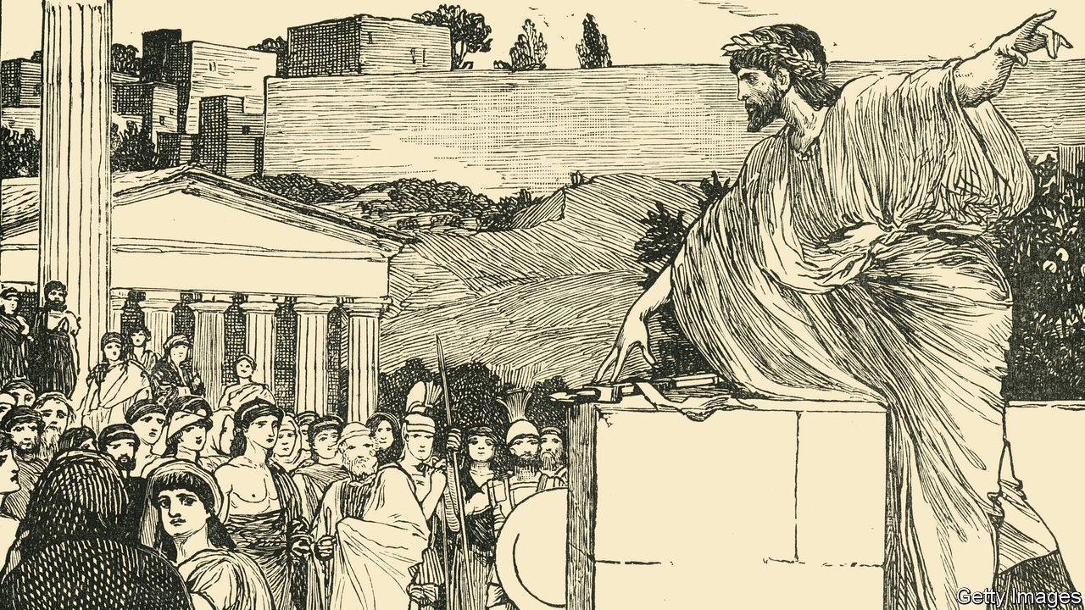

The Decline and Rise of Democracy: A Global History from Antiquity to Today. By David Stasavage. Princeton University Press; 424 pages; $35 and £30.

TWO COMMON beliefs about democracy are that it began in ancient Athens and, on spreading from there, remained peculiarly Western. David Stasavage, a professor of politics at New York University, finds both views mistaken. Without them, he thinks it will be easier to get hopes and fears for present-day democracy into better perspective and balance.

Understood as government by consultation and consent, democracy, he shows, can be found in many early civilisations, not just classical Greece—including ancient Mesopotamia, Buddhist India, the tribal lands of the American Great Lakes, pre-conquest Mesoamerica and pre-colonial Africa. With that spread in mind, he writes that under given conditions, “democratic governance…comes naturally to humans”. The puzzle is that autocratic governance was just as natural. It, too, was found in many places. In pre-modern China and the Islamic world, for example, autocracy—together with a centralised bureaucracy—was for centuries the norm.

To find out why early democracy occurred where it did, the author draws on evidence from archaeology, soil science, demographics and climate studies. The key, in his account, was information.

Early democracy tended to flourish where rulers knew little of what people were growing and had few ways to find out. They might underguess taxable produce (forgoing revenue) or overguess (provoking non-compliance). It was better to ask people how much they grew and, in return, listen to their demands. That pattern was typical where populations were small and a central state weak or non-existent.

With big populations, consultation was impractical. Rulers instead sent officials to see how much was grown and, before long, how many young men could be drafted into armies. Bureaucracies emerged. With their aid, autocratic rule imposed itself on local custom. In pre-modern settings, this autocratic bureaucracy was more common where soil was good, yields high and know-how advanced, especially in writing and measuring. Such systems were able to tax heavily. Song China (10th-13th centuries) and the Abbasid Caliphate (8th-13th centuries) extracted at their height respectively 10% and 7% of gross yearly product. Medieval European rulers managed barely 1%.

Once established, central bureaucracies were hard to dismantle. They took well to modernity and new technologies. Early democracy, by contrast, was notably—although not fatally—vulnerable to the rise of modern states and rapid economic development. It accordingly vanished in many places, while surviving in others.

Modernity and central states, in other words, allowed for either autocracy or democracy. But was there a pattern? Mr Stasavage thinks so. He calls it “sequencing”. “If the early democratic institutions of government by consent are established first,” he writes, “then it is possible to subsequently build a bureaucracy without veering inevitably into autocracy or despotism.” It depends on what went before.

## First-mover advantage

Awkwardly for this argument, the West is the one part of the world where early democracy of the small-scale, direct kind evolved most securely into modern, representative democracy. Does that not make democracy peculiarly Western after all? In modern democracy’s three waves—in the 19th century, post-1945 and post-1989—Western democracy was first. Despite glaring collapses, it has fared best. Yet, in Mr Stasavage’s telling, there was nothing essential—a liberal outlook, say, or respect for property, or a gift for industry—that tied the West and modern democracy together, beyond the luck of the past.

Pre-modern Europe had (with exceptions) democratic customs and weak rulers without effective bureaucracies. Where it occurs, and is not wiped out by autocracy, consensual government, the author writes, leaves “very deep traces”. Democracy and autocracy each have strong roots. There are good reasons to expect each to endure.

That conclusion may seem small yield for such intellectual labour. But a bracing stringency is one of the virtues of “The Decline and Rise of Democracy”. It sweeps across the globe in command of recent scholarship. It takes an economic view of politics as putative bargaining between rulers and ruled, dispensing with what actual people thought and did and skirting fastidious analysis of key ideas. Its strongest lessons are negative: it shows how complex democracy’s patterns are and, on the evidence, how simpler accounts of its past and prospects stumble. ■

This article was downloaded by calibre from <https://www.economist.com/books-and-arts/2020/08/15/why-democracy-thrives-in-some-places-and-not-in-others>

|  |  |  |  |
| --- | --- | --- | --- |
| Previous | Articles | Sections | Next |

|  |  |  |  |
| --- | --- | --- | --- |
| Previous | Articles | Sections | Next |

#### Nazi spies in America

# The Führer’s man in Manhattan

In the 1930s America was blind to the threat of German espionage

Aug 15th 2020 |



Ring of Spies. By Rhodri Jeffreys-Jones.History Press; 288 pages; £20. Published in America as “The Nazi Spy Ring in America” by Georgetown University Press in September; $29.95.

AS GERMANY PURSUED its territorial expansion in 1938, many Americans wanted nothing more than to be left alone. President Franklin Roosevelt had signed three neutrality acts forbidding involvement in Europe’s troubles. Of the fears that kept his compatriots awake, Hitler was eclipsed by mobsters, dust bowls and unemployment. This was to change, explains Rhodri Jeffreys-Jones in his new book, when the FBI’s unveiling of a Nazi spy ring poisoned relations with Germany and forced America to confront a hostile world.

A historian at Edinburgh University, Mr Jeffreys-Jones draws the reader in with thrilling, but initially disparate, tales of German espionage. The sense of Nazi audacity steadily rises. A widow with a pen-pal in Hamburg suddenly develops a penchant for photographing naval bases. A group of agents smuggle out secret documents as stamp-size pictures hidden in pocket-watches. Another cell plots to snatch mobilisation plans by subduing a colonel with a sedative-loaded fountain pen. Blueprints for American fighter-planes are stolen.

These pieces are gradually put together by Leon Turrou, the story’s fascinating central figure. A Jewish immigrant from Belarus, Turrou was an FBI agent who spent the 1930s fighting fascist and communist saboteurs with equal fervour. In 1938 he made the connections between the German spies, and tracked down a prime suspect. Ignatz Griebl ran a quiet medical practice in Manhattan, but his candid confession confirmed Turrou’s darkest fears (and unites the book’s scattered incidents):

Turrou: When did spy activities in this country start?  
Griebl: In 1933, soon after Hitler came to power.

The reader, like Turrou in the dimly lit interrogation room, is suddenly daunted by the scale of the Nazi scheme. German diplomats cut Griebl loose, which helped turn him into an FBI informant. From that point on, the spy ring unravelled.

This is an entertaining tale that doubles as an important work of scholarship. From its first days in power, Mr Jeffreys-Jones shows, the Nazi party strove to undermine American democracy. Along with recent work by other historians, his suggests that Nazi hostility to America—with its bill of rights, balanced constitution and thriving Jewish community—equalled or even exceeded its hatred of the Soviet Union.

Blind to the threat, America had made itself an easy target. The army gave its data on the spread of venereal diseases to a Nazi agent, inadvertently revealing up-to-date statistics on American troops and bases. This was a mix of incompetence and institutional failure. In 1918 America had 1,441 military-intelligence officers. In 1935 it had 69. Mr Jeffreys-Jones touches only lightly on the strategic lessons, observing that the episode “carries a serious message about spies from a foreign country who try to subvert American democracy”.

The agents who had not already fled to Germany were tried in late 1938, as Hitler’s troops were marching into Czechoslovakia. American legislators were clinging to the neutrality doctrine, and the politically astute judge opted for leniency: the four main conspirators received a combined sentence of just 14 years. Dissatisfied, Turrou left the FBI to write newspaper articles about the Nazi threat. In 1939 Hollywood adapted his exhortations into a film, “Confessions of a Nazi Spy”, in which Turrou had a cameo. This was America’s first anti-Nazi blockbuster, and public attitudes were changing.

In 1941 the discovery of another spy ring in New York provoked outrage. Its three leaders were awaiting sentencing when Japan attacked Pearl Harbour. A few weeks later, the spies received a combined sentence of 52 years. ■

This article was downloaded by calibre from <https://www.economist.com/books-and-arts/2020/08/15/the-fuhrers-man-in-manhattan>

|  |  |  |  |
| --- | --- | --- | --- |
| Previous | Articles | Sections | Next |

|  |  |  |  |
| --- | --- | --- | --- |
| Previous | Articles | Sections | Next |

#### Home Entertainment

# Discover the riotous prose of a classic Brazilian author

“The Posthumous Memoirs of Brás Cubas” is an invigorating read

Aug 15th 2020 |

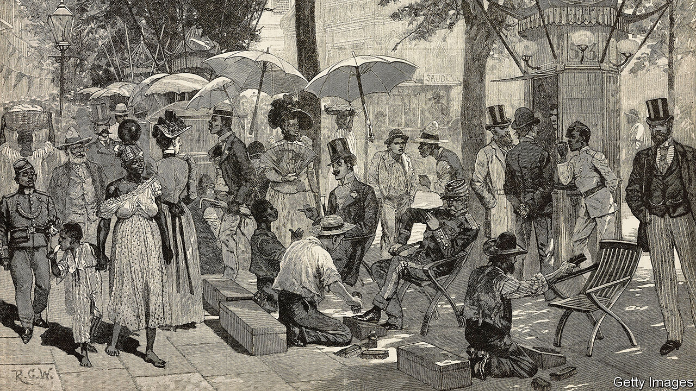

HIS GRANDPARENTS were slaves. His father painted houses. His immigrant mother washed laundry. For a poor, mixed-race boy born in Brazil in 1839, their son had done well to become an apprentice typesetter in Rio de Janeiro. But a priest taught him Latin, and a literary gent spotted the gifted lad at the Imprensa Nacional, the government press, and soon he was contributing to newspapers, writing plays and poems and starting a literary circle.

But it was as a novelist that Joaquim Maria Machado de Assis would truly shine. Machado worked as a civil servant and co-founded the Brazilian Academy of Letters; he married happily (although his Portuguese in-laws initially objected to the colour of his skin). Beneath all this outward respectability, his prose was radically ingenious. Ever since “The Posthumous Memoirs of Brás Cubas”, Machado’s fifth novel, appeared in 1881 it has astonished readers with its lordly ironies and scorn for convention. The book’s invigorating style, as much as its backdrop of racial and social injustice, makes it ideal reading for this morbid, insurgent summer.

Brás Cubas, the fictional memoirist, has just died from pneumonia. As a thwarted corpse who failed in almost everything he tried, he wants to set the record straight about his drifting life as an idle, pleasure-seeking dandy in Rio. Beneath his jaunty veneer, Cubas harbours a melancholy pessimism. He sees a freedman lash a slave he has bought—to relieve his own sufferings “by passing them on to someone else”. Yet the novel floats free of the ambient oppression on currents of mischief and urbanity.

Sprinkled with epigrams, dreams, gags and asides, the story teases, dances and delights. Across 160 short chapters (“Long chapters suit long-winded readers”), Machado mocks every rule of the 19th-century novel. A chapter of dialogue is written entirely in punctuation (“!…?…!”). In another the disgraceful narrator acknowledges (in a new translation by Margaret Jull Costa and Robin Patterson),“I have just written an utterly pointless chapter.” Dave Eggers, an American author, recently called this “one of the wittiest, most playful, and therefore most alive and ageless books ever written”.

At its heart lies a passionate love triangle. Cubas pursues a long, clandestine affair with married Virgília while working for her politician husband. Like his creator, he is a romantic as much as a cynic; his worldly, bruised voice reaches out to touch readers today with its rueful comedy and wry sensuality. After one more heartbreak with Virgília, “I ought to be plunged into deep despair, shed a few tears, and certainly not have lunch.” But he does, munching on “Monsieur Prudhon’s finest hors d’oeuvres”. That is two valuable lessons in one passage: don’t throw away your precious love—but don’t skip lunch either. ■

This article was downloaded by calibre from <https://www.economist.com/books-and-arts/2020/08/15/discover-the-riotous-prose-of-a-classic-brazilian-author>

|  |  |  |  |
| --- | --- | --- | --- |
| Previous | Articles | Sections | Next |

|  |  |  |
| --- | --- | --- |
| Books & arts | Sections | Graphic detail |

Economic & financial indicators

Economic data, commodities and markets

.

|  |  |  |
| --- | --- | --- |
| Books & arts | Sections | Graphic detail |

|  |  |  |  |
| --- | --- | --- | --- |
|  | Articles | Sections | Next |

# Economic data, commodities and markets

Aug 15th 2020 |

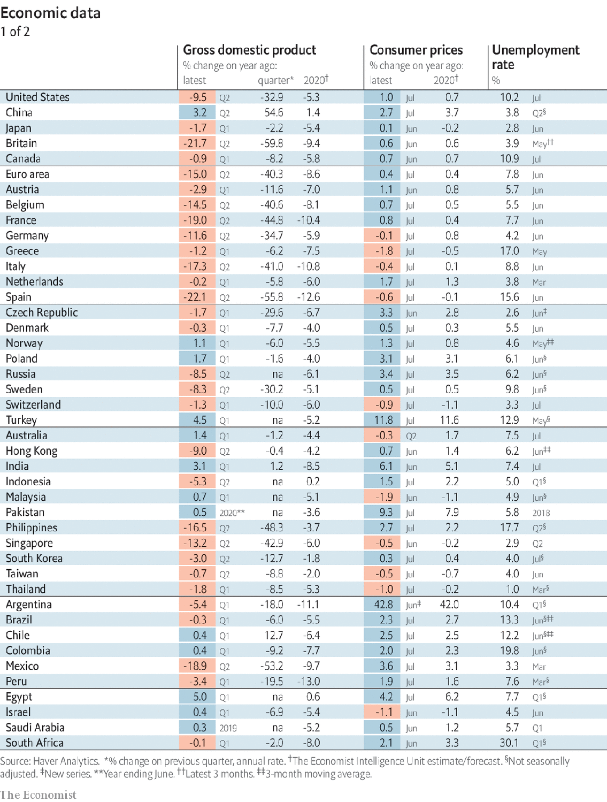

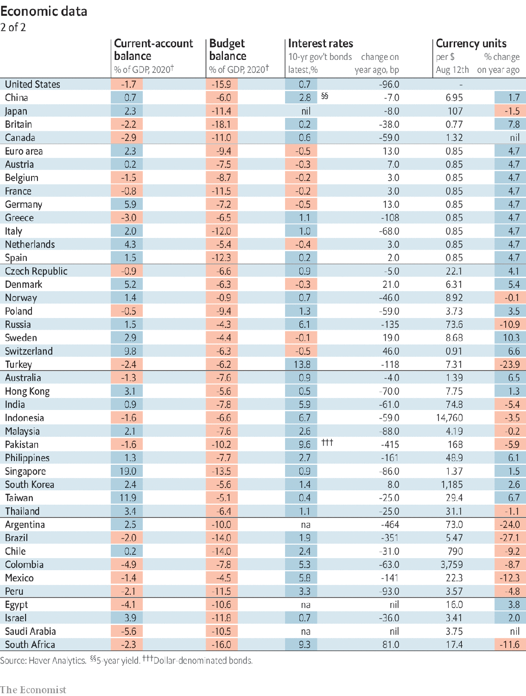

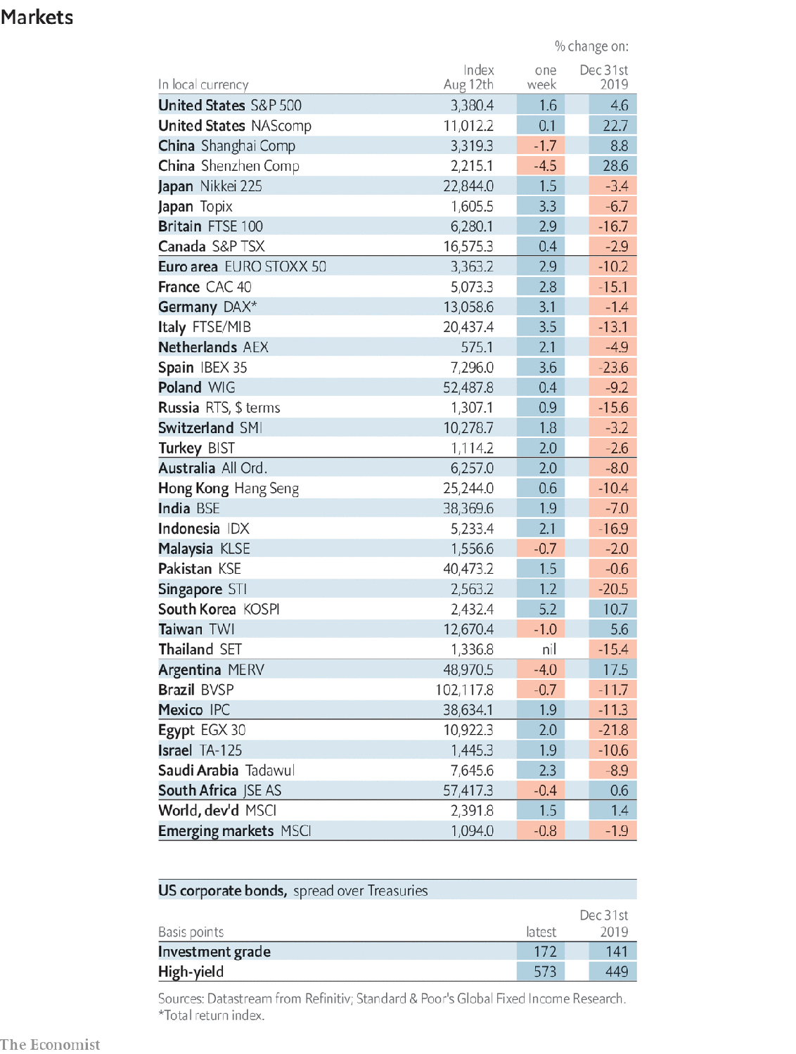

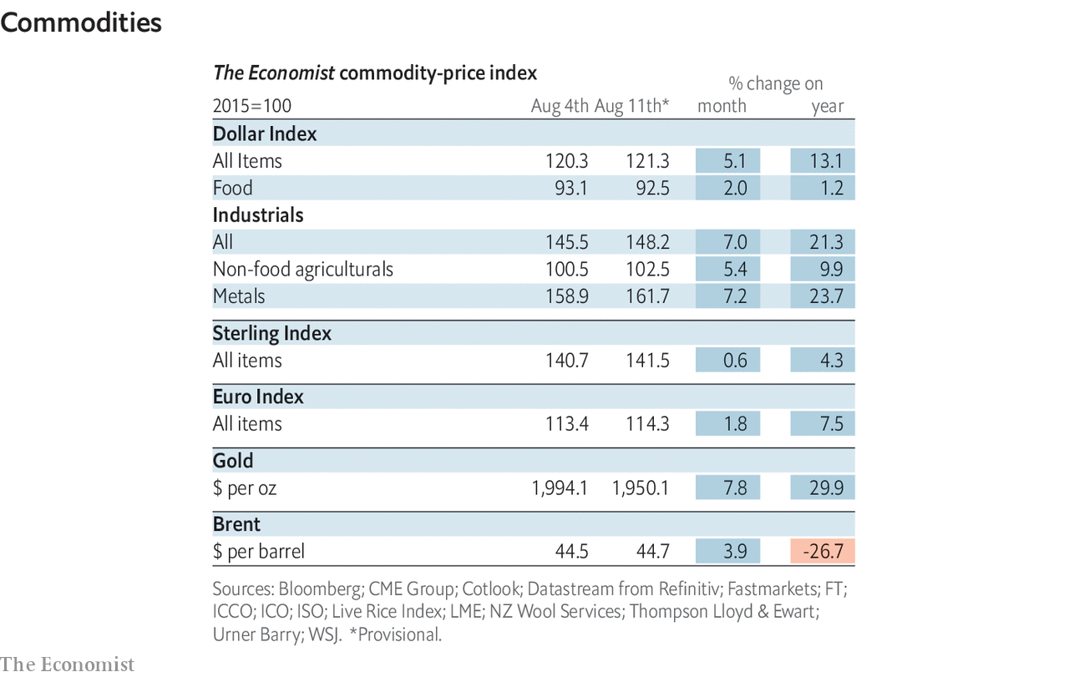

This article was downloaded by calibre from <https://www.economist.com/economic-and-financial-indicators/2020/08/15/economic-data-commodities-and-markets>

|  |  |  |  |
| --- | --- | --- | --- |
|  | Articles | Sections | Next |

|  |  |  |
| --- | --- | --- |
| Economic & ... | Sections | Obituary |

Graphic detail

US presidential election: The old college try

.

|  |  |  |
| --- | --- | --- |
| Economic & ... | Sections | Obituary |

|  |  |  |  |
| --- | --- | --- | --- |
|  | Articles | Sections | Next |

#### The old college try

# How America’s electoral college favours white voters

A ballot cast in New Hampshire is 100,000 times likelier to tip the result than one in Washington, DC

Aug 15th 2020 |

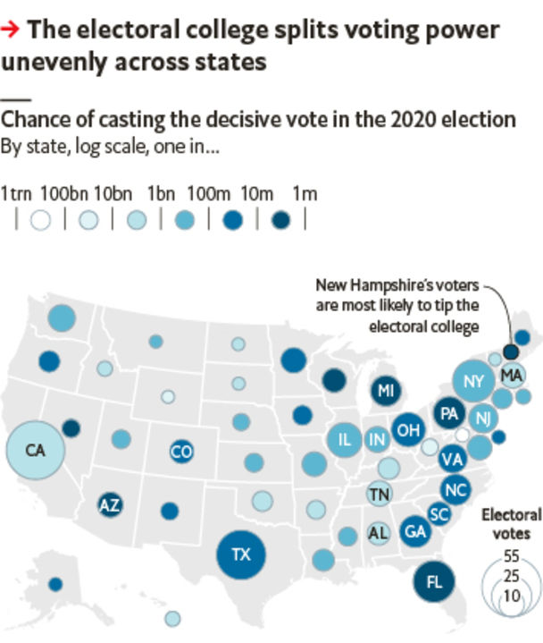

A FUNDAMENTAL TEST for any voting system is whether it treats citizens equally. America’s presidential election uses the “electoral college”, which allocates 538 votes based on states’ representation in Congress. A candidate who wins the popular vote in a state is allocated its chunk of electoral-college votes (ECVS)—from just three for Vermont, to 55 for California. Nominees must amass 270 ECVS to win.

This system can lead to unfair outcomes: in two of the past five elections, the winner of the White House (a Republican) did not win the national popular vote. Some cite this as evidence that the system is biased against the Democratic Party. It is more complicated than that.

The Economist used its presidential-election-forecasting model—which simulates the election 20,000 times a day—to quantify the system’s biases. Using each forecast for every state we determined the chance that any given voter in a particular state casts the decisive ballot in November. That figure is the product of two probabilities: whether a single state is likely to edge a candidate over 270 ECVS; and whether that state is won by a single voter.

The odds are shortest in New Hampshire, where the chance that someone casts the decisive vote is around 1-in-10m elections. By contrast, a resident of Washington, DC, will tip the contest only once in a trillion elections. The point is not that these chances are small, but that the gaps between them are large. Our model suggests that a Granite Stater who moves to neighbouring Vermont becomes 1,000 times less likely to affect the result of the election, simply by moving a few miles.

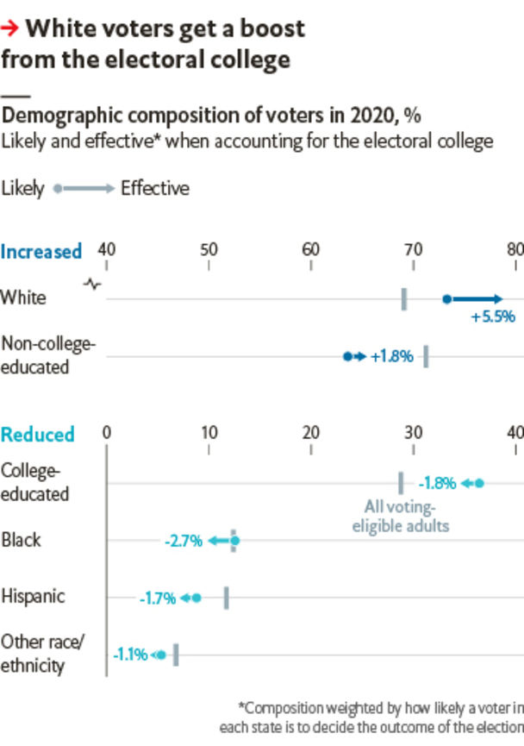

As states have different demographic mixes the electoral college can exaggerate the clout of some voter groups. For example, white people are expected to comprise roughly 73% of an average state’s voters come November. But if the average is weighted instead by how likely a voter in each state is to decide the outcome of the election, the white share of voting power climbs to 79%. That is because the most competitive states are whiter than the national average.

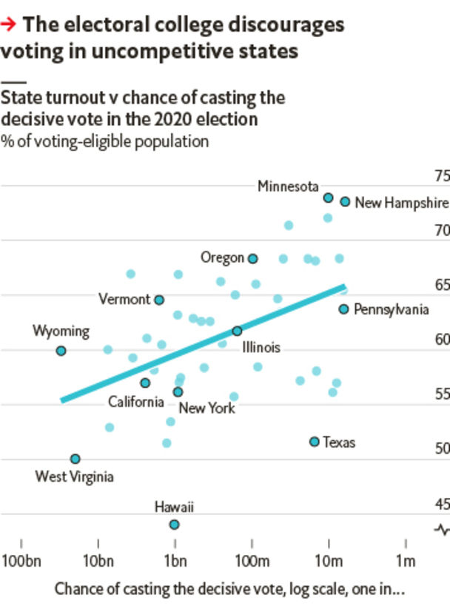

Those whose votes count for less are less likely to bother casting a ballot, it seems. Voters from states that were most likely to decide the election in 2016 were ten percentage points more likely to vote. That suggests that replacing the electoral college might lead to increased turnout.■

Sources: Andrew Gelman, Columbia University; US Census Bureau; YouGov; The Economist

This article was downloaded by calibre from <https://www.economist.com/graphic-detail/2020/08/15/how-americas-electoral-college-favours-white-voters>

|  |  |  |  |
| --- | --- | --- | --- |
|  | Articles | Sections | Next |

|  |  |  |
| --- | --- | --- |
| Graphic detail | Sections |  |

Obituary

Leon Fleisher: Right hand, left hand

.

|  |  |  |
| --- | --- | --- |
| Graphic detail | Sections |  |

|  |  |  |  |
| --- | --- | --- | --- |
|  | Articles | Sections | Next |

#### Right hand, left hand

# Leon Fleisher died on August 2nd

The acclaimed pianist who lost the use of his right hand was 92

Aug 15th 2020 |



A WHILE AFTER his argument with the patio table, when his sliced right thumb had had stitches and appeared to be healing, Leon Fleisher noticed a sluggishness in his right index finger. It was especially unresponsive when he tried to play trills, and that was no small matter. The ascending trills in the cadenza of the adagio of the Brahms first piano concerto, each joined by the next and then prolonged with a touch of the pedal—just a little, nothing showy—had a resonance like the shimmering of the universe.

He noticed, too, that the fourth and fifth fingers of his right hand were starting to curl under. This made the playing of triplets more or less impossible. Yet in the third movement of the Brahms they made the dancing culmination of the work, delighting him so much that they made the hairs stand up on the back of his neck.

In short he could no longer play the most important piece in his life, the one that had first struck him like Thor’s thunder on his 12th birthday, had anchored his debut as “the pianistic find of the century” at Carnegie Hall in New York when he was 16, and had been his talisman and friend ever since. He, whose greatest terror was failure, could not, in fact, play anything.

It was 1964, and he was 36. In the spring he was due to tour the Soviet Union, having performed in America and Europe all through the 1950s. He had made definitive recordings of Liszt, Beethoven and Brahms with George Szell and the Cleveland Orchestra, with Leonard Bernstein and with Otto Klemperer. Such a career had possessed him from childhood, and his slightly crazy mother had also thought of nothing else, pushing him under the nose of every eminent musician she could find in San Francisco, Pierre Monteux, Alfred Hertz, even Sergei Rachmaninoff once, as the maestro came off stage. His path had long been set.

Yet he felt he was only beginning to understand what music needed. Ten years of training with Artur Schnabel had laid down firm principles of faithfulness to the score and integrity in the playing; watching Schnabel had taught him to treasure not only each note, but also the potency of silence. In his 20s he developed his own opinions, discovering French, Russian and 20th-century composers. But now he might, after all, be going nowhere.

For 30 years his right hand was little use to him. He tried lidocaine injections, massage, psychotherapy, acupuncture, Tiger Balm. Quacks and gurus were called in. He let Bernstein pour Scotch on it. The condition had a name, focal dystonia, and a cause, over-practising, but there was no cure. At times the fingers loosened, but nothing helped for long. And since music was his life, taking priority over everything including, to his regret, his first two wives and their children, he had to keep making it somehow. Pieces like the Brahms lay not only in his fingers but in his mind and heart, and his purpose, paraphrasing Beethoven’s inscription in the “Missa Solemnis”, was to communicate their power to other hearts. He just had to find alternative means of doing so.

One was teaching. He had already been giving classes at the Peabody Conservatory in Baltimore, and now he did so, both there and at the Boston Symphony’s Tanglewood, as energetically as if his life depended on it, as it did. He also took up conducting, which—despite the oddity of standing in front of an orchestra—he greatly enjoyed. Both activities plunged him deeper into music, letting him see it through the eyes of other instrumentalists and, when he was teaching, pushing him to pin down the ephemeral beauty of notes with words alone. They went most of the way.

Yet still he was not playing. Stubbornly he went on practising a bit, though it was hopeless and probably did damage, and his attempt at a public two-handed comeback, in 1982, was a failure. Stubbornly, too, he resisted for a long time the left-hand piano repertoire. Though it was wide, most of it was bad. The whole notion seemed gimmicky, as well as an admission that, from now on, a left-handed pianist was all he could be. Old prejudices would keep surfacing. The right hand was the singer, doing most of the important work and so wearing out faster. The left balanced it and did its share, but inevitably had second billing.

The disaster that had befallen him slowly changed that view. He found left-hand masterpieces, notably Ravel’s “Concerto for the Left Hand” and a transcription by Brahms of the Bach D minor Chaconne for solo violin, which became firm favourites. Friends and colleagues wrote new pieces for him. And he discovered that his left hand, even by itself, gave him more to say at the piano. Unlike the right, it was built for the instrument, since the high tune could still be tapped out by the thumb while the other fingers kept to the bass. Besides, melody was the least important element in a piece. Rhythm came first, the heartbeat, then harmony, and these were both the province of the left hand—though they might emerge, as in the opening of the Ravel, out of the murkiest depths.

He performed that piece in concert, by his reckoning, more than 1,000 times, sliding across the stool through its leaps and glissandi, his right hand now a mere anchor to grip the frame. A later album cover of his work showed his left hand protectively covering the still-eager, straining right. But he had never quite given up hope that the same karma that had knocked him sideways might one day, equally mysteriously, heal that hand again.

By 1994 a combination of Botox and Rolfing, or deep massage, seemed to be helping. He was cautious. The pretence of his “comeback” more than a decade before still haunted him, when the cheering audience had no idea how he had struggled to control his right hand, and when he had had to rule out playing Beethoven’s fourth concerto in favour of something less exposed. This time, as it turned out, the improvement heralded a definite return to full playing. But on that first day of real hope he took no public chances. As he felt his hand properly opening again, he went instead to his study, where only the sun observed him through the windows. There, in the sunlight, with two hands, the piece growing note by note whole and complete, he played the Brahms. ■

This article was downloaded by calibre from <https://www.economist.com/obituary/2020/08/15/leon-fleisher-died-on-august-2nd>

|  |  |  |  |
| --- | --- | --- | --- |
|  | Articles | Sections | Next |